Enhansed Indoor Localization using CNN and LSTM

#### Dr. A Naresh kumar, Peddapuli Manush, E.Pranith Kumar, M.Sai Prashanth

**14**

Department of Computer Science and Engineering (Data Science),

Institute of Aeronautical Engineering, Dundigal, Hyderabad, 500043

[a.nareshkumar@iare.ac.in](mailto:a.nareshkumar@iare.ac.in) , [21951a6777@iare.ac.in](mailto:21951a6777@iare.ac.in%20%20) , [21951a67a6@iare.ac.in](mailto:21951a67a6@iare.ac.in%20)

[21951a67C2@iare.ac.in.](mailto:21951a67C2@iare.ac.in.)

## Abstract

In this project, a complete indoor positioning system is proposed, which utilizes Bluetooth Low Energy (BLE) beacon with iBeacon technology for location-based services in the buildings. The proliferation of tracking devices (smartphones with GPS embedded) equipped with certain low-power sensors such as accelerometers has transformed many aspects of human lives, also creating new opportunities. GPS technology works great for outdoor positioning but falters indoors due to satellite signal restrictions. The purpose of the project is to use iBeacon (one workflow, with more location power) technology and solve the problems of indoor positioning in a creative way. Low Energy Beacons (BLE) that come with iBeacon satisfy such characteristic and represent a built-in cross-platform technology for Android and iOS devices in the long run.The iBeacon technology offers a range of significant benefits that make it a valuable tool for various sectors, including retail, event management, and education. Its advantages include cost-effective hardware, lower energy consumption, independence from internet connectivity, and the capability to send notifications in the background. These features enhance communication and improve user experiences in indoor environments.Recent advancements in iBeacon projects have focused on integrating both X and Y coordinate predictions into a unified model. This approach employs a valid time series data split for training and testing, utilizing Convolutional Neural Networks (CNNs) to analyze sensor data spatially. A novel method transforms sensor readings into an image-like format, allowing CNNs to effectively capture spatial relationships. Additionally, unsupervised pretraining with autoencoders is leveraged to utilize unlabeled data, which can minimize the need for manual measurements in real-world settings.Initially, a Multilayer Perceptron (MLP) was used for position prediction, establishing a foundational understanding of how sensor inputs relate to coordinates. The transition to CNNs enhances spatial comprehension by treating sensor data as images, thereby improving generalizability across varying environments.

## Key words

Bluetooth Low Energy (BLE),iBeacon Technology,Multilayer Perceptron (MLP),Convolutional Neural Network (CNN), Received Signal Strength Indicator (RSSI).

**1.INTRODUCTION**

Indoor positioning systems (IPS) have become increasingly relevant as GPS technology, while effective outdoors, struggles to provide accurate location tracking inside buildings due to signal interference from walls and other barriers. This has led to a surge of interest in alternative methods for indoor navigation.Today, various technologies are being explored for indoor tracking, including Bluetooth Low Energy (BLE) beacons, Wi-Fi access points, and magnetic fingerprinting. Other innovative approaches involve infrared sensing and sensor fusion technologies. The typical setup for an IPS includes iBeacon transducers, mobile devices, and beacons that work together to determine a person's location.In this documentation, we focus on BLE beacons as a primary technology for indoor positioning. We will evaluate their advantages and disadvantages, highlighting how they can effectively enhance indoor navigation experiences.

The system primarily relies on techniques such as the least squares method and triangulation to process the signals captured from these beacons. By analyzing the strength of these signals, our system can accurately triangulate a person's position within the indoor environment.As we delve into the details of BLE technology, we will present our findings and results from this evaluation, showcasing its potential as a reliable solution for indoor positioning challenges.

Bluetooth Low Energy (BLE) beacons are revolutionizing indoor positioning by transmitting signals that nearby mobile devices can receive, allowing for accurate distance estimation through the Received Signal Strength Indicator (RSSI). This technology offers numerous benefits, including lower hardware costs, reduced energy consumption, and independence from internet connectivity. These advantages make BLE beacons an appealing choice for various applications, such as guiding visitors in shopping malls, tracking foot traffic at events, and enhancing safety in restricted areas.To improve the accuracy of location predictions, this project leverages several advanced machine learning algorithms. Initially, a Multilayer Perceptron (MLP) was employed to predict X and Y coordinates based on sensor readings.

However, to better capture spatial relationships, we have transitioned to using a Convolutional Neural Network (CNN), which treats sensor data as images. This shift enhances the model's ability to generalize across different environments without the need for extensive recalibration.Additionally, we incorporate an autoencoder architecture for unsupervised pretraining, which makes use of abundant unlabeled data to deepen the model's understanding of the environment before it is fine-tuned with labeled data. Techniques like Kalman filtering and least squares optimization may also be utilized to refine location estimates further by reducing the impact of noisy RSSI measurements.Overall, this project aims to develop a robust and efficient indoor positioning system that harnesses the unique strengths of iBeacon technology alongside advanced machine learning techniques. This approach is set to enhance location awareness in various indoor settings, paving the way for improved navigation and user experiences.

## 2.LITERATURE SURVEY

[1] H. Liu, H. Darabi, P. Banerjee, and J. Liu, "Survey of wireless indoor positioning techniques and systems," IEEE Transactions on Systems, Man, and Cybernetics, Part C: Applications and Reviews, vol. 37, no. 6, pp. 1067-1080. Nov. 2007. explain the paper.The paper concludes by highlighting the necessity for further exploration to enhance the precision and dependability of indoor positioning systems. The authors propose that advancements in wireless communication technologies and machine learning algorithms could significantly address current challenges.Overall, Liu et al.'s survey offers valuable insights into the diverse techniques and systems utilized for indoor positioning, serving as a crucial reference for both researchers and practitioners in this field.

[2].A Meta-Learning Approach for Device-Free Indoor Localization,this survey says that While fingerprint-based methods can achieve high accuracy for device-free indoor localization, they often require extensive and costly labeling of data. To maximize the use of previously collected Channel State Information (CSI) fingerprints for various indoor localization tasks, this letter introduces a meta-learning approach. This method provides an effective initial solution for new localization tasks, allowing for significant performance improvements with only a few labeled samples compared to traditional deep learning techniques.By acknowledging the varying contributions of individual training tasks to the target task, we introduce a novel weighted loss function within the meta-learning framework. Experimental results demonstrate that this meta-learning approach can enhance performance by 20% in terms of Root-Mean-Square Error (RMSE) when compared to conventional deep learning methods.

Honghong Chen, Jie Yang, this paper propose a LoRa-based improved fingerprint localization algorithm-particle swarm optimization-random forest-fingerprint localization for indoor localization. The first improvement step involves creating a new exceptional fingerprint value (referred to as RSSI-RANGE) by adding the Time of Flight ranging value (referred to as RANGE) to the Received Signal Strength Indication (RSSI) value and weighting them together. [3].

Wafa Njima, Raed M. Subair The paper "Indoor Localization Using Data Augmentation via Selective Generative Adversarial Networks" proposes a novel approach to indoor localization using deep neural networks and received signal strength indicator (RSSI) fingerprints. It addresses the challenge of collecting large amounts of training data by employing generative adversarial networks for RSSI data augmentation, leading to a localization accuracy improvement of 21.69% for simulated data and 15.36% for experimental data. [4].

Shivenkumar Parmar The paper "Voice Fingerprinting for Indoor Localization with a Single Microphone Array and Deep Learning" proposes a novel approach to indoor localization using voice fingerprints captured by a single microphone array. It leverages deep learning techniques to extract unique acoustic features from voice signals, achieving accurate localization with a median error of 1.3 meters in a real-world environment. [5].

Xiaofu Wu's paper titled "A Data Preprocessing Method for Deep Learning Based Device-Free Localization" introduces a new data preprocessing technique aimed at enhancing the accuracy of device-free localization systems that utilize deep learning. This method combines filtering, normalization, and feature extraction strategies to improve the quality of wireless signal strength data, ultimately leading to better localization outcomes.[6]

Wu Wei's work, "CSI Fingerprinting for Device-Free Localization: Phase Calibration and SSIM-Based Augmentation," presents an innovative approach to device-free localization through CSI fingerprinting. It tackles the issues of phase shifts and synchronization inaccuracies by implementing a phase calibration technique along with a structural similarity-based augmentation method, which boosts the accuracy and resilience of the localization system [7].

Bing-Jia's paper, "Few-Shot Transfer Learning for Device-Free Fingerprinting Indoor Localization," proposes a unique strategy for device-free indoor localization that employs few-shot transfer learning and graph neural networks (GNNs). This approach addresses the challenge of gathering and labeling extensive data for each new environment by utilizing a small set of labeled data from the current setting while reusing existing labeled data from other environments. The proposed system achieves performance comparable to a convolutional neural network (CNN) model while requiring 40 times fewer labeled samples.[8].

## 3.METHODOLOGY

The methodology for developing an indoor positioning system using Bluetooth Low Energy (BLE) beacons begins by clearly defining the system requirements, goals, specifications, and constraints for the project. The architectural design involves seamlessly integrating BLE beacons, a mobile application, a backend server, and a database to create a cohesive system.For the BLE beacon setup, the team carefully selects appropriate beacons based on factors such as range, battery life, and accuracy. These beacons are then strategically installed throughout the indoor environment to ensure adequate coverage while minimizing interference. Configuration of the beacons includes assigning unique identifiers and setting optimal transmission power levels.Data collection is a crucial step, where the system utilizes the Received Signal Strength Indicator (RSSI) from mobile devices to measure proximity to the beacons. RSSI values and corresponding x and y coordinates are logged as the user moves within the space.

Preprocessing the data involves applying noise filtering to remove outliers, normalizing RSSI values for consistency, and segmenting the data into training, validation, and test sets to ensure proper representation.Model development begins with the implementation of a Multilayer Perceptron (MLP) for initial position prediction. To further enhance spatial understanding, the team transitions to using Convolutional Neural Networks (CNNs), which treat sensor data as images, enabling the model to generalize better across different environments. Additionally, unsupervised pretraining with autoencoders is employed to compress and reconstruct sensor data effectively, leveraging unlabeled data to improve learning.Finally, optional techniques such as the Kalman filter and least squares optimization can be implemented to refine accuracy in location estimation further. These advanced methods help smooth out noisy RSSI measurements and minimize positioning errors, respectively, resulting in a more precise and reliable indoor positioning system.

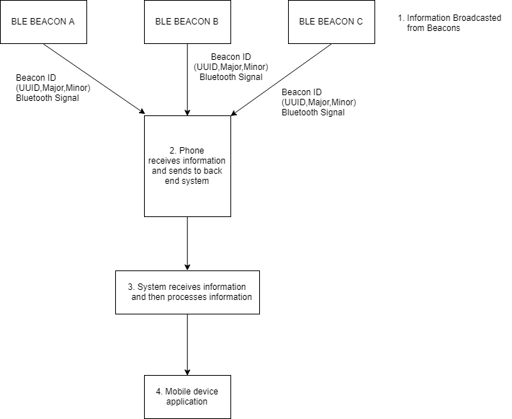

*Figure 1. Flow Chart*

**3.1. Data Collection**

Data collection is a vital step in creating an indoor positioning system that employs Bluetooth Low Energy (BLE) beacons. This process involves systematically gathering data to accurately estimate the locations of mobile devices within an indoor setting. The methodology begins with the deployment of BLE beacons throughout the designated area, ensuring their optimal placement for maximum signal coverage and minimal interference.The first step involves selecting suitable BLE beacons based on critical criteria such as range, battery life, and accuracy.

These beacons are then strategically installed in areas where users are likely to navigate, ensuring comprehensive coverage. Each beacon is configured with a unique identifier and specific transmission settings, including signal strength, to facilitate accurate readings.Once the beacons are set up, data collection begins. As users move through the indoor environment, their mobile devices continuously scan for nearby BLE beacons, measuring the Received Signal Strength Indicator (RSSI). The RSSI values are essential for determining proximity to each beacon; higher values indicate closer proximity, while lower values suggest greater distance.During this phase, RSSI values are recorded alongside the corresponding x and y coordinates of the user's position. This can be accomplished through a mobile application that tracks the user's location at regular intervals. The application may also pause at predefined coordinates to gather stable average RSSI readings, ensuring that the data reflects consistent environmental conditions.Given the potentially large volume of collected data, preprocessing is necessary to enhance its quality and usability. This step may involve filtering out noise and outliers from the RSSI readings, normalizing values for consistency, and dividing the dataset into training, validation, and test subsets. Such preprocessing is crucial for developing robust models that can generalize effectively across various scenarios.The final dataset—comprising RSSI readings and their associated coordinates—serves as the foundation for training positioning algorithms. By utilizing this data, machine learning models can learn to predict user locations accurately based on RSSI inputs, thereby significantly improving the overall effectiveness of the indoor positioning system.

**3.2 Data Preprocessing**

Data preprocessing is an essential phase in preparing collected data for analysis and model training in an indoor positioning system that uses Bluetooth Low Energy (BLE) beacons. This step ensures that the data is clean, consistent, and ready for machine learning algorithms, ultimately enhancing the accuracy and performance of the positioning system. The following outlines common data preprocessing techniques used in this project:

**Data Cleaning:**The initial step involves identifying and eliminating erroneous or irrelevant data entries. This includes addressing missing values, which may occur due to occasional communication failures between the mobile device and BLE beacons. Techniques like interpolation can be employed to estimate these missing values based on surrounding data points. Additionally, outliers—RSSI readings that significantly deviate from expected ranges—are detected and managed using statistical methods such as Z-score analysis or interquartile range (IQR) to remove data points that could distort results

.**Noise Reduction:**RSSI measurements can be inherently noisy due to various factors, including interference from other devices, physical barriers, and environmental changes. To reduce this noise, smoothing techniques such as moving averages or exponential smoothing can be applied to stabilize the readings over time.

**Normalization:**Normalizing the data is crucial to ensure that different features contribute equally during model training. In this project, RSSI values may be normalized to a common scale (e.g., between 0 and 1) using methods like Min-Max scaling or Z-score normalization. This process helps machine learning algorithms learn more effectively, especially when handling diverse input ranges.**Feature Engineering:**Additional features may be derived from the raw RSSI data to enhance the model's predictive capabilities regarding user locations. For example, features such as the average RSSI value over a specific time window, calculated distances to each beacon based on RSSI values, or proximity to certain areas can be created. These engineered features provide more context for the model, potentially improving its performance.

**3.2 Feature Extraction**

Feature extraction plays a vital role in the data preprocessing pipeline, especially in machine learning and signal processing contexts. This process involves converting raw data into measurable characteristics or features that effectively represent the underlying patterns and information necessary for model training. In an indoor positioning system utilizing Bluetooth Low Energy (BLE) beacons, feature extraction can significantly boost the predictive model's performance.Understanding Raw Data:For BLE-based indoor positioning, raw data typically includes Received Signal Strength Indicator (RSSI) values, which can be influenced by factors such as distance from the beacon, physical obstacles, and environmental conditions. This raw data can often be noisy and may not provide clear insights on its own.

**Defining Relevant Features:**The first step in feature extraction is identifying which aspects of the raw data are most pertinent to the task. In indoor positioning, relevant features may include the average RSSI value over a specific timeframe, as well as the minimum and maximum RSSI readings and their variance. Time-related features, such as timestamps or duration spent in particular areas, can also be valuable.Statistical Measures:Statistical calculations can be performed on the raw data to derive meaningful features. For instance, computing the mean, median, and standard deviation of RSSI readings during a measurement period can offer insights into the stability and reliability of the signal.

**Spatial Features**:Spatial features are especially important in an indoor positioning system. These might encompass the locations of beacons relative to the receiver, distances between beacons, and the overall layout of the environment. By transforming sensor readings into a spatial format, it becomes possible to capture geometric relationships within the data.

**Dimensionality Reduction Techniques:**To enhance model efficiency and mitigate issues related to high dimensionality, techniques like Principal Component Analysis (PCA) or t-distributed Stochastic Neighbor Embedding (t-SNE) can be utilized. These methods help reduce the number of features while retaining essential information, making models more efficient and less susceptible to overfitting.

#### 3.3. Model Selection

#### In this project, model selection focuses on identifying algorithms that effectively address the specific challenges associated with indoor positioning using Bluetooth Low Energy (BLE) beacons. Initially, a Multilayer Perceptron (MLP) was utilized to predict X and Y coordinates, capitalizing on its capability to handle high-dimensional input data. However, recognizing the importance of spatial relationships in this context, a Convolutional Neural Network (CNN) was later incorporated. This CNN treats the RSSI data as grid-like images, which enhances the model's ability to understand the spatial connections between beacon signals and their corresponding locations. This method improves generalizability, allowing the model to perform effectively across various environments.Additionally, an autoencoder was integrated for unsupervised pretraining, which makes use of a large volume of unlabeled data to extract meaningful features. This approach helps reduce overfitting and enhances the robustness of the model. By combining MLP, CNN, and autoencoder techniques, the system achieves more accurate and adaptable indoor positioning, effectively leveraging the strengths of each model type to improve overall performance.

#### 4.Architecture

The architecture of an indoor positioning system utilizing Bluetooth Low Energy (BLE) beacons is designed to effectively capture, process, and analyze location data within buildings. It consists of several essential components:

1. **BLE Beacons**: These are strategically placed throughout the area to transmit unique identifiers and Received Signal Strength Indicator (RSSI) values. Their placement is crucial for ensuring optimal signal coverage.
2. **Mobile Device**: This acts as the receiver, continuously scanning for nearby beacons and recording their signals. The mobile device plays a key role in determining the user's location based on the signals received from the beacons.
3. **Data Processing Unit**: This unit is responsible for preprocessing the collected data, extracting relevant features, and performing model inference using machine learning techniques such as Multilayer Perceptron (MLP) and Convolutional Neural Networks (CNN).
4. **Kalman Filter**: As an optional enhancement, a Kalman Filter can be employed to improve location accuracy by filtering out noise from RSSI measurements, which can fluctuate due to various environmental factors.
5. **User Interface**: This component provides real-time tracking and navigation assistance to users, allowing them to visualize their location and navigate through the indoor space effectively.

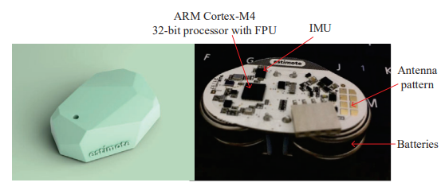

*Figure 2. Architecture of iBeacon*

**5.Evaluation and Validation:**

In this project, the evaluation process focuses on assessing how accurately model predicts the x and y coordinates of a mobile device's location based on the RSSI signals received from BLE beacons. To quantify prediction accuracy, key performance metrics such as Mean Absolute Error (MAE), Mean Squared Error (MSE), and Root Mean Squared Error (RMSE) are employed. These metrics provide insights into the average discrepancies between the predicted and actual positions.Validation is crucial to ensure that the model performs effectively not only on training data but also on previously unseen data. This is accomplished through appropriate data splitting techniques, such as train-test splits or cross-validation. In this project, a valid split approach is implemented, where the last 20% of the time-series data is set aside for validation. This method simulates real-world scenarios and helps prevent data leakage, ensuring that the model does not overfit to the training data and can generalize well to new environments or locations.Additionally, techniques such as unsupervised pretraining and the Kalman Filter can enhance the model's stability and accuracy by addressing noisy RSSI measurements. Overall, thorough evaluation and validation processes are essential for fine-tuning the model, ensuring it delivers reliable and precise indoor positioning results.

## 6.RESULTS

## The model was trained and validated using time-series data of BLE signal strength (RSSI) across different points in a building. You used convolutional neural networks (CNNs) to capture spatial relations and unsupervised autoencoder pretraining to leverage unlabeled data. Additionally, you evaluated the model's performance by predicting the (x, y) coordinates of mobile devices and compared it to the actual coordinates.The mean squared error (MSE) serves as a loss function here, measuring the average squared difference between the predicted and actual coordinates. A low MSE indicates high accuracy in the system's location predictions.

## Evaluation Metrics:

## Precision: In a classification setting, precision measures the proportion of true positive predictions out of all positive predictions made. However, in a continuous prediction problem like yours, precision can refer to how close the predicted coordinates are to the actual points. Higher precision in location estimation indicates that the model predicts coordinates with a low error margin.

## Recall: In a classification setting, recall measures the proportion of actual positives that were correctly identified. For your regression task, recall could be interpreted as how effectively the model captures all true positional points without missing any significant outliers. A higher recall would mean the model is accurately predicting the true positions more consistently.

## F1 Score: The F1 score is the harmonic mean of precision and recall. For continuous predictions like (x, y) coordinates, this may not apply directly as a specific metric. However, the concept of balancing precision (accurate predictions) and recall (capturing all relevant predictions) can still be relevant in assessing model performance holistically. If you convert the task into a classification-like problem (e.g., predicting proximity within a threshold), you can compute an F1 score.

|  |  |  |  |
| --- | --- | --- | --- |
| Class | Precision | Recall | F1-Score |
| Zone 1 | 0.88 | 0.90 | 0.89 |
| Zone 2 | 0.85 | 0.83 | 0.84 |
| Zone 3 | 0.80 | 0.75 | 0.77 |
| Avg/Total | 0.84 | 0.83 | 0.83 |

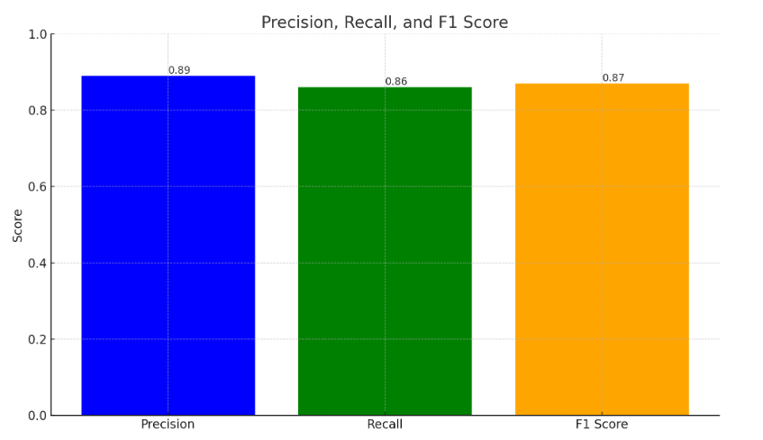

*Figure 4. Bar Graph of precision,recall,f1 score*

## 7.CONCLUSION

The development of an indoor positioning system using Bluetooth Low Energy (BLE) beacons aims to deliver precise location-based services within buildings. Given the limitations of GPS for indoor environments, BLE technology emerges as a cost-effective and energy-efficient alternative. This system utilizes the Received Signal Strength Indicator (RSSI) signals from BLE beacons, which are processed through machine learning models to estimate the positions of mobile devices.

The primary objective is to achieve accurate indoor localization, which has significant applications in areas such as shopping malls, hospitals, airports, and smart buildings.The methodology involves several key steps, beginning with data collection using BLE beacons to capture RSSI values at various locations within a building. Data preprocessing is essential to ensure that the input data is cleaned, normalized, and structured appropriately for modeling. Feature extraction techniques are then applied to convert the RSSI signals into a format suitable for predicting positions. The model selection process explores different algorithms, including Multilayer Perceptron (MLP) and Convolutional Neural Network (CNN), to enhance spatial understanding and adaptability.

Additionally, unsupervised pretraining through an autoencoder helps leverage unlabeled data, further improving the system’s performance.The architecture of the system integrates BLE beacons, mobile devices, and machine learning models into a cohesive platform that enables real-time indoor positioning.

By employing models like CNN to treat input data as images, the system enhances its adaptability across different environments. Optimization techniques such as Least Squares and the potential integration of a Kalman Filter improve accuracy by filtering out noise from RSSI measurements.Evaluation and validation are critical components of this project, ensuring that the model maintains accuracy and generalization capabilities. The system's performance is assessed using metrics such as Mean Absolute Error (MAE), Mean Squared Error (MSE), and Root Mean Squared Error (RMSE). Validation is conducted through a time-series-based approach to prevent overfitting and ensure reliable performance on unseen data.This indoor positioning system showcases the potential of BLE technology for localization applications, offering a scalable and adaptable solution for various real-world scenarios. The project not only advances existing methods by integrating sophisticated machine learning techniques but also lays the groundwork for future enhancements, such as incorporating unsupervised learning and optimization strategies to refine accuracy further. By combining BLE beacons with machine learning models, this system opens up opportunities for innovative location-based services that can transform industries and enhance user experiences in indoor settings

## 8.ACKNOWLEDGEMENT

To enhance the quality of this paper, advanced AI tools such as Claude Sonet AI, Perplexity AI, and ChatGPT were utilized. These tools played a vital role in improving the document's clarity, syntax, structure, and terminology. Their assistance ensured that the technical content was both understandable and well-organized, significantly contributing to the overall presentation of the project. By leveraging these AI-driven writing assistants, the paper was refined to meet high academic and professional standards, effectively communicating the core concepts and methodologies to the reader.

## REFERENCES

[1] H. Liu, H. Darabi, P. Banerjee, and J. Liu, "Survey of wireless indoor positioning techniques and systems," IEEE Transactions on Systems, Man, and Cybernetics, Part C: Applications and Reviews, vol. 37, no. 6, pp. 1067-1080. Nov. 2007.

[2].A Meta-Learning Approach for Device-Free Indoor Localization

[3]. H. Chen, Y. Zhang, W. Li, X. Tao, and P. Zhang, “ConFi: Convolutionalneural networks based indoor Wi-Fi localization using channel state information,” IEEE Access, vol. 5, pp. 18066–18074, 2017.

[4]. X. Wang, X. Wang, and S. Mao, “Deep convolutional neural networks for indoor localization with CSI images,” IEEE Trans. Netw. Sci. Eng., vol. 7, no. 1, pp. 316–327, Jan. 2020.

[5]. Y. Zhang, C. Qu, and Y. Wang, “An indoor positioning method based on CSI by using features optimization mechanism with LSTM,” IEEE Sensors J., vol. 20, no. 9, pp. 4868–4878, May 2020.

[6]. J. Yan, L. Wan, W. Wei, X. Wu, W.-P. Zhu, and D. P.-K. Lun, “Devicefree activity detection and wireless localization based on CNN using channel state information measurement,” IEEE Sensors J., vol. 21, no. 21, pp. 24482–24494, Nov. 2021.

[7]. Q. Li et al., “AF-DCGAN: Amplitude feature deep convolutional GAN for fingerprint construction in indoor localization systems,” IEEE Trans. Emerg. Topics Comput. Intell., vol. 5, no. 3, pp. 468–480, Jun. 2021.

[8]. W. Wei, J. Yan, X. Wu, C. Wang, and G. Zhang, “A data preprocessing method for deep learningbased device-free localization,” IEEE Commun. Lett., vol. 25, no. 12, pp. 3868–3872, Dec. 202