String 🡺 words type of data

String is **immutable Object** 🡺 Once we assign data, it wont change the state of it(memory location) until we assign new data.

Objects stores in 🡺 heap memory

String 🡺 heap memory🡪 **String constant pool**

String is class

String s = “hello”; 🡺 String laterals 🡺 stores in String constant pool

String s1 = new String(“Hello”); 🡺 Object way 🡺 stores in heap memory

String s = “hello”;

s = s.toLowercase(); // immutable

String s1 = “hello”;

String s2 = “hi”;

String s3 = new String(“hello”);

String s4 = new String (“hello”);

String mutable 🡺 StringBuilder and StringBuffer 🡺 Mutable

StringBuilder sb = new StringBuilder(“Hello”);

Sb.toLowerCase(); // hello

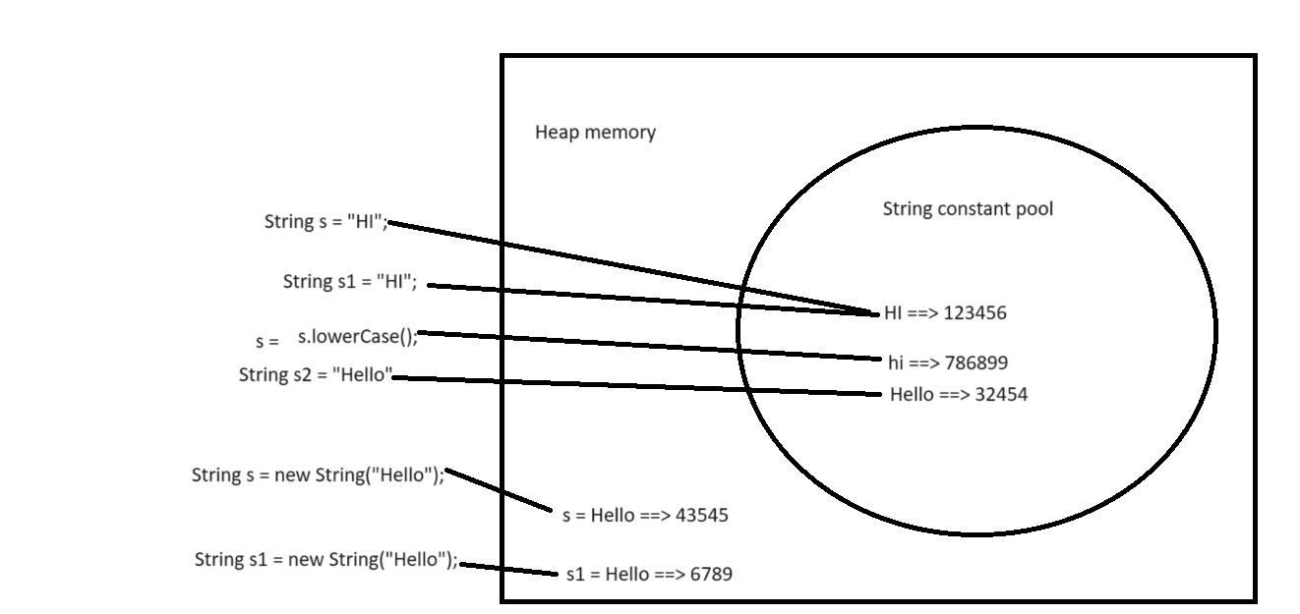

String s = “HI Welcome”;

S = s.toLowerCase(); // hi welcome

sop(s);

String s = “Hi”; 🡺 SCP 🡺 12345

String s1 = “Hi”; 🡺 SCP 🡺 12345

Obj = “ABC”

OBJ = “CND”