**Monolithic:**

* it is single server application
* it contains only one db
* it can be developed with only one language ex: java

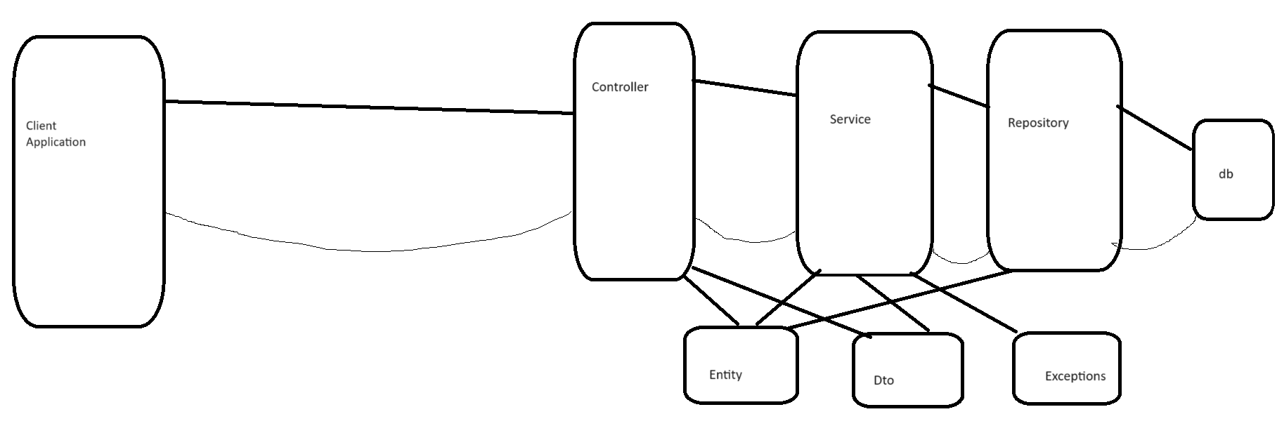

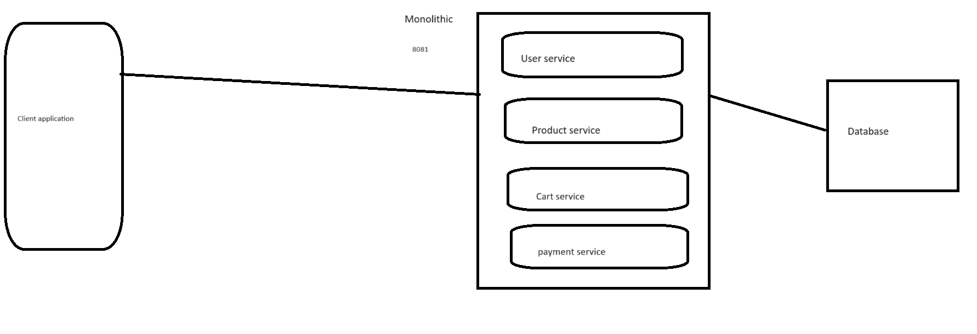

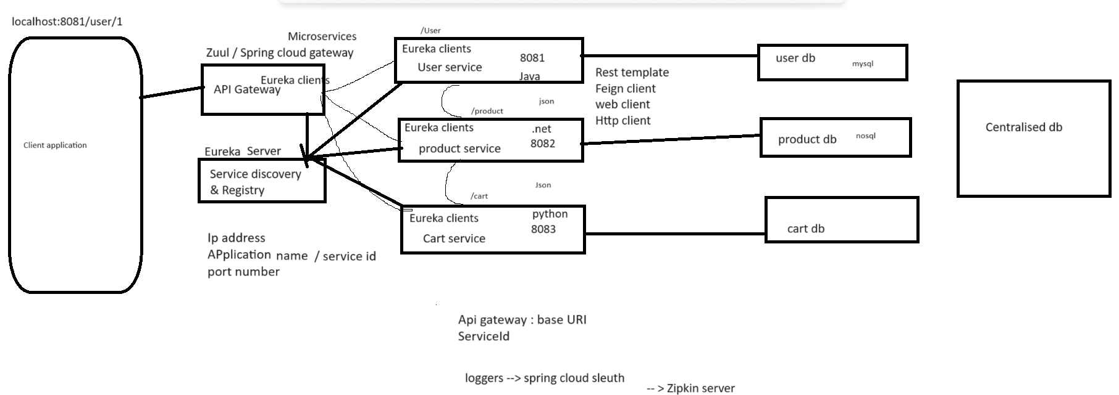

Logs : span id, trace id [spanid, trance id, application name] – log details

Span id unique Id for each application

Trance id will be common for microservices calling application

Resiliance4j 🡪

Spring cloud config🡪