SQL Assignment Solution Document

Exercise 1:

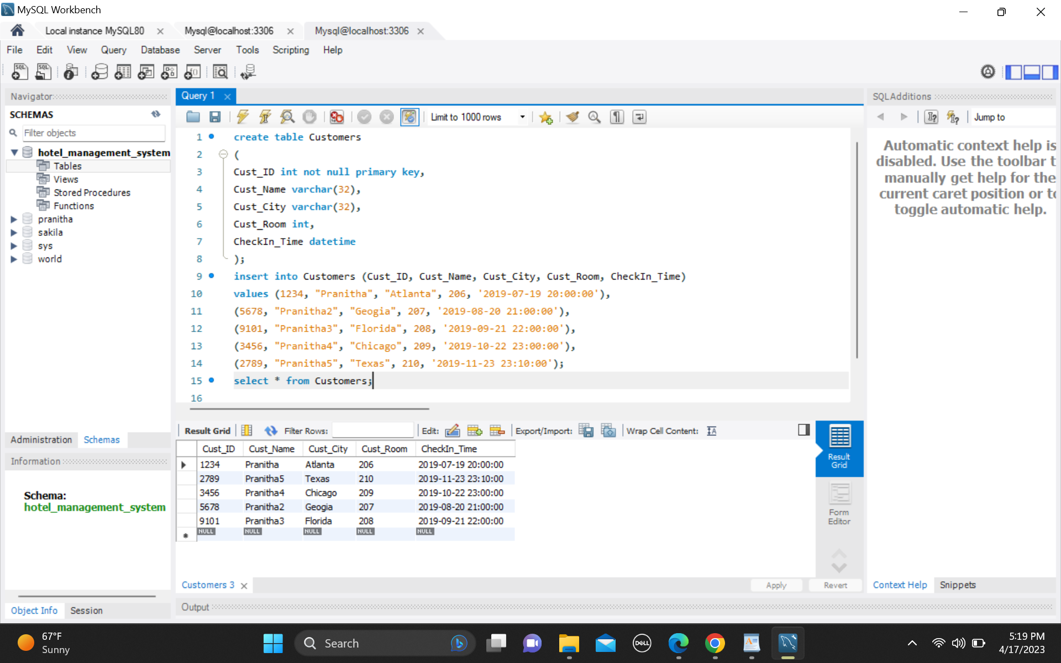

Exercise 2

Question-1**: Print Distinct City from Table Customers and Print Count Distinct City from Table Customers**.

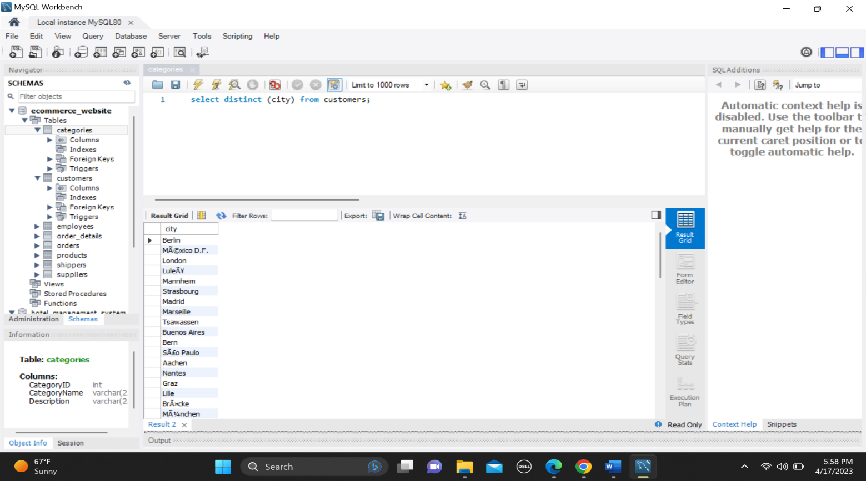

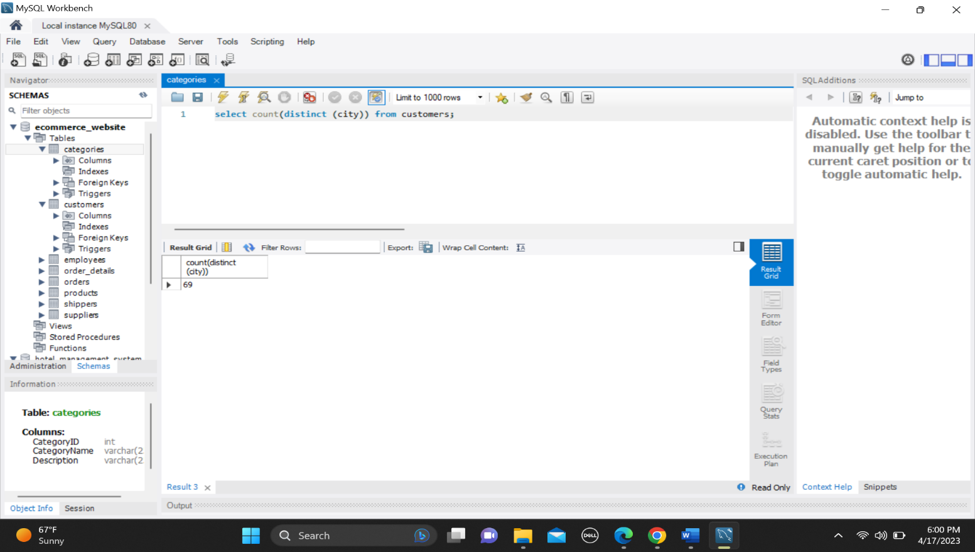

Question 2: **Write a SQL query to get the least number of quantities and the highest number of quantities bought by the user consider the OrderDetails Table.**

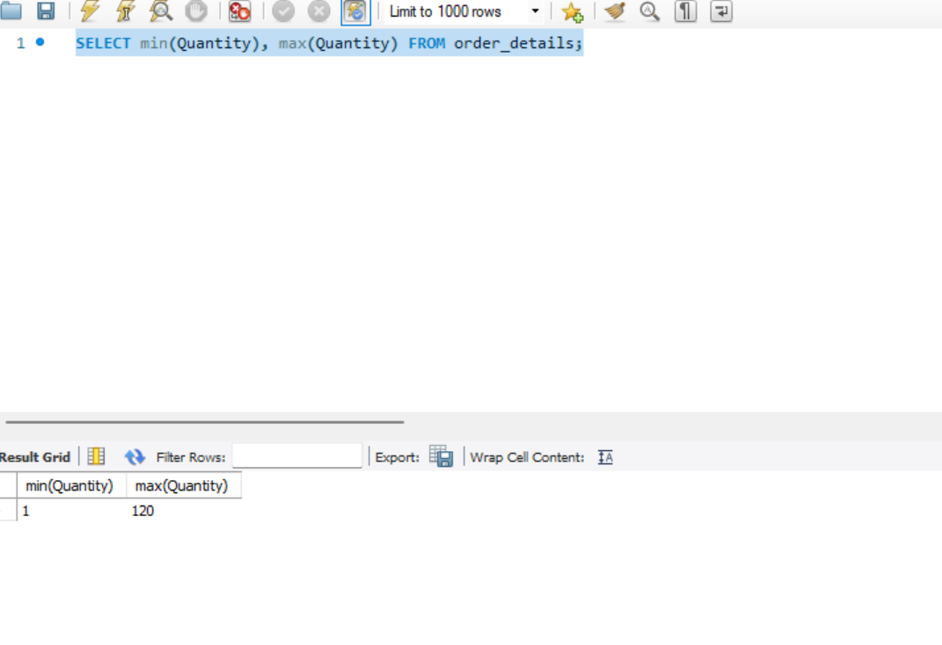

Question 3: **Print the total and an average number of quantities ordered by users, consider the OrderDetails Table.**

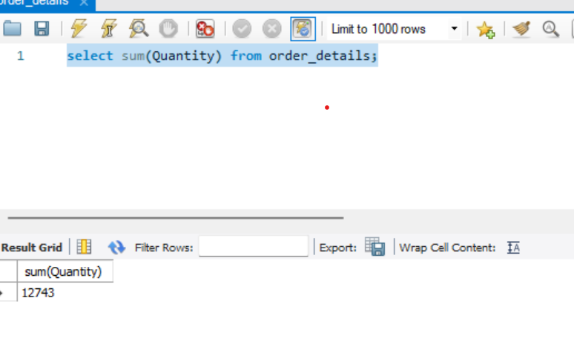

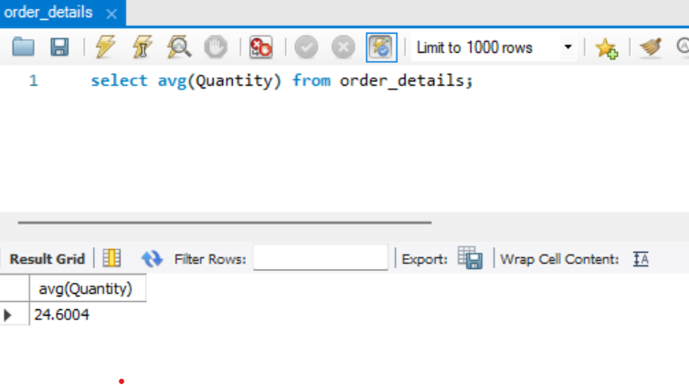

Question 4: **Print name of the product which is present at the 5th position till the 15th position from Products table, use LIMIT keyword.**

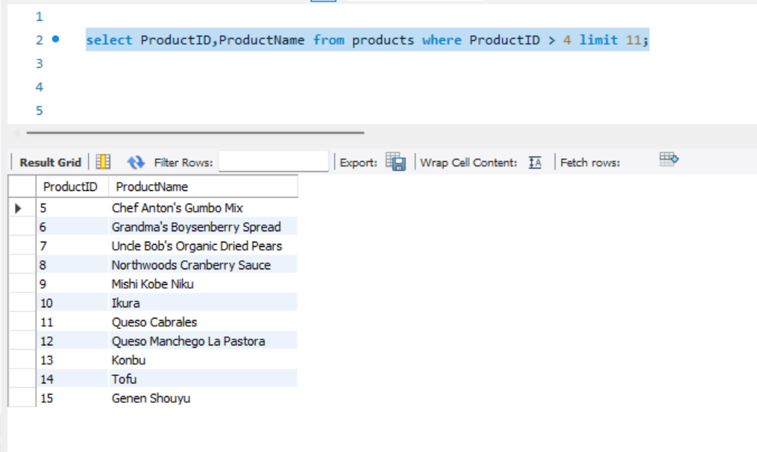

Question 5: **Write a SQL query for all the details of the supplier whose name consists of “A” at the second position from the Suppliers table.**

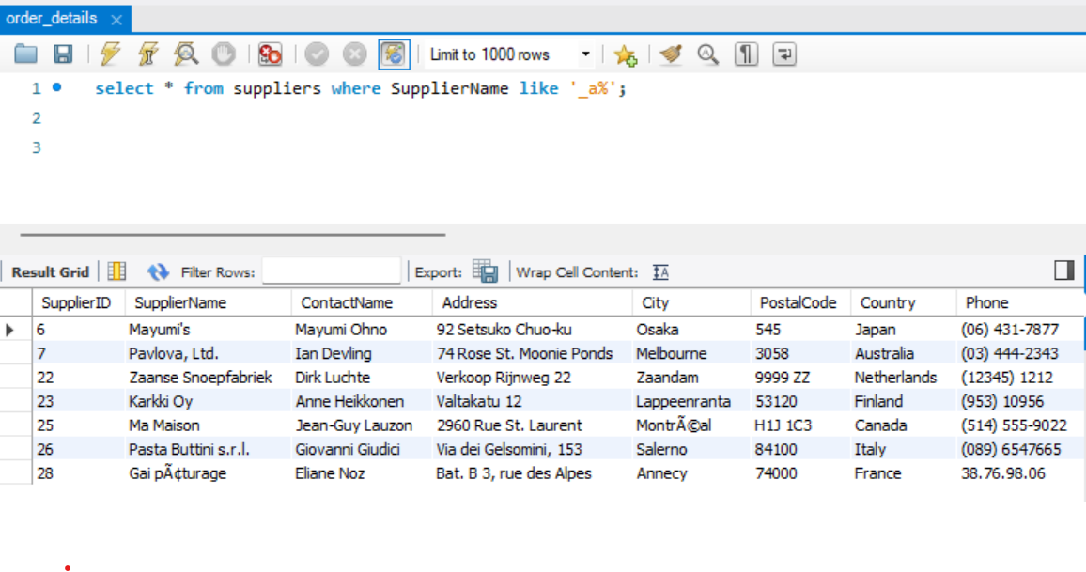

Question 6: **Print the details of the customer who doesn’t stay in the USA and Canada from the Customers table**

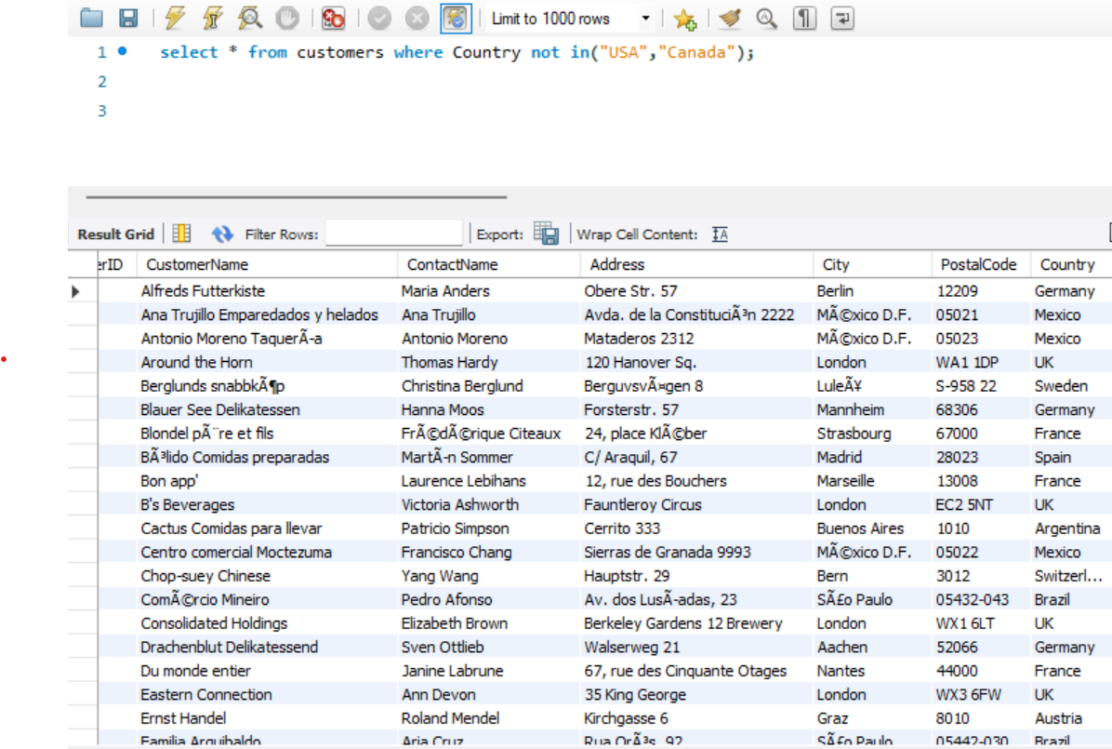

Question 7: **Print the details of all the orders which were placed between the year 2020 to 2021 also print the same in descending order from the OrderDetails table.**

I couldn’t find year column in table order_details.

Question 8: **Write a query to show the distinct city and their count from the Customers table.**

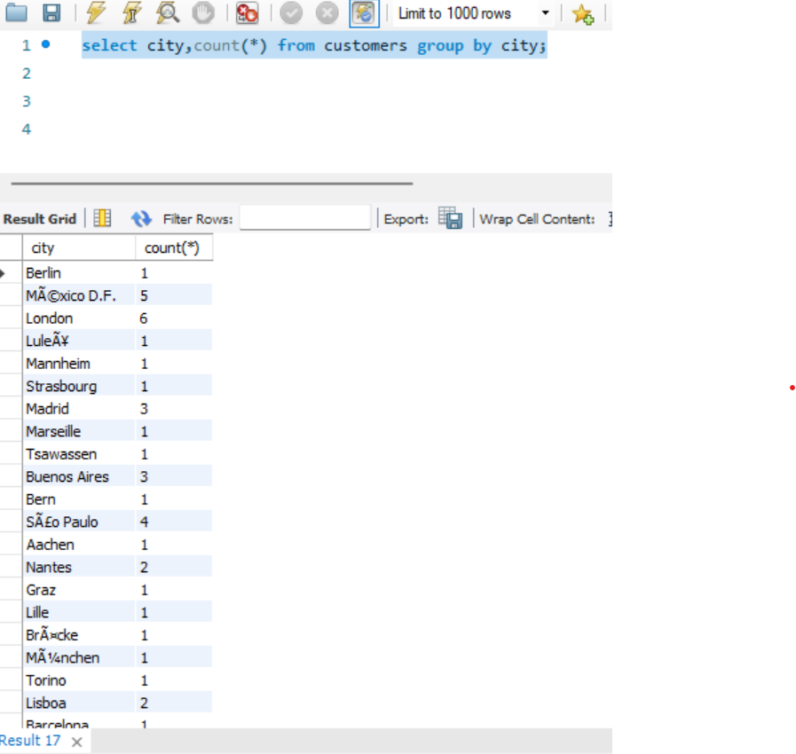

Question 9**: Write a query to fetch details of all employees excluding the employees with first names, “Sanjay” and “Sonia” from the Employees table**.

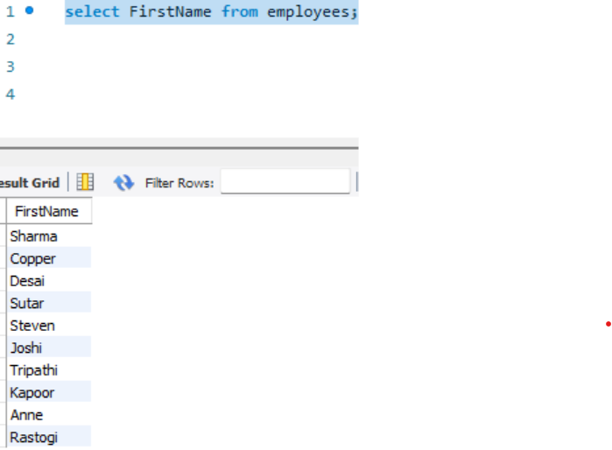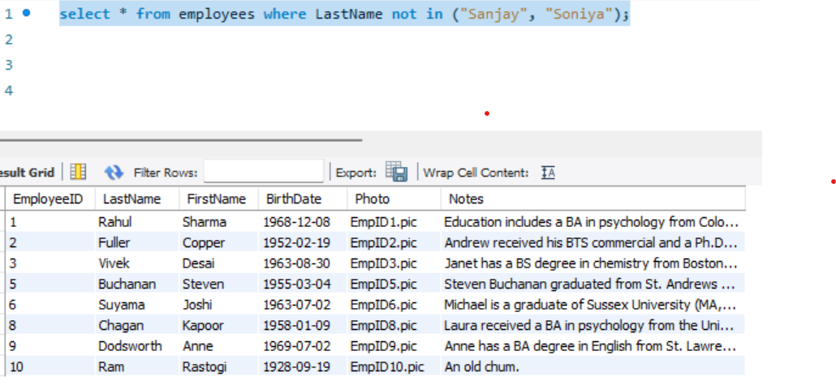As there is no FirstName with Sanjay or Soniya, I applied condition on LastName.

Question 10: **Duplicate a table as similar to the Suppliers table and name it as SupplierDetail**.

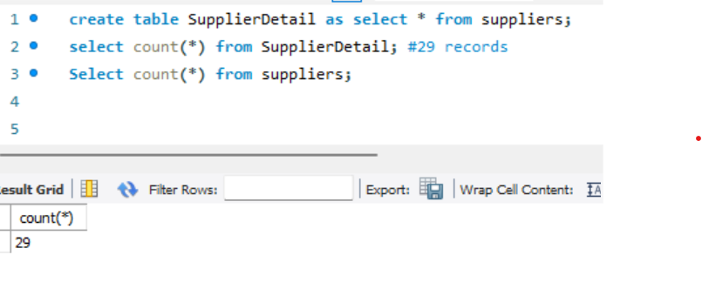

Question 11: **Delete customer details whose country is Venezuela and print the rest of the Customer table**

