Tumor Detection Screen
In this project as per your instructions we have designed application to take liver CT-SCAN image as input and then segment out tumor part if exists and then calculate affected area percentage and based on area size tumor stage will be calculated.
To implement this project we have designed following modules
- Admin Login: admin can login to system using default username and password as ‘admin and admin’. Later can change his account details
- Home Page: will display details on segmentation
- Detection: admin will upload image and then application will segment tumor and then calculate affected part and stage
SCREEN SHOTS
To run project double click on run.bat file to get below screen
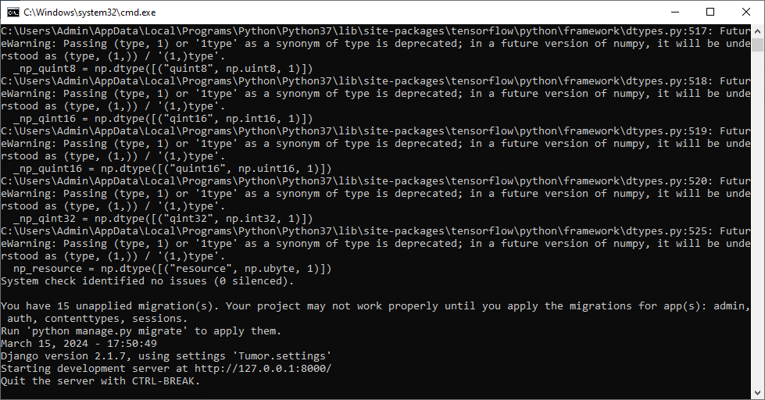
In above screen python server started and now open browser and enter URL as http://127.0.0.1:8000/index.html and press enter key to get below page
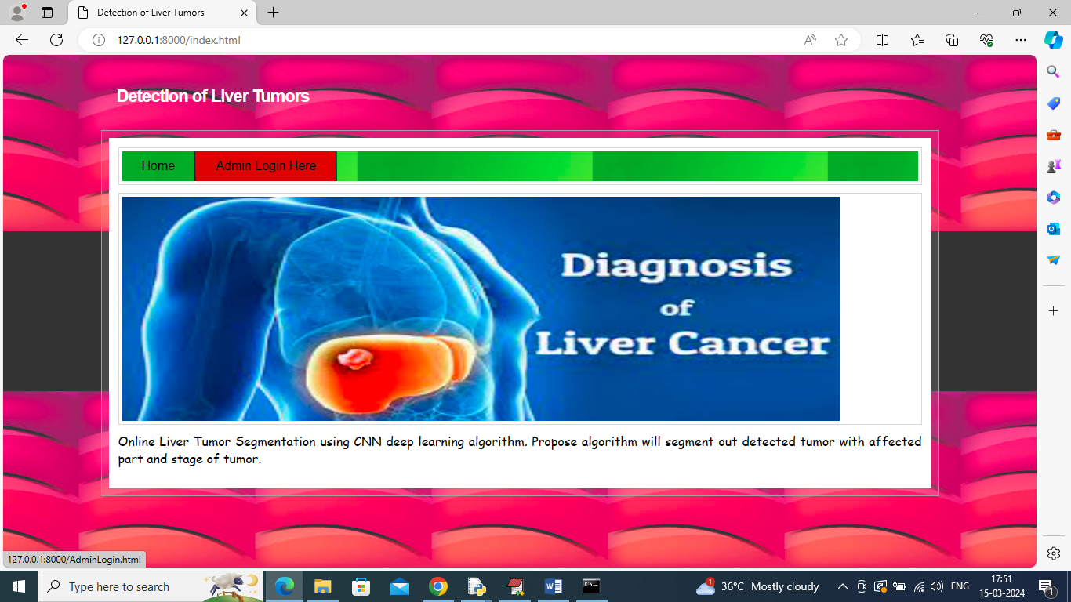
In above screen click on ‘Admin Login’ link to get below page
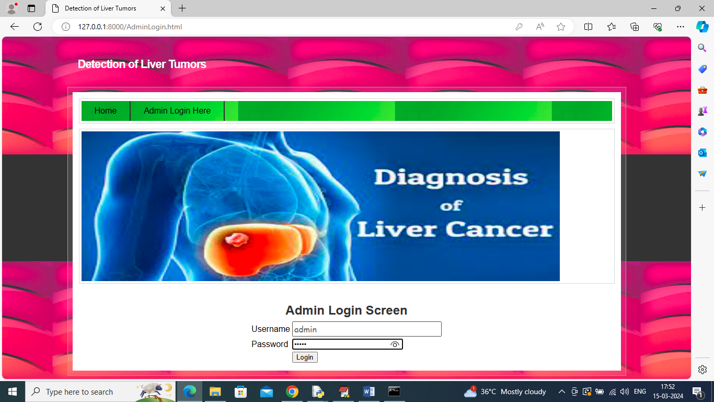
In above screen admin is login and after login will get below page
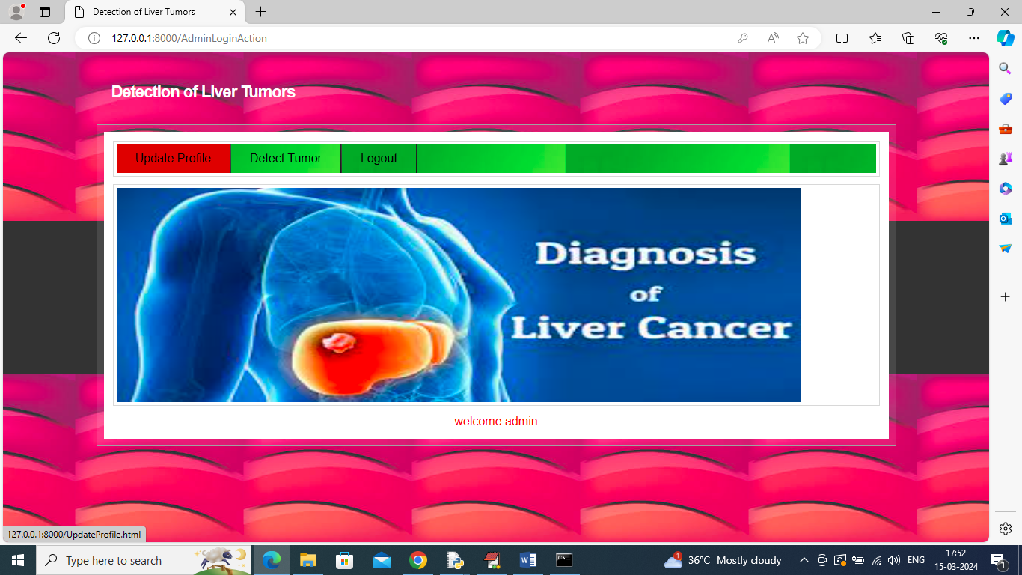
In above screen admin can click on ‘Update Profile’ link to change login details
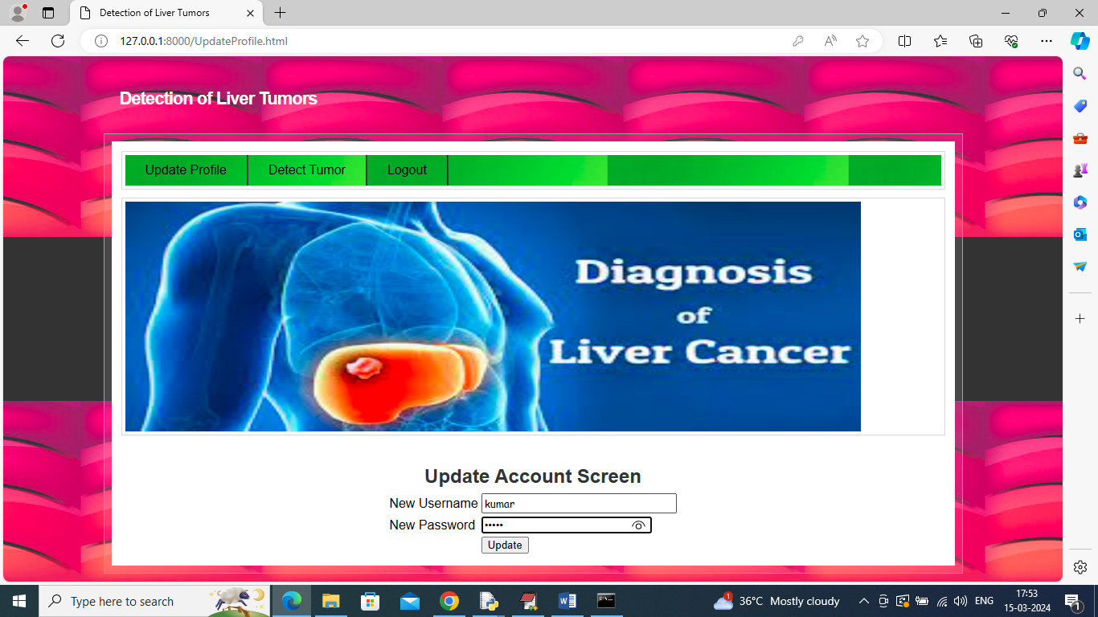
In above screen admin will enter new username and password and then press button to update account and get below page
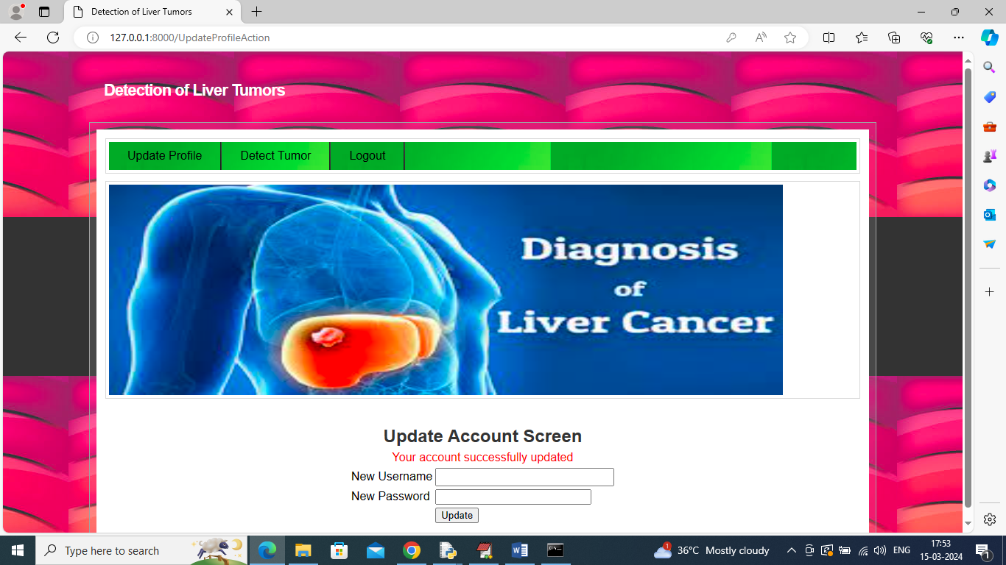
In above screen account updated and now click on ‘Detect Tumor’ link to get below page
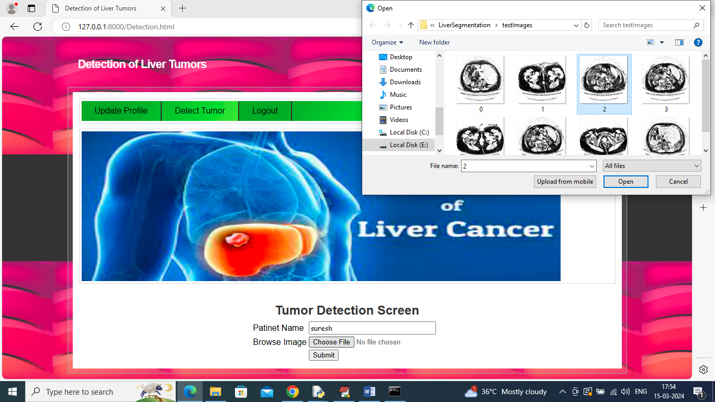
In above screen upload liver test image and then click on ‘Open’ and ‘Submit’ button to get below page
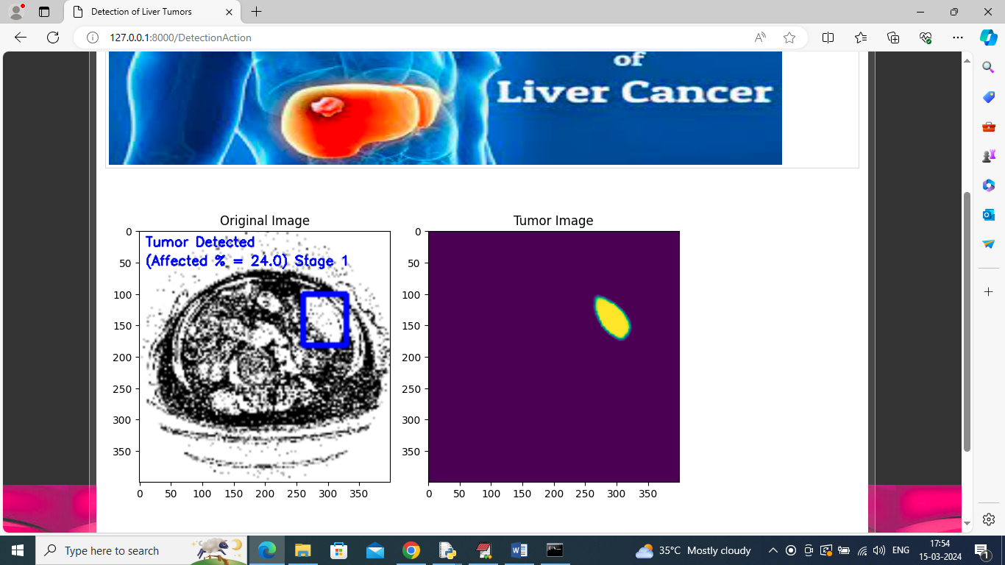
In above screen can see tumor part detected region showing blue colour box and then detected percentage is 24% and stage is 1 and can see segmented tumor in second image. Similarly you can upload and test other images. Below is another sample output
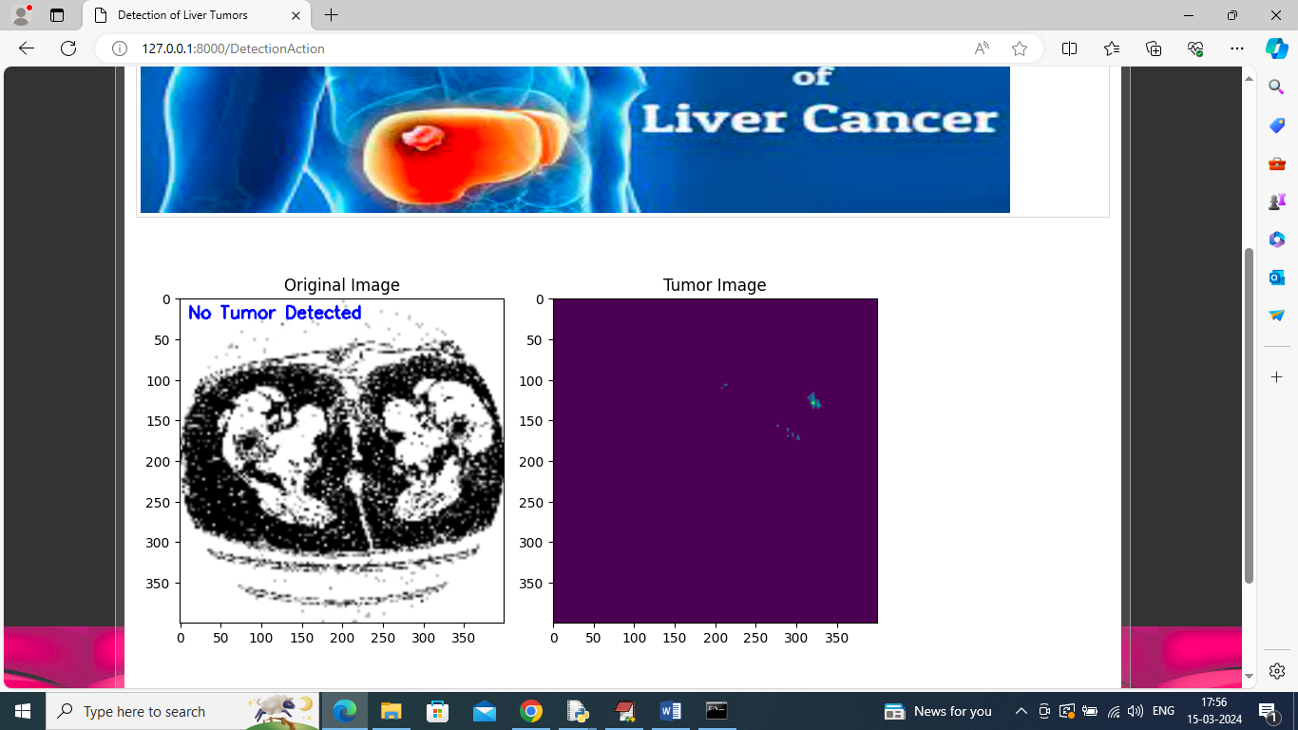
In above screen tumor not detected
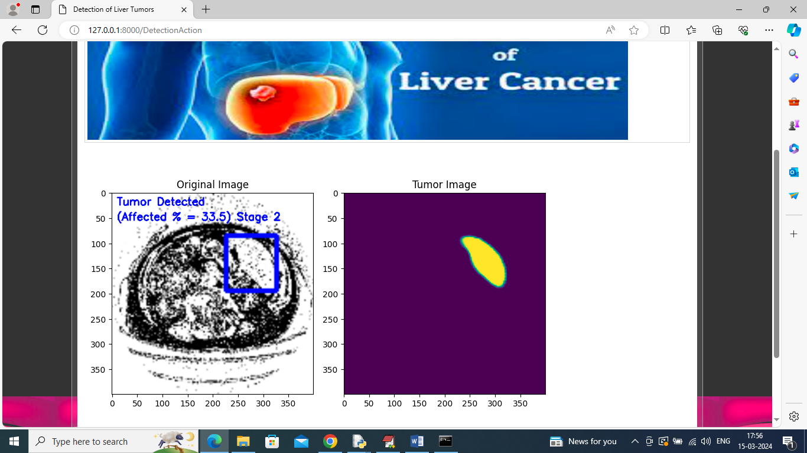
In above screen tumor stage 2 detected
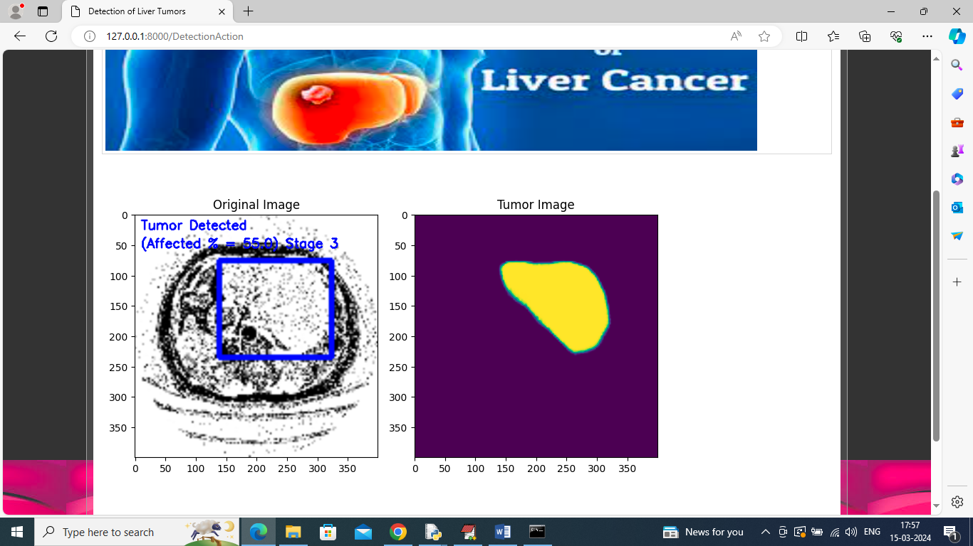
Stage 3 tumor detected
