Task 1 - OWASP ZAP Vulnerability Scan
Target Website: http://demo.testfire.net
Vulnerabilities Identified:
- Cross Site Scripting (XSS)

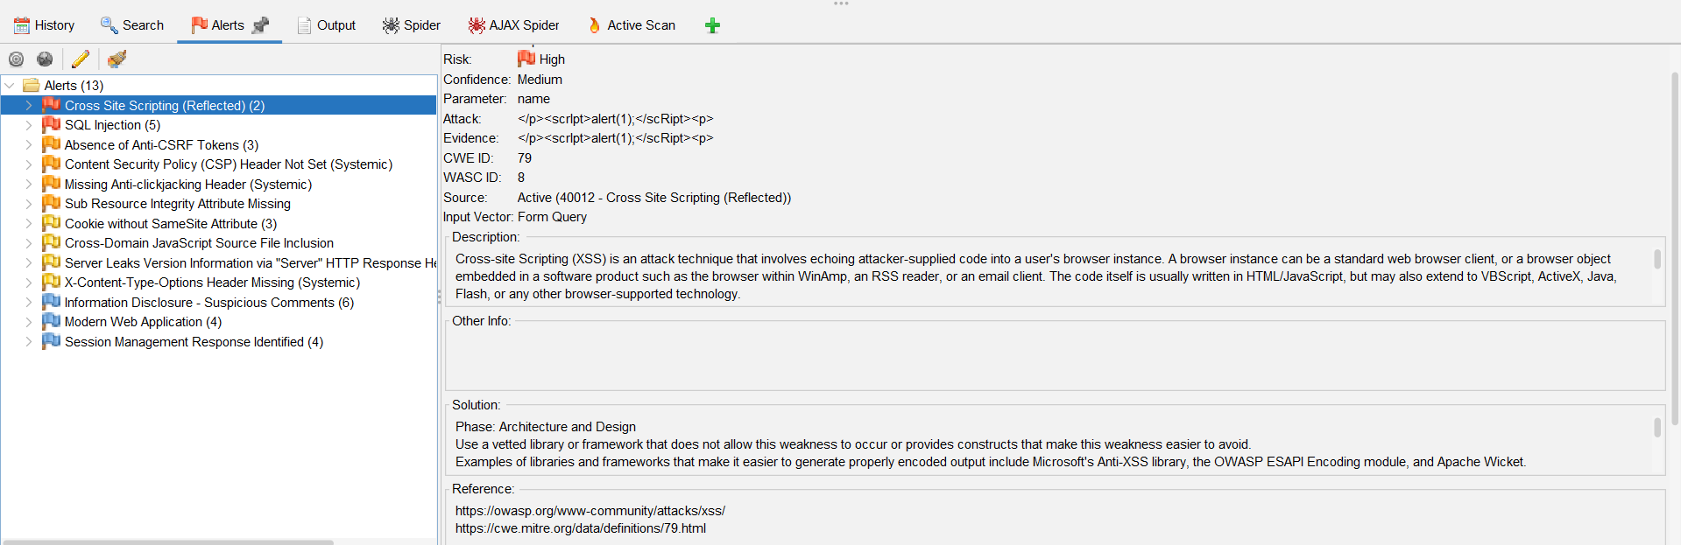

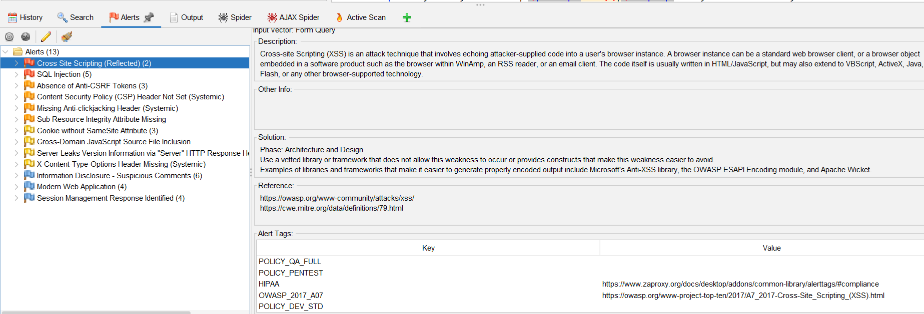
- SQL Injection

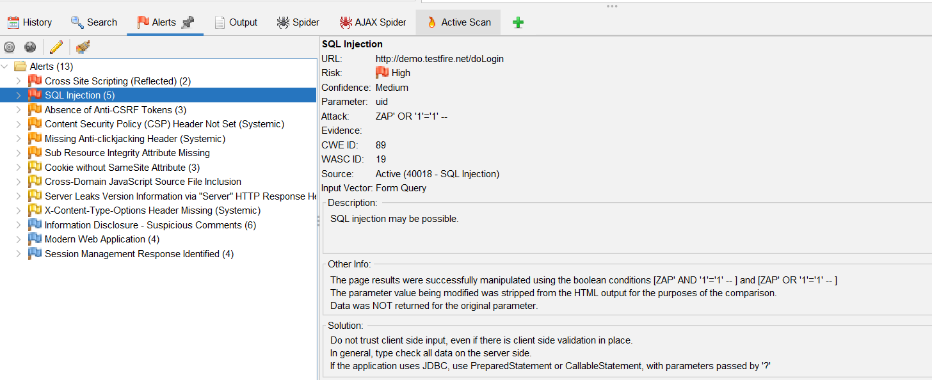
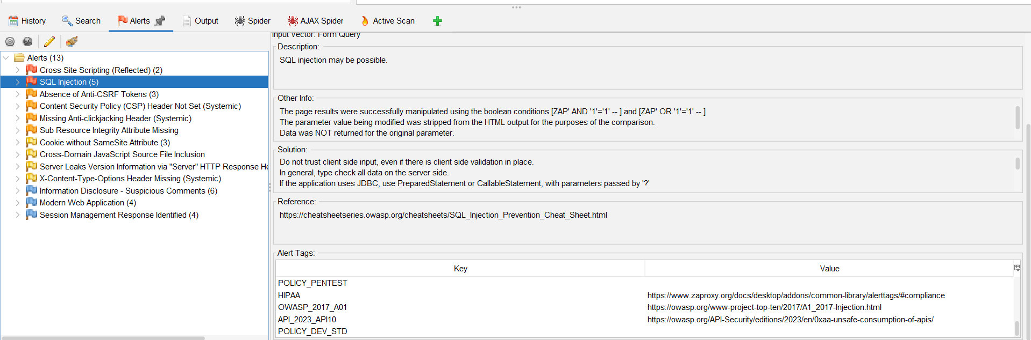

3.Alerts Summary

