Task 1 – Vulnerability Assessment Evidence
Target Website: https://demo.testfire.net
Tools Used:
- Nmap
- OWASP ZAP
- Browser Developer Tools
Nmap Scan Evidence
Description: Nmap service detection scan was performed to identify open ports and services
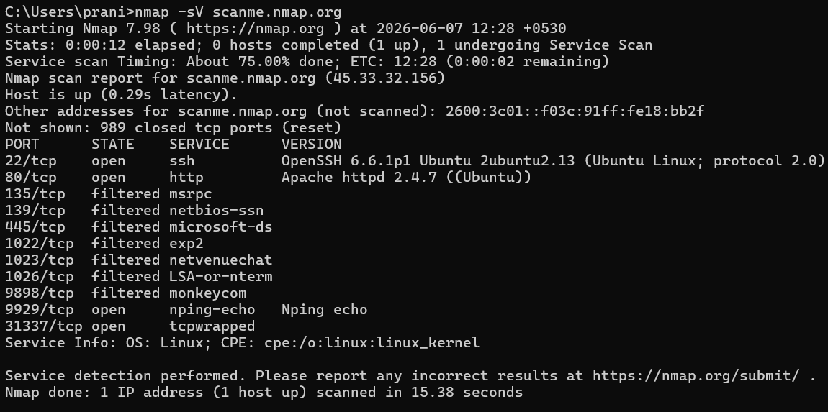
Cross-Site Scripting (XSS)
Risk Level: High
Description: OWASP ZAP identified a reflected XSS vulnerability
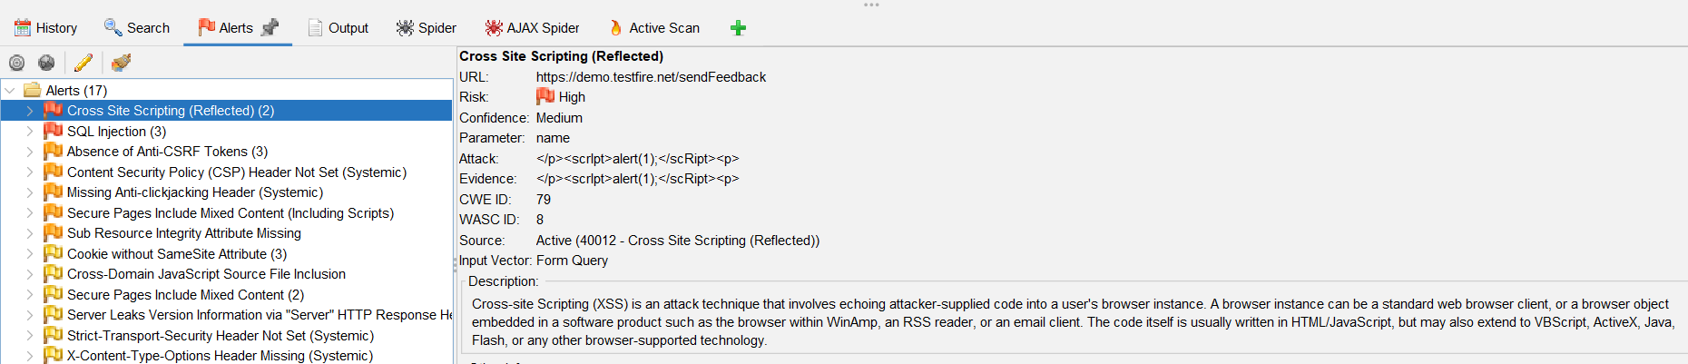
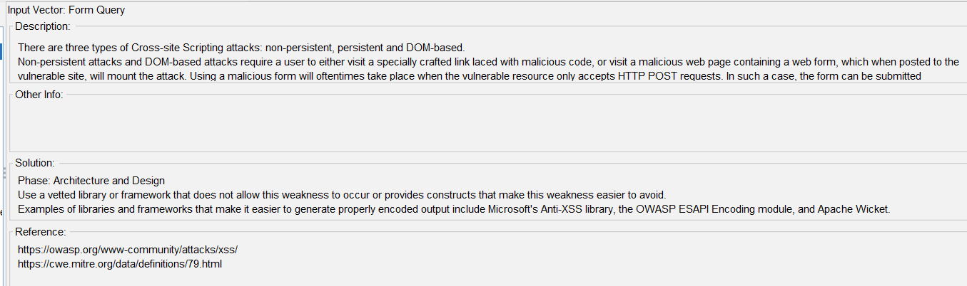
SQL Injection
Risk Level: High
Description: OWASP ZAP detected a possible SQL Injection vulnerability.
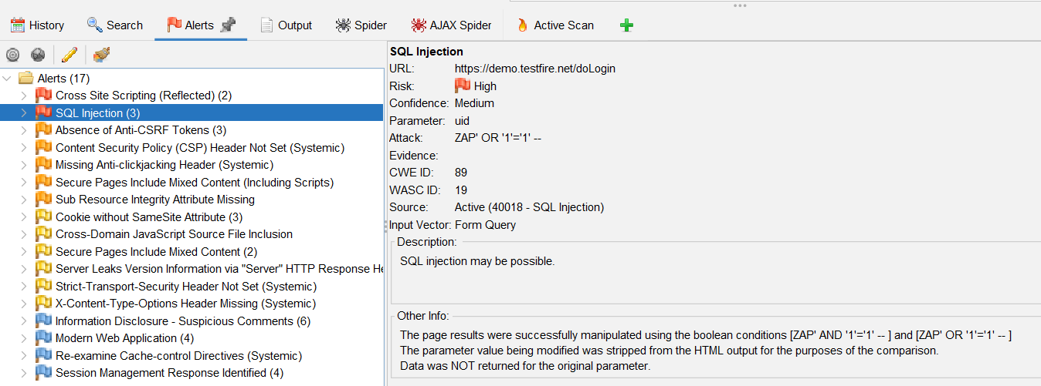
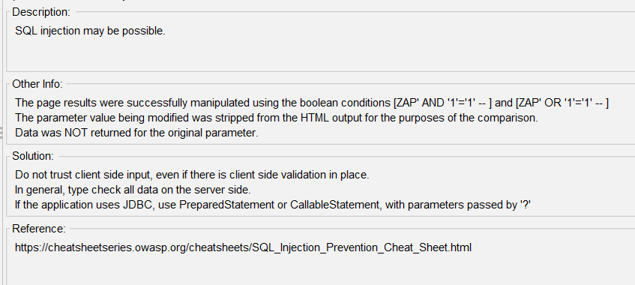

Missing Anti-CSRF Tokens
Risk Level: Medium
Description:
Forms were found without Anti-CSRF protection tokens.
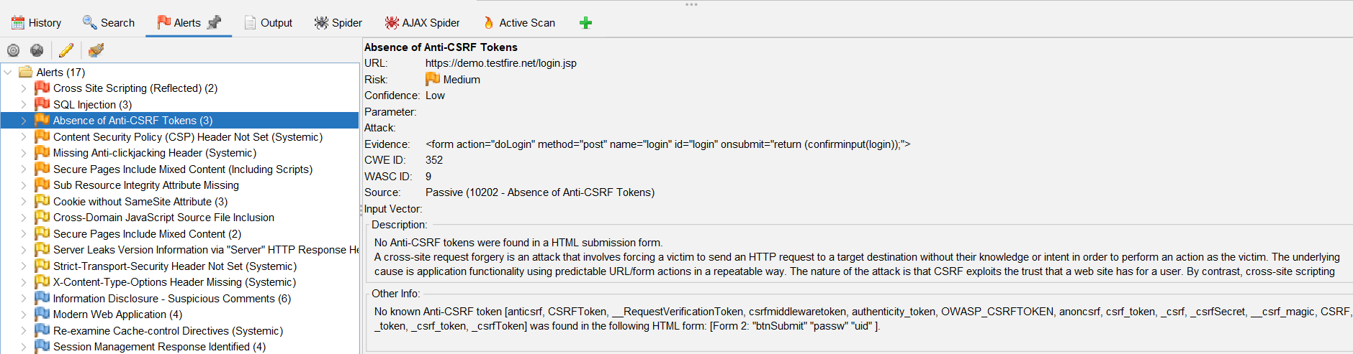
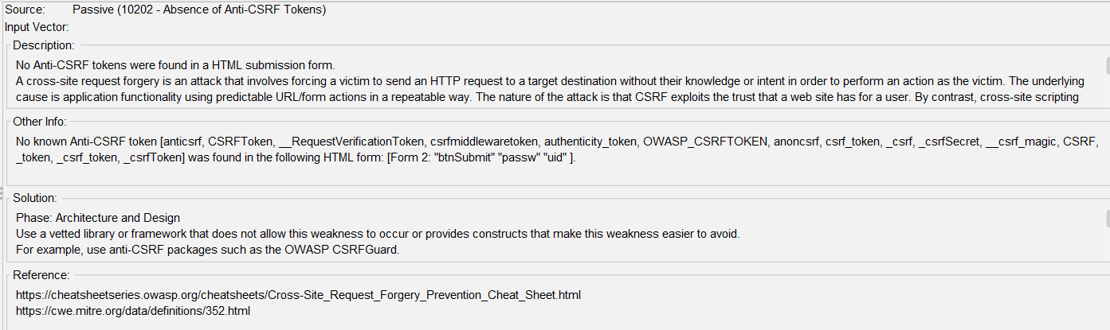
CSP Header Not Set
Risk Level: Medium
Description:
Content Security Policy header was not configured.
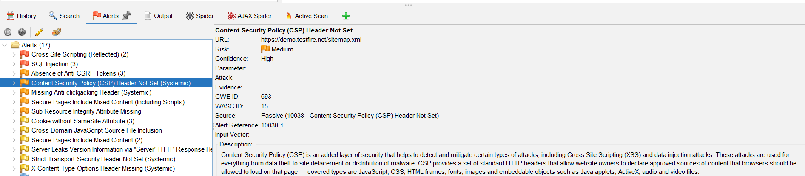
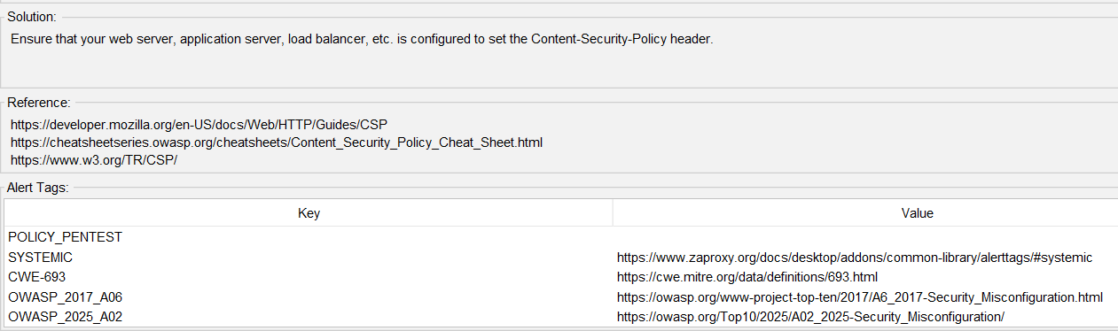
Missing Anti-Clickjacking Header
Risk Level: Medium
Description:
X-Frame-Options or frame-ancestors protection was not implemented.
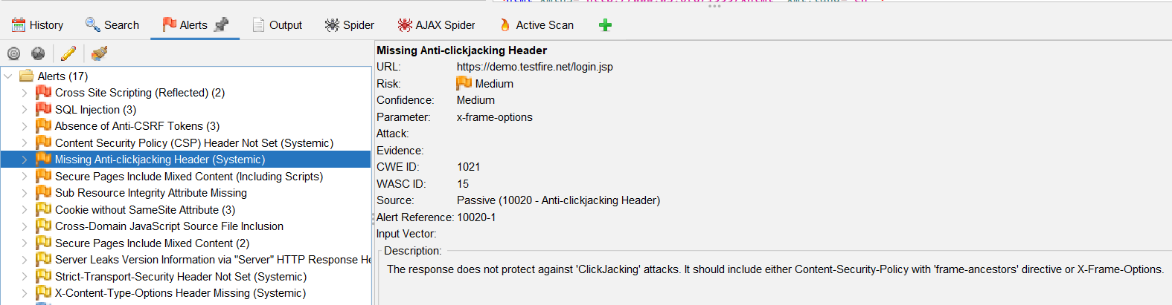
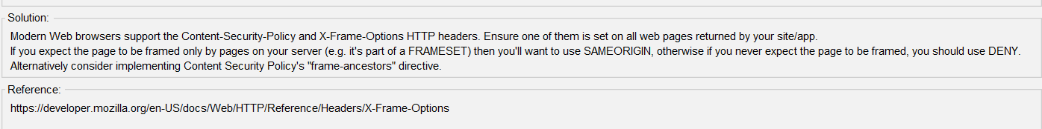
Conclusion
The vulnerability assessment identified multiple High and Medium risk findings. Appropriate remediation recommendations were documented to improve the security posture of the target application.

