**No Objection Certificate for Copyright Application - "** **Modelling Comprehensive Webframework for Enhancing Administrative Efficiency in An Educational Institute"**

To Whom It May Concern,

We, the undersigned, along with the following co-authors, hereby declare that we have jointly authored the software work titled “Modelling Comprehensive Webframework for Enhancing Administrative Efficiency in An Educational Institute”. Collectively, we provide no objection to the copyright of this work being held, as detailed below.

1. **Praniv Warungshe**; Address: 06, Ganesh Row Houses CHS LTD., Annapurna Nagar, Adharwadi, Kalyan West , 421301
2. **Siddhi Desale**; Address: 1003, Horizon Exotica, New dp road, Near Dnyanganga College, Anand nagar, Thane (W)

1. **Sushant Mhatre**; Address: Madhura Co-op soc, Plot no 53, room no D-10, Near Pranjali Hospital, Veer Savarkar Nagar, Thane west. - 400606
2. **Ms. Rujata Chaudhari**;Address: A. P. Shah Institute of Technology, Kasarvadavali, Thane (W)-400615
3. **Ms. Saylee Lapalikar**;Address: A. P. Shah Institute of Technology, Kasarvadavali, Thane (W)-400615
4. **Dr. Kiran Deshpande**;Address: A. P. Shah Institute of Technology, Kasarvadavali, Thane (W)-400615

We have no objection to the copyright application filed under Diary Number …………..for the software work “Modelling Comprehensive Webframework for Enhancing Administrative Efficiency in An Educational Institute” being applied by Praniv Warungshe. We further declare that we have provided our full consent willingly and are aware of the implications of the copyright application.

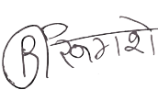Each author has signed below:

1. **(Praniv Warungshe)**

**Place: A. P. Shah Institute of Technology,**

**Thane**

**Date: 04/28/2025**

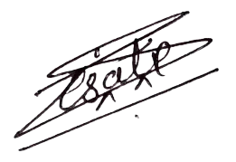

1. **(Siddhi Desale)**

**Place: A. P. Shah Institute of Technology,**

**Thane**

**Date: 04/28/2025**

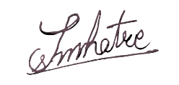

1. **(Sushant Mhatre)**

**Place: A. P. Shah Institute of Technology,**

**Thane**

**Date: 04/28/2025**

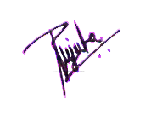

1. **(Ms. Rujata Chaudhari)**

**Place: A. P. Shah Institute of Technology,**

**Thane**

**Date: 04/28/2025**

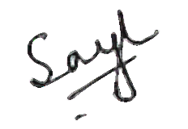

1. **(Ms. Saylee Lapalikar)**

**Place: A. P. Shah Institute of Technology,**

**Thane**

**Date: 04/28/2025**

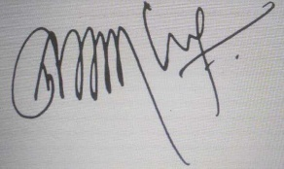

1. **(Dr. Kiran Deshpande)**

**Place: A. P. Shah Institute of Technology,**

**Thane**

**Date: 04/28/2025**