1. **Write a Simple console Application Calculator with the help of Visual Studio .NET IDE which will perform following operations on two numbers:**
   1. **Addition.**
   2. **Subtraction.**
   3. **Multiplication.**

**Division**

using System;

using System.Collections.Generic;

using System.Linq;

using System.Text;

using System.Threading.Tasks;

namespace CalculatorApp

{

class Program

{

static void Main(string[] args)

{

Console.WriteLine("Enter the action to be performed");

Console.WriteLine("Press 1 for Addition");

Console.WriteLine("Press 2 for Subtraction");

Console.WriteLine("Press 3 for Multiplication");

Console.WriteLine("Press 4 for Division \n");

int action = Convert.ToInt32(Console.ReadLine());

Console.WriteLine("Enter 1st input");

int input_1 = Convert.ToInt32(Console.ReadLine());

Console.WriteLine("Enter 2nd input");

int input_2 = Convert.ToInt32(Console.ReadLine());

int result = 0;

switch (action)

{

case 1:

{

result = Addition(input_1, input_2);

break;

}

case 2:

{

result = Subtraction(input_1, input_2);

break;

}

case 3:

{

result = Multiplication(input_1, input_2);

break;

}

case 4:

{

result = Division(input_1, input_2);

break;

}

default:

Console.WriteLine("Wrong action!! try again");

break;

}

Console.WriteLine("The result is {0}", result);

Console.ReadKey();

}

//Addition

public static int Addition(int input_1, int input_2)

{

int result = input_1 + input_2;

return result;

}

//Substraction

public static int Subtraction(int input_1, int input_2)

{

int result = input_1 - input_2;

return result;

}

//Multiplication

public static int Multiplication(int input_1, int input_2)

{

int result = input_1 * input_2;

return result;

}

//Division

public static int Division(int input_1, int input_2)

{

int result = input_1 / input_2;

return result;

}

}

}

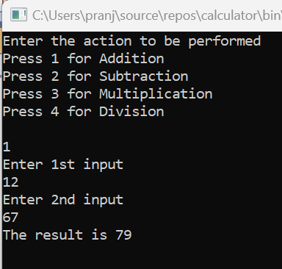 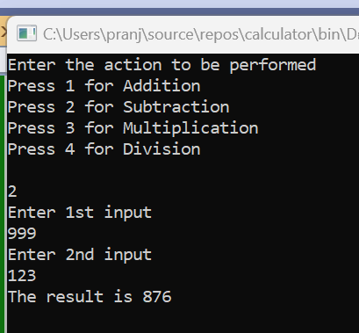

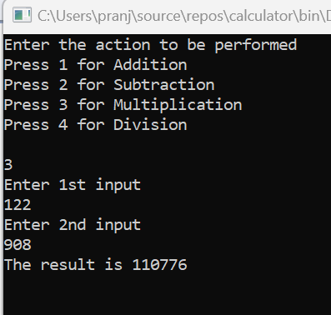 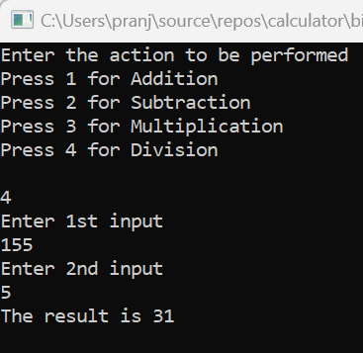

**Write a method to swap two integers. The client code should call the method and print the swapped value.**

using System;

public class Exercise5

{

public static void Main(string[] args)

{

int number1, number2, temp;

Console.Write("\nInput the First Number : ");

number1 = int.Parse(Console.ReadLine());

Console.Write("\nInput the Second Number : ");

number2 = int.Parse(Console.ReadLine());

temp = number1;

number1 = number2;

number2 = temp;

Console.Write("\nBefore Swapping : ");

Console.Write("\nFirst Number : "+number2);

Console.Write("\nSecond Number : " + number1);

Console.Write("\n\nAfter Swapping : ");

Console.Write("\nFirst Number : " + number1);

Console.Write("\nSecond Number : " + number2);

Console.Read();

}

}

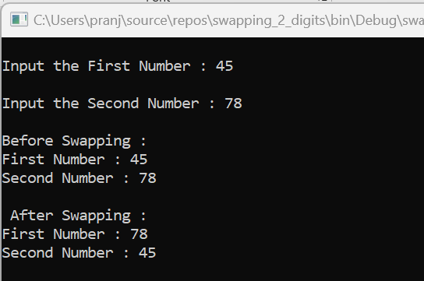

**Write a single method that calculates the area and circumference of the circle. The area and circumference should be displayed through the client code.**

using System;

class Circle

{

static void Main(string[] args)

{

Console.Write("Enter Radius: ");

double Radius = Convert.ToDouble(Console.ReadLine());

double Area = Math.PI * Radius * Radius;

double circumferenceOfCircle = 2 * Math.PI * Radius;

Console.WriteLine("Area of circle: " + Area);

Console.WriteLine("\n\nCircumference of circle is: " + circumferenceOfCircle);

Console.ReadKey();

}

}

