**What is Apache Storm?**

Apache Storm is a powerful tool for crunching massive amounts of big data in real-time. It’s specially designed to handle huge streams of information without failing, and you can easily scale it up by just adding more machines to the system. One of its standout features is its ability to ingest data at incredibly high speeds.

While Storm itself doesn't store data, it cleverly uses Apache ZooKeeper to manage and coordinate everything across the cluster. It’s also refreshingly simple, allowing you to perform all kinds of parallel manipulations on your live data.

This is why Apache Storm is still a leading choice for real-time analytics. It's easy to get up and running, straightforward to operate, and it comes with a crucial guarantee: every piece of data you send it will be processed at least once.

**Apache Storm vs Hadoop**

**Apache Hadoop 🐘**

Hadoop is designed for **batch processing**. Think of it like a system that works on huge, stored piles of data.

* **How it works:** It uses a model called **MapReduce**, which breaks a massive job into smaller pieces. It processes these pieces in stages, often writing results to a disk in between, which can slow things down.
* **Speed:** It has **high latency**, meaning it's not built for speed. It's designed to eventually finish enormous jobs, not to give you instant answers.
* **Data Type:** It's best for **static, historical data**—information that's already been collected and stored, like old logs or archives.
* **Common Uses:** It’s perfect for tasks where speed isn't critical. Think of generating large weekly or monthly reports, data mining, or big data-warehousing jobs.

**Apache Storm ⚡**

Storm is the opposite; it's all about **real-time stream processing**. It handles data that's continuously flowing, like a river.

* **How it works:** It uses a "topology" (basically a flowchart) made of "spouts" (data sources) and "bolts" (processing steps). Data zips through this entire process in memory, making it incredibly fast.
* **Speed:** It offers **low latency**, processing data the moment it arrives. This allows you to get insights and take action almost immediately.
* **Data Type:** It's built for **dynamic, live data** from sources like social media feeds, financial tickers, or real-time sensor readings.
* **Real-World Examples:**
  + **NaviSite** uses Storm to monitor its system logs live. Storm instantly scans every log for specific patterns, and if it finds a match (like an error or a security threat), it immediately saves that event to a database for review.
  + The travel search engine **Wego** uses Storm to process a constant, worldwide flood of flight and hotel data. Storm helps it sift through this live information to find the best, most up-to-the-second deals for its users.

**So, why use Apache Storm?**

One of the best things about Storm is that it's open-source, powerful, and easy to get started with, making it great for both small teams and large companies. It's built to be **fault-tolerant** and **reliable**, and you can even use it with any programming language you're comfortable with.

The main advantage, of course, is its mind-blowing speed and ability to process data in **real-time**. It's highly **scalable**, so if your data load increases, you can just add more resources to keep performance up. All this means Storm has very **low latency**, delivering answers and insights in seconds.

**Apache Storm's Core Components:**

**1. Topology: The Data Factory Blueprint 🏭**

A **Topology** is the complete plan for your real-time application. It's the master blueprint that maps out the entire data flow: where data enters, what happens to it, and where it goes. Unlike a typical program that runs and then stops, a topology is designed to run continuously until you manually shut it down.

**2. Streams: The River of Data 🌊**

A **Stream** is simply an endless sequence of data flowing through your topology. It's the fundamental concept in Storm, representing a non-stop, unbounded flow of information. Think of it as a conveyor belt that's always moving data from one station to the next.

**3. Tuples: The Packet of Data 📦**

A **Tuple** is the basic unit of data that travels on a stream. It's a single, structured message or record. For instance, a tuple representing a tweet might contain fields for the username, the message text, and the timestamp. Every piece of information moving through Storm is packaged as a tuple.

**4. Spouts: The Data Source 🚰**

A **Spout** is the entry point for data into your topology. It connects to an external source—like a Twitter feed, a message queue (e.g., Kafka), or IoT sensors—and converts that raw data into a stream of tuples. Its main job is to **emit** (or send) these tuples into the system for processing. Spouts are also responsible for ensuring data reliability.

**5. Bolts: The Data Worker 🛠️**

A **Bolt** is where the actual work gets done. Bolts receive streams of tuples, perform some kind of processing, and can then pass new tuples along to other bolts. This is where your core logic lives, whether it's filtering data, running calculations, counting items, or saving results to a database.

**6. Stream Groupings: The Traffic Controller 🚦**

A **Stream Grouping** defines how a stream of tuples is distributed among the different instances of a bolt. It's the traffic controller that's crucial for managing your parallel processing workload effectively. The most common types are:

* **Shuffle Grouping:** Randomly sends tuples to bolt instances to distribute the load evenly.
* **Fields Grouping:** Guarantees that tuples with the same value in a specific field (like a user_id) always go to the same bolt instance. This is essential for accurate counting.
* **All Grouping:** Sends a copy of every single tuple to *all* bolt instances. Use this one with care!
* **Global Grouping:** Sends all tuples from a stream to a single, specific bolt instance.

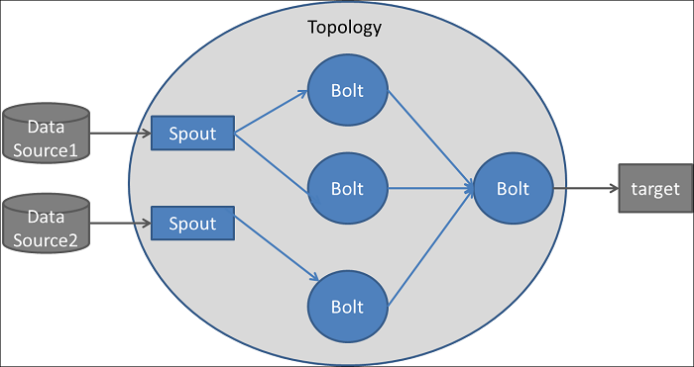

**Apache Storm Architecture:**

**1. Nimbus: The Mastermind 🧠**

Think of **Nimbus** as the brain or the CEO of the entire Storm cluster. It's the central daemon that coordinates everything. When you submit your application (a **topology**), Nimbus takes charge. It's responsible for analyzing your code, distributing it to the worker machines, and assigning tasks. It constantly monitors the cluster's health, and if a worker node fails, Nimbus quickly reassigns the work to a healthy node to ensure your data processing continues without a hitch.

**2. Supervisor: The Local Manager 👷**

Every machine in the cluster that performs the actual data processing runs a **Supervisor** daemon. You can think of a Supervisor as a factory floor manager. It listens for commands from Nimbus and, based on those instructions, starts and stops **worker processes** on its local machine. Each Supervisor manages its machine's resources and sends regular "heartbeats" back to Nimbus to let it know everything is running smoothly.

**3. Apache ZooKeeper: The Central Coordinator 🔗**

Storm relies heavily on **Apache ZooKeeper** to act as the cluster's unbreakable coordination service. It’s like a central, shared whiteboard that Nimbus and the Supervisors use to communicate and stay in sync. ZooKeeper stores all the critical state information—like which topologies are running and where tasks are assigned. This is vital for **fault tolerance**. Because Storm's components are stateless, if a node crashes, it can simply restart, connect to ZooKeeper, and retrieve all the information it needs to pick up right where it left off.

**4. The Actual Workforce: Workers, Executors, and Tasks ⚙️**

Here’s how your code actually gets executed on the worker nodes, from the largest container down to the smallest unit of work.

* **Worker Process:** This is a dedicated Java Virtual Machine (JVM) that runs a subset of a single topology. It's like a specific workstation in the factory.
* **Executor:** An **Executor** is a thread running inside a Worker Process. It’s responsible for executing tasks for a specific Spout or Bolt. Think of it as a robotic arm on the workstation.
* **Task:** A **Task** is the final, physical instance of your Spout or Bolt logic. This is where your code actually runs. It's the specific operation the robotic arm performs, like "filter this record" or "count this word."

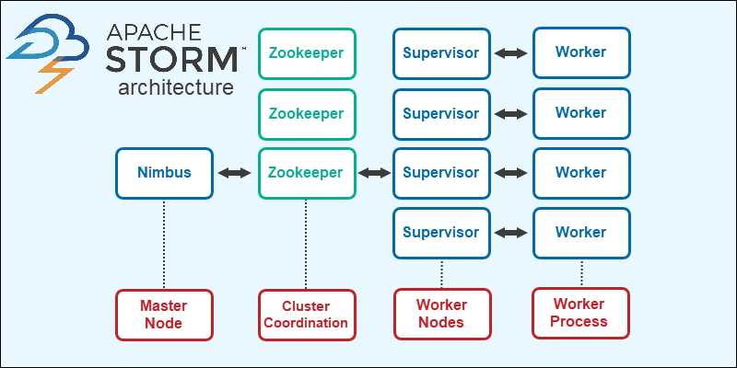

### Apache Storm Workflow:

Let's follow a single piece of data on its lightning-fast journey through your Storm topology from start to finish.

**Stage 1: Data Enters the System 📥**

The process kicks off when a **Spout**, your topology's data source, grabs new information from an external system like a message queue or an API. The Spout's job is to:

1. Package this raw data into a structured **Tuple**.
2. Tag the tuple with a unique **Message ID** for tracking.
3. **Emit** (send) the tuple into the topology.

Crucially, the Spout keeps a record of this Message ID. It's now waiting to hear whether this piece of data was processed successfully.

**Stage 2: The Bolts Get to Work ⚙️**

Once emitted, the tuple travels to a **Bolt** for processing.

1. **Routing:** A **Stream Grouping** acts as a traffic controller, deciding exactly which instance of the next Bolt should receive the tuple.
2. **Processing:** The Bolt receives the tuple and does its job—filtering, calculating, transforming, etc.
3. **Anchoring:** If the Bolt creates *new* tuples from the one it received (e.g., splitting a sentence into word tuples), it "anchors" them to the original. This creates a "tuple tree," linking all derived data back to its source.

This cycle of routing and processing repeats as data flows through the chain of Bolts in your topology.

**Stage 3: The Reliability Check ✅ 🔁**

This is how Storm guarantees that no data is lost.

* **Success (ACK):** Once every tuple in the "tree" (the original and all its children) has been fully processed by every Bolt, the system sends an acknowledgment signal (**ACK**) all the way back to the original Spout. When the Spout receives the ACK, it knows the data was processed successfully and can safely discard the tracking ID.
* **Failure (FAIL):** If a tuple isn't processed within a specific timeout (e.g., a Bolt crashes), Storm automatically sends a **FAIL** signal back to the Spout. The Spout then knows the data was lost mid-process and **replays** the original tuple, sending it into the topology again to ensure it gets processed. This is Storm's "at-least-once" processing guarantee in action.

**Stage 4: The Non-Stop Loop ♾️**

This entire workflow—emit, process, and acknowledge/fail—isn't a one-time event. It happens continuously and in parallel for millions of tuples, allowing your topology to process a massive, unending stream of data in real-time.

