B. Major Market of District Agra:

'Achnera', 'Fatehpur Sikri', 'Jagnair', 'Jarar', 'Khairagarh', 'Samsabad', 'Agra', 'Fatehabad'

Graphs :

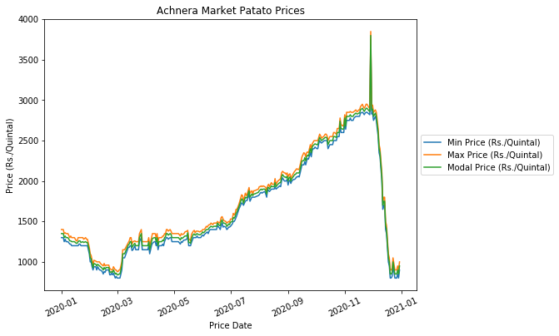

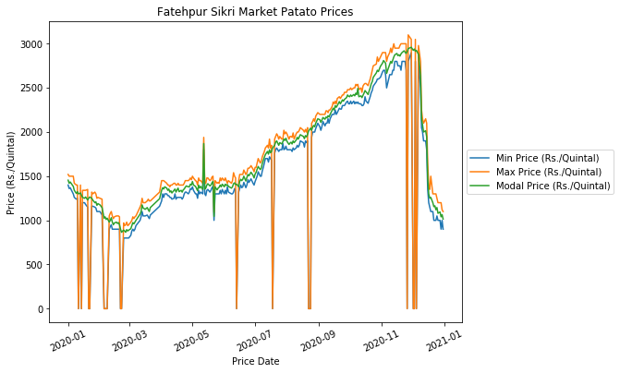

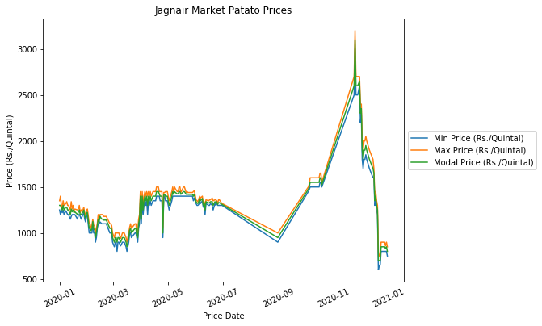

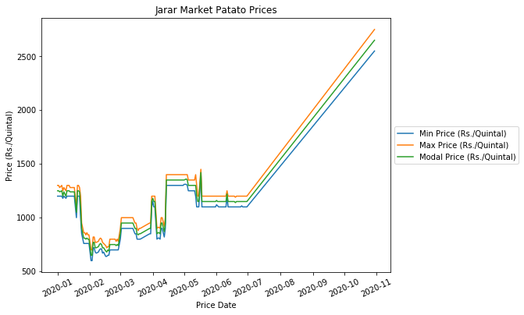

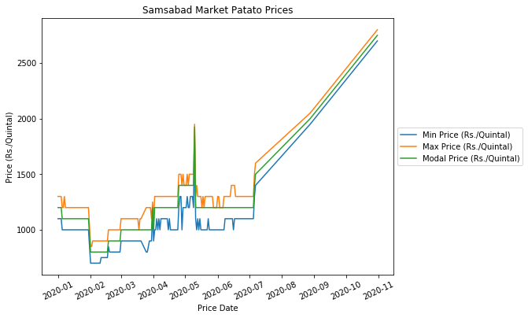

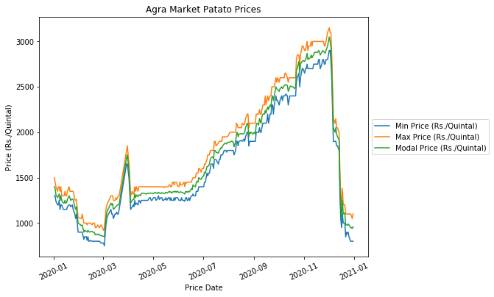

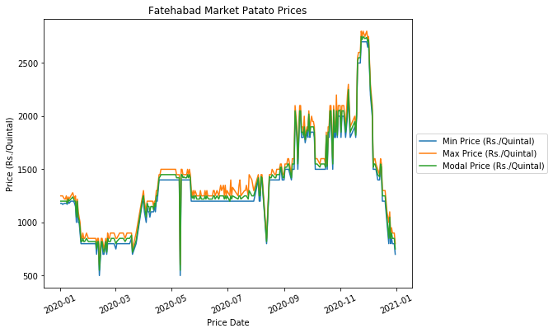

Insights From the graphs:

Prices decrease initially till the month of March then it begins to increase. Then prices are static in the month of April, May, and June and again they increase till the month of December. Then again decrease heavily in the month of December in some markets.

“Jarar” and “Samsabad” have similar graphs, it means prices are quite similar in both market throughout the year.

C.

(i) Data/Preprocessing and cleaning techniques:

1. Drop the unnecessary columns like “Sl no”, “District Name”, “Commodity”, and “Grade”.
2. Convert price data to pandas DateTime object to apply various transformations and generate new features.
3. One hot encoding of Variety Feature and Market Name.
4. Remove the seasonality from the dataset or normalizing the dataset
5. Generate Feature from like month, weekday
6. Check for correlation of the feature and remove the redundant features

(ii) Features to create the model :

Market Name, Variety Model, Month, Week Day

(iii) Framing the problem as a machine learning problem :

For the given data of potatoes, prices predict the future prices of the potatoes. The target variable can be the Modal Price.

(iv) Simple linear regression algorithm can be used to extract the prices or we can use time series models like ARMA, ARMAX, etc.

(v) Mean Average Error(MAE) can be used as a loss function.

(vi) The potato prices also depend on the season and any natural calamity in the region, so we can use weather forecast data to predict the future prices. It helps us to predict a more accurate result because weather heavily affects the production of corps. Deep learning techniques such as Recurrent Neural Network can also be used to predict future prices.