Synopsis

Intelligent Logistics Route Planner using Heuristic Search

Problem Id: 11

Name : Pranjal Negi
University Roll number : 2028801
Section : L

- Problem Description:
This project is about designing an intelligent system to find the best route using the A* (A-Star) search algorithm. In this, we represent a delivery network as a graph with 10 locations (nodes). The roads between these locations are edges, and each edge has a cost called road distance (actual travel cost).
Each location also has a value called Euclidean distance to the goal, which works as a heuristic (an estimated distance to reach the destination). The A* algorithm uses both values together with the formula:
f(n) = g(n) + h(n)
Where:
- g(n) = actual cost from start node to current node
- h(n) = estimated cost from current node to goal
By combining these two, the algorithm finds the shortest and most efficient path.
In real life, this concept is widely used in navigation and delivery systems. Companies like FedEx and Amazon use such techniques to reduce fuel cost, save time, and improve delivery efficiency. Similarly, apps like Google Maps and Waze use similar algorithms to suggest the fastest routes based on distance and traffic.
This project helps students understand how intelligent systems make decisions in real-world situations and shows the practical use of AI in areas like transportation, robotics, and logistics.
- Steps of Implementation:
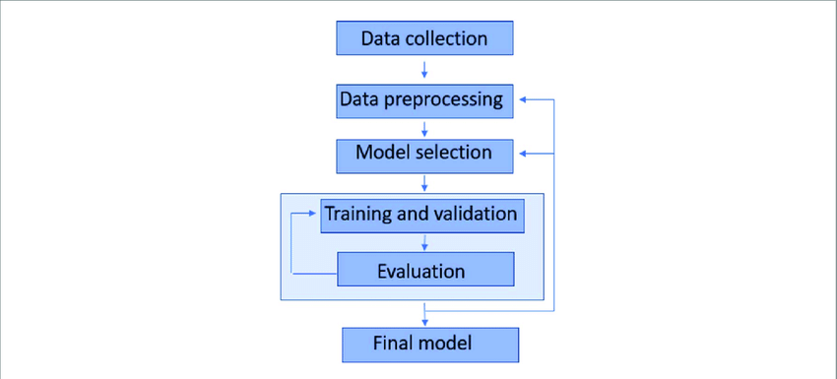

1. Data Collection
Collect data for 10 locations (nodes). This includes:
- Road distances between locations (edge weights)
- Coordinates of each location (to compute Euclidean distance)

2. Data Preprocessing
Prepare the data by:
- Representing locations as a graph structure
- Cleaning or organizing distance values
- Calculating Euclidean Distance to Goal for each node (heuristic)

3. Model Selection
Choose the A* search algorithm as the model since it efficiently finds the shortest path using both:
- Actual cost (g(n))
- Heuristic cost (h(n))

4. Training and Validation
In this context, “training” means:
- Testing the A* algorithm on different start and goal nodes
- Validating whether the algorithm consistently finds optimal paths

5. Evaluation
Evaluate performance based on:
- Path optimality (shortest distance)
- Time efficiency
- Number of nodes explored

6. Final Model
The final output is a working A* agent that:
- Takes a start and goal location
- Returns the most efficient route using the graph

- Expected Modules/ Libraries to be used :
- Pandas (pandas)
A powerful data analysis library used to read, manipulate, and process structured data like CSV files. It provides DataFrames, which make handling tabular data easy and efficient.
- NetworkX (networkx)
A Python library designed for creating, analyzing, and working with graphs and networks. It includes built-in algorithms like A* to find the shortest path in weighted graphs.
- Required topics from the subject:

1. Graph
A graph is a data structure consisting of nodes (locations) and edges (roads) connecting them. It is used to represent real-world networks like maps. In this project, the graph models delivery routes.

2. Weighted Graph
A weighted graph assigns a cost (weight) to each edge, such as distance or time. These weights help determine the shortest or most efficient path. In your project, road distance acts as the weight.

3. Nodes and Edges
Nodes represent locations or cities, while edges represent the paths between them. Each edge connects two nodes and may have a weight. Together, they form the structure of the graph.

4. A* (A-Star) Algorithm
A* is a search algorithm used to find the optimal path between two nodes. It combines actual cost and estimated cost using f(n) = g(n) + h(n). It is efficient and guarantees the shortest path if the heuristic is valid.

5. Heuristic Function
A heuristic is an estimated cost from a node to the goal. It helps guide the algorithm toward the destination faster. In this project, Euclidean distance is used as the heuristic.

6. Euclidean Distance
Euclidean distance is the straight-line distance between two points in a plane. It is commonly used as a heuristic in A* because it provides a good estimate of actual distance.
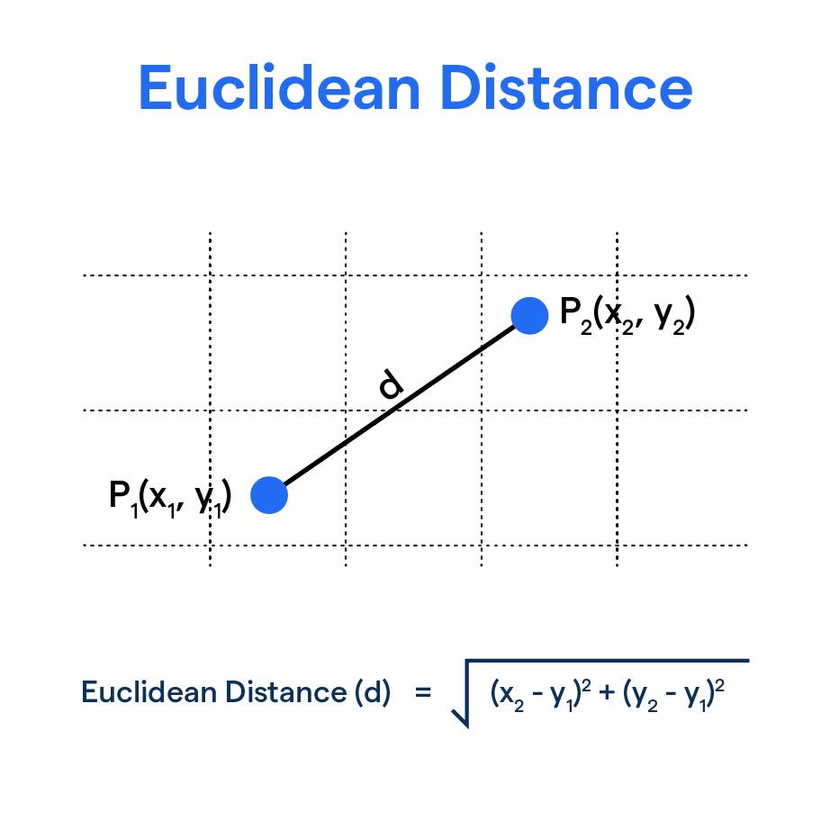

7. Cost Function (f(n))
The cost function in A* is defined as f(n) = g(n) + h(n). Here, g(n) is the actual cost from the start node, and h(n) is the estimated cost to the goal. The algorithm selects the node with the lowest f(n).

8. Pandas Library
Pandas is used to read and manage CSV data efficiently. It helps in loading node and edge information into the program. DataFrames make data handling simple and organized.

9. NetworkX Library
NetworkX is used to create and manipulate graphs in Python. It provides built-in functions like A* to find optimal paths. It simplifies graph-based problem solving

- Platform Required:
- Jupyter Notebook
An interactive environment that allows writing and executing code in cells. It is useful for step-by-step execution, visualization, and testing algorithms like A*.
- Books and Link Sources:
- Artificial Intelligence : A Modern Approach - Stuart Russell & Peter Norvig
A standard textbook covering A* search, intelligent agents, and problem-solving techniques in AI.
- Introduction to Artificial Intelligence – Eugene Charniak
Explains fundamental AI concepts including search algorithms and heuristics.
- GeeksforGeeks A* Algorithm Explanation
Simple explanation of A* algorithm with examples and code.
- NetworkX Official Documentation
Provides detailed guidance on graph creation and A* algorithm implementation.

