1.What are the two values of the Boolean data type? How do you write them?

ANS- Two Values for Boolean data type are True & False. We can write them either True/False or 0/1.

2. What are the three different types of Boolean operators?

Three different types of boolean operators are and,or& not.

i) AND-

The logical AND operator returns True if both operands are True, and False otherwise.

Example: True and False evaluates to False.

ii) OR-

The logical OR operator returns True if at least one of the operands is True, and False otherwise.

Example: True or False evaluates to True.

iii)Not-

The logical NOT operator returns the opposite of the operand's Boolean value.

Example: not True evaluates to False.

3. Make a list of each Boolean operator's truth tables (i.e. every possible combination of Boolean values for the operator and what it evaluate ).

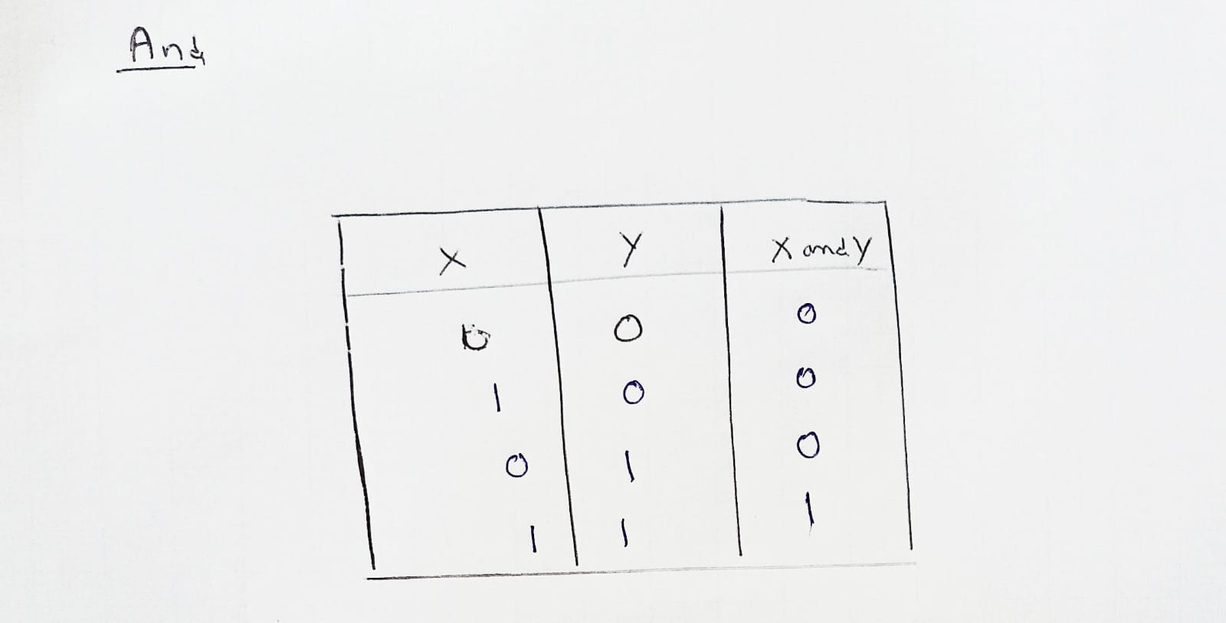

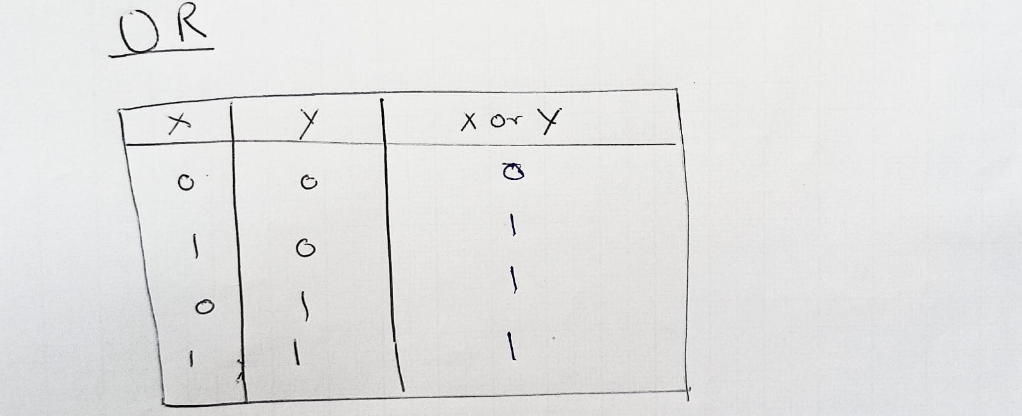



4. What are the values of the following expressions?

(5 > 4) and (3 == 5) - False

not (5 > 4) - False

(5 > 4) or (3 == 5) - True

not ((5 > 4) or (3 == 5))- False

(True and True) and (True == False) - False

(not False) or (not True) - True

5. What are the six comparison operators?

ANS- The six comparison operators are-

1. Equal to (==):

Checks if two values are equal.

Example: 2 == 2 evaluates to True.

1. Not equal to (!=):

Checks if two values are not equal.

Example: 3 != 4 evaluates to True.

1. Greater than (>):

Checks if the left operand is greater than the right operand.

Example: 5 > 3 evaluates to True.

1. Less than (<):

Checks if the left operand is less than the right operand.

Example: 2 < 7 evaluates to True.

1. Greater than or equal to (>=):

Checks if the left operand is greater than or equal to the right operand.

Example: 4 >= 4 evaluates to True.

1. Less than or equal to (<=):

Checks if the left operand is less than or equal to the right operand.

Example: 6 <= 9 evaluates to True.

6. How do you tell the difference between the equal to and assignment operators?Describe a condition and when you would use one.

ANS-

The equal to operator (==) is used for comparison, while the assignment operator (=) is used to assign a value to a variable.

The equal to operator (==) is used to compare two values and determine if they are equal. It returns True if the values are equal and False otherwise. For example

Eg- x = 5

y = 7

if x == y:

print("x and y are equal")

else:

print("x and y are not equal")

On the other hand, the assignment operator (=) is used to assign a value to a variable. It takes the value on the right-hand side and assigns it to the variable on the left-hand side. For example:

Eg- x = 5

y = x + 2

7. Identify the three blocks in this code:

ANS-

spam = 0 #<-------- Block one

if spam == 10: #<----------Block two

print('eggs')

if spam > 5:

print('bacon') #<------------Block three

else:

print('ham')

print('spam')

print('spam')

8. Write code that prints Hello if 1 is stored in spam, prints Howdy if 2 is stored in spam, and prints Greetings! if anything else is stored in spam.

ANS-

```

spam= input('Enter the value')

if(spam==1):

print("Hello!")

elif(spam==2):

print("Howdy ")

else:

print("Greetings!")

```

9.If your programme is stuck in an endless loop, what keys you’ll press?

To terminate the execution we have to press the `Ctrl + C`.

10. How can you tell the difference between break and continue?

ANS- The main difference between break and continue is as follows:

* break statement:

When encountered in a loop (such as for or while), the break statement immediately terminates the loop and transfers control to the next statement after the loop.

It is commonly used to exit a loop prematurely if a certain condition is met.

Example:

for i in range(1, 6):

if i == 3:

break

print(i)

Output:

1

2

* continue statement:

When encountered in a loop, the continue statement skips the current iteration and jumps to the next iteration of the loop.

It is commonly used to bypass certain iterations based on a specific condition without terminating the loop.

Example:

for i in range(1, 6):

if i == 3:

continue

print(i)

Output:

1

2

4

5

11. In a for loop, what is the difference between range(10), range(0, 10), and range(0, 10, 1)?

ANS- These are three different ways of range to initialize the for loop. But the output for each is same.

12. Write a short program that prints the numbers 1 to 10 using a for loop. Then write an equivalent program that prints the numbers 1 to 10 using a while loop.

ANS- Using for-

for i in range(1,11):

print(i)

Using While-

i=0;

while(i<10):

i+=1

print(i)

13. If you had a function named bacon() inside a module named spam, how would you call it after importing spam?

ANS-

After importing the module named spam, you can call the function bacon() using the following syntax-

```

Import spam

spam.bacon()

```