Linux Commands Assignment
Course: Linux / DevOps

Objective
The objective of this assignment is to understand and practice basic Linux commands such as file and directory management, viewing file contents, searching patterns, compression, permissions, downloading files, and environment variables.

1. Creating and Renaming Files/Directories
Commands:
mkdir test_dir
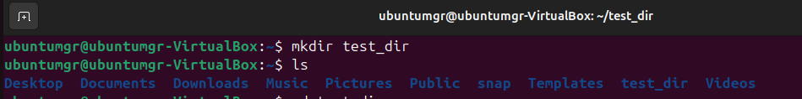
cd test_dir
touch example.txt
ls

cd test_dir
mv example.txt renamed_example.txt
ls

Explanation:
These commands create a directory, create an empty file, rename it, and list files.

2. Viewing File Contents
Commands:
cat /etc/passwd
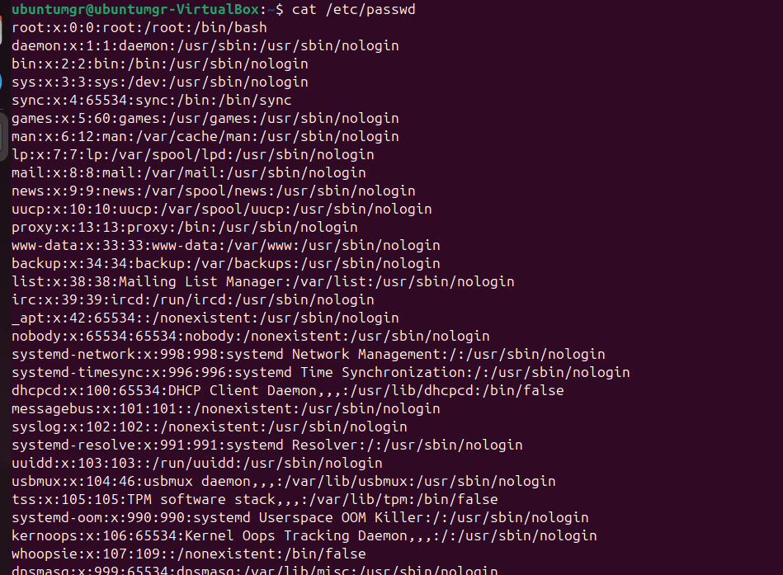
head -n 5 /etc/passwd
tail -n 5 /etc/passwd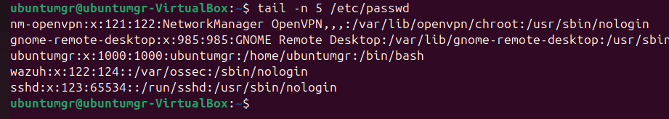
Explanation:
These commands display full, first five, and last five lines of a file.

3. Searching for Patterns
Command:
grep "root" /etc/passwd
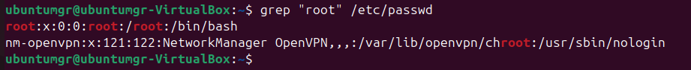
Explanation:
This command searches for lines containing the word 'root'.

4. Zipping and Unzipping
Commands:
zip -r test_dir.zip test_dir
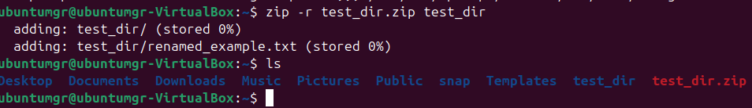
unzip test_dir.zip -d unzipped_dir
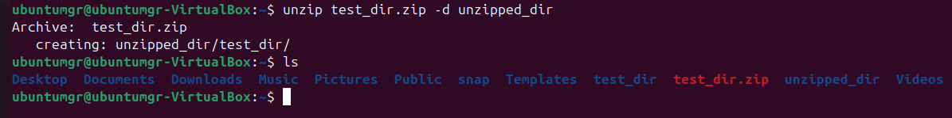
Explanation:
These commands compress and extract a directory.

5. Downloading Files
Command:
wget https://example.com/sample.txt
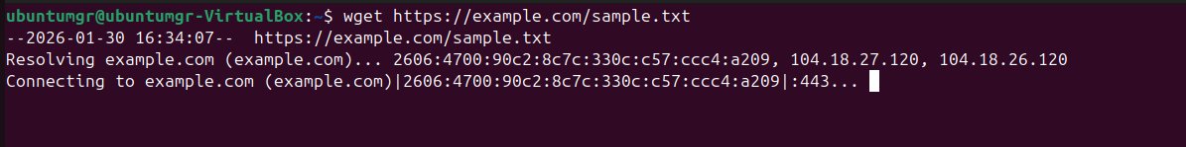
Explanation:
This command downloads files from the internet.

6. Changing Permissions
Commands:
touch secure.txt
chmod 444 secure.txt
ls -l secure.txt
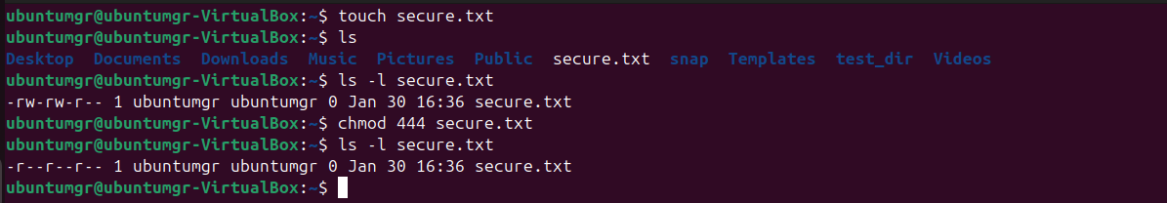
Explanation:
These commands create a file and set it to read-only for everyone.

7. Environment Variables
Commands:
export MY_VAR="HELLO LINUX"
echo $MY_VAR
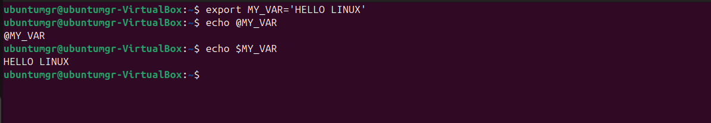
Explanation:
These commands set and display an environment variable.

Conclusion
This assignment provided hands-on experience with essential Linux commands and improved command-line skills.

