

Fashion Recommendation System

Jotangiya Pranjal – 23CI2010393 Bhavsar Priyanshi – 23CI2010378 Dobariya Avadh – 23CI2010385 Patel Rahi –23CI2010412


CHIMANBHAI PATEL INSTITUTE OF COMPUTER APPLICATIONS

Project Report on
Fashion Recommendation System

In Partial Fulfillment of
Bachelor of Computer Applications (BCA)
October – 2025

Developed By: Under Guidance of

- Jotangiya Pranjal - 23CI2010393 Prof. Purnima Baggdi
- Bhavsar Priyanshi - 23CI2010378
- Dobariya Avadh - 23CI2010385
- Patel Rahi - 23CI2010412

Submitted To

SARDAR VALLABHBHAI GLOBAL UNIVERSITY
CHIMANBHAI PATEL INSTITUTE OF COMPUTER APPLICATIONS
Opp. Karnavati Club, Prahladnagar, Sarkhej Gandhinagar Highway, Ahmedabad-380015

Acknowledgement

We would like to express our sincere gratitude to our professor, Purnima Baggdi, for their invaluable guidance,
encouragement, and support throughout the development of Our Fashion Recommendations System Website. Their insightful
feedback and constant motivation helped me to enhance the quality of this project.

We are also deeply thankful to our classmates, who provided constructive suggestions, shared ideas, and extended their
cooperation whenever needed. Their collaboration created a supportive learning environment and made this journey more engaging and productive.

Although this project is still in progress, the knowledge and experience we have gained so far have been very meaningful.

INDEX

Sr.no. | Topic | Page NO
1. | Introduction…
2. | Project Profile  - Existing System  - Proposed System  - Tools and Technology
3. | Screen Layouts
4. | Test Cases
5. | Reports
6. | Semple Code
7. | Future Enhancement
8. | Conclusion
9. | Bibliography

Introduction

Trendify is a online Fashion website. The platform is designed to help users discover outfits that match their personality, occasion, according to the trend, and budget. Our Fashion Recommendation Website provides user’s some suggestion like occasion based, latest trend according and, most selling items.

Whether someone is looking for casual wear, formal attire, or trending accessories, our system ensures that users receive that make shopping simple, enjoyable, and stylish.

By combining these three types of recommendations, our
website ensures that every user finds outfits that match their style, taste, and needs.

- Occasion-Based : Whether it’s a party, office meeting, wedding, or casual outing, we help you pick outfits that suit the occasion perfectly.
- Most Selling Items : See what’s popular among other fashion
enthusiasts. These top-selling items are tried, tested, and loved by many, so you can shop with confidence.
- Latest Trending Styles : Stay ahead of the fashion curve with suggestions based on the newest trends and seasonal
collections.

Project profile

  - Existing System

  - Proposed System

  - Tools & Technology

  - Modules

Existing System

Our fashion recommendation systems focus on helping users find outfits based on general preferences or past purchase history. We provide suggestions like popular products, user ratings, and similar items to what the user has browsed before.

  - Personalized Recommendations- Suggest products based on user browsing or purchase history.
  - Trending Items – Show items that are currently popular on the platform.
  - Category-Based Suggestions – Recommend clothes based on categories like tops, bottoms, accessories, etc.
  - Ratings and Reviews–Help users make informed decisions based on
other customers’ feedback.

Limitations of Existing System:

  - Real-Time Updates – The system may not instantly update suggestions when trends or best-selling items change quickly.
  - Occasion Restriction – Occasion-based recommendations are predefined and may not cover all possible events or unique user needs.

Proposed System

Our Fashion recommendation system aims to provide personalized suggestions for clothing and accessories to users, enhancing their shopping experience and helping them discover new styles.

Well-organized product with categories, filters, and search functionality.
Allows users to explore items beyond recommendations if they prefer.

User can receive recommendations for like Occasion-based fashion (e.g., wedding, casual, office wear), Most-selling items (trending popular products) and, Latest fashion trends (new arrivals and trending styles)

  - Focused, three-type suggestion system (occasion, best-selling, trending) reduces choice overload for users.
  - Personalized fashion guidance enhances user satisfaction and increases the likelihood of purchase.

Tools & Technology

Tools & Technology | Logo
Python | 
Html | 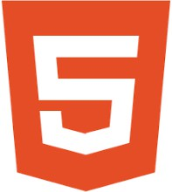
Css | 
Node js | 
Vs Code | 
Java Script | 

12

Modules

* User Registration and Login
* Category Management
* Search Box
* Shopping Cart Management
* Order and Purchase Management
* Feedback and Rating System
* Admin Management

* User Registration and Login
- User Registration is the process through which a new user creates an account on the website. store their information, and securely interact with the system.
- Information Collected During Registration
- The registration form generally includes the following fields:
- Email Address – Used as a unique identifier and for communication.
- Mobile Number – For contact and verification purposes.
- Username – A unique name used for login.
- Password – A secure password chosen by the user.
- Confirm Password – To ensure the password is entered correctly.

* Category Management
- Category Management is an important module of the website that allows the administrator to organize products or content into different categories. It helps users easily navigate the website and find items quickly. By grouping similar products or services under a specific category, the website becomes more structured, user-friendly, and efficient.

* Search Box

- The Search Box in the Trendify website is an essential feature that helps users quickly find products available on the platform. Instead of browsing through multiple categories, users can simply type the name of a product or a keyword into the search box to instantly view relevant items.

* Shopping Cart Management
- Shopping Cart Management is an important feature of our fashion website that allows customers to easily select, review, and manage the fashion products they want to purchase. Customers can add clothing items such as shirts, jeans, dresses, and accessories to their cart while browsing the website.

* Order and Purchase Management
- Order and Purchase Management is a key feature of our fashion website that helps manage customer orders from the time a purchase is made until the product is delivered. When customers select fashion items such as shirts, jeans, dresses, or accessories and complete the checkout process, the system generates an order with all necessary details.

* Feedback and Rating System
- share their opinions and experiences about products or services on the website. After purchasing or using a product, users can give ratings (usually from 1 to 5 stars) and write reviews or comments.

* Admin Management
- control and manage the entire website from a single dashboard. The admin can manage users, categories, products/books, orders, and other system activities

Screen Layouts

- Registration

- Login

- Forgot Password

- Home

- Search Bar

- Cart

- Feedback

- My Orde
Registration

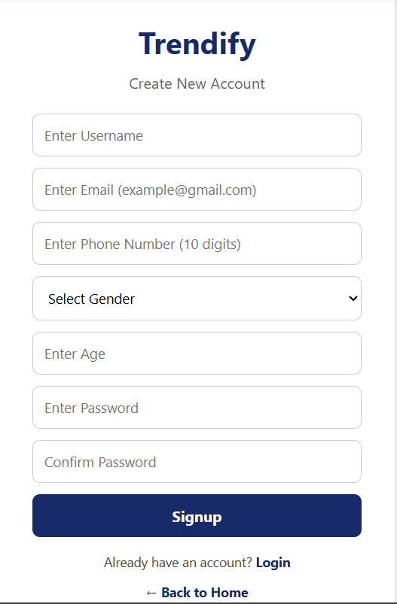
Login

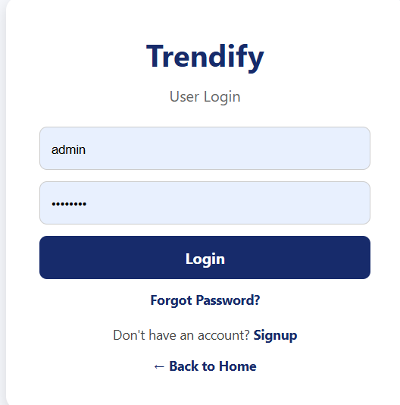

Forgot Password

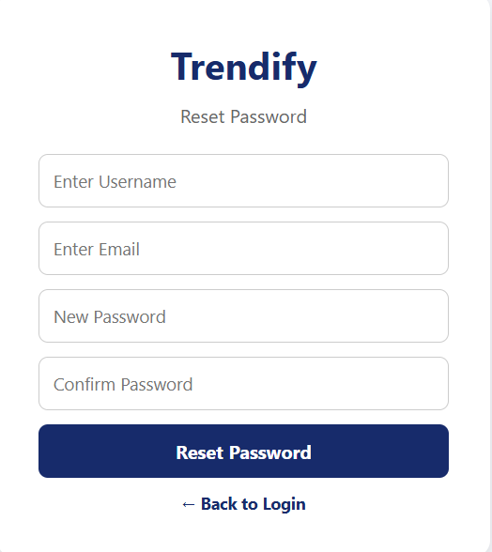

Home

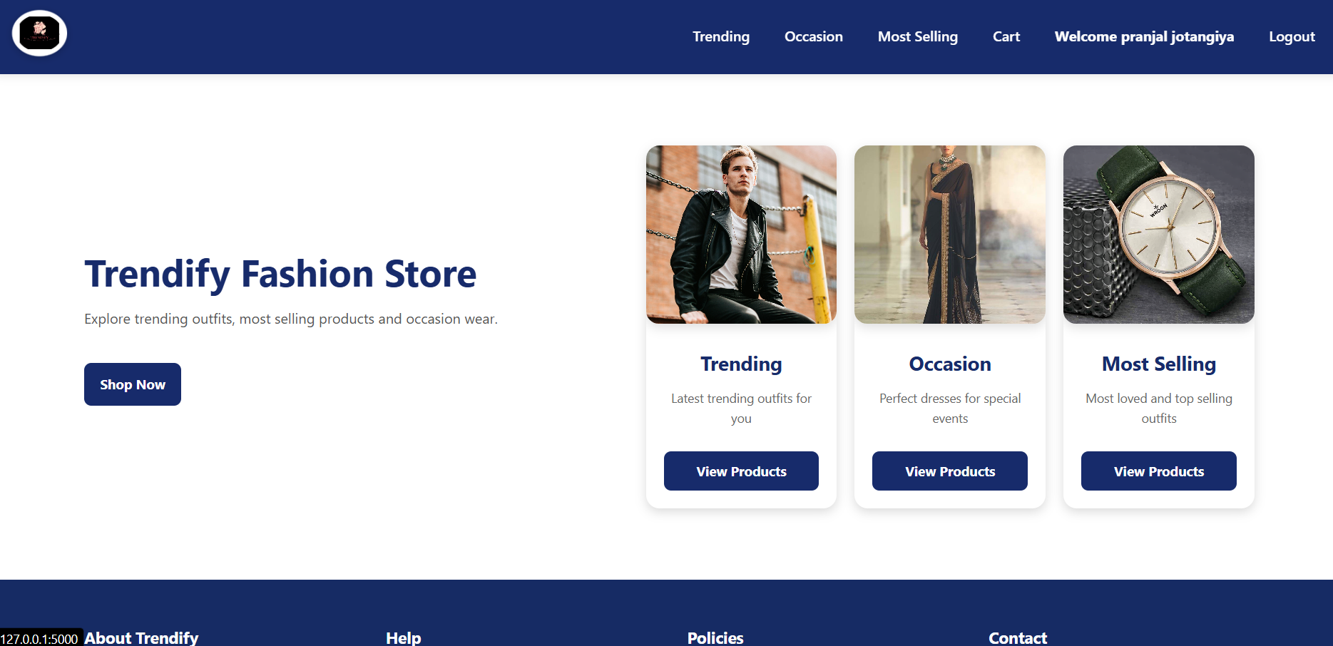

Search Box

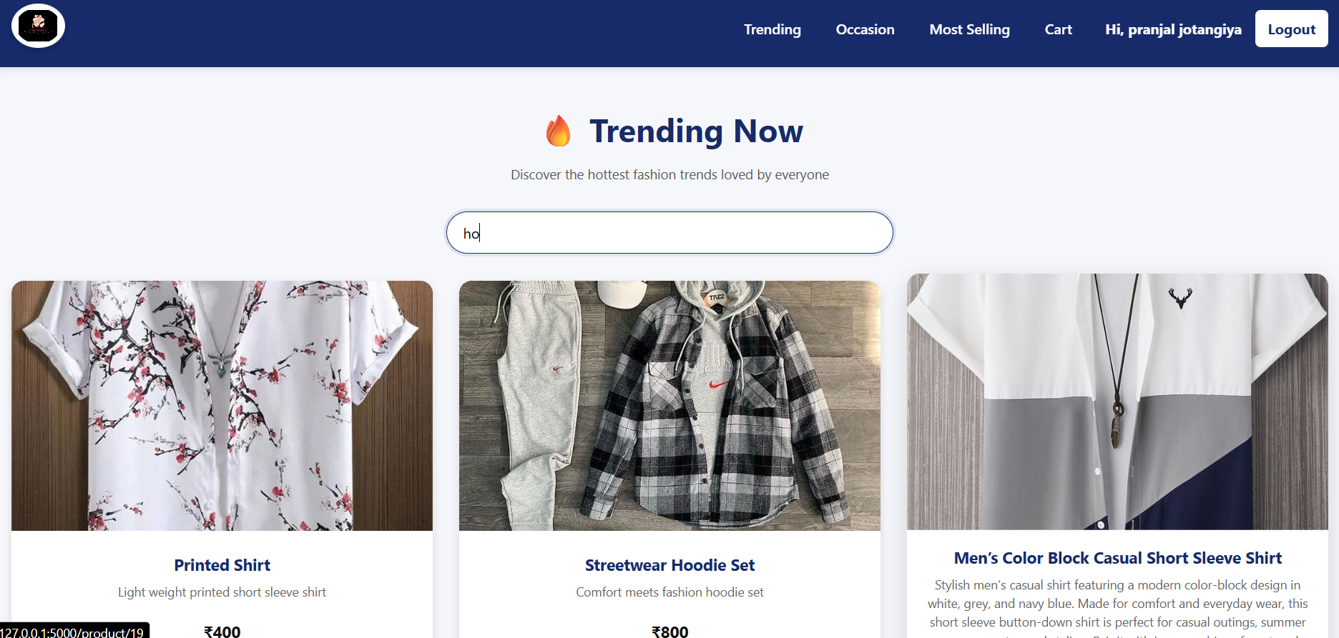

Add To Cart

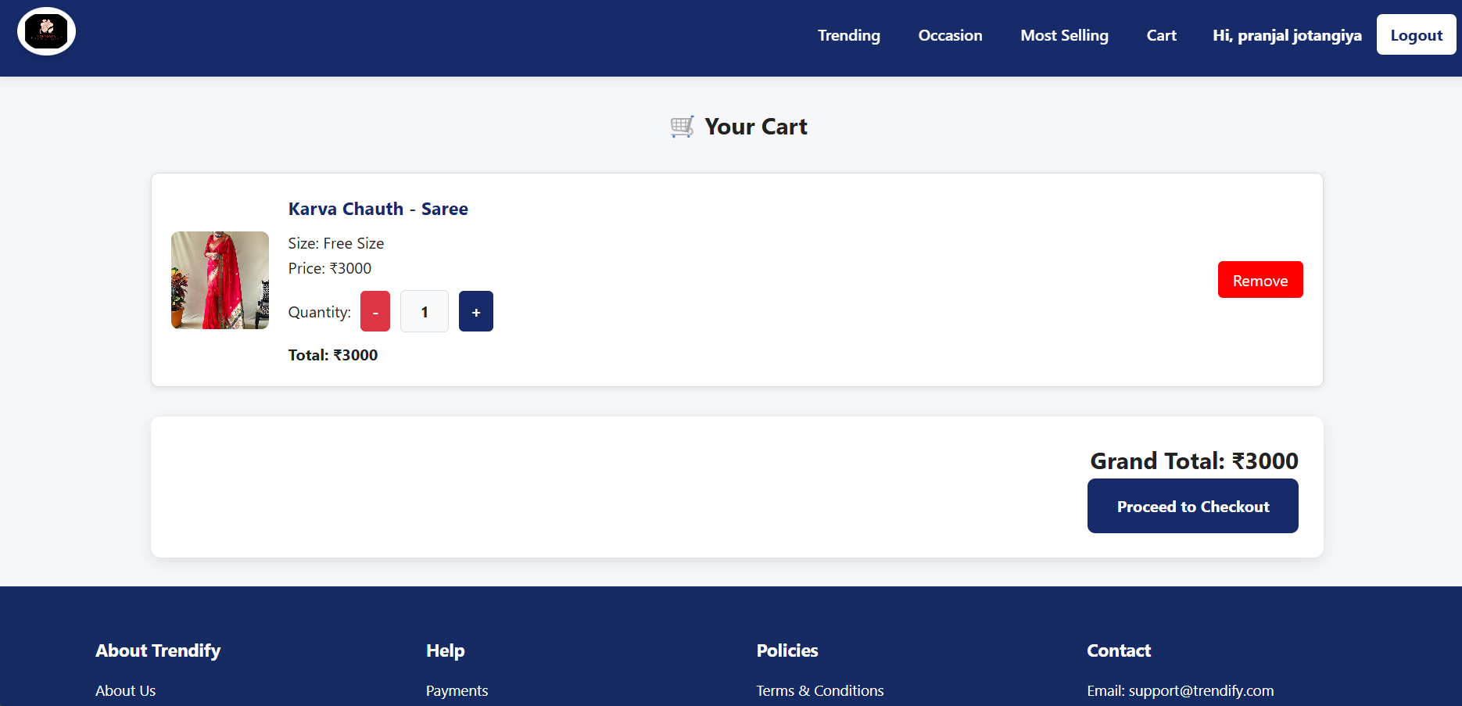

Feedback

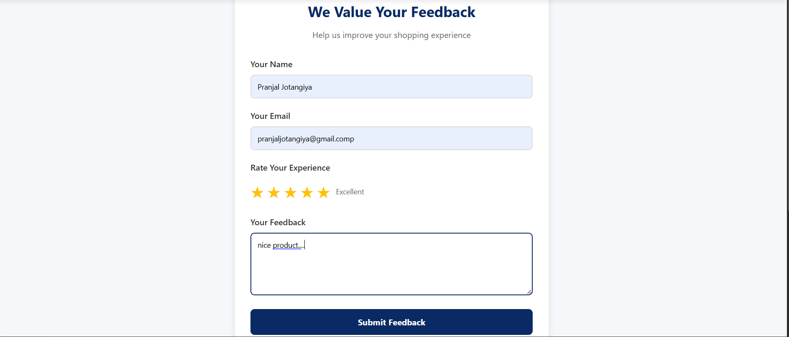

My Order

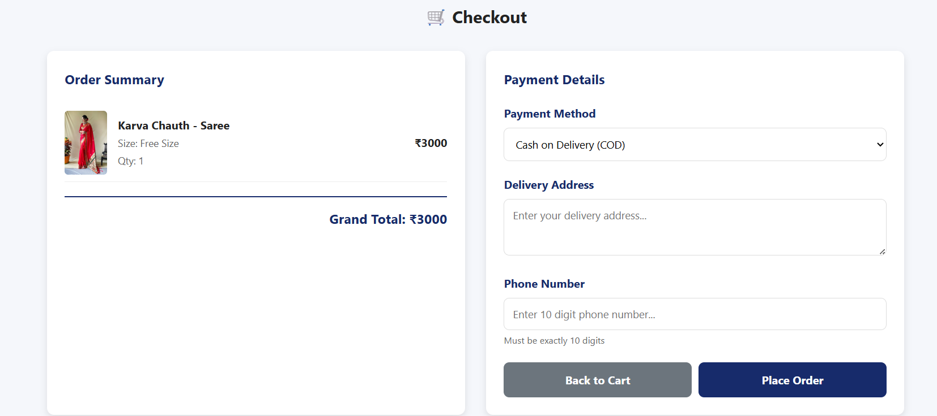

Test Cases

1.Validation of register form.

