Project Documentation

Topic
Marriage hall booking system.

Team Members’
- Pranjal Srivastava
- Rishabh Varshney
- Sharindidu
- Saksham Mishra
- Sabdansh
Case Study Problem Statement
Marriage Hall booking Application is to provide venue details to customers, with various modules Admin, Supervisor, Vendors, and Customer. This application provides Hall details like seating capacity, no of rooms available etc. Provides online and offline booking system

Actors
- Admin
- Vendor
- Supervisor
- Customer

Services
Admin Vendor Service to add, delete, update and list available vendors Admin supervisor Service to add, delete , update and list available supervisors/managers Booking service : This service is to the customer for booking the hall with his preferences Supervisor Service can provides with all services with details like Venue details , Electrical equipment details, Dining details, housekeeping details, pricing and billing etc Vendor service : This service can provide various facility with costing like catering, flower decors, music systems, Video coverage etc.

Technology Used
Java 8
Postgres

Modules used in project
- Entity: It has two classes
- Customer class
- Booking class

- Repository: It has two classes
- Customer Repository
- Booking Repository

- Controller: It has booking controller

- Dto: It has two classes
- Booking request
- Order response
Positives of Marriage Hall booking system
- It become very easy for customer to book a venue according to his budget, on a particular date.
- It become easy payment option as there are multiple gateways available.
- There are some additional benefits are provided to the customer.
- Customers can provide some additional changes if wanted to.
- It is budget friendly as many things are available in same amount.

High Level Architecture

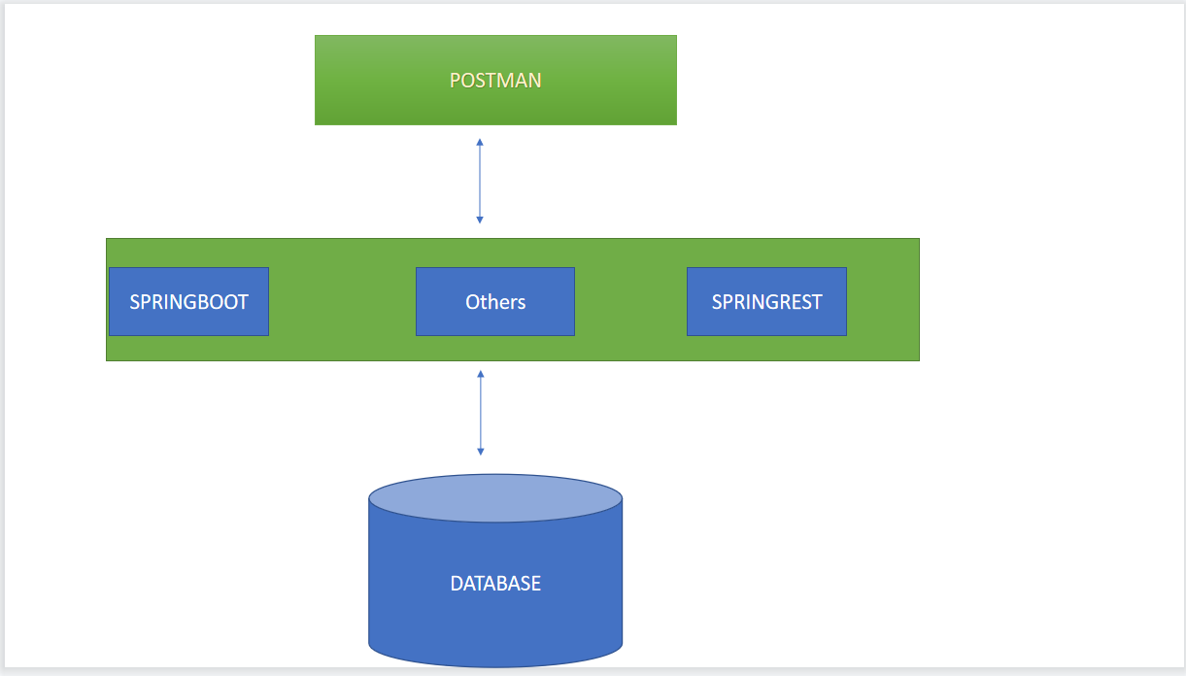

ER Diagram
