2048 – GAME

About

The objective of this game to merge numbers with arrow keys to get the 2048 tile!

Screenshots

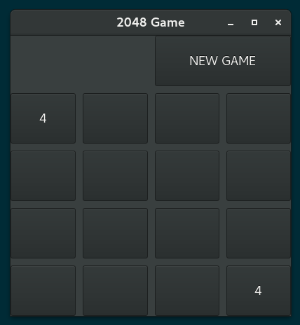
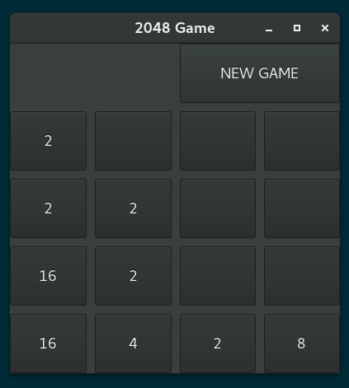

Getting Started

Copy the below command in your terminal/ powershell window :
git clone “https://github.com/PranjalGupta2199/2048.git”

This will download a clone of the repository in your system.

Then go to your directory (in your terminal) containing the repository and run the ‘ main.py ‘ file by typing the command in your terminal window
python main.py

This will run your application.

Prerequisites

- Gtk 3.0
- Gdk 3.0
- Python ( 2.7 version)

Installing
Follow the instructions given in the link -

- Gtk 3.0

‘ http://pygobject.readthedocs.io/en/latest/getting_started.html ‘

- Gdk 3.0

‘ http://galil.com/sw/pub/all/doc/gdk/html/installation.html ‘

- Python

‘ https://www.python.org/downloads/ ‘

Author

Name – Pranjal Gupta
Github Link - ‘ https://github.com/PranjalGupta2199 ‘

