YOLO (You Only Look Once)

- Best & latest comared to other/traditoinal
- Single Forward Pass: YOLO divides the image into an S×S grid. Each grid cell predicts a fixed number of bounding boxes, confidence scores for these boxes, and class probabilities.
- Bounding Box Prediction: Each bounding box has 5 predictions: x, y, width, height, and confidence score. x and y coordinates represent the center of the box relative to the bounds of the grid cell.
- Class Prediction: For each bounding box, YOLO predicts a set of class probabilities, indicating the likelihood that the box contains an object of a particular class

Advantages of YOLO
- Speed: Extremely fast because it processes the entire image in a single forward pass, making it suitable for real-time applications.
- Global Context: YOLO considers the entire image when making predictions, leading to fewer background errors.
- Unified Architecture: The single neural network architecture makes YOLO easier to optimize and deploy compared to models that require separate region proposal and classification steps.

However there is disadvantage that YOLO may struggle with small objects or objects that are close to each other due to its coarse grid structure
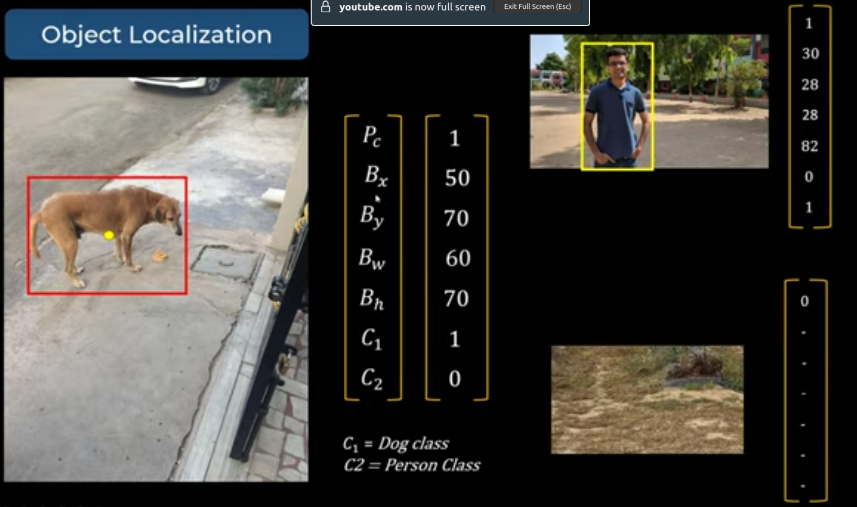

Like in this image
- Pc is the probablity of Dog or Person if this 0 other value not matter
- Bx, By are coordinate of center of box wrt left-top
- Bw, Bh are width & hiegth of box
- C1 & C2 refers for class of dog & human
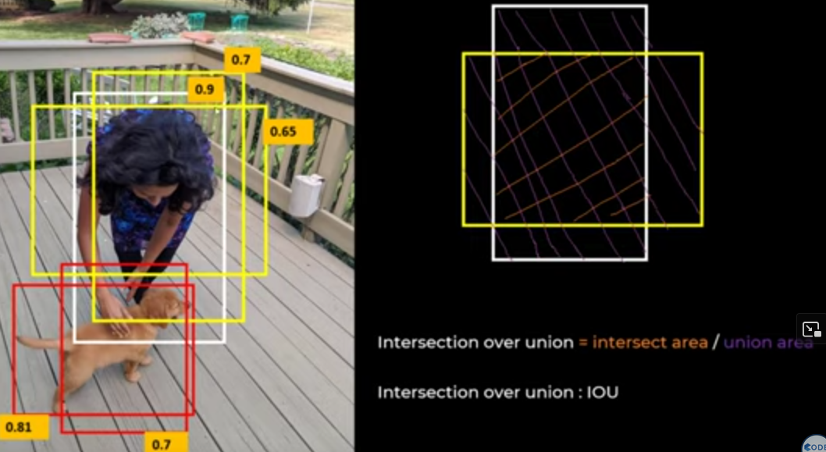

In multiple boxes, it doesnt take maximum (cofidence one) , rather it takes the most common among all, like

