**VoiceBank**  
Revolutionizing Banking with Your Voice

**Experience the Future of Banking**

Welcome to VoiceBank, where we've reimagined banking to be as simple as having a conversation. Harness the power of your voice to manage your finances effortlessly.

Learn More (CTA with downward arrow that scrolls to features)

**Features**

Secure Voice Login: Your voice is your key to a secure banking experience. Log in effortlessly with our advanced voice recognition technology.

Seamless Fund Transfers:- Transfer funds effortlessly between your accounts or to other recipients, just by speaking.

Access Transaction History:- Retrieve your transaction history by speaking the date or transaction details.

**How It Works**

Voice Login:- Begin your banking journey by saying your unique passphrase. Our advanced voice recognition technology securely logs you into your account.

Command Centre:- Navigate your accounts, transactions, and payments using intuitive voice commands.

Explore Additional Commands: Dive deeper by exploring other voice commands. For instance:

"Get a summary of my spending.”

“Apply for a loan [amount]”

“Scroll up/down ensuring smooth navigation”

**About Us**

At VoiceBank, we believe in making banking accessible, secure, and user-friendly. Our team of experts is dedicated to providing you with a banking experience tailored to your needs. Join us in embracing the future of finance.

**Customer Testimonials**

VoiceBank has transformed the way I manage my finances. The voice-activated features are intuitive and make banking a breeze!” –John Doe.

Security was my primary concern, but VoiceBank's voice authentication has proven to be both reliable and convenient. Highly recommended!” – John Doe.

The simplicity of conducting transactions with just my voice is unmatched. I highly recommend VoiceBank to anyone looking for a modern and user-friendly banking experience!" – John Doe.

**Contact Us**

Have questions or need assistance? Our customer support team is here to help.

-Email: - support@voicebank.com

-Phone: - 1-800-123-4567

-Socials  
Instagram Twitter Facebook

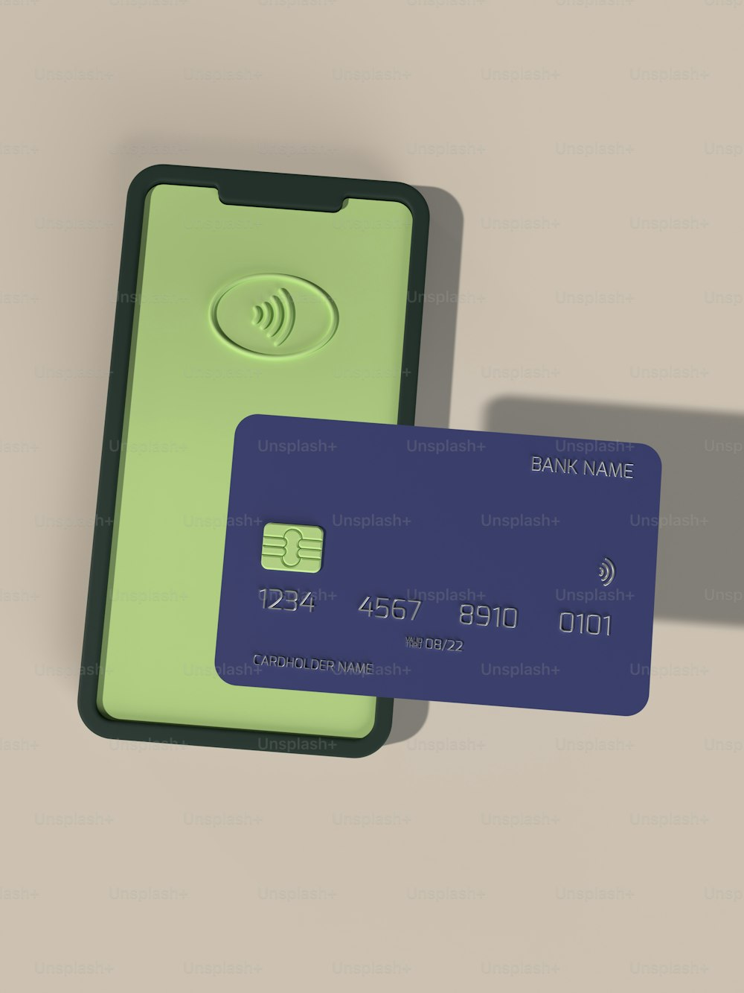

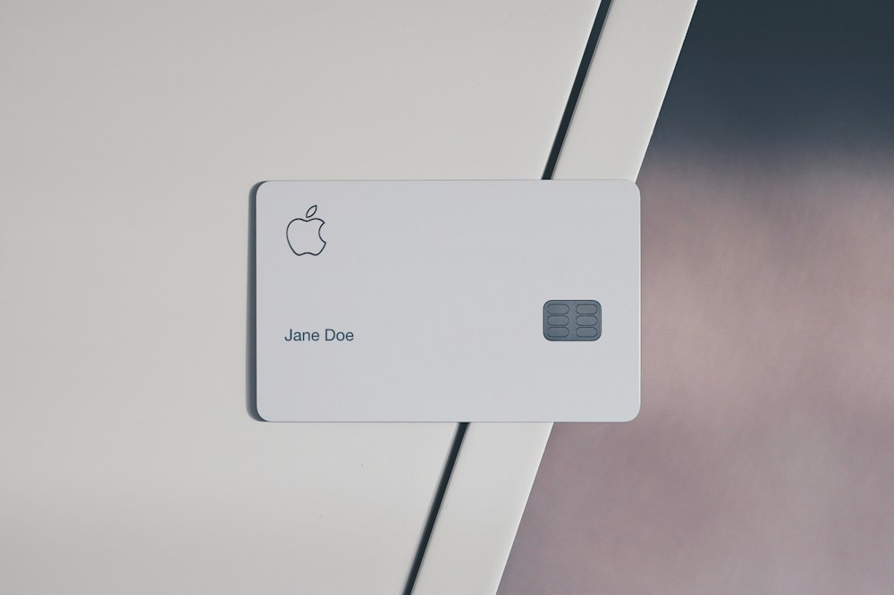









(Can edit a screenshot of our website into image of a laptop)