AIDS/HIV

Precautions to prevent the transmission of HIV/AIDS are necessary in order to lower infectivity rates. Here are some key strategies:

1. Practice Safe Sex:

- Always Use Condoms: Correct and consistent use of latex or polyurethane condoms during vaginal, anal, and oral sex can greatly reduce the risk of HIV transmission.

- Number of Sexual Partners: Lower numbers decrease the risk of being exposed to HIV and other sexually transmitted infections (STIs).

- Go for Testing: You as well as your spouses should go testing regularly. Especially before bonking a new partner by all means please do that!

2. Pre-Exposure Prophylactic [PrEP]:

- PrEP Medication: Pre-Exposure Prophylaxis (or PrEP) medication, which can reduce the risk of getting HIV from sex by more than 90% when taken every day. It is suggested for people who are most likely to acquire HIV, like-for-instance those with an HIV+ sexual partner or other high-risk conduct individuals.

3. Avoid Sharing Needles:

- Use Clean Needles: If you inject drugs, always use a clean needle negative of all traces. Using a needle or syringe also increases the probability of acquiring HIV.

- Use needle exchange programs: In some places, there are programs to help people safely get rid of used needles and obtain new ones.

4. Post-Exposure Prophylaxis (PEP) for non-contact exposures after sexual assault:

- PEP Medication: If you have had unprotected sex or shared needles with someone who might be sick, and then think that a person may start to get HIV (more specifically up to 3 days after), it is important necessary take Post-phylactic prophylaxis (PEP Medicine) because the chances of contracting AIDS can drop enormously. This requires the use of antiretroviral medications for 28 days.

5. Get Tested and Learn Your HIV status:

- Regular HIV Testing: The best defense to stop HIV is regular testing. When you know where you're at, that equips yourself and others to take the required measures in order not put your lives or someone else's life if risk.

- Early Detection : Identifying the problem early, so that timely management can be deployed in a bid to curb viral replication and hence risk of spread.

6. Test and Treat or Treatment as Prevention (TasP):

- Antiretroviral Therapy (ART): People taking ART who sustain undetectable viral loads can no longer spread the virus through sex. This slogan is "Undetectable = Untransmittable" (U=U).

7. Prevent the Transfer of Mother to Child:

- HIV Testing in Pregnancy: HIV testing during pregnancy to help get early treatment and cut transmission from mother to baby throughout the process of pregnancy, childbirth or breastfeeding.

- ART In Pregnancy: If the mother is HIV positive, taking antiretroviral drugs when pregnant and giving birth reduces dramatically the odds of transmission to the baby.

8. Avoid Blood Contact:

-Be Mindful in Clinical Environments : Healthcare employees should always take precautions when dealing with blood and body fluids.

- Safe Blood Transfusions: Verify that all blood products are tested for HIV and other pathogens prior to a transfusion.

9. Be Informed About HIV/AIDS:

- Education: Knowledge is power and knowing how HIV can be contracted and the significance of preventing these strategies, you can give a person an edge to make wiser decisions….

- Myths and Stigma To Avoid: HIV is not transmitted through everyday contact — like hugging or sharing food, so having the right information may bring down stigma. Knowledge is the key to preventing discrimination

10. Support Immune System Health:

- Healthy lifestyle: A healthy diet, regular exercise and not smoking or drinking alcohol excessively can help strengthen your immune system if you are living with HIV.

Additional Precautions:

- Male Circumcision: Studies have shown that male circumcision can reduce the risk of HIV transmission by about 60% in heterosexual men.

- Avoid High-Risk Behavior: Stay away from situations that could lead to risky behaviors, such as unprotected sex or drug use.

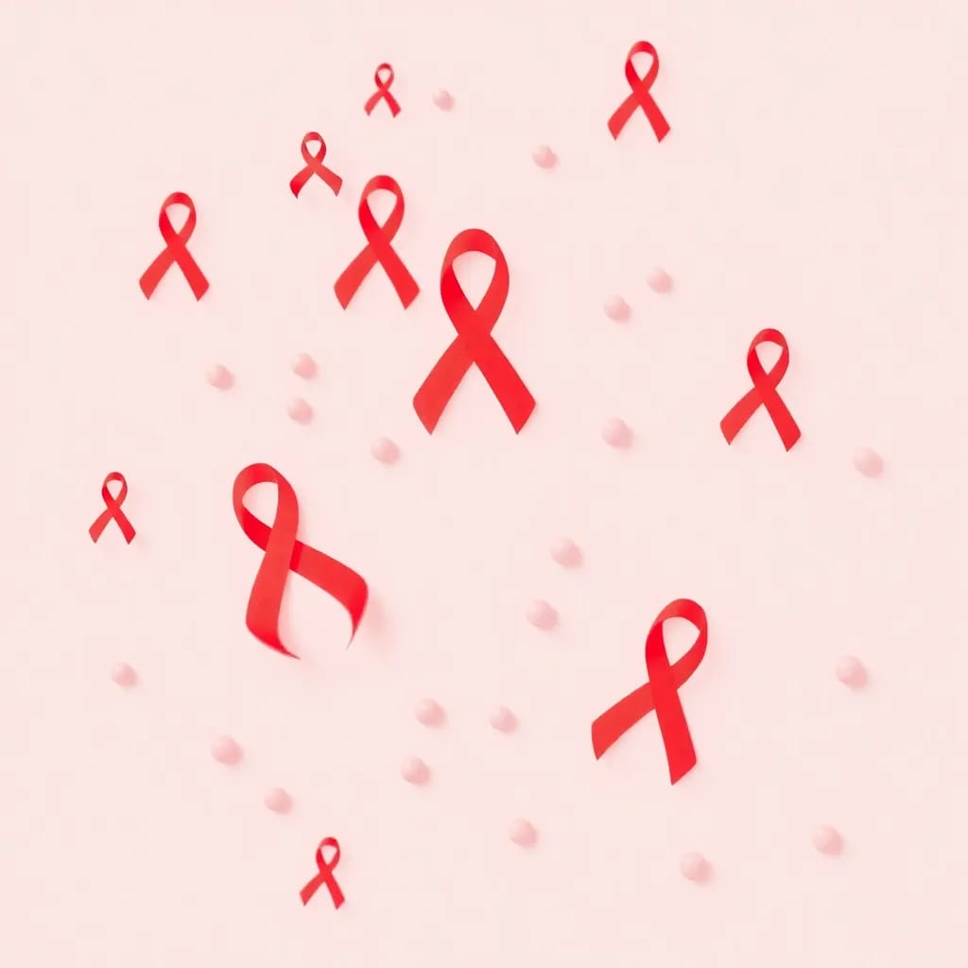

Taking these precautions can significantly reduce the risk of HIV infection and help prevent the spread of HIV/AIDS. If you believe you are at risk, consult a healthcare provider for advice on testing, treatment, and preventive measures like PrEP or PEP.