Colorado Motor Vehicle Sales Data Analysis
Author: Pranjal Waghmare
Date: November 11, 2025

Project Overview: This report analyzes motor vehicle sales across Colorado counties by year and quarter, presenting trends, key insights, and recommendations.

Dataset Description
This dataset contains information on motor vehicle sales in various counties across Colorado, segmented by year and quarter. Fields included:
- Year: calendar year of the record
- Quarter: quarter in the year (1-4)
- County: county name
- Sales: total dollar amount of vehicle sales in the county and quarter

Data Cleaning Summary
- Rows (after cleaning): 501
- Unique counties: 17
- Years covered: 2008 - 2015
- Total sales (all records): $88,205,300,000
- Cleaning steps applied: removed duplicates, trimmed whitespace, standardized county names (title case, replaced '/' with ' & '), ensured numeric types for sales, sorted by year-quarter-county.

Exploratory Data Analysis (EDA)

Total Sales by Year
This chart shows aggregated yearly motor vehicle sales across all counties in Colorado.
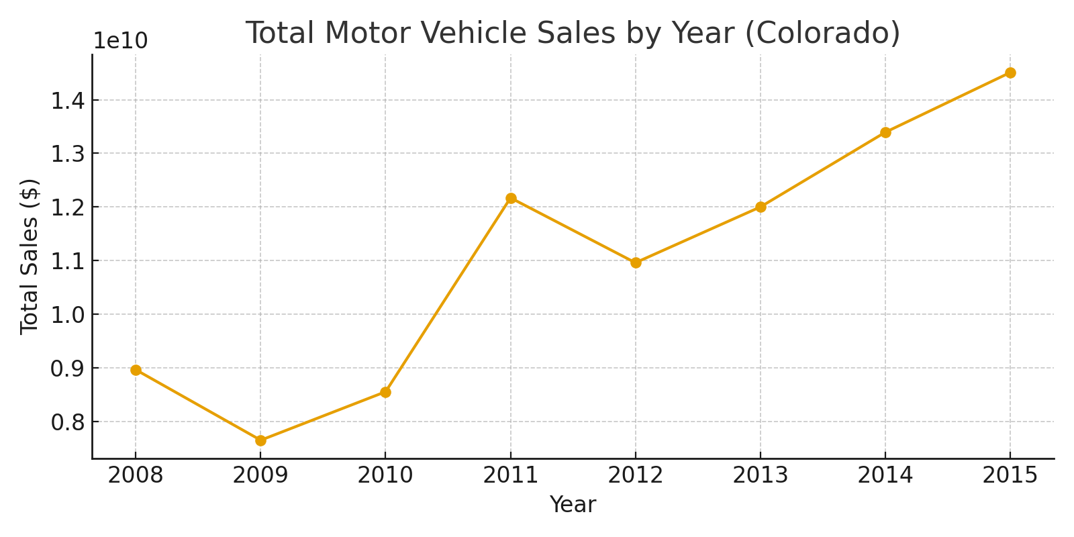
Yearly totals and year-over-year percentage change:
Year | Total Sales ($) | YoY Change (%)
2008 | 8,965,561,000 | 0.00
2009 | 7,652,500,000 | -14.65
2010 | 8,556,088,000 | 11.81
2011 | 12,170,441,000 | 42.24
2012 | 10,960,876,000 | -9.94
2013 | 12,000,615,000 | 9.49
2014 | 13,392,487,000 | 11.60
2015 | 14,506,732,000 | 8.32

Total Sales by Quarter (All Years Combined)
Aggregated sales by quarter across all years show seasonal patterns.
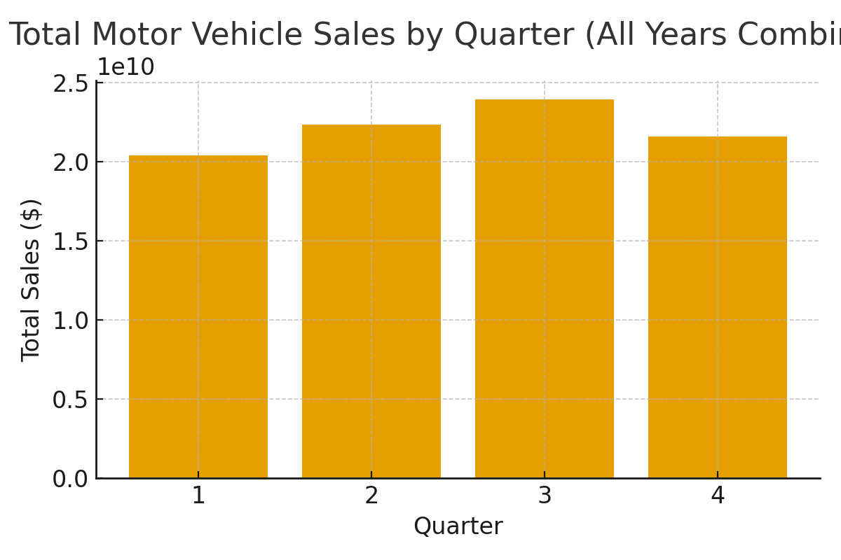
Quarterly totals:
Quarter | Total Sales ($)
1 | 20,376,846,000
2 | 22,343,294,000
3 | 23,914,934,000
4 | 21,570,226,000

Top & Bottom Performing Counties
Top 10 counties by total sales:
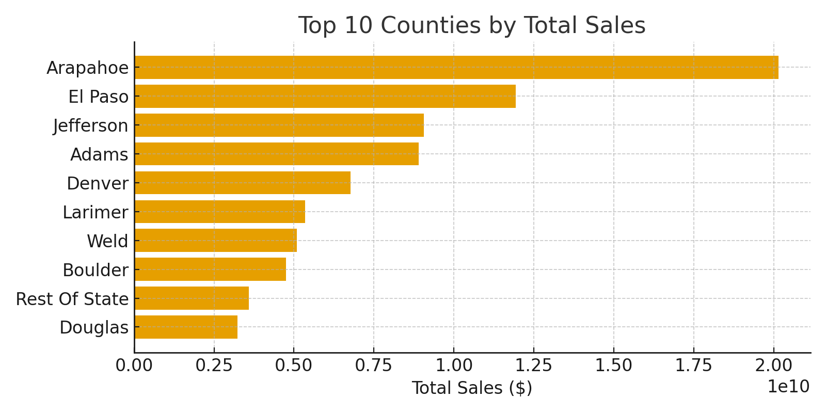
Top 10 counties (by total sales):
County | Total Sales ($)
Arapahoe | 20,142,323,000
El Paso | 11,926,044,000
Jefferson | 9,058,407,000
Adams | 8,902,115,000
Denver | 6,763,613,000
Larimer | 5,344,367,000
Weld | 5,086,889,000
Boulder | 4,742,532,000
Rest Of State | 3,582,170,000
Douglas | 3,236,493,000
Bottom 10 counties (by total sales):
County | Total Sales ($)
Boulder | 4,742,532,000
Rest Of State | 3,582,170,000
Douglas | 3,236,493,000
Mesa | 2,621,436,000
Pueblo | 2,384,044,000
Garfield | 1,600,594,000
Broomfield | 1,027,326,000
La Plata | 792,807,000
Boulder & Broomfield | 677,201,000
Fremont | 316,939,000

State-level Quarterly Sales Timeline
Quarterly sales across the state over the full time period.
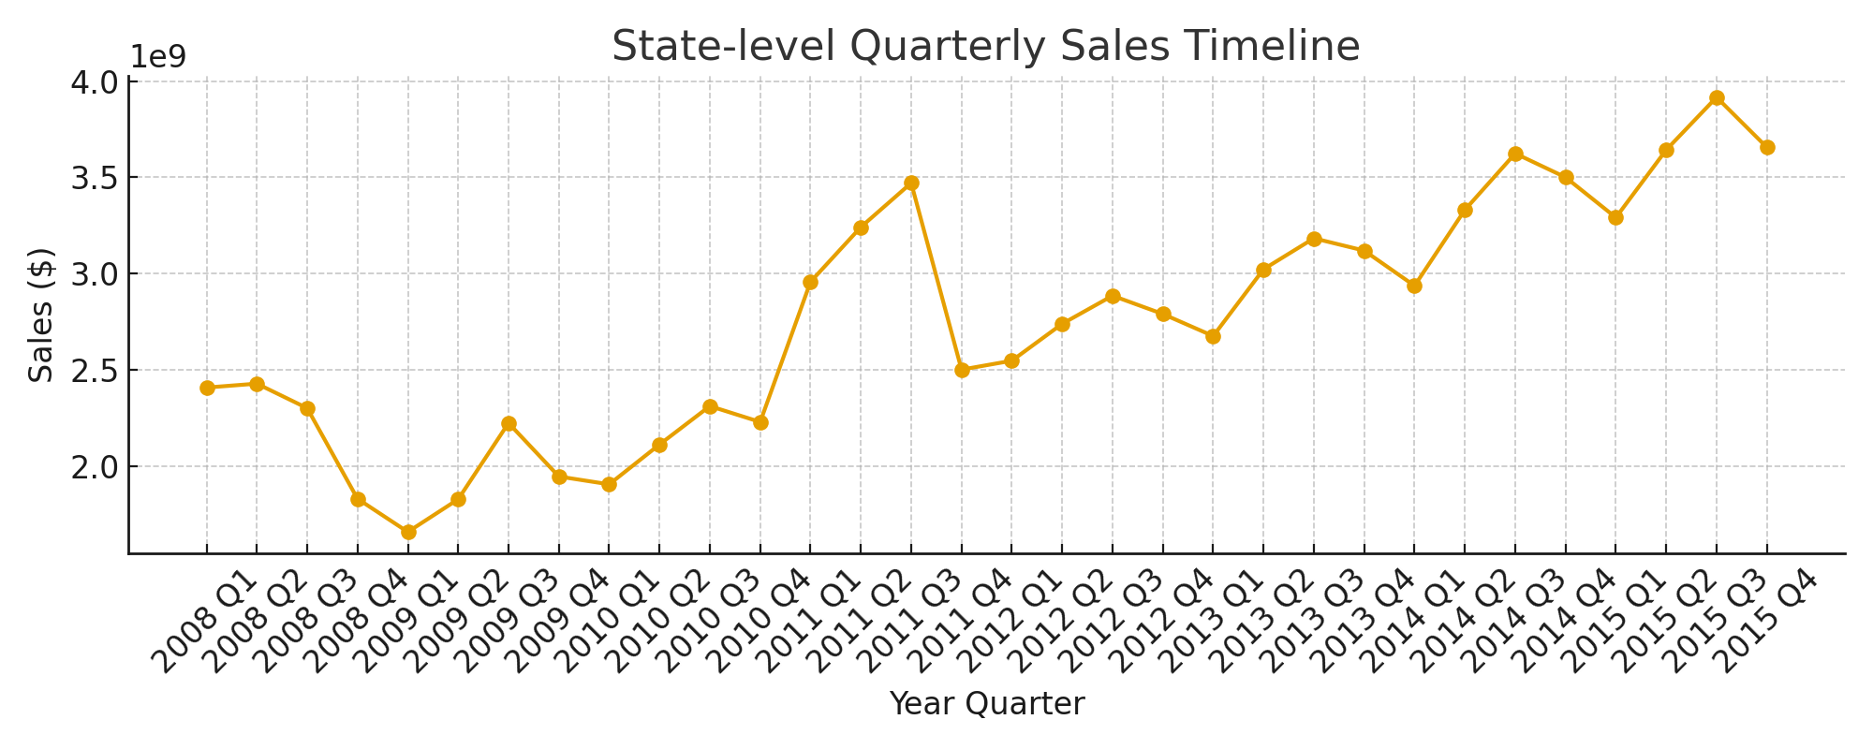

Key Insights & Findings
- Total dataset rows: 501.
- The dataset covers years 2008 - 2015 across 17 counties.
- The highest total sales counties are shown in the Top 10 table; these counties represent the majority share of statewide vehicle sales.
- Seasonal patterns are visible in the quarterly breakdown; certain quarters consistently show higher sales.
- Year-over-year changes indicate which years had growth or declines; see the Yearly table for specifics.

Recommendations
- For market research: focus promotional efforts and dealership expansion in top-performing counties.
- For policy makers: investigate infrastructure needs in high-sales counties and consider targeted economic programs for low-sales counties.
- For forecasting: build time-series models (ARIMA/SARIMA) at the state and county level to produce short-term forecasts and scenario analysis.

Appendix: Data Snapshot
Below is a snapshot of the first 10 rows from the cleaned dataset.
year | quarter | county | sales
2008 | 1 | Adams | 231609000
2008 | 1 | Arapahoe | 550378000
2008 | 1 | Boulder & Broomfield | 176771000
2008 | 1 | Denver | 200103000
2008 | 1 | Douglas | 93259000
2008 | 1 | El Paso | 325737000
2008 | 1 | Fremont | 9911000
2008 | 1 | Garfield | 55701000
2008 | 1 | Jefferson | 277611000
2008 | 1 | La Plata | 19558000

