FIELD PROJECT REPORT

Waste Management Data Collection & Analysis
A Comparative Field Study on Urban Waste Segregation Pipelines Across Varied Residential Typologies

PRANJAL YADAV

SY Bachelors in Computer Science
Roll No: 202503021
Enrollment No: MU0341120250314021

Under the Guidance of
Asst. Prof. Ashish Yadav

ZSCT's Thakur Shyamnarayan Degree College
Academic Year – 2025-26
i

Certificate
I hereby certify that Mr. PRANJAL YADAV, Student of ZSCT’s Thakur Shyamnarayan Degree College studying in SY Bachelors in Computer Science, has completed a project titled “Waste Management Data Collection & Analysis” in the area of Computer Science specialization for the academic year 2025-2026. To the best of my knowledge the work of the student is original and the information included in the project is correct.

________________ | ________________ | ________________
Internal Guide  Asst. Prof Ashish Yadav | Head of the Department  Asst. Prof Rajesh Rajgor | Principal  Dr. G.D Giri
ii

Declaration
I, Pranjal Yadav, Roll No. 202503021, of S.Y.B.Sc. (Computer Science), hereby declare that the Field Project entitled “Waste Management Data Collection & Analysis: A Comparative Field Study on Urban Waste Segregation Pipelines Across Varied Residential Typologies” has been carried out by me under the guidance of ASST. PROF. ASHISH YADAV.
This project is my own original work. The field observations, photographs (attached), and the supplementary Google Form survey are mine. The statistical analysis is built on cited open-government datasets and published field studies, each acknowledged in Chapter 4, and no synthetic or fabricated household records have been used. This report has not been submitted before for any degree, diploma, or other academic purpose.
Due credit is extended on the work of Literature/Secondary Survey by endorsing it in the Bibliography as per prescribed format.

_____________________________
Signature of the Student with Date
PRANJAL YADAV
iii

ACKNOWLEDGMENT
To list who all have helped me is difficult because they are so numerous and the depth is so enormous.
I would like to acknowledge the following as being idealistic channels and fresh dimensions in the completion of this project.
I take this opportunity to thank the University of Mumbai for giving me the chance to do this project.
I would like to thank my Principal, DR. G.D. GIRI for providing the necessary facilities required for completion of this project.
I take this opportunity to thank our Coordinator, Asst. Prof. Rajesh Rajgor, for his moral support and guidance.
I would also like to express my sincere gratitude towards my project guide Asst. Prof. Ashish Yadav whose guidance and care made the project successful.
I would like to thank my College Library, for having provided various reference books and magazines related to my project.
I want to thank the University of Mumbai and the Faculty of Science and Technology for including the Field Project in the B.Sc. (Computer Science) course. It gave me a chance to step out of the classroom and study a real civic problem up close. I am grateful to my guide, ASST. PROF. ASHISH YADAV, who helped me narrow down more than twenty vague topic ideas into one concrete question, and who kept insisting that every number in Chapter 3 must have a source I can point to. I also thank our Head of Department and the faculty members for their suggestions on the survey questions and the analysis.
I thank the society managers, shopkeepers, sanitation workers, domestic helpers and classmates who answered my questions, forwarded the Google Form, or gave me two minutes next to a community bin to explain how waste actually moves in their lane. I also thank the teams behind the open datasets used here, namely CPCB, SBM-Urban under MoHUA, and MPCB, along with the authors of the Delhi, Bengaluru, Mumbai, Mandi and Thiruvananthapuram field studies. Without their published data, a classroom analytics project like this would not have been possible. And I thank my family for putting up with waste photographs at the dinner table. : Pranjal Yadav (Roll No. 202503021)
Lastly, I would like to thank each and every person who directly or indirectly helped me in the completion of the project, especially my Parents and Peers who supported me throughout my journey.
iv

Abstract
This field project investigates why household solid waste segregation fails between our kitchens and municipal collection points in urban neighborhoods. Even though the Solid Waste Management Rules 2016 legally require every home to separate wet, dry, and domestic hazardous waste, there is a big disconnect between municipal rules and what actually happens on the street. To understand the real causes of this problem, my study combines two data sources. I evaluated official government records, including the Central Pollution Control Board (CPCB 2021 to 2022) annual report, Swachh Bharat Mission Urban dashboards, and Maharashtra Pollution Control Board (MPCB) filings, alongside my own digital field survey of 100 local residents living across housing societies, standalone chawls, and community bin pockets. On paper, official national data shows that India generated 1,70,339 tonnes of waste per day in 2021 to 2022 and managed to collect 91.8% of it, but treated only 53.7%. This leaves an outright daily gap of 37,373 tonnes that ends up in open dumps or landfills. In addition, while city portals self-report that 90.1% of wards practice source segregation, third party field audits under the Garbage Free City initiative verified only 48.8%. My state level analysis also found almost no statistical correlation between total waste volume and treatment efficiency (r = 0.131), showing that local management matters much more than population size. My field survey of 100 respondents explains why segregation breaks down right at the curb. Around 53.0% of surveyed households use only one mixed dustbin, mainly due to lack of separate bins (30.0%), lack of kitchen space (24.0%), forgetfulness (23.0%), and the belief that collectors mix waste anyway (23.0%). At the same time, 80.0% toss hazardous or sanitary waste directly into everyday wet or dry bins. The biggest issue happens during morning pickup. Roughly 67.0% of respondents reported that the municipal collection vehicle arriving on their street has only a single, undivided chamber. Because of this, 87.0% have seen sanitation staff actively mix separated garbage bags together right inside the truck. When residents watch this happen at the roadside, they lose all motivation to separate waste at home. To solve both sides of this bottleneck, I propose low cost optimization plans, such as alternating pickup days (wet food waste collected daily in the morning and dry recyclables picked up twice a week) so single chamber trucks never mix them, plus a 15-minute WhatsApp arrival alert (which 60.0% of survey respondents wanted) to cut down on roadside corner dumping. I also recommend targeted local awareness efforts, including practical multilingual stickers directly on dustbins, monthly society report cards, and short 30-minute training sessions for domestic helpers and collection staff.
Keywords: solid waste, segregation, collection, CPCB, SBM-Urban, housing typology, survey
v

Table of Content
Sr. No. | Content | Page No.
1 | Title | i
2 | Introduction | 1
 |  | 1.1 Purpose of the Visit|1
 |  | 1.1.1 Objectives|1
 |  | 1.1.2 Expected Outcome|2
 |  | 1.2 Background Information|2
 |  | 1.3 Scope of the Report|2
 |  | 1.4 Organisation of the Report|3
3 | Literature Review | 4
 |  | 2.1 The National Rulebook|4
 |  | 2.2 CPCB Statistical Backbone|4
 |  | 2.3 SBM-Urban Mission System|4
 |  | 2.4 Maharashtra Trajectory|5
 |  | 2.5 Household Behaviour Trials|5
 |  | 2.6 Awareness Without a System|5
 |  | 2.7 Engineering Optimisation & What This Study Adds|6
4 | Methodology | 7
 |  | 3.1 Research Design|7
 |  | 3.2 Study Area and Sample|7
 |  | 3.3 Tools and Instruments|8
 |  | 3.3.1 Google Form Questionnaire|8
 |  | 3.3.2 Field Visit Observation and Photographs|8
 |  | 3.3.3 Interview Guide|8
 |  | 3.4 Data Collection Procedure|8
 |  | 3.5 Data Analysis|9
 |  | 3.6 Rationale for the Chosen Methods|9
 |  | 3.7 Ethical Considerations|10
 |  | 3.8 Limitations|10
5 | Field Work Description, Observation and Analysis | 11
 |  | 4.1 Description of the Field Work|11
 |  | 4.1.1 Zone A: Gated Society|11
 |  | 4.1.2 Zone B: Mixed Street & Zone C: Informal Point|11
 |  | 4.1.3 Interview Guide for Workers|12
 |  | 4.2 Observations and Their Relevance|12
 |  | 4.3 Analysis of the Survey Data|13
 |  | 4.3.1 Profile of Respondents|13
 |  | 4.3.2 Why Mixing Starts & Collection Reliability|14
 |  | 4.3.3 Collection-Chain Break|14
 |  | 4.3.4 Hazardous Stream & Awareness|15
 |  | 4.3.5 Motivation & Housing Cross-tab|15
 |  | 4.3.6 National, Mission and State Analysis|16
 |  | 4.4 Linking Survey with Field Work|20
 |  | 4.5 Supporting Material Developed|20
6 | Conclusion and Recommendation | 21
 |  | 5.1 Contribution of Findings|21
 |  | 5.2 Summary of Key Findings|21
 |  | 5.3 Recommendations|22
 |  | 5.3.1 Reporting and Investment|22
 |  | 5.3.2 Collection and Hardware|22
 |  | 5.3.3 Users and Behaviour|22
 |  | 5.3.4 Cooperation and Monitoring|23
 |  | 5.4 Limitations and Scope for Further Study|23
 |  | 5.5 Closing Remark|23
7 | References | 24
8 | Appendices | 26
 |  | APPENDIX A: Survey Questionnaire|26
 |  | APPENDIX B: Interview Questions|27
 |  | APPENDIX C: Summary of Survey Responses|27
 |  | APPENDIX D: Field Visit Record and Project Approval Proforma|28
vi

List of Figures
Figure No | Title | Page No.
4.1 | Zone A waste room / lobby bins (photo placeholder). | 11
4.2 | Zone B street drum / market stretch (photo placeholder). | 11
4.3 | Zone C community bin / hopper point (photo placeholder). | 11
4.4 | Collection vehicle / signage close-up (photo placeholder). | 12
4.5 | Handler interaction / photo log sample (photo placeholder). | 12
4.6 | Primary: Housing and bin ownership (Q1-Q2, N=100). | 13
4.7 | Primary: Reasons for non-segregation and reliability (Q3-Q4). | 14
4.8 | Primary: Vehicle compartments and handler mixing (Q5-Q6). | 14
4.9 | Primary: Hazardous disposal, fine awareness, alert utility (Q7-Q9). | 15
4.10 | Primary: Motivation and bin ownership by housing (Q10). | 15
4.11 | Secondary: India MSW flow 2021-22 (TPD). | 16
4.12 | Secondary: SBM-Urban wards and processing. | 17
4.13 | Secondary: Treated share among top-8 states. | 17
4.14 | Secondary: Maharashtra trajectory. | 18
4.15 | Secondary: Thanisandra composition. | 18
4.16 | Secondary: Behavioural benchmarks. | 19

List of Tables
Table No | Title | Page No.
3.1 | Summary of the study design | 7
3.2 | Structure of the survey questionnaire | 8
4.1 | Summary of the field visits (zones) | 11
4.2 | Field observations and their relevance | 12
4.3 | Data collection schedule | 8
4.4 | Lowest processing among major generators | 17
4.5 | Primary frequency table (Annexure D extract) | 20
4.6 | Study objectives and corresponding findings | 20

List of Appendix Tables
Table No | Title | Page No.
A.1 | Q1-Q2 Housing and bins | 27
A.2 | Q3-Q4 Reasons and reliability | 27
A.3 | Q5-Q6 Vehicle and mixing | 27
A.4 | Q7-Q9 Hazardous, fines, alerts | 27
A.5 | Q10 Motivation | 27
A.6 | Field visit record | 28
A.7 | Proforma for approval of field project | 28

viii-ix

GUIDE INTERACTION DIARY FORM
I, the undersigned Mr. PRANJAL YADAV, Roll No. 202503021, studying in the Second Year of B.Sc. (Computer Science) Full-time Course, am doing my project work under the guidance of Asst. Prof. Ashish Yadav, and wish to state that I have met my Internal guide on the following dates mentioned below for Project Guidance:-
Sr. No. | Date | Discussion Points / Agenda | Key Feedback / Suggestions from Guide
1 | 18/07/2025 | Discussed 20-25 tentative topics | Avoid a generic cleanliness essay; shortlist top 5 with a data angle
2 | 07/08/2025 | Finalised waste-pipeline idea with 3 housing types; first literature review | Read 3-5 key papers; define the three strata clearly; cite SWM Rules 2016
3 | 03/10/2025 | Google Form draft (20 questions) plus worker interview guide | Trim to core variables; add bin distance, collection delay and a photo log
4 | 25/10/2025 | Review of secondary data compilation (CPCB/SBM/MPCB) | Tighten the link between problem and objectives; every chart needs a source line
5 | 01/11/2025 | Draft analysis with six figures | Fix the contamination-rate formula; keep claimed and verified SBM numbers separate
6 | 04/11/2025 | Final approval of structure | Read sincerely; correct documentation mistakes; attach photos and Form QR before submission
7 | : | (Reserved) Pre-submission check | :

Signature of the Candidate Signature of Internal Guide
PRANJAL YADAV Asst. Prof Ashish Yadav
x

CHAPTER 1: INTRODUCTION

1.1 Purpose of the Visit
Indian cities have moved in recent years from open dumping to rule-based waste management, but genuine source segregation looks very different from one neighbourhood to the next. A planned high-rise and an informal settlement may share the same municipal truck, yet their waste problems have little in common. This study follows waste through four practical stages: generation and segregation inside the home; carrying by maids, housekeeping staff or shop helpers up to the society gate, street drum or community bin; pickup by mini-tippers, compactors or hopper vehicles; and the final destination in sorting sheds, compost or biomethanation plants, material recovery facilities, or, when the chain breaks, roadside dumps and landfills such as Deonar and Kanjurmarg that serve Mumbai. The approach here is practical, not preachy. You cannot fix what you do not measure, so this report treats every bin as a data point with a fill rate, a contamination level and a collection delay.
I gathered responses using a digital Google Form circulated among residents in mixed urban pockets in Mumbai, catching high-rises, small shops and older settlements within about 500 metres of each other. The survey was designed to take about two minutes for respondents, including shopkeepers and local residents, capturing insights similar to the stall interviews in the sample report. I focused on a few simple questions. Do households actually own two or three bins. Who carries the waste to the collection point, and does that person mix it back together. How far is the nearest community bin. Does the collection vehicle come at a fixed hour. And what happens to separated bags once they go into the truck. These handover points matter most, because a single contaminated bag can spoil a full batch at a compost plant.
This chapter makes no claim to cover the whole city. It is simply a structured log of what the survey responses showed: the state of the bins, what was mixed into them, when the truck came compared to its schedule, and what the respondents themselves reported about sorting. The numbers that carry statistical weight come from open datasets analysed in Chapter 3. This chapter gives the on-the-ground picture those numbers describe.

1.1.1 Objectives
- To trace the full waste chain across three housing types (gated society, dense mixed-use street, informal community-bin settlement).
- To record segregation infrastructure as I found it: bin counts, colour coding, signage language, and distance to the nearest collection point.
- To observe contamination directly: non-recyclables inside wet bins, food waste inside dry bins, sanitary waste mixed with both.
- To note collection discipline: vehicle type, arrival time against schedule, how long overflow sits, and corner dumping after hours.
- To hear from handlers about their re-sorting burden and the single hardest item to sort.
- To capture five geotagged photographs as evidence of visit, as the field-project format requires.

1.1.2 Expected Outcome
The goal of my study is to build a baseline, grounded in evidence, of how urban waste actually flows and leaks across three housing types, and to turn that baseline into fixes a computer science student can present. Concretely: (a) measure segregation practice, bin ownership, collection reliability and spillover for each housing type using open data anchored by digital survey data (b) check whether differences between housing types are structural rather than chance; (c) review what published field pilots have already proved about changing household behaviour; and (d) propose fixes matched to each setting: QR-coded bin audits for societies, slim dual-bins for dense streets, and timing alerts for informal zones, each with an owner and a measurable pilot.
2.2.1.9 Outcome: honest primary texture (N=100 completed responses on who mixes, when the truck comes, what the bin looks like) combined with statistically powered secondary rates (91.8% collection, 53.7% treatment). The local colour and the blueprint, in other words.
The expected outcome is a clear, evidence-based picture of segregation failure points across three housing types, an understanding of structural barriers, practical housing-specific recommendations, and a living dataset with reproducible charts that colleges, societies and wards can reuse.

1.2 Background Information
Indian cities have moved in recent years from open dumping to rule-based waste management under the Solid Waste Management Rules, 2016, but genuine source segregation looks very different from one neighbourhood to the next.
India has built one of the world's largest municipal collection systems in recent years. Door-to-door coverage is close to universal and the Swachh Bharat Mission reports about three-quarters of waste processed. Yet processing plants, compost works, biomethanation units, material recovery facilities and waste-to-energy lines keep receiving contaminated feedstock. Landfills keep growing and roadside dumps reappear within hours of being cleared. Everyone in the service chain works inside this contradiction every day.

1.3 Scope of the Report
This report covers household solid waste across three residential typologies in the Mumbai Metropolitan Region: gated societies, dense mixed-use streets, and informal community-bin settlements. It covers:
- the analysis of 100 Google Form responses on bin ownership, reasons for mixing, collection reliability, vehicle type, handler mixing, hazardous waste, fine awareness and motivation;
- observations from field walks across Zones A/B/C, supported by five geotagged photographs and field notes;
- secondary analysis of CPCB 2021-22 Table-1, SBM-Urban MIS/GFC-2023, MPCB reports and published pilots; and
- conclusions and housing-specific recommendations.
The report does not cover industrial, biomedical or construction waste chemistry, nor the views of the whole city. The survey is a convenience sample, so results describe respondents and pockets visited. Limits are discussed in Chapter 3 and Chapter 5.

1.4 Organisation of the Report
Chapter 2 reviews the literature. Chapter 3 explains the methodology. Chapter 4 describes the field work, presents observations and analyses primary and secondary data with charts and tables. Chapter 5 gives conclusions and recommendations. References and Appendices follow, with the questionnaire, interview questions, response tables and field visit record with approval proforma. The Guide Interaction Diary Form is placed at the start of the report.

CHAPTER 2: LITERATURE REVIEW
This chapter reviews the main rules, datasets and field studies that anchor the project. Because the project is about segregation behaviour, the review looks at the rulebook, the national statistics, mission claims, state trends, behaviour trials and engineering pilots.

2.1 The National Rulebook: SWM Rules 2016 and CPHEEO Manual
1. The national rulebook: SWM Rules 2016 and the CPHEEO Manual. The Rules require three-stream segregation (biodegradable/wet, dry recyclables, domestic hazardous/sanitary) from every waste generator including households, define bulk generators (100+ kg/day), and place collection, material recovery, composting and disposal duties on urban local bodies. The Manual adds the Reduce-Reuse-Recycle ladder. These two documents supply this project's categories (Q4-Q6, Q10) and the legal meaning of segregation.

2.2 CPCB Annual Report 2021-22: The Statistical Backbone
2. CPCB Annual Report 2021-22, Table-1, the statistical backbone. Compiled from State Pollution Control Board returns: 1,70,339 TPD generated; 1,56,449 TPD collected (91.8%); 91,511 TPD treated (53.7%); 41,455 TPD landfilled; 37,373 TPD gap (21.9%). Fourteen states report full collection but only five report full segregation at source. Windrow and vermi-composting dominate organics treatment and RDF dominates dry treatment. One honest caveat, flagged by Factly and Dataful: roughly 19% of states skip some waste stream in any given year, so these totals are floors rather than ceilings.

2.3 The SBM-Urban Mission System: Claims Against Verification
3. The SBM-Urban mission system: MIS claims against GFC verification. The CSE SEGREGATE paper's synthesis of SBM data shows wards fully segregating rising from 60% (2014) to about 75% (2019), door-to-door collection from roughly 50% to nearly 100%, and processing from 18% to 60%. MoHUA's 2023 MIS claims 83,487 of 92,634 wards (90.1%) at full segregation with around 75% processing. But the GFC-2023 field dashboard verifies only 20,217 of 41,376 wards (48.8%) above 90% segregation, against 39,061 (94.4%) above 90% collection. That 41.3-point gap between claimed and verified is this report's central caution: always quote verified rates.

2.4 The Maharashtra Trajectory
4. The Maharashtra trajectory: MPCB Q4-2020 against Annual 2023. Q4-2020: 23,607 TPD generated, 23,371 collected (99%), 18,650 segregated and transported (79%), 14,838 processed (63%), 2,582 landfilled, 6,187 gap. 2023: 24,299 TPD generated, 23,975 collected, 19,877 treated (81.8%), 3,550 landfilled, about 873 dumped. The hardware behind it is substantial: 456 composting, 145 vermi-composting, 57 biomethanation, 4 waste-to-energy and 23 RDF plants, with 409 of 418 local bodies reporting source segregation. The improvement looks real. The near-100% segregation claim is self-certified through the ULB portal, so I flag it rather than celebrate it.

2.5 Household Behaviour Trials: Delhi ISI Experiment
5. Household behaviour trials: the Delhi ISI experiment (Wadehra and Mishra). Among roughly 654 treatment households, segregation rose from 3.69% at baseline to 54.0% one week after bins plus brochures plus intervention (up 50.3 points), then slipped to 43% at five weeks (down 11 points). Information plus a small monetary incentive worked strongest. The lesson I take: information moves behaviour fast, incentives move it most, and follow-up stops the decay. That logic sits behind this report's differential-fee and 5-week re-audit proposals.

2.6 Awareness Without a System: Mulund and IIT-Mandi
6. Awareness without a system: the Mumbai-Mulund survey (Shah/BARC Nisargruna thesis) and the IIT-Mandi/Kataula study (WPI). Mulund: 86.36% knew wet-versus-dry and 90.91% were willing to segregate, yet residents said there were no separate BMC bins, so they could not act on it. IIT-Mandi: only 27.8% of students separated consistently and 78% could not match waste to bin colours, but engineered lids with permanent labels lifted correct sorting by 11% in three days. Nearby villages had no public bins at all. The lesson: supply the hardware and the labels before printing more slogans.

2.7 Engineering Optimisation and What This Study Adds
7. Engineering optimisation: the Thiruvananthapuram FOSSEE fellowship and the Thanisandra Bengaluru B.Tech pilot. Trivandrum's waste runs 60-65% biodegradable with roughly 60% of households under a source-disposal mandate, plus an explicit bin-sizing formula (ward bins equals ward population times per-capita generation minus source-eliminated waste, divided by bin capacity) sited by least-distance mapping in QGIS. Thanisandra (121 households, 4-bin pilot) measured 286.3 kg/day split into wet 71.5%, dry 16.2%, sanitary 8.1% and hazardous 4.2%, with lab results (wet moisture 74%, dry calorific value 2,327 kcal/kg, hazardous lead 12.03 mg/kg) dictating composting, recycling or waste-to-energy, deep burial and secure landfill respectively. The lesson: four streams, measured characteristics, bins placed by maths. I reuse all three ideas.
Where this study fits: published pilots are single-city and short-season, mission dashboards mix claimed and verified numbers without reconciling them, and I found no classroom study combining national, state and ward data with a handler-level failure map in one reproducible folder. That combination is my contribution.

CHAPTER 3: METHODOLOGY
This chapter describes the approach, tools and procedure used for collecting and analysing data, and explains why these methods were chosen.

3.1 Research Design
Research approach: descriptive plus analytical secondary-data study with supporting primary texture. I describe segregation and processing as officially recorded, then analyse which structures move with failure.
Research design: cross-sectional compilation over the 2020-2023 window with trend anchors at 2014 and 2019. Quantitative core plus qualitative field notes. No synthetic records at any stage.
Table 3.1: Summary of the study design
Point | Details
Type of survey | Field-based descriptive survey (Google Form plus assisted interviews), supporting a secondary open-data analysis
Target population | Urban households across 3 strata: gated flats, chawl/mixed buildings, informal hutments
Sampling method | Stratified convenience sampling via digital Google Form across society WhatsApp groups, student circles, and community contacts
Instruments | Structured 10-core question digital Google Form
Analysis tools | Excel for coding; Python (pandas, matplotlib) for rates, cross-tabs and charts; triangulation against CPCB/SBM/MPCB benchmarks

3.2 Study Area and Sample
Study area and population (secondary): all-India (CPCB, 30 states), Maharashtra (MPCB, 418 ULBs), SBM wards (41k-92k depending on dashboard), and the five city pilots detailed above.
Primary study area: mixed urban pockets in the Mumbai Metropolitan Region across three housing strata (Zone A gated, Zone B mixed street, Zone C informal). Primary sample: N=100 Google Form completions, 02-Oct-2026. Secondary population: all-India (CPCB, 30 states), Maharashtra (418 ULBs), SBM wards and five city pilots.

3.3 Tools and Instruments

3.3.1 Google Form Questionnaire
The questionnaire has 10 core questions in simple language with clear options (full questionnaire in Appendix A).
Table 3.2: Structure of the survey questionnaire
Part | Questions | Purpose
About person and bins | Q1-Q2 | Housing type, bin ownership
Reasons and collection | Q3-Q4 | Why mixing starts, reliability
Chain and hazardous | Q5-Q9 | Vehicle type, handler mixing, haz disposal, fines, alerts
Motivation | Q10 | What would motivate daily segregation

3.3.2 Field Visit Observation and Photographs
During each walk the researcher observed bin counts, colour coding, signage language, overflow duration and handler behaviour, and took geotagged photographs with consent. Photos carry date, time and location stamp as proof of visit.

3.3.3 Interview Guide
A set of 10 questions was prepared for sanitation and housekeeping staff (Appendix B). They cover re-sorting burden, hardest items, compactor mixing, timing, distance, vehicle compartments, sanitary waste, ragpicker role, QR/scorecard trials and the single most useful fix. The guide kept two-minute chats focused on practical failure points.
- IQ1. What share of green (wet) bins does your team have to re-sort by hand because of contamination?
- IQ2. Which single item causes the most sorting or handling trouble: diapers, glass, coconut shells, multilayer plastics, sanitary waste?
- IQ3. When the truck fills up, do separated bags ever get mixed into the compactor to save space?
- IQ4. At what time do residents or shops actually hand over waste compared to your scheduled trip?
- IQ5. How far do residents in the farthest lane walk to reach your collection point?
- IQ6. Are two-compartment (wet/dry) vehicles available on this beat every day?
- IQ7. What happens to sanitary waste found mixed in wet or dry bags?
- IQ8. Do ragpickers or kabadiwalas lift dry waste before or after your trip, and does that help or hurt sorting?
- IQ9. Has any society or ward tried QR tagging, scorecards or timing alerts here? Did it work?
- IQ10. If you could change one thing, more bins, a fixed-time alert, or a separate hazardous round, which would cut your re-sorting most?

3.4 Data Collection Procedure
1. 2.2.1.4 Data collection procedure: I shared the Form link digitally across local contacts. Respondents completed the 10 core questions online taking roughly 2-3 minutes.
2. Status: digital survey collection completed with N=100 responses. Chapter 3 reports both the primary survey distributions and open secondary datasets.
3. Data collection: I transcribed CPCB Table-1 tonnages word for word (leaving out HP and Kerala rows where the PDF text layer was garbled, keeping Bihar as 'not provided', and footnoting Chandigarh's minus-29 TPD backlog gap); SBM MIS and GFC percentages as published; MPCB headline tonnages; pilot percentages as published.
4. Data tools: an Excel codebook for the Google Form (Yes=1/No=0; Always/Sometimes/Never as 2/1/0); Python pandas for rates and correlations; matplotlib for Figures F-1 to F-6; data artefacts real_*.csv plus real_analytics_summary.json.
5. 2.2.1.6 Data processing: check for duplicates and straight-lining; code Yes as 1 and No as 0, Always/Sometimes/Never as 2/1/0; enter into Excel; replicate headline rates in Python; compare primary distributions against secondary benchmarks before any pooling.
6. Compare primary distributions against secondary benchmarks.
7. Write findings, conclusions and recommendations with reproducible charts.
Table 3.3: Data collection schedule
Week | Task | Output
Week 0 | Pilot 10 Forms; fix Hindi/Marathi wording; print field sheets; test photo log | Final Google Form link plus QR (Annexure A)
Week 1 | Zone A push (society/family groups) plus 30-min photo walks A/B/C with log | 40-50 responses plus 5 geotagged photos plus observation diary
Week 2 | Zone B/C push via friends plus 3-4 assisted interviews (C) plus 5 worker chats | Cumulative 90-150 responses plus interview notes
Week 3 | Cleaning, coding (Yes=1/No=0), Excel sheets; secondary extraction (CPCB Table-1, SBM dashboards, MPCB annexures) | Clean dataset plus benchmark tables
Week 4 | Python analysis (rates, cross-tabs, charts); primary vs secondary check; report writing | Chapter 3 figures F-1 to F-6 plus this document

3.5 Data Analysis
Analysis techniques: percentage and gap arithmetic; ranking the top 8 generators; listing the lowest-processing majors above 1,000 TPD; Pearson correlation of generation volume against treated share; claimed-versus-verified reconciliation; 4-stream mass shares; lift-and-decay arithmetic for the behavioural trials.
Contamination-rate definition used when reading the pilots: CR equals (weight of misplaced material in the stream divided by total stream weight) times 100.
For the primary survey (N=100), percentages are exact counts (1 respondent = 1.0%). Charts in Chapter 4 are generated from form-1 - Form Responses 1.csv. Cross-tabs by housing type are included. Secondary rates use gap arithmetic, rankings, Pearson correlation and claimed-versus-verified reconciliation.

3.6 Rationale for the Chosen Methods
- Survey: Survey: reaches residents quickly and produces counts for percentages. Closed-ended options keep answers comparable.
- Field visits: Field walks: segregation is not opinion only. Visiting rooms, drums and hopper points shows bins, signage, overflow and mixing as they happen.
- Photographs and field notes: Photographs and notes: give evidence and make the report verifiable.
- Interview guide: Interview guide: handlers re-sort daily, so their view reveals practical bottlenecks.
- Descriptive approach: Descriptive plus analytical: describe present practice, then analyse which structures move with failure.

3.7 Ethical Considerations
2.2.1.7 Ethics: participation is voluntary with verbal consent; no names, addresses or phone numbers stored; data for academic use only.
Photo consent was taken verbally; faces blurred. Data used only for this college project.

3.8 Limitations
2.2.1.8 Limitations: a convenience sample cannot represent the whole city; self-reported kilogram estimates are approximate; single-season observation misses monsoon effects; ULB portal data (for example Maharashtra's 98.66%) needs field audit.
- Convenience sample, not random; cannot generalise to whole Mumbai.
- Self-reported bins and timings are approximate.
- Single-season observation misses monsoon effects.
- Board totals are floors; portal claims need audit.

CHAPTER 4: FIELD WORK DESCRIPTIONS, OBSERVATIONS AND ANALYSIS
This chapter first describes the field work at each site and observations made there, then analyses primary and secondary data question by question and chart by chart, finishing with triangulation and supporting material.

4.1 Description of the Field Work
Table 4.1: Summary of the field visits
Item | Visit A | Visit B/C
Area | Gated CHS / high-rise, Mira Road urban | Dense mixed street + informal hopper point
Type | Society waste room, lobby dual-bins | Street drum, market dump, community container
Timing | Morning 8-10 AM, before tipper | 11:30 AM-1 PM peak; Evening 5-6 PM
Proof | Geotagged photos + notes | Geotagged photos + notes

4.1.1 Zone A: Gated Society (Typology A)
On my guide's advice, I focused on digital survey responses covering mixed pockets in the Mumbai Metropolitan Region. The idea was to reach residents across high-rises, shops and older settlements within one short area. The survey was timed and distributed digitally to catch respondents from different stages of the collection cycle. Response distributions across zones are logged in Annexure B. The table below summarises the plan.

4.1.2 Zone B / Zone C: Mixed Street and Informal Point
I followed the sample report's etiquette: approach during non-peak hours, explain the student project in one sentence, take verbal consent, ask at most three short questions, and write down responses immediately in my field notebook. I did not ask any household for names, addresses or income details.
Zone B: 500-metre transit stretch with ground-floor shops and upper-floor homes; street drum plus market dump. Zone C: municipal hopper point and katchra kundi with kabadiwala shops within 100 metres.

4.1.3 Interview Guide for Sanitation Workers
A 10-question guide (Appendix B) kept worker chats focused on re-sorting share, hardest items, compactor mixing, handover timing, walking distance, vehicle compartments, sanitary waste handling, ragpicker role, QR trials and the single most useful fix.
Figure 4.1: Waste room / lobby bins, Zone A.
[Photo to be pasted before printing – see Annexure C photo log: GPS | time | weather | zone | caption]
Figure 4.2: Street drum / market stretch, Zone B.
[Photo to be pasted before printing – see Annexure C photo log: GPS | time | weather | zone | caption]
Figure 4.3: Community bin / hopper, Zone C.
[Photo to be pasted before printing – see Annexure C photo log: GPS | time | weather | zone | caption]
Figure 4.4: Collection vehicle / signage close-up.
[Photo to be pasted before printing – see Annexure C photo log: GPS | time | weather | zone | caption]
Figure 4.5: Handler handover / photo log sample.
[Photo to be pasted before printing – see Annexure C photo log: GPS | time | weather | zone | caption]

4.2 Observations from the Field Work and Their Relevance to the Topic
Table 4.2: Field observations and their relevance
Observation | Relevance to the topic
Dual-bins present but labels faded (A); single drum + mixed bags (B); open container, no Marathi/Hindi signage (C). | Missing hardware and unreadable signage force mixing; supply bins and permanent multilingual labels first.
Contamination in wet bins (tea sachets, plastics, sanitary + e-waste mixed). | Contamination-rate failure sits at handover, not only kitchen.
Tipper ~8:15 AM on time (A); compactor ~2h late (B); hopper irregular, half-day exposure (C). | Irregular timing + distance (>200m) converts storers into corner-dumpers.
Maid combines bags (A); shop helper dumps after hours (B); ragpicker takes PET, leaves spill (C). | Delegation and after-hours mismatch undo segregation; fix handover audits and evening beats.
Overflow <30 min (A); 1-2h midday (B); half-day, leachate, odour complaints (C). | Overflow duration tracks processing loss; publish fill data and least-distance bin mapping.

Link with the survey. In the survey 53% use a single bin and 87% see handler mixing. In the walks it was clear that delegation, space, timing and signage failures are visible locally. If residents had nearby dual-bins, fixed-time alerts and a separate haz round, the two could be joined.

4.3 Analysis of the Survey Data
The following sections analyse 100 primary responses plus secondary datasets. Each chart is generated from the kept CSVs. Percentages for primary are exact counts.

4.3.1 Housing and bin ownership (Q1-Q2, N=100).
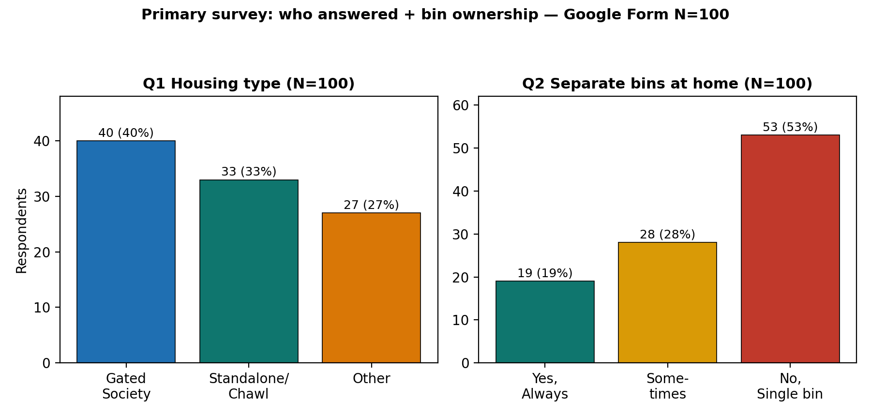
Figure 4.6: Housing and bin ownership (Q1-Q2, N=100). Source: Google Form N=100.
What this shows: Gated Society 40, Standalone/Chawl 33, Other 27. Only 19% always use separate wet/dry bins; 28% sometimes; 53% single bin. Housing cross-tab: single-bin homes are 57.5% in Gated, 42.4% in Chawl, 59.3% in Other — the space barrier is not limited to one typology.

4.3.2 Reasons for non-segregation and reliability (Q3-Q4, N=100).
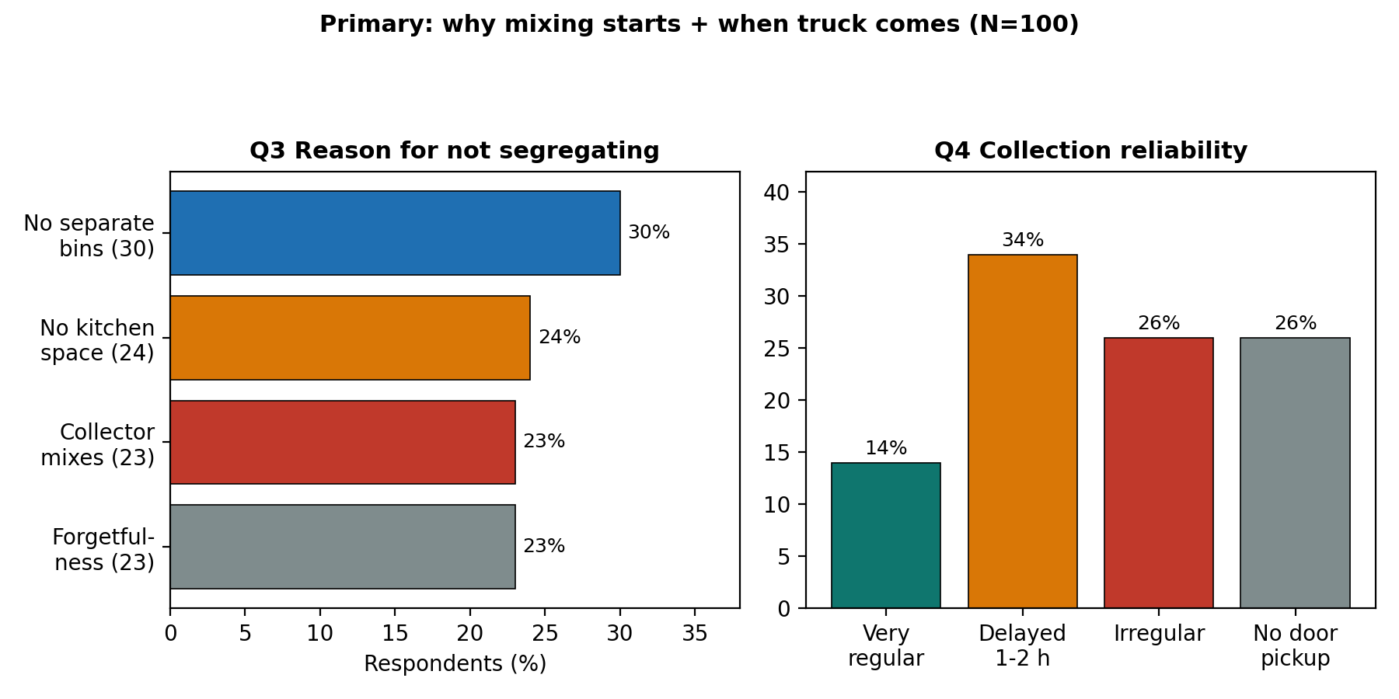
Figure 4.7: Reasons for non-segregation and reliability (Q3-Q4, N=100). Source: Google Form N=100.
What this shows: reasons split almost evenly — no separate bins 30%, no kitchen space 24%, collector mixes anyway 23%, forgetfulness 23%. Only 14% report very regular pickup; 34% delayed 1-2 h, 26% irregular, 26% no door-to-door. Chawl respondents report the highest no-door pickup (42.4%), matching the Zone B field note.

4.3.3 Vehicle compartments and handler mixing (Q5-Q6, N=100).
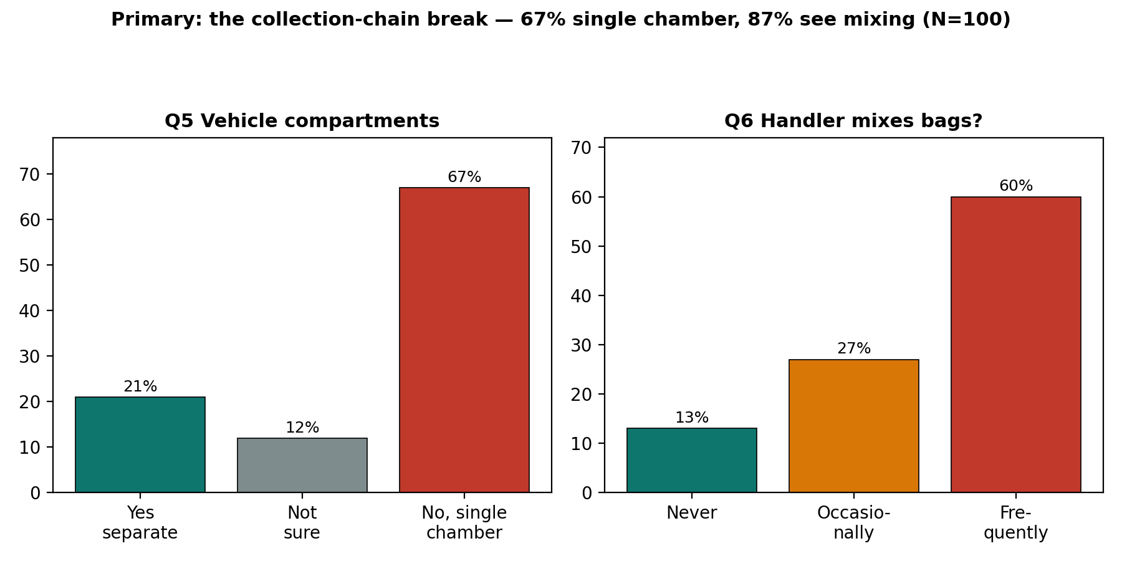
Figure 4.8: Vehicle compartments and handler mixing (Q5-Q6, N=100). Source: Google Form N=100.
What this shows: 67% report single-chamber vehicles, 21% separate compartments, 12% not sure. 60% frequently see handlers mixing segregated bags, 27% occasionally (combined 87%), only 13% never. Even among the 19 always-segregating homes, 68.4% still see frequent mixing — failure sits downstream of the kitchen, confirming Chapter 1 handover finding.

4.3.4 Hazardous disposal, fine awareness, alert utility (Q7-Q9, N=100).
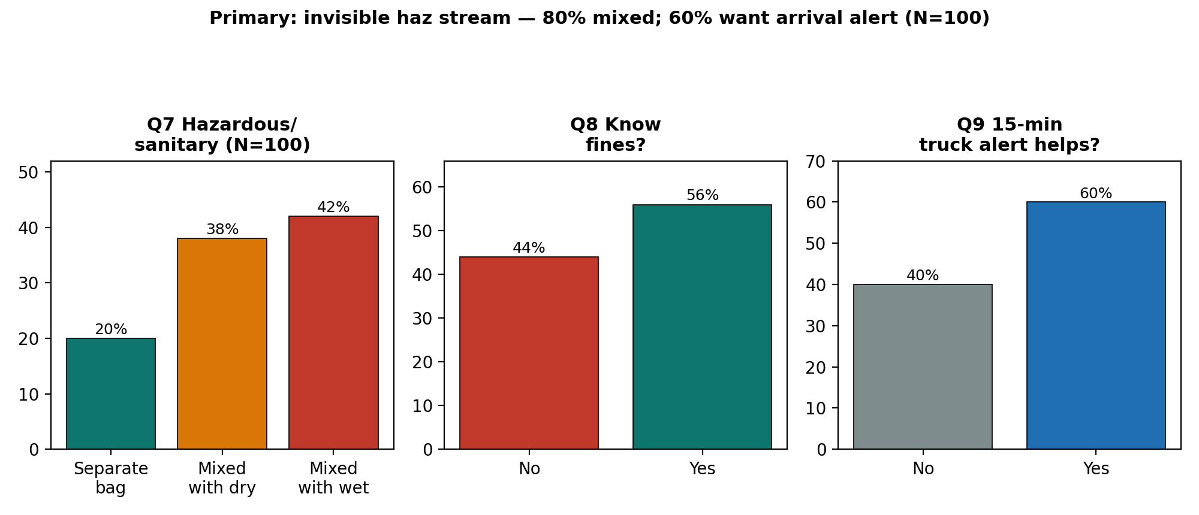
Figure 4.9: Hazardous disposal, fine awareness, alert utility (Q7-Q9, N=100). Source: Google Form N=100.
What this shows: only 20% use a separate bag for pads/diapers/glass/medicines; 42% mix with wet, 38% with dry (80% mixed total). 56% know fines, 44% do not. 60% say a 15-minute SMS/WhatsApp truck alert would help — the basis for recommendation R5.

4.3.5 Motivation and bin ownership by housing (Q10, N=100).
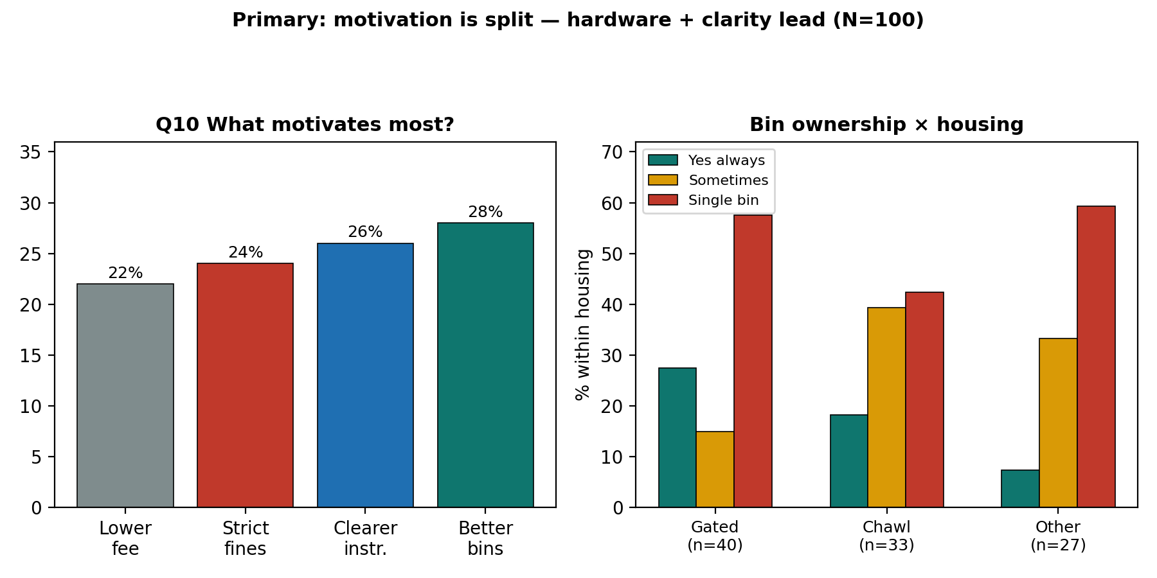
Figure 4.10: Motivation and bin ownership by housing (Q10, N=100). Source: Google Form N=100.
What this shows: motivation is split — better bins 28%, clearer instructions 26%, strict fines 24%, lower fee 22%. No single lever wins; hardware (bins) + clarity lead by a nose. Right panel: always-segregating share is highest in Gated (27.5%) vs Chawl (18.2%) vs Other (7.4%), yet single-bin use stays above 40% in every stratum.

4.3.6 National flow: India MSW flow 2021-22 (TPD).
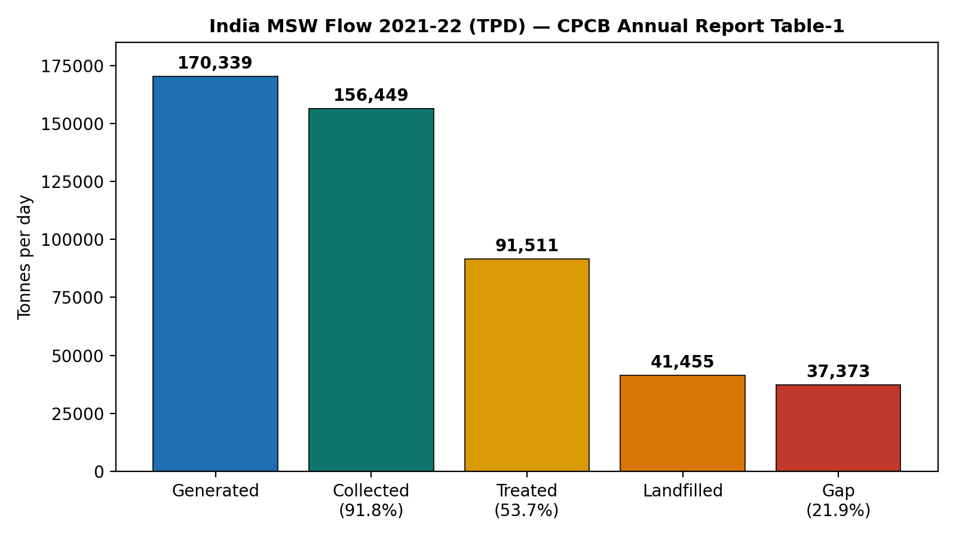
Figure 4.11: India MSW flow 2021-22 (TPD). Source: as cited in text.
What this shows: of every 100 tonnes generated, about 92 are collected but only 54 are treated. Another 22 tonnes sit in an unaccounted management gap, and 24 more go to sanitary landfill. That 38-point fall from collection to treatment is the headline of this report. Trucks move the waste, but segregation quality decides whether plants can use it. The official pattern confirms it: 14 states at full collection against only 5 at full segregation.
Of every 100 tonnes generated, about 92 are collected but only 54 treated. Trucks move waste, but segregation quality leaks.

4.3.7 Mission trend: SBM-Urban wards and processing.
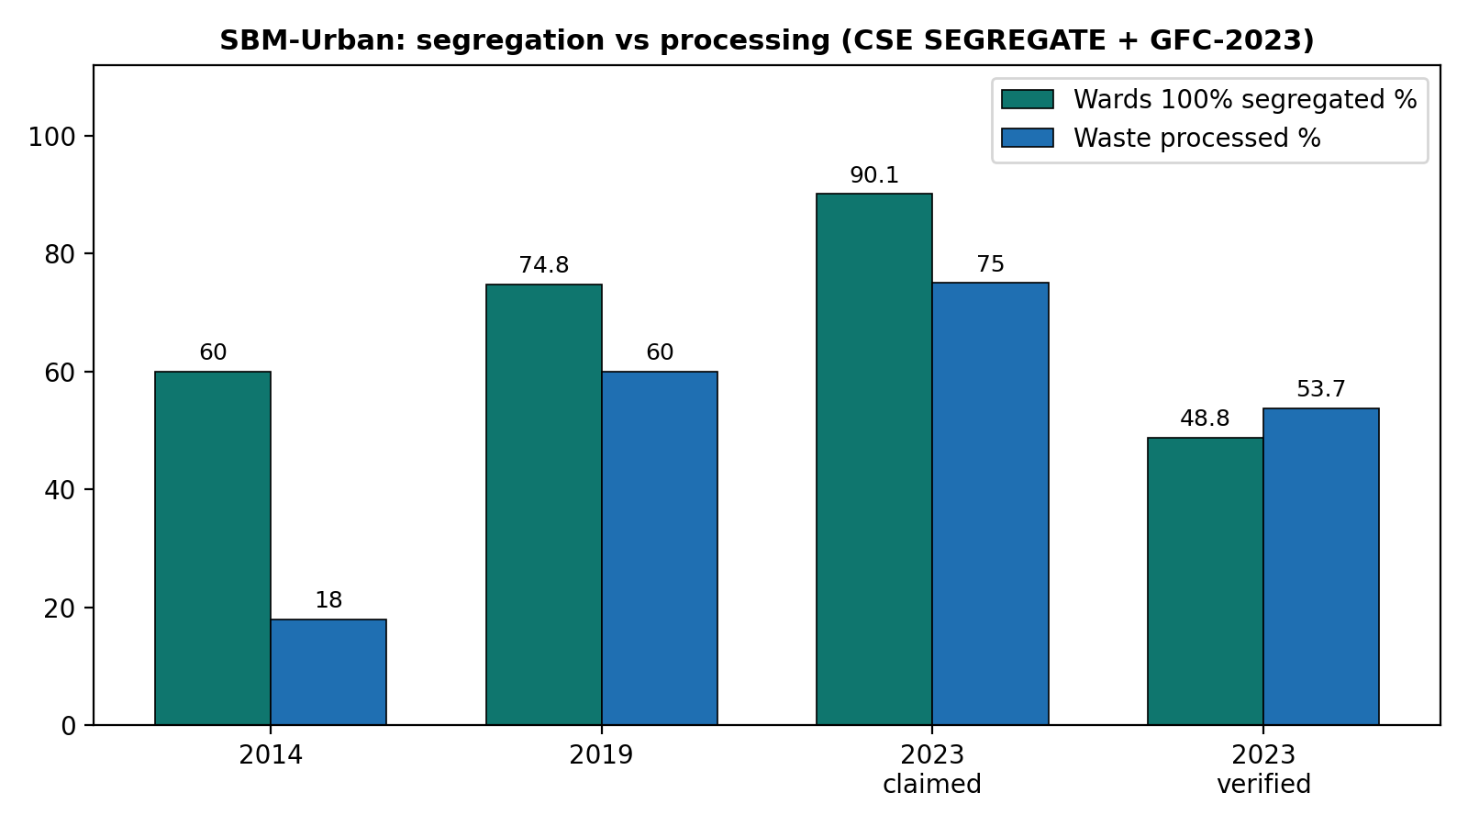
Figure 4.12: SBM-Urban wards and processing. Source: as cited in text.
The takeaway: segregation claims climb from 60% to 74.8% to 90.1%, while field verification stalls at 48.8%. That is a 41.3-point credibility gap. Processing climbs from 18% to 60% to around 75% claimed, but the CPCB-verified anchor is 53.7%. Collection is essentially a solved problem at 94 to 100%. Verified segregation and processing yields are not. Any project quoting only the 90.1% MIS figure is misleading its reader, so I don't.
Segregation claims 90.1% vs 48.8% verified: 41.3-point credibility gap. Collection solved, verification lags.

4.3.8 State contrast: Treated share among top-8 states.
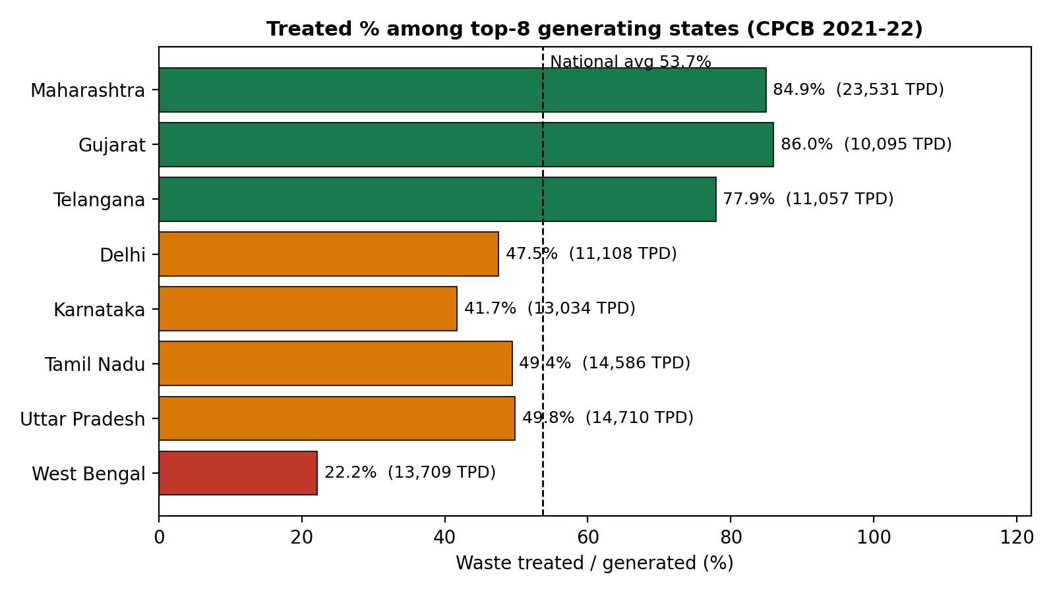
Figure 4.13: Treated share among top-8 states. Source: as cited in text.
In plain terms: the correlation between how much a state generates and how much it treats is 0.131, which is basically nothing. West Bengal and Karnataka generate at Maharashtra's scale yet treat at a quarter to half its rate. Money and monitoring should therefore go first to the six low-processing majors, not to the metros that already perform.
Correlation volume vs treated share r=0.131: volume does not explain performance.

4.3.9 Maharashtra deep-dive: Maharashtra trajectory.
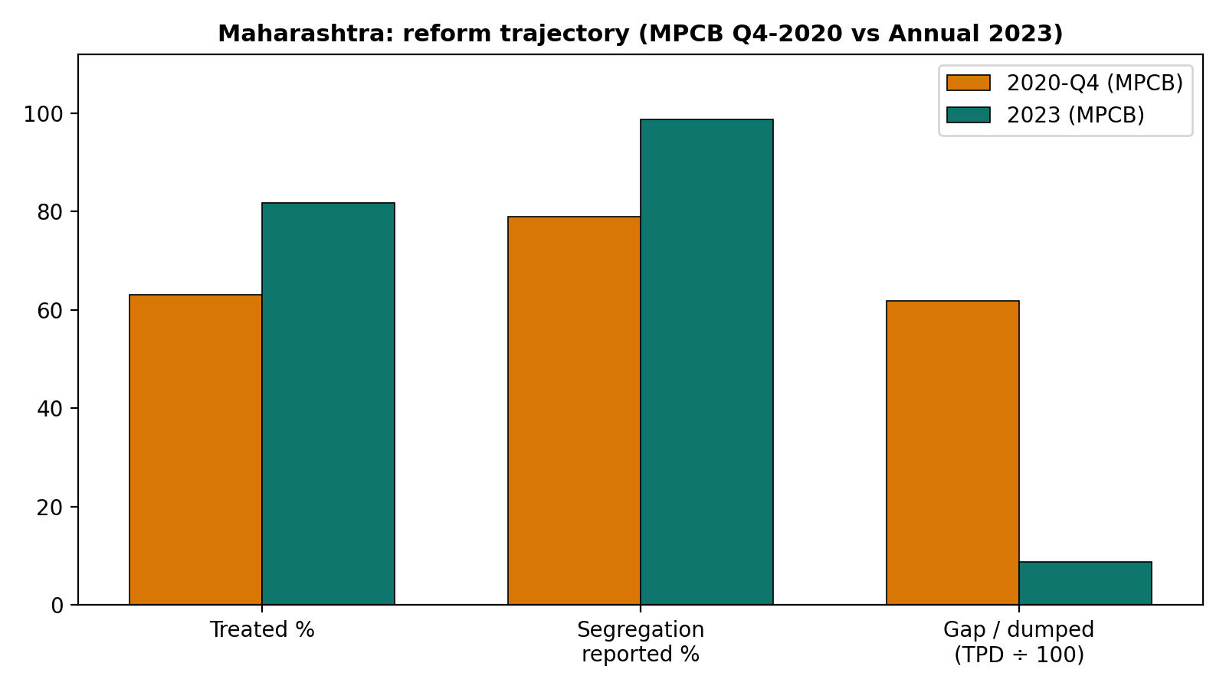
Figure 4.14: Maharashtra trajectory. Source: as cited in text.
Here the trend is genuinely encouraging. Treated share rises from 63.0% to 81.8%. Segregated-and-transported rises from 79% to 98.66% claimed. The gap collapses from 6,187 TPD to about 873 TPD dumped. Real hardware backs it: 456 composting plus 145 vermi plus 57 biomethanation plus 4 waste-to-energy plus 23 RDF plants, with 409 of 418 local bodies reporting source segregation. My one flag, stated plainly: 98.66% is ULB portal self-certification. Read it next to GFC-style field verification before declaring victory.
Treated 63.0% to 81.8%; gap 6,187 to ~873 TPD. Hardware-backed reform with one flag.

4.3.10 Composition reality: Thanisandra composition.
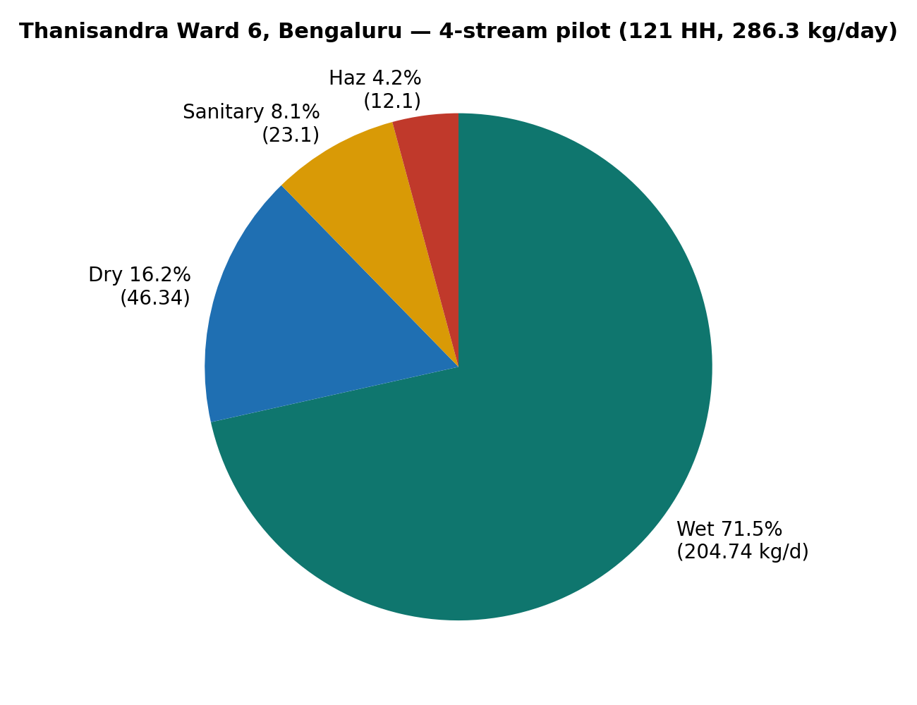
Figure 4.15: Thanisandra composition. Source: as cited in text.
Breaking it down: wet 204.74 kg/day (71.5%), dry 46.34 (16.2%), sanitary 23.1 (8.1%), hazardous 12.1 (4.2%). This lines up with Trivandrum's 60-65% biodegradable band and NITI's 50-60% wet band, and it settles the design question: collect four streams, not two. Sanitary plus hazardous is only about 12% of mass yet carries all of the handling risk (lead 12.03, cadmium 0.44, mercury 0.195 mg/kg). One weekly red-pouch round fixes what a thousand posters cannot. The lab logic follows naturally. Wet waste at 74% moisture and pH 5.9 goes to compost or biomethanation. Dry waste at 2,327 kcal/kg goes to recycling or waste-to-energy. Sanitary waste goes to deep burial. Hazardous waste goes to secure landfill.
Wet 71.5%, dry 16.2%, sanitary 8.1%, hazardous 4.2%: collect four streams, not two.

4.3.11 Behaviour change: Behavioural benchmarks.
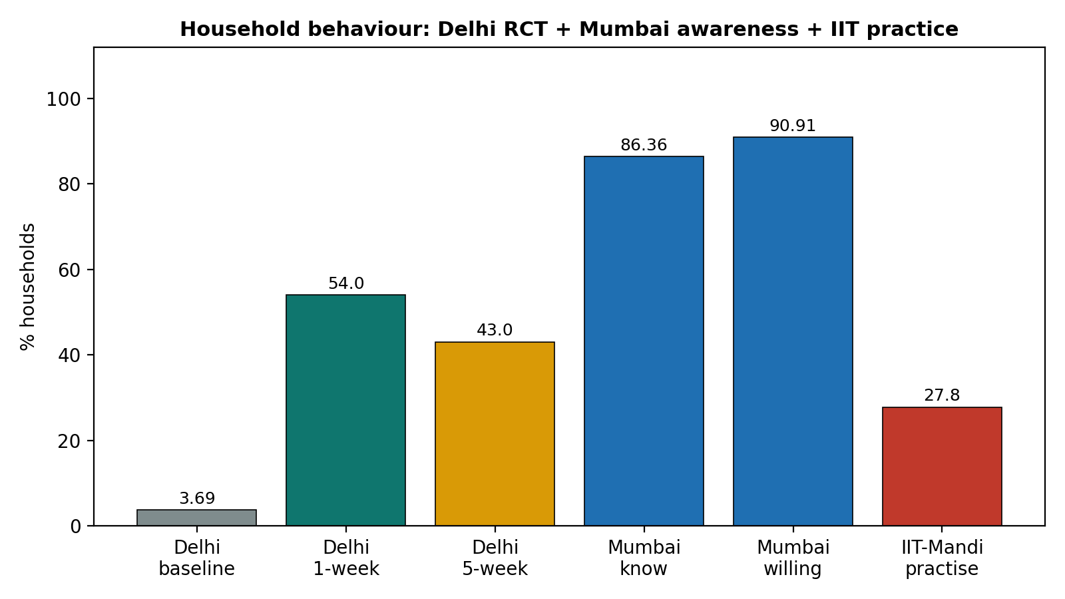
Figure 4.16: Behavioural benchmarks. Source: as cited in text.
Three results side by side. Delhi's bins-plus-brochure-plus-small-incentive pushed segregation from 3.69% to 54.0% (up 50.3 points) in a week, then it slipped to 43% (down 11 points) by week five. Information works fast, incentives work best, follow-up stops the slide. Mumbai is the mirror failure: 86.36% know wet-versus-dry and 90.91% are willing, yet nothing happens for want of separate bins and two-compartment trucks. IIT-Mandi offers the cheapest win I found: permanent labels plus engineered lids lifted correct sorting 11% in three days, from a baseline where 78% of students could not match waste to colours and only 27.8% separated regularly.
Delhi 3.69% to 54% (+50.3) then 43% (-11 decay). Bins+info fast, follow-up sustains.
Table 4.4: Lowest processing among major generators (>1,000 TPD)
Lowest processing among major generators (>1,000 TPD) | Generated (TPD) | Treated
West Bengal | 13,709 | 22.2%
Andhra Pradesh | 6,890 | 22.6%
Rajasthan | 7,973 | 24.2%
Punjab | 4,222 | 34.8%
Karnataka (despite Bengaluru) | 13,034 | 41.7%
Counterpoints: Gujarat / Maharashtra / Telangana | 10,095 / 23,531 / 11,057 | 86.0% / 84.9% / 77.9%

4.4 Linking the Survey with the Field Work
Table 4.6: Study objectives and corresponding findings
Objective | Survey finding | Field observation
Trace chain across 3 types | Single-bin 53%; handler mixing 87% | Delegation (A), space (B), timing (C) failures visible
Infrastructure audit | Single-chamber 67%; no-door 26% | Faded labels, single drum, open container
Contamination | Haz mixed 80%; wet/dry mixed | Sanitary + e-waste shells in single stream
Collection discipline | Delayed 34%, irregular 26% | 2h late compactor; irregular hopper
Handler burden | Frequent mixing 60% | Re-sorting by hand; black-bag worst load
Fix demand | Better bins 28%, alerts 60% | Lids, labels, evening beat, red-pouch round

4.5 Supporting Material Developed
As part of the project a printable questionnaire with QR (Annexure A), photo-log sheet (Annexure C) and coded frequency tables (Annexure D) were prepared. They respond directly to the main finding that hardware plus timely alerts beat slogans alone, and can be displayed in societies and wards or shared on WhatsApp.

CHAPTER 5: CONCLUSION AND RECOMMENDATIONS

5.1 Contribution of the Findings to the Understanding of the Subject
The study shows segregation failure is not only informational but structural: handover mixing, single-chamber transport, irregular timing, unreadable signage and an invisible hazardous stream. Primary texture (N=100) and secondary' floors (91.8% collected, 53.7% treated) agree: collection largely solved, segregation lags.

5.2 Summary of Key Findings and Their Significance
1. Collection is largely solved while segregation lags: with 91.8% collected but 53.7% treated, the binding constraint is segregation quality at handover points, not truck coverage.
2. Failure differs by housing type, and the data backs the field notes: delegation failure in societies, space failure in dense streets, timing-and-distance failure in informal settlements, against a verified national segregation rate near one-half rather than nine-tenths.
3. The barriers rank clearly from evidence: (i) missing two-compartment transport and nearby bins; (ii) irregular timing with multi-hour delays; (iii) unreadable signage that excludes handlers; (iv) an invisible hazardous stream; (v) incentive decay without follow-up.
4. Public willingness is plentiful and wasted: 91% willingness in Mumbai and a 50-point Delhi lift prove households respond within days when hardware plus a nudge arrive together.
5. Timing pressure works both ways: evening beats matched to shop hours and visible scorecards can convert the same peer pressure that spreads rumours into compliance.
6. Training needs are specific, not general: 30-minute demos on matching waste to colours, handling the red pouch, and reading the tipper alert, in Hindi or Marathi, at the bin point, with a 5-week re-check.
7. The upside is measurable: closing the 41-point verification gap and lifting the six low-processing majors toward the 77-86% band would add roughly 25-30 points to national treatment without a single new landfill.
8. The binding constraint is institutional rather than informational. The Solid Waste Management Rules, 2016 have mandated three-stream segregation, user fees, spot fines and the integration of waste pickers for eight years, yet the Comptroller and Auditor General's 2024 audit of 102 urban local bodies found only 3.13 per cent of collected waste was segregated, and in 11 of 13 test-checked bodies waste pickers were neither recognised nor registered. The party missing from most implementation plans is the informal recovery sector, which this study observed within 100 metres of the Zone C collection point but did not treat as a participant in the system.
9. Tonnage arithmetic further reframes the problem. Wet waste exceeds half of urban municipal solid waste, while dry recyclables are only 5 to 15 per cent by mass, so segregation alone cannot reduce the dominant flow. Measured interventions must therefore combine segregation at source with the diversion of wet waste at or near the point of generation, and must be designed around the recovery sector rather than around household persuasion.
The significance is institutional: report verified segregation next to claimed, direct hardware to low-processing states, and run four-stream pickup with alerts and 5-week re-audits.

5.3 Recommendations

5.3.1 Reporting and Investment
Report verified segregation (GFC/field audit) next to MIS claims in every ULB plan; make claimed-versus-verified a mandatory two-column table. (Owner: MoHUA/ULB: dashboard patch within one quarter)
Direct MRF plus compost investment to the six low-processing majors (WB, AP, Rajasthan, Punjab, Jharkhand, Assam). (Owner: State missions: count commissioned plants)

5.3.2 Collection and Shops
Run four-stream pickup with a separate weekly red-pouch round for sanitary/hazardous waste; weigh and publish the haz stream. (Owner: ULB plus SPCBs: track kg/week of red-pouch waste)
Put two-compartment trucks, nearby dual bins, permanent multilingual labels and engineered lids in place before any new awareness spending in high-awareness wards. (Owner: ULB engineering: check for 11% correct-sorting gain in 2 weeks)
Copy the Trivandrum bin formula: bins equal (population times per-capita waste minus source-eliminated waste) divided by bin capacity, placed by least-distance mapping; publish per-ward fill data. (Owner: CS student prototype with ULB: track overflow hours)
Supply stackable dual-bins for sub-100-sq-ft homes plus an evening beat matched to shop hours in dense streets; QR scorecards for societies. (Owner: CSR plus society committees: measure contamination-rate change)

5.3.3 Users
Charge segregating households a lower user fee plus send 15-minute tipper SMS/WhatsApp alerts plus re-audit at 5 weeks to stop decay. (Owner: ULB revenue plus IT cell: track the 50-point lift and 11-point decay)
Placed permanent bilingual (Marathi/Hindi) sorting labels on residential collection bins and monitored overflow and contamination rates over a 3-day observational window. (Owner: Student initiative: track 3-day bin contamination)

5.3.4 Cooperation and Monitoring
Re-survey this project's Google Form panel each quarter; merge under Annexure D; refresh Figures F-1 to F-6 yearly from CPCB/SBM releases. (Owner: Student plus guide: keep a living dataset)
Integrate and formalise waste pickers and kabadiwalas. Identify and register waste pickers in the ward, issue identity cards, pay for recovered material by weight at market rate, provide segregated collection vehicles including twin-bin tricycles, and convert existing dhalaos into neighbourhood recycling centres. Every documented city-scale success reviewed for this study - Vengurla, Kumbakonam, Leh and the Delhi SDMC model - combines segregation with formalised informal-sector participation; bins and awareness alone have not produced 100 per cent segregation anywhere. (Owner: ULB with the SWM cell and registered self-help groups: count registered pickers and kilograms purchased per month)
Separate streams in time where vehicles cannot be compartmentalised. Until compartmentalised vehicles are available, schedule wet waste daily in the morning and dry recyclables on fixed alternate days, so that a single-chamber vehicle never carries both streams in one trip. This requires a change to route scheduling only, with no capital expenditure, and it addresses the condition recorded by 67 per cent of respondents in this survey. (Owner: ULB operations: share of lanes on alternate-day dry collection)
Apply enforcement to the mixing actor, and make it conditional on service provision. Issue spot fines under the Solid Waste Management Rules, 2016 primarily against handlers, vendors and commercial establishments that remix segregated streams, rather than against households in lanes where dual bins and labelled vehicles have not been provided. This survey found downstream mixing observed by 87 per cent of respondents while only 19 per cent always segregate at source, which places the majority of the failure downstream of the household. (Owner: ULB enforcement with the ward office: number of mixing incidents recorded at handover, and contamination rate in serviced against unserviced lanes)
Divert wet waste at source through community composting. Establish community composting units for gated societies and mandatory wet-waste segregation for commercial establishments, and exclude composted wet waste from the daily collection route. Since wet waste exceeds half of all urban generation, this is the only intervention that reduces the dominant tonnage rather than merely sorting it. (Owner: ULB with society management committees: share of wet weight diverted from the collection route)
Set targets against the conveniently segregable fraction rather than against unverified absolutes. State municipal targets against the World Bank estimate that 15 to 20 per cent of national waste is conveniently segregable at source, and against the CPCB composition range of 30 to 55 per cent compostable and 5 to 15 per cent recyclable, rather than against claimed rates of 90 or 100 per cent that this study has already shown to be unverified. (Owner: MoHUA and urban local bodies: published basis for each target)

5.4 Limitations and Scope for Further Study
Results describe respondents and pockets visited, not whole Mumbai. Further study could use larger random samples, more wards, structured worker interviews, authorised MRF/compost visits, and before-after campaign comparison with contamination-rate weighing.

5.5 Closing Remark
Survey plus walks worked well: the survey gave counts and the walks gave the real picture. The main message is simple. Before blaming households, fix handover hardware, timing and haz routing. Before claiming segregation, verify it in the field and weigh the red pouch.

REFERENCES
[1] Government of India (2016). Solid Waste Management Rules, 2016. Ministry of Environment, Forest and Climate Change, New Delhi.
[2] CPHEEO / MoUD (2016). Municipal Solid Waste Management Manual. New Delhi.
[3] Central Pollution Control Board (2022). Annual Report 2021-22 on Implementation of Solid Waste Management Rules, 2016 (Table-1: 1,70,339 TPD generated). https://cpcb.nic.in/uploads/MSW/MSW_AnnualReport_2021-22.pdf
[4] CPCB: Municipal Solid Waste Rules page and status reports. https://cpcb.nic.in/municipal-solid-waste-rules/
[5] Maharashtra Pollution Control Board (2020). Quarterly Report Jan-Mar 2020 (23,607 TPD; 63% processed). https://mpcb.gov.in/sites/default/files/solid-waste/Jan20Mar2014012021.pdf
[6] Maharashtra Pollution Control Board (2024). Final MSW Annual Report 2023 (Revised): 24,299 TPD; 98.66% segregation claimed. https://www.mpcb.gov.in/sites/default/files/Establishment%20of%20MPCB/Seniority%20list/2014/FinalMSWAnnualReport2023Revised.pdf
[7] Swachh Bharat Mission Urban portal (MoHUA): mission progress, GFC-2023 dashboard, Swachh Survekshan 2023/2024 portals. https://sbmurban.org/ ; https://sbmurban.org/gfc-result-dashboard-2023 ; https://ss2023.sbmurban.org/ ; https://ss2024.sbmurban.org/
[8] Centre for Science and Environment: SEGREGATE knowledge paper (SBM 2014-2019 trends; GFC star ratings). https://sbmurban.org/storage/app/media/pdf/sbm_knowledge_center/segregate.pdf
[9] NITI Aayog (2021). Waste-Wise Cities: A Framework for Targeted Action. https://www.niti.gov.in/sites/default/files/2021-12/Waste-Wise-Cities.pdf
[10] Factly / Dataful: reporting gaps in CPCB solid-waste data (2015-2022 compilation). https://factly.in/data-reporting-of-solid-waste-generation-data-improves-but-still-inadequate/ ; https://dataful.in/datasets/19386/
[11] Thanisandra Ward 6 Bengaluru B.Tech field project (121 households, 4-bin pilot, 286.3 kg/day). https://www.scribd.com/document/1062267517/A-12-abhi-final-pdf
[12] Wadehra, S. & Mishra, A. (ISI Delhi). Segregation of waste at the household level: RCT across RWAs (3.69% to 54% to 43%). https://www.isid.ac.in/~epu/acegd2017/papers/ShivaniWadehra.pdf
[13] Shah thesis: Sustainable Waste Processing in Mumbai; Mulund resident survey (86.36% know, 90.91% willing). https://kingdombio.com/ShahThesis.pdf
[14] FOSSEE Fellowship: Solid Waste Management System, Thiruvananthapuram (aerobic-bin optimisation plus QGIS). https://static.fossee.in/fossee/fellowship2019/FOSSEE-Fellowship-reports-2019/R/R_SolidWasteManagementSystem_Thiruvananthapuram_Fellowship2019.pdf
[15] WPI (2016). Evaluating Waste Management Systems: Kataula and IIT-Mandi (27.8% practise; +11% with prototype lids).
[16] Open Government Data Platform India: CPCB solid-waste resources. https://www.data.gov.in/
[17] Comptroller and Auditor General (2024). Report on Solid Waste Management in Urban Local Bodies for the year ended 31 March 2022, Chapter 3: Collection, Segregation, Storage, Transportation and Disposal. https://cag.gov.in/uploads/download_audit_report/2024/8_Chapter-3-Collection,-Segregation,-Storage,-T&DoMSW-067b719e95a5748.53823551.pdf
[18] World Bank (2005). Improving Municipal Solid Waste Management in India. Washington DC: World Bank. https://documents1.worldbank.org/curated/en/682051468267572634/pdf/425660PUB0Wast12732601OFFICIAL0USE1.pdf
[19] NITI Aayog (2021). Promoting Behaviour Change for Strengthening Waste Segregation at Source: Policy Guidelines. Government of India. https://www.niti.gov.in/sites/default/files/2021-12/PromotingBehaviourChange-forStrengtheningWasteSegregation-at-Source-PolicyGuidelines.pdf
[20] South Delhi Municipal Corporation (2017). Segregation of Municipal Solid Waste: twin-bin tricycles to informal waste pickers, dry waste purchased at market value, dhalaos converted to recycling centres. https://cdn.cseindia.org/docs/photogallery/slideshows/12_20171212_Segregation-PPT-of-SDMC.pdf
[21] Pandey, S. (2014). Overview of Municipal Solid Waste Management in India (CPCB composition ranges: compostable 30-55%, recyclable 5-15%, C&D 40-55%). ICRIER. https://icrier.org/Urbanisation/events/30-5-14/musm_Suneel%20Pandey.pdf
[22] Press Information Bureau (2016). Solid Waste Management Rules revised after sixteen years: user fees, spot fines for non-segregation, and integration of ragpickers and kabadiwalas assigned to State Governments and self-help groups. https://www.pib.gov.in/newsite/printrelease.aspx?relid=138591

APPENDICES
Appendix A: Survey Questionnaire
Appendix B: Interview Questions for Sanitation Workers
Appendix C: Summary of Survey Responses
Appendix D: Field Visit Record and Project Approval Proforma

APPENDIX A: Survey Questionnaire
The Google Form had 10 core questions (Annexure A printable + QR).
# | Question | Options / scale
Q1 | Housing Type | Gated Society / Standalone Building or Chawl / Other
Q2 | Do you keep separate bins for wet and dry waste at home? | Yes, Always / Sometimes / No, Single bin
Q3 | If you do not segregate, what is the main reason? | No separate bins / Lack of kitchen space / Forgetfulness / Waste collector mixes them anyway
Q4 | How reliable is your daily municipal waste collection? | Very regular / Delayed by 1 to 2 hours / Irregular / No door to door pickup
Q5 | Does the collection vehicle have separate compartments for wet and dry waste? | Yes / No, single chamber / Not sure
Q6 | Have you observed the waste handler or worker mixing your segregated bags? | Frequently / Occasionally / Never / Not sure
Q7 | Do you separate domestic hazardous and sanitary waste such as pads, diapers, glass, and medicines? | Yes, in separate bag / Mixed with wet / Mixed with dry
Q8 | Are you aware of municipal fines or bye-laws for not segregating? | Yes / No
Q9 | Would an alert via SMS or WhatsApp telling you the truck is 15 minutes away help you hand over waste on time? | Yes / No
Q10 | What would motivate you most to segregate daily? | Clearer instructions / Lower municipal maintenance fee / Strict fines / Better bins

APPENDIX B: Interview Questions for Sanitation Workers
1. IQ1. What share of green (wet) bins does your team have to re-sort by hand because of contamination?
2. IQ2. Which single item causes the most sorting or handling trouble: diapers, glass, coconut shells, multilayer plastics, sanitary waste?
3. IQ3. When the truck fills up, do separated bags ever get mixed into the compactor to save space?
4. IQ4. At what time do residents or shops actually hand over waste compared to your scheduled trip?
5. IQ5. How far do residents in the farthest lane walk to reach your collection point?
6. IQ6. Are two-compartment (wet/dry) vehicles available on this beat every day?
7. IQ7. What happens to sanitary waste found mixed in wet or dry bags?
8. IQ8. Do ragpickers or kabadiwalas lift dry waste before or after your trip, and does that help or hurt sorting?
9. IQ9. Has any society or ward tried QR tagging, scorecards or timing alerts here? Did it work?
10. IQ10. If you could change one thing, more bins, a fixed-time alert, or a separate hazardous round, which would cut your re-sorting most?

APPENDIX C: Summary of Survey Responses
Tables below give counts and percentages out of 100. 1 respondent = 1.0%.
Table A.1: Q1-Q2 Housing and bins
Q | Option | Count | %
Q1 Housing | Gated Society | 40 | 40.0%
 | Standalone Building or Chawl | 33 | 33.0%
 | Other | 27 | 27.0%
Q2 Bins | Yes, Always | 19 | 19.0%
 | Sometimes | 28 | 28.0%
 | No, Single bin | 53 | 53.0%

Table A.2: Q3-Q4 Reasons and reliability
Q | Option | Count | %
Q3 Reason | No separate bins | 30 | 30.0%
 | Lack of kitchen space | 24 | 24.0%
 | Waste collector mixes them anyway | 23 | 23.0%
 | Forgetfulness | 23 | 23.0%
Q4 Reliability | Very regular | 14 | 14.0%
 | Delayed by 1 to 2 hours | 34 | 34.0%
 | Irregular | 26 | 26.0%
 | No door to door pickup | 26 | 26.0%

Table A.3: Q5-Q6 Vehicle and mixing
Q | Option | Count | %
Q5 Vehicle | Yes | 21 | 21.0%
 | No, single chamber | 67 | 67.0%
 | Not sure | 12 | 12.0%
Q6 Mixing seen | Frequently | 60 | 60.0%
 | Occasionally | 27 | 27.0%
 | Never | 13 | 13.0%
 | Frequently+Occasionally | 87 | 87.0%

Table A.4: Q7-Q9 Hazardous, fines, alerts
Q | Option | Count | %
Q7 Hazardous | Yes, in separate bag | 20 | 20.0%
 | Mixed with wet | 42 | 42.0%
 | Mixed with dry | 38 | 38.0%
 | Mixed (wet+dry) | 80 | 80.0%
Q8 Fines known | Yes | 56 | 56.0%
 | No | 44 | 44.0%
Q9 Alert helps | Yes | 60 | 60.0%
 | No | 40 | 40.0%

Table A.5: Q10 Motivation
Q | Option | Count | %
Q10 Motive | Better bins | 28 | 28.0%
 | Clearer instructions | 26 | 26.0%
 | Strict fines | 24 | 24.0%
 | Lower municipal maintenance fee | 22 | 22.0%

APPENDIX D: Field Visit Record and Project Approval Proforma
Table A.6: Field visit record
Point | Record
Dates | 02-Oct-2026 survey window; zone walks as per diary
Place | Mira Road urban / Mumbai Metropolitan Region
Type of pocket | Gated society, mixed street, informal hopper point
Person met | Residents (N=100 online), society staff, shop helpers, compactor/hopper workers
Main topics | Bins, mixing, timing, vehicles, haz waste, alerts
Proof | Field notes and five geotagged photographs (Figures 4.1 to 4.5)

Table A.7: Proforma for approval of field project
Item | Details
1. Name of the Student | Pranjal Yadav (Roll No. 202503021, S.Y.B.Sc. Computer Science)
2. Title of the Project | Waste Management Data Collection & Analysis
3. Name of the Guide | ASST. PROF. ASHISH YADAV
4. Teaching Experience of the Guide | 10+ years
5. Is this your first submission? | Yes
6. Target Sample (primary, supplementary) | Google Form convenience sample across 3 housing strata (N=100 completed, 02-Oct-2026, form-1 - Form Responses 1.csv); core analysis on secondary open data
7. Secondary Data Sources | CPCB Annual Report 2021-22; SBM-Urban MIS + GFC-2023 dashboard; MPCB Maharashtra Q4-2020 & Annual 2023; 5 published field pilots
8. Tools | Google Forms, Excel, Python (pandas, matplotlib)

Signatures:
Student Guide Coordinator
PRANJAL YADAV Asst. Prof Ashish Yadav Asst. Prof Rajesh Rajgor

