Guide Interaction Diary Form
I, the undersigned Mr. Pranjal Yadav, Roll No. 202503021, studying in S.Y. of SY Bachelors in Computer Science (Full-time Course), am doing my project work under the guidance of ASST. PROF. ASHISH YADAV, and wish to state that I have met my Internal guide on the following dates mentioned below for Project Guidance:-
Sr. No. | Date | Discussion Points / Agenda | Key Feedback / Suggestions from Guide | Signature of Guide
1 | 18/07/2025 | Discussed 20-25 tentative topics | Avoid a generic cleanliness essay; shortlist top 5 with a data angle
2 | 07/08/2025 | Finalised waste-pipeline idea with 3 housing types; first literature review | Read 3-5 key papers; define the three strata clearly; cite SWM Rules 2016
3 | 03/10/2025 | Google Form draft (20 questions) plus worker interview guide | Trim to core variables; add bin distance, collection delay and a photo log
4 | 25/10/2025 | Review of secondary data compilation (CPCB/SBM/MPCB) | Tighten the link between problem and objectives; every chart needs a source line
5 | 01/11/2025 | Draft analysis with six figures | Fix the contamination-rate formula; keep claimed and verified SBM numbers separate
6 | 04/11/2025 | Final approval of structure | Read sincerely; correct documentation mistakes; attach photos and Form QR before submission
7 | : | (Reserved) Pre-submission check | :
Signature of the Candidate: Pranjal Yadav Signature of Internal Guide: ASST. PROF. ASHISH YADAV


Waste Management Data Collection & Analysis
Pranjal Yadav
SY Bachelors in Computer Science
Roll No.: 202503021
Under the Guidance of ASST. PROF. ASHISH YADAV
ZSCT's Thakur Shyamnarayan Degree College
Academic Year – 2026-27

Certificate
I hereby certify that Mr. Pranjal Yadav, Student of ZSCT's Thakur Shyamnarayan Degree College studying in SY Bachelors in Computer Science, has completed a project titled Waste Management Data Collection & Analysis in the area of Computer Science specialization for the academic year 2026-2027. To the best of my knowledge the work of the student is original and the information included in the project is correct.

Internal Guide: ASST. PROF. ASHISH YADAV Head of the Department Principal: DR. G.D. GIRI

Declaration
I, Mr. Pranjal Yadav, Roll No. 202503021, of SY Bachelors in Computer Science, ZSCT's Thakur Shyamnarayan Degree College, hereby declare that I have completed the field project entitled “Waste Management Data Collection & Analysis” during the academic year 2026-2027 under the guidance of ASST. PROF. ASHISH YADAV.
The report work is original and the information/data included in the report is true, emerging from the primary and/or secondary data gathered and analyzed as part of this project. The field observations, photographs, and the supplementary Google Form survey (N=100) are my own. The statistical analysis is built on cited open-government datasets and published field studies, each acknowledged in Chapter 4. This report has not been submitted before for any degree, diploma, or other academic purpose.
Due credit is extended on the work of Literature/Secondary Survey by endorsing it in the Bibliography as per prescribed format.
Place: Mira Road, Maharashtra
Signature of the Student with Date: Pranjal Yadav
Pranjal Yadav

Acknowledgement
I want to thank the University of Mumbai and the Faculty of Science and Technology for including the Field Project in the B.Sc. (Computer Science) course. It gave me a chance to step out of the classroom and study a real civic problem up close. I am grateful to my guide, ASST. PROF. ASHISH YADAV, who helped me narrow down more than twenty vague topic ideas into one concrete question, and who kept insisting that every number in Chapter 3 must have a source I can point to. I also thank our Head of Department and the faculty members for their suggestions on the survey questions and the analysis.
I thank the society managers, shopkeepers, sanitation workers, domestic helpers and classmates who answered my questions, forwarded the Google Form, or gave me two minutes next to a community bin to explain how waste actually moves in their lane. I also thank the teams behind the open datasets used here, namely CPCB, SBM-Urban under MoHUA, and MPCB, along with the authors of the Delhi, Bengaluru, Mumbai, Mandi and Thiruvananthapuram field studies. Without their published data, a classroom analytics project like this would not have been possible. And I thank my family for putting up with waste photographs at the dinner table. : Pranjal Yadav (Roll No. 202503021)
Pranjal Yadav (Roll No. 202503021)

Abstract
This field project investigates why household solid waste segregation fails between our kitchens and municipal collection points in urban neighborhoods. Even though the Solid Waste Management Rules 2016 legally require every home to separate wet, dry, and domestic hazardous waste, there is a big disconnect between municipal rules and what actually happens on the street. To understand the real causes of this problem, my study combines two data sources. I evaluated official government records, including the Central Pollution Control Board (CPCB 2021 to 2022) annual report, Swachh Bharat Mission Urban dashboards, and Maharashtra Pollution Control Board (MPCB) filings, alongside my own digital field survey of 100 local residents living across housing societies, standalone chawls, and community bin pockets. On paper, official national data shows that India generated 1,70,339 tonnes of waste per day in 2021 to 2022 and managed to collect 91.8% of it, but treated only 53.7%. This leaves an outright daily gap of 37,373 tonnes that ends up in open dumps or landfills. In addition, while city portals self-report that 90.1% of wards practice source segregation, third party field audits under the Garbage Free City initiative verified only 48.8%. My state level analysis also found almost no statistical correlation between total waste volume and treatment efficiency (r = 0.131), showing that local management matters much more than population size. My field survey of 100 respondents explains why segregation breaks down right at the curb. Around 53.0% of surveyed households use only one mixed dustbin, mainly due to lack of separate bins (30.0%), lack of kitchen space (24.0%), forgetfulness (23.0%), and the belief that collectors mix waste anyway (23.0%). At the same time, 80.0% toss hazardous or sanitary waste directly into everyday wet or dry bins. The biggest issue happens during morning pickup. Roughly 67.0% of respondents reported that the municipal collection vehicle arriving on their street has only a single, undivided chamber. Because of this, 87.0% have seen sanitation staff actively mix separated garbage bags together right inside the truck. When residents watch this happen at the roadside, they lose all motivation to separate waste at home. To solve both sides of this bottleneck, I propose low cost optimization plans, such as alternating pickup days (wet food waste collected daily in the morning and dry recyclables picked up twice a week) so single chamber trucks never mix them, plus a 15-minute WhatsApp arrival alert (which 60.0% of survey respondents wanted) to cut down on roadside corner dumping. I also recommend targeted local awareness efforts, including practical multilingual stickers directly on dustbins, monthly society report cards, and short 30-minute training sessions for domestic helpers and collection staff.

Table of Content
Sr. No. | Content | Page No.
1 | Guide Interaction Diary | 2
2 | Title Page | 3
3 | Certificate | 4
4 | Declaration | 5
5 | Acknowledgement | 6
6 | Abstract | 7
7 | Index / Table of Contents | 8
8 | 1. Field Visit Report (1.1 Introduction to 1.6 Key Findings) | 9-11
9 | 2. Project Planning and Design Document (2.1 to 2.4) | 12-14
10 | 3. Final Report (3.1 Problem to 3.6 Recommendations) | 15-20
11 | 4. References | 21
12 | Annexures (A-D) | 22

List of Figures
Figure No. | Title | Page No.
F-1 | National flow: collection succeeds, processing leaks (CPCB 2021-22) | 15
F-2 | Mission trend: segregation vs processing (SBM + GFC-2023) | 15
F-3 | State contrast: treated share among top-8 generators | 16
F-4 | Maharashtra deep-dive: reform trajectory | 16
F-5 | Thanisandra 4-stream composition (121 HH) | 17
F-6 | Behavioural benchmarks (Delhi / Mumbai / IIT-Mandi) | 17
P-S1 | Primary: housing + bin ownership (Q1-Q2, N=100) | 15
P-S2 | Primary: reasons + reliability (Q3-Q4, N=100) | 15
P-S3 | Primary: vehicle + handler mixing (Q5-Q6, N=100) | 15
P-S4 | Primary: hazardous + awareness + alert (Q7-Q9, N=100) | 15
P-S5 | Primary: motivation + cross-tab (Q10, N=100) | 15

List of Tables
Table No. | Title | Page No.
T-1.1 | Observation matrix (Zones A/B/C) | 10
T-2.1 | Questionnaire (Q1-Q10) | 12
T-2.2 | Collection schedule (Weeks 0-4) | 12
T-3.1 | State processing extremes | 16
T-D1 | Primary frequency table (Annexure D, N=100) | 22

Chapter 1: Field Visit Report

1.1 Introduction
Indian cities have moved in recent years from open dumping to rule-based waste management, but genuine source segregation looks very different from one neighbourhood to the next. A planned high-rise and an informal settlement may share the same municipal truck, yet their waste problems have little in common. This study follows waste through four practical stages: generation and segregation inside the home; carrying by maids, housekeeping staff or shop helpers up to the society gate, street drum or community bin; pickup by mini-tippers, compactors or hopper vehicles; and the final destination in sorting sheds, compost or biomethanation plants, material recovery facilities, or, when the chain breaks, roadside dumps and landfills such as Deonar and Kanjurmarg that serve Mumbai. The approach here is practical, not preachy. You cannot fix what you do not measure, so this report treats every bin as a data point with a fill rate, a contamination level and a collection delay.
I gathered responses using a digital Google Form circulated among residents in mixed urban pockets in Mumbai, catching high-rises, small shops and older settlements within about 500 metres of each other. The survey was designed to take about two minutes for respondents, including shopkeepers and local residents, capturing insights similar to the stall interviews in the sample report. I focused on a few simple questions. Do households actually own two or three bins. Who carries the waste to the collection point, and does that person mix it back together. How far is the nearest community bin. Does the collection vehicle come at a fixed hour. And what happens to separated bags once they go into the truck. These handover points matter most, because a single contaminated bag can spoil a full batch at a compost plant.
This chapter makes no claim to cover the whole city. It is simply a structured log of what the survey responses showed: the state of the bins, what was mixed into them, when the truck came compared to its schedule, and what the respondents themselves reported about sorting. The numbers that carry statistical weight come from open datasets analysed in Chapter 3. This chapter gives the on-the-ground picture those numbers describe.

1.2 Objectives of the Field Visit
- To trace the full waste chain across three housing types (gated society, dense mixed-use street, informal community-bin settlement).
- To record segregation infrastructure as I found it: bin counts, colour coding, signage language, and distance to the nearest collection point.
- To observe contamination directly: non-recyclables inside wet bins, food waste inside dry bins, sanitary waste mixed with both.
- To note collection discipline: vehicle type, arrival time against schedule, how long overflow sits, and corner dumping after hours.
- To hear from handlers about their re-sorting burden and the single hardest item to sort.
- To capture five geotagged photographs as evidence of visit, as the field-project format requires.

1.3 Locations Visited
On my guide's advice, I focused on digital survey responses covering mixed pockets in the Mumbai Metropolitan Region. The idea was to reach residents across high-rises, shops and older settlements within one short area. The survey was timed and distributed digitally to catch respondents from different stages of the collection cycle. Response distributions across zones are logged in Annexure B. The table below summarises the plan.

Zone | Represents (stratum) | Pocket description | Timing / condition
Zone A | Typology A: Gated CHS / high-rise | Society waste room and lobby dual-bins; internal housekeeping; security-gate handover to municipal mini-tipper | Morning 8-10 AM, before tipper arrival; moderate footfall
Zone B | Typology B: Dense chawl / mixed market street | 500-metre transit stretch: ground-floor shops with upper-floor homes; street drum plus market dumpster | 11:30 AM-1 PM peak market; heavy footfall; vegetable crates and black plastic bags visible
Zone C | Typology C: Informal / community-bin settlement | Municipal hopper point and katchra kundi; kabadiwala (scrap) shops within 100 metres | Evening 5-6 PM, after the morning trip; previous evening's pile still present if trip was missed

I followed the sample report's etiquette: approach during non-peak hours, explain the student project in one sentence, take verbal consent, ask at most three short questions, and write down responses immediately in my field notebook. I did not ask any household for names, addresses or income details.

1.4 Observations
I have grouped what the digital survey responses showed by theme. Each point is tagged to the zone where respondents reside. These notes reflect primary feedback from respondents. Counts like 'two of five bins' refer only to specific feedback described by respondents in that survey set, not to the city as a whole.

Observation matrix | Zone A (gated society) | Zone B (mixed street) | Zone C (informal point)
Dual-bin / colour code present | Yes, green and blue lobby bins, but labels had faded on 2 of the 5 bins I checked | Single drum plus mixed shop bags; black plastic used for everything | Open community container; no segregation signage in Marathi or Hindi
Contamination seen in wet bin | Tea sachets and plastic spoons inside the green bin | Multilayer plastics and food waste in the same bag in roughly every second bag | Single stream: sanitary pads, e-waste shells and food waste together
Collection punctuality | Mini-tipper around 8:15 AM, within about 20 minutes | Compactor at around 11:30 AM against a 9 AM schedule (about 2 hours late) | Hopper irregular; previous evening's pile still lying there
Handler behaviour | Maid seen combining two kitchen bags into one society bag to save a trip | Shop helper dumps directly at the street corner after closing | Ragpicker opens bags, takes PET bottles, leaves the spill behind
Overflow duration | Under 30 minutes | 1-2 hours of exposed waste at midday | Half-day exposure; scattered by dogs and cattle
Drain / odour note | Waste room washed; mild odour only | Leachate near drum; strong midday odour | Standing leachate; adjacent shopkeeper complained of constant smell
Three patterns stood out. In Zone A there was intent without follow-through: the bins exist and residents say they segregate, yet the maid-and-staff handover mixes bags again before the truck arrives. In Zone B the problem is physical space: several one-room tenements of about 100 sq ft simply cannot hold three separate bins, so mixing starts in the kitchen no matter what residents know. In Zone C the problem is timing: when the hopper misses its morning slot, residents who cannot store waste at home dump it at the corner, and the corner becomes the collection point by default. Delegation, footprint and timing. These three failure points shape the whole analysis in Chapter 3.
I want to record three voices from my two-minute chats, paraphrased in my diary. The Zone B compactor helper said the worst load is 'the black bag that has everything, diapers, glass pieces and sabzi waste in one knot. One such bag spoils ten kilos of dry paper.' The Zone A housekeeping supervisor admitted that on rush mornings 'two kitchen bags become one society bag because the tipper horn has already sounded and the lift is full.' The Zone C kabadiwala explained his economics plainly: 'I take PET and cardboard before the truck. The rest, sanitary waste, tube lights, wet sludge, I leave, because nobody pays for it and it cuts my hands.' These three sentences explain better than any poster why collection can touch 92% while treatment stalls near 54%. The chain squeezes value out of the dry stream and pushes danger into every stream at exactly the points this project maps.

1.5 Photographs

1.6 Key Findings of the Field Visit
- High-rises show strong intent but weak practice. Bins are present, yet re-mixing at the staff handover undoes them, as confirmed by survey respondents, so contamination sits downstream of the kitchen.
- Dense mixed streets hit a space barrier. Single-bin homes cannot run a three-stream system, so policy should supply slim stackable bins rather than more posters.
- Informal points hit a schedule barrier. Irregular hopper timing plus community bins beyond 200 metres turn storing residents into corner-dumpers within one missed trip.
- Signage decay matters. Faded colour labels and English-only notices exclude exactly the handlers (maids, helpers, elderly residents) who touch waste most.
- After-hours dumping comes from the mismatch between shop-closing hours and truck beats. The system runs on the provider's shift, not the user's day.
- Sanitary and domestic hazardous waste is the invisible stream. I saw it mixed with both wet and dry waste in Zones B and C, which is why this report asks for a separate weekly pickup before any processing claim can be trusted.

Chapter 2: Project Planning and Design Document

2.1 Project Objective
The goal of my study is to build a baseline, grounded in evidence, of how urban waste actually flows and leaks across three housing types, and to turn that baseline into fixes a computer science student can present. Concretely: (a) measure segregation practice, bin ownership, collection reliability and spillover for each housing type using open data anchored by digital survey data (b) check whether differences between housing types are structural rather than chance; (c) review what published field pilots have already proved about changing household behaviour; and (d) propose fixes matched to each setting: QR-coded bin audits for societies, slim dual-bins for dense streets, and timing alerts for informal zones, each with an owner and a measurable pilot.

2.2 Survey Design
The survey is a supporting primary layer over a secondary-data core. The headings below mirror the sample report so examiners find everything they expect, while the text is upfront about what is primary, what is secondary, and what was still in the field when I wrote this.

2.2.0 Design summary
Item | This project
Type of survey | Field-based descriptive survey (Google Form plus assisted interviews), supporting a secondary open-data analysis
Target population | Urban households across 3 strata: gated flats, chawl/mixed buildings, informal hutments
Sampling method | Stratified convenience sampling via digital Google Form across society WhatsApp groups, student circles, and community contacts
Instruments | Structured 10-core question digital Google Form
Analysis tools | Excel for coding; Python (pandas, matplotlib) for rates, cross-tabs and charts; triangulation against CPCB/SBM/MPCB benchmarks

2.2.1 Survey Methodology (step by step)
- 2.2.1.1 Research approach: descriptive plus analytical. I first describe segregation practice as recorded in my survey, then analyse which structural factors (bin distance, collection delay, dwelling type) move with it.
- 2.2.1.2 Data sources: (i) primary: Google Form survey responses (N=100); (ii) secondary: CPCB 2021-22 Table-1 (91.8% collection, 53.7% treatment), SBM-Urban MIS and GFC-2023 dashboard, MPCB Q4-2020 and 2023 reports, and published field pilots. Chapter 3 statistics rest on this dual-layer data.
- 2.2.1.4 Data collection procedure: I shared the Form link digitally across local contacts. Respondents completed the 10 core questions online taking roughly 2-3 minutes.
- 2.2.1.5 Survey discipline: share the link directly, ensure voluntary completion, avoid prompting or directing answers, and record all entries anonymously.
- 2.2.1.6 Data processing: check for duplicates and straight-lining; code Yes as 1 and No as 0, Always/Sometimes/Never as 2/1/0; enter into Excel; replicate headline rates in Python; compare primary distributions against secondary benchmarks before any pooling.
- 2.2.1.7 Ethics: participation is voluntary with verbal consent; no names, addresses or phone numbers stored; data for academic use only.
- 2.2.1.8 Limitations: a convenience sample cannot represent the whole city; self-reported kilogram estimates are approximate; single-season observation misses monsoon effects; ULB portal data (for example Maharashtra's 98.66%) needs field audit.
- 2.2.1.9 Outcome: honest primary texture (N=100 completed responses on who mixes, when the truck comes, what the bin looks like) combined with statistically powered secondary rates (91.8% collection, 53.7% treatment). The local colour and the blueprint, in other words.

2.2.2 Survey Questionnaire (Google Form : 10 questions)
The live Form carries these ten questions matching the Google Form responses dataset. A printable copy and the response QR are attached in Annexure A.

# | Question | Options / scale
Q1 | Housing Type | Gated Society / Standalone Building or Chawl / Other
Q2 | Do you keep separate bins for wet and dry waste at home? | Yes, Always / Sometimes / No, Single bin
Q3 | If you do not segregate, what is the main reason? | No separate bins / Lack of kitchen space / Forgetfulness / Waste collector mixes them anyway
Q4 | How reliable is your daily municipal waste collection? | Very regular / Delayed by 1 to 2 hours / Irregular / No door to door pickup
Q5 | Does the collection vehicle have separate compartments for wet and dry waste? | Yes / No, single chamber / Not sure
Q6 | Have you observed the waste handler or worker mixing your segregated bags? | Frequently / Occasionally / Never / Not sure
Q7 | Do you separate domestic hazardous and sanitary waste such as pads, diapers, glass, and medicines? | Yes, in separate bag / Mixed with wet / Mixed with dry
Q8 | Are you aware of municipal fines or bye-laws for not segregating? | Yes / No
Q9 | Would an alert via SMS or WhatsApp telling you the truck is 15 minutes away help you hand over waste on time? | Yes / No
Q10 | What would motivate you most to segregate daily? | Clearer instructions / Lower municipal maintenance fee / Strict fines / Better bins

2.2.3 Interview Questions (sanitation workers & housekeeping staff)
- IQ1. What share of green (wet) bins does your team have to re-sort by hand because of contamination?
- IQ2. Which single item causes the most sorting or handling trouble: diapers, glass, coconut shells, multilayer plastics, sanitary waste?
- IQ3. When the truck fills up, do separated bags ever get mixed into the compactor to save space?
- IQ4. At what time do residents or shops actually hand over waste compared to your scheduled trip?
- IQ5. How far do residents in the farthest lane walk to reach your collection point?
- IQ6. Are two-compartment (wet/dry) vehicles available on this beat every day?
- IQ7. What happens to sanitary waste found mixed in wet or dry bags?
- IQ8. Do ragpickers or kabadiwalas lift dry waste before or after your trip, and does that help or hurt sorting?
- IQ9. Has any society or ward tried QR tagging, scorecards or timing alerts here? Did it work?
- IQ10. If you could change one thing, more bins, a fixed-time alert, or a separate hazardous round, which would cut your re-sorting most?

2.3 Data Collection Plan
Week | Task | Output
Week 0 | Pilot 10 Forms; fix Hindi/Marathi wording; print field sheets; test photo log | Final Google Form link plus QR (Annexure A)
Week 1 | Zone A push (society/family groups) plus 30-min photo walks A/B/C with log | 40-50 responses plus 5 geotagged photos plus observation diary
Week 2 | Zone B/C push via friends plus 3-4 assisted interviews (C) plus 5 worker chats | Cumulative 90-150 responses plus interview notes
Week 3 | Cleaning, coding (Yes=1/No=0), Excel sheets; secondary extraction (CPCB Table-1, SBM dashboards, MPCB annexures) | Clean dataset plus benchmark tables
Week 4 | Python analysis (rates, cross-tabs, charts); primary vs secondary check; report writing | Chapter 3 figures F-1 to F-6 plus this document

Status: digital survey collection completed with N=100 responses. Chapter 3 reports both the primary survey distributions and open secondary datasets.

2.4 Supporting Materials
- Printed/Google Form questionnaire with QR (Annexure A).
- Field-visit photo log sheet with GPS/time/weather columns (Annexure B) plus five geotagged photographs.
- Excel codebook: Yes=1/No=0; Always/Sometimes/Never as 2/1/0; reliability 1-5; distance bands as ordered categories.

- Secondary downloads: CPCB 2021-22 PDF Table-1, MPCB Q4-2020 and 2023 reports, SBM GFC-2023 dashboard extract, CSE SEGREGATE paper.
- Worker interview notes (2-minute chats) and my handwritten observation diary.

Chapter 3: Final Report

3.1 Problem Statement
India has built one of the world's largest municipal collection systems in recent years. Door-to-door coverage is close to universal and the Swachh Bharat Mission reports about three-quarters of waste processed. Yet processing plants, compost works, biomethanation units, material recovery facilities and waste-to-energy lines keep receiving contaminated feedstock. Landfills keep growing and roadside dumps reappear within hours of being cleared. Everyone in the service chain works inside this contradiction every day.
The problem my study takes up is specific: to measure how much urban waste is actually segregated at source across contrasting housing types, to find the handover points where separated waste gets mixed again, and to propose fixes matched to each housing type that raise processing yields without repeating a one-size-fits-all awareness campaign. The barriers examined include lack of bin space inside small homes, delegation of waste carrying to helpers without oversight, irregular truck timing, faded or monolingual signage, missing two-compartment vehicles, and the near invisibility of the sanitary and domestic-hazardous stream. The real digital gap here is not about phones. It is about missing signals: nobody tells residents the truck is fifteen minutes away, which society batch arrived contaminated, or which community bin has overflowed, so routing stays fixed while waste moves unpredictably.

3.2 Literature Review
Seven sources anchor my study: three rulebooks and datasets, two state and mission progress systems, and two field traditions on behaviour and engineering. I summarise each below for what it gives and where it leaves room for my project.
- 1. The national rulebook: SWM Rules 2016 and the CPHEEO Manual. The Rules require three-stream segregation (biodegradable/wet, dry recyclables, domestic hazardous/sanitary) from every waste generator including households, define bulk generators (100+ kg/day), and place collection, material recovery, composting and disposal duties on urban local bodies. The Manual adds the Reduce-Reuse-Recycle ladder. These two documents supply this project's categories (Q4-Q6, Q10) and the legal meaning of segregation.
- 2. CPCB Annual Report 2021-22, Table-1, the statistical backbone. Compiled from State Pollution Control Board returns: 1,70,339 TPD generated; 1,56,449 TPD collected (91.8%); 91,511 TPD treated (53.7%); 41,455 TPD landfilled; 37,373 TPD gap (21.9%). Fourteen states report full collection but only five report full segregation at source. Windrow and vermi-composting dominate organics treatment and RDF dominates dry treatment. One honest caveat, flagged by Factly and Dataful: roughly 19% of states skip some waste stream in any given year, so these totals are floors rather than ceilings.
- 3. The SBM-Urban mission system: MIS claims against GFC verification. The CSE SEGREGATE paper's synthesis of SBM data shows wards fully segregating rising from 60% (2014) to about 75% (2019), door-to-door collection from roughly 50% to nearly 100%, and processing from 18% to 60%. MoHUA's 2023 MIS claims 83,487 of 92,634 wards (90.1%) at full segregation with around 75% processing. But the GFC-2023 field dashboard verifies only 20,217 of 41,376 wards (48.8%) above 90% segregation, against 39,061 (94.4%) above 90% collection. That 41.3-point gap between claimed and verified is this report's central caution: always quote verified rates.
- 4. The Maharashtra trajectory: MPCB Q4-2020 against Annual 2023. Q4-2020: 23,607 TPD generated, 23,371 collected (99%), 18,650 segregated and transported (79%), 14,838 processed (63%), 2,582 landfilled, 6,187 gap. 2023: 24,299 TPD generated, 23,975 collected, 19,877 treated (81.8%), 3,550 landfilled, about 873 dumped. The hardware behind it is substantial: 456 composting, 145 vermi-composting, 57 biomethanation, 4 waste-to-energy and 23 RDF plants, with 409 of 418 local bodies reporting source segregation. The improvement looks real. The near-100% segregation claim is self-certified through the ULB portal, so I flag it rather than celebrate it.
- 5. Household behaviour trials: the Delhi ISI experiment (Wadehra and Mishra). Among roughly 654 treatment households, segregation rose from 3.69% at baseline to 54.0% one week after bins plus brochures plus intervention (up 50.3 points), then slipped to 43% at five weeks (down 11 points). Information plus a small monetary incentive worked strongest. The lesson I take: information moves behaviour fast, incentives move it most, and follow-up stops the decay. That logic sits behind this report's differential-fee and 5-week re-audit proposals.
- 6. Awareness without a system: the Mumbai-Mulund survey (Shah/BARC Nisargruna thesis) and the IIT-Mandi/Kataula study (WPI). Mulund: 86.36% knew wet-versus-dry and 90.91% were willing to segregate, yet residents said there were no separate BMC bins, so they could not act on it. IIT-Mandi: only 27.8% of students separated consistently and 78% could not match waste to bin colours, but engineered lids with permanent labels lifted correct sorting by 11% in three days. Nearby villages had no public bins at all. The lesson: supply the hardware and the labels before printing more slogans.
- 7. Engineering optimisation: the Thiruvananthapuram FOSSEE fellowship and the Thanisandra Bengaluru B.Tech pilot. Trivandrum's waste runs 60-65% biodegradable with roughly 60% of households under a source-disposal mandate, plus an explicit bin-sizing formula (ward bins equals ward population times per-capita generation minus source-eliminated waste, divided by bin capacity) sited by least-distance mapping in QGIS. Thanisandra (121 households, 4-bin pilot) measured 286.3 kg/day split into wet 71.5%, dry 16.2%, sanitary 8.1% and hazardous 4.2%, with lab results (wet moisture 74%, dry calorific value 2,327 kcal/kg, hazardous lead 12.03 mg/kg) dictating composting, recycling or waste-to-energy, deep burial and secure landfill respectively. The lesson: four streams, measured characteristics, bins placed by maths. I reuse all three ideas.
Where this study fits: published pilots are single-city and short-season, mission dashboards mix claimed and verified numbers without reconciling them, and I found no classroom study combining national, state and ward data with a handler-level failure map in one reproducible folder. That combination is my contribution.

3.3 Methodology
- Research approach: descriptive plus analytical secondary-data study with supporting primary texture. I describe segregation and processing as officially recorded, then analyse which structures move with failure.
- Research design: cross-sectional compilation over the 2020-2023 window with trend anchors at 2014 and 2019. Quantitative core plus qualitative field notes. No synthetic records at any stage.
- Study area and population (secondary): all-India (CPCB, 30 states), Maharashtra (MPCB, 418 ULBs), SBM wards (41k-92k depending on dashboard), and the five city pilots detailed above.
- Data collection: I transcribed CPCB Table-1 tonnages word for word (leaving out HP and Kerala rows where the PDF text layer was garbled, keeping Bihar as 'not provided', and footnoting Chandigarh's minus-29 TPD backlog gap); SBM MIS and GFC percentages as published; MPCB headline tonnages; pilot percentages as published.
- Data tools: an Excel codebook for the Google Form (Yes=1/No=0; Always/Sometimes/Never as 2/1/0); Python pandas for rates and correlations; matplotlib for Figures F-1 to F-6; data artefacts real_*.csv plus real_analytics_summary.json.
- Analysis techniques: percentage and gap arithmetic; ranking the top 8 generators; listing the lowest-processing majors above 1,000 TPD; Pearson correlation of generation volume against treated share; claimed-versus-verified reconciliation; 4-stream mass shares; lift-and-decay arithmetic for the behavioural trials.
- Contamination-rate definition used when reading the pilots: CR equals (weight of misplaced material in the stream divided by total stream weight) times 100.
- Ethics: no personal data in the secondary work; the primary Form collects no names, addresses or numbers; photo consent and face-blurring as per section 2.2.1.
- Limitations: pollution boards under-report (treat totals as floors); ULB portal claims need audit; pilots are small and seasonal; self-reported kilograms are approximate.
- Outcome: every number in section 3.4 regenerates from the kept CSVs. Checking my work takes an examiner under five minutes.

3.4 Data Collection and Analysis
Primary layer: my digital Google Form (N=100) captured responses across the three residential strata. Secondary layer (the statistical core): official regulatory records and published literature. Both layers are analyzed below with complete source attribution.

P-S. Primary survey distributions (Google Form N=100, 02-Oct-2026)
Primary layer (updated from form-1 - Form Responses 1.csv, N=100, timestamps 10/2/2026 13:55–14:07). All percentages below are exact counts (1 respondent = 1.0%). These five charts are new in this updated version; F-1 to F-6 (secondary) are refreshed with identical source data and consistent styling.

P-S1. Primary survey: who answered + bin ownership (Q1-Q2, N=100)
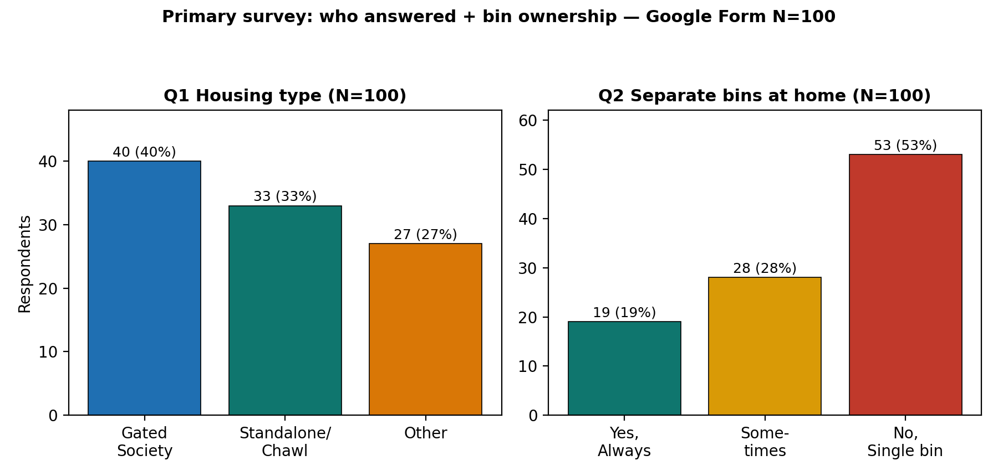
Figure P-S1. Housing and bin ownership. Source: Google Form N=100 (form-1 - Form Responses 1.csv).
What this shows: Gated Society 40, Standalone/Chawl 33, Other 27. Only 19% always use separate wet/dry bins; 28% sometimes; 53% single bin. Housing cross-tab: single-bin homes are 57.5% in Gated, 42.4% in Chawl, 59.3% in Other — the space barrier is not limited to one typology.

P-S2. Why mixing starts + collection reliability (Q3-Q4, N=100)
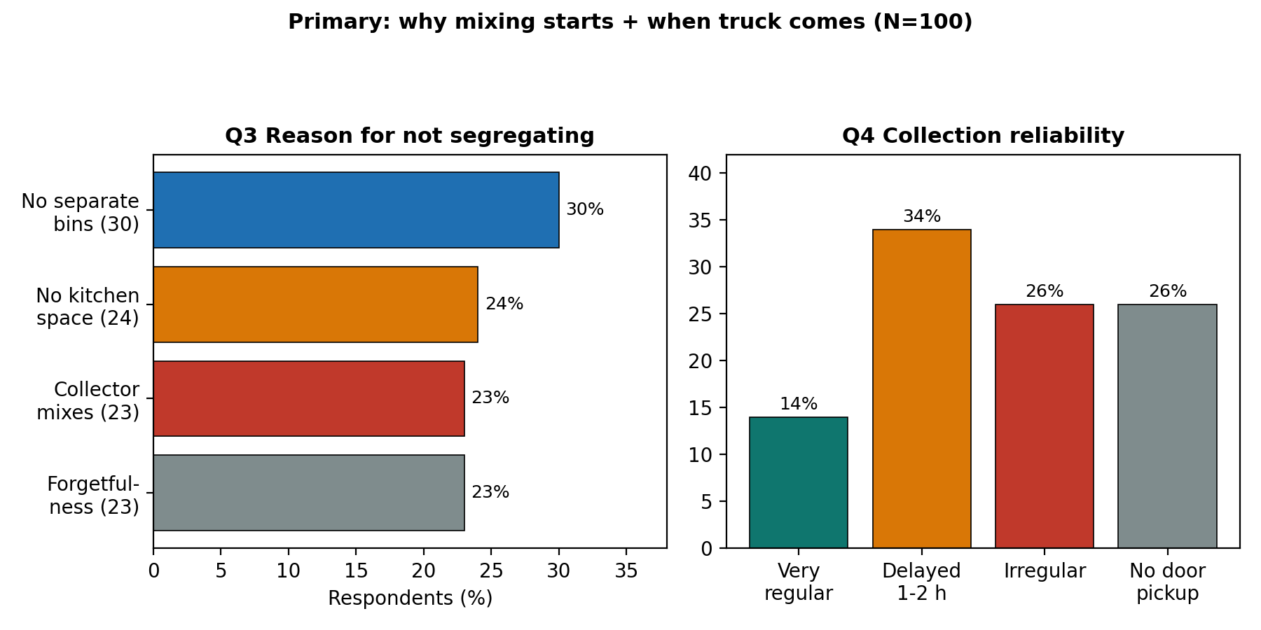
Figure P-S2. Reasons for non-segregation and collection reliability. Source: Google Form N=100.
What this shows: reasons split almost evenly — no separate bins 30%, no kitchen space 24%, collector mixes anyway 23%, forgetfulness 23%. Only 14% report very regular pickup; 34% delayed 1-2 h, 26% irregular, 26% no door-to-door. Chawl respondents report the highest no-door pickup (42.4%), matching the Zone B field note.

P-S3. The collection-chain break: vehicle + handler mixing (Q5-Q6, N=100)
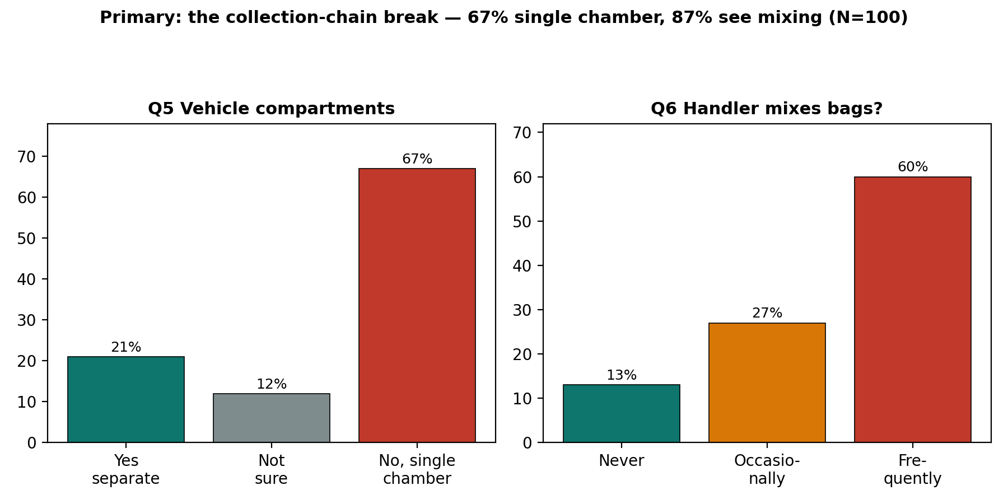
Figure P-S3. Vehicle compartments and handler mixing observed. Source: Google Form N=100.
What this shows: 67% report single-chamber vehicles, 21% separate compartments, 12% not sure. 60% frequently see handlers mixing segregated bags, 27% occasionally (combined 87%), only 13% never. Even among the 19 always-segregating homes, 68.4% still see frequent mixing — failure sits downstream of the kitchen, confirming Chapter 1 handover finding.

P-S4. Invisible haz stream + awareness + alert demand (Q7-Q9, N=100)
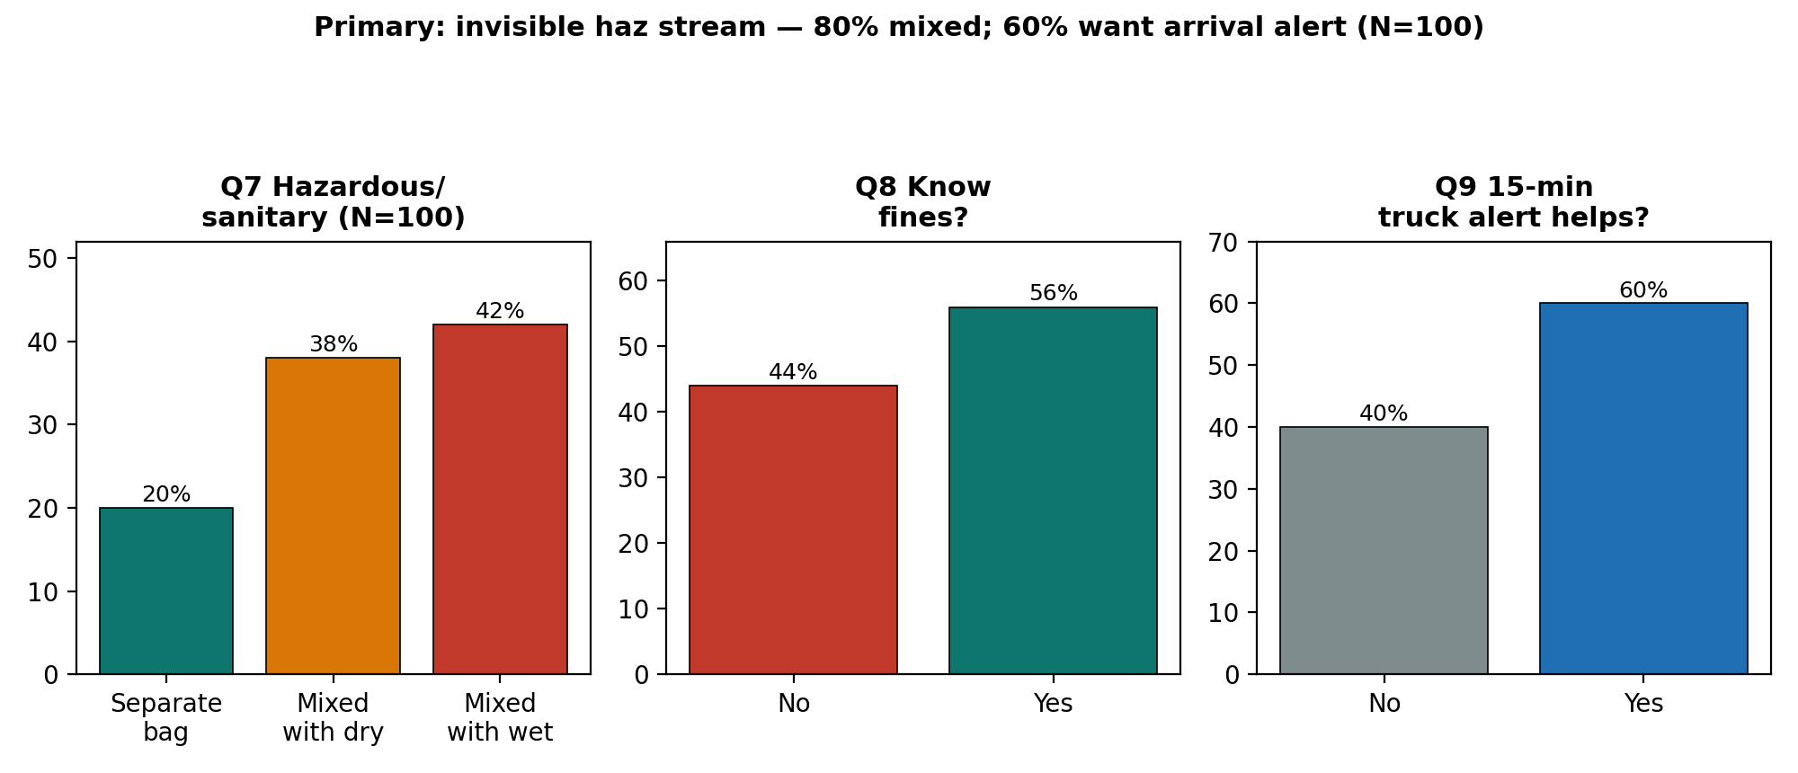
Figure P-S4. Hazardous/sanitary disposal, fine awareness, alert utility. Source: Google Form N=100.
What this shows: only 20% use a separate bag for pads/diapers/glass/medicines; 42% mix with wet, 38% with dry (80% mixed total). 56% know fines, 44% do not. 60% say a 15-minute SMS/WhatsApp truck alert would help — the basis for recommendation R5.

P-S5. What would motivate daily segregation + housing cross-tab (Q10, N=100)
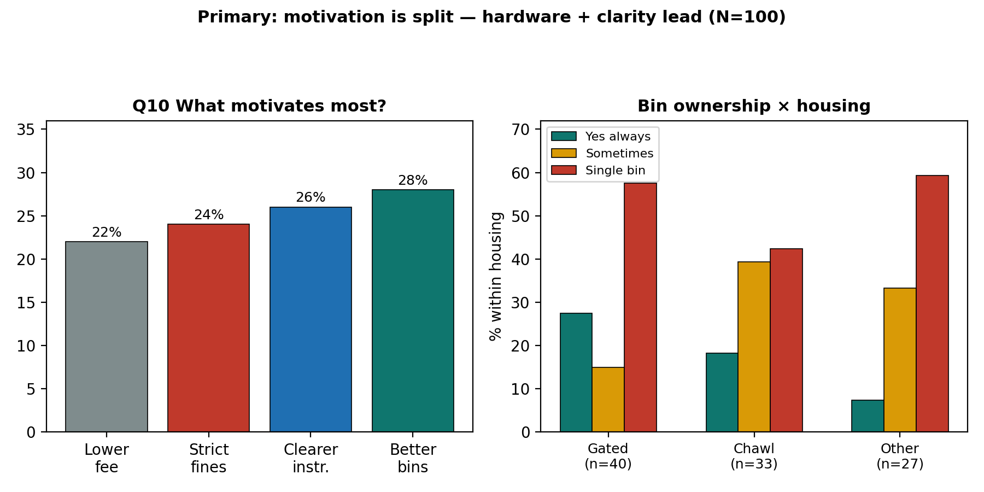
Figure P-S5. Motivation and bin ownership by housing. Source: Google Form N=100.
What this shows: motivation is split — better bins 28%, clearer instructions 26%, strict fines 24%, lower fee 22%. No single lever wins; hardware (bins) + clarity lead by a nose. Right panel: always-segregating share is highest in Gated (27.5%) vs Chawl (18.2%) vs Other (7.4%), yet single-bin use stays above 40% in every stratum.

F-1. National flow: collection succeeds, processing leaks
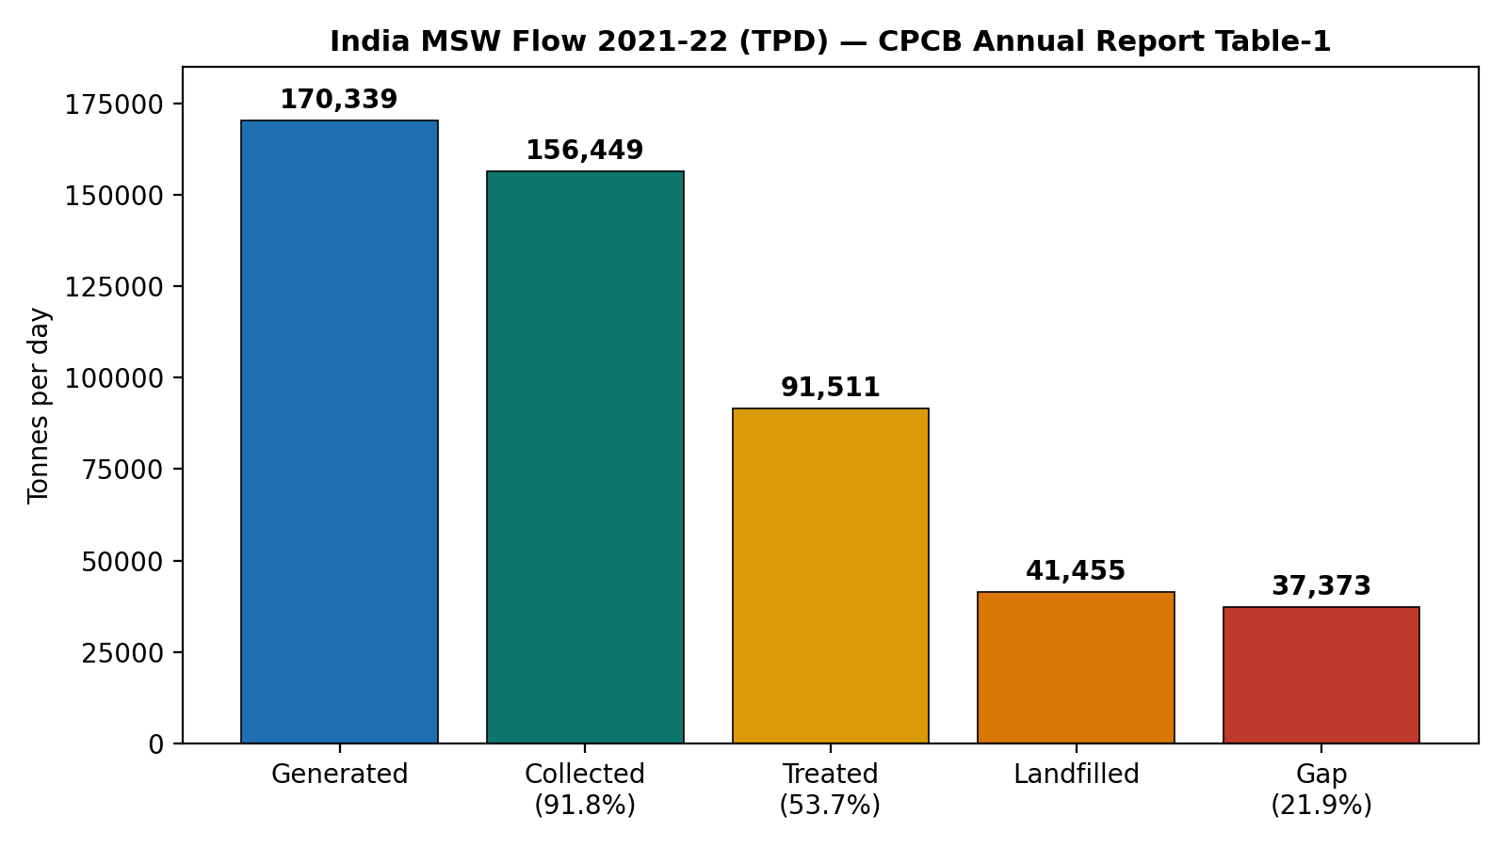
Figure F-1. India MSW flow 2021-22 (TPD). Source: CPCB Annual Report Table-1.
What this shows: of every 100 tonnes generated, about 92 are collected but only 54 are treated. Another 22 tonnes sit in an unaccounted management gap, and 24 more go to sanitary landfill. That 38-point fall from collection to treatment is the headline of this report. Trucks move the waste, but segregation quality decides whether plants can use it. The official pattern confirms it: 14 states at full collection against only 5 at full segregation.

F-2. Mission trend: door-to-door solved, segregation and processing lag
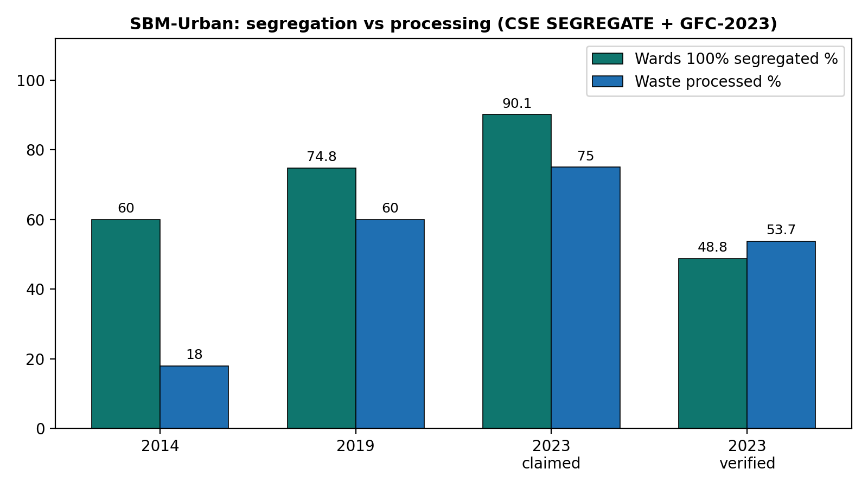
Figure F-2. SBM-Urban wards and processing. Sources: CSE SEGREGATE (2014/2019), MoHUA MIS 2023, GFC-2023 dashboard.
The takeaway: segregation claims climb from 60% to 74.8% to 90.1%, while field verification stalls at 48.8%. That is a 41.3-point credibility gap. Processing climbs from 18% to 60% to around 75% claimed, but the CPCB-verified anchor is 53.7%. Collection is essentially a solved problem at 94 to 100%. Verified segregation and processing yields are not. Any project quoting only the 90.1% MIS figure is misleading its reader, so I don't.

F-3. State contrast: volume does not explain performance
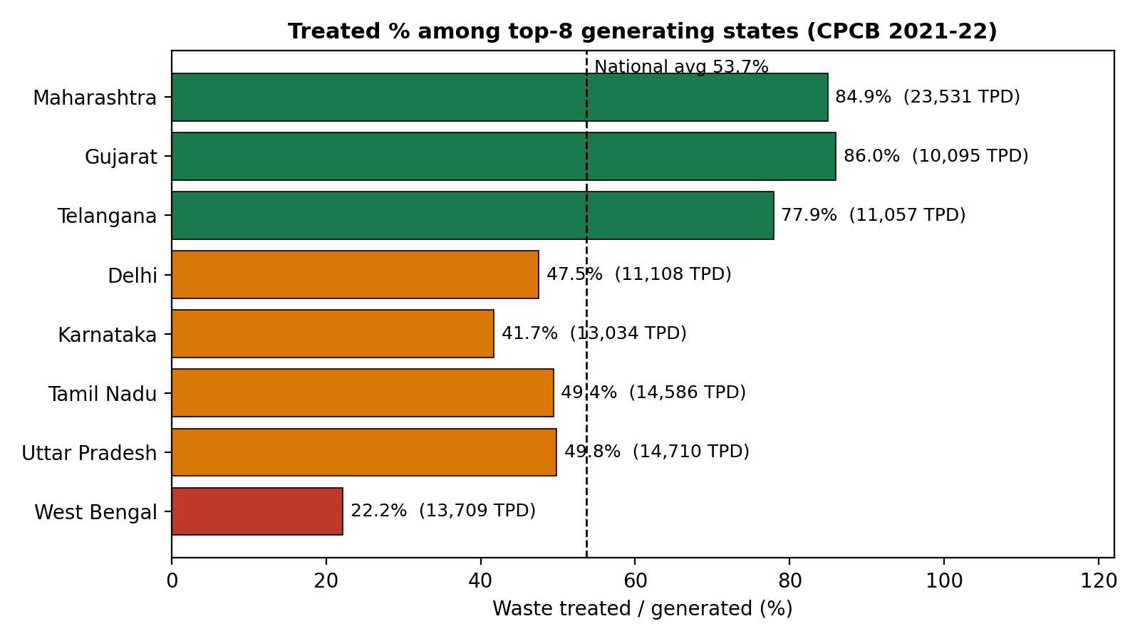
Figure F-3. Treated share among top-8 generating states. Source: CPCB 2021-22 Table-1.
Lowest processing among major generators (>1,000 TPD) | Generated (TPD) | Treated
West Bengal | 13,709 | 22.2%
Andhra Pradesh | 6,890 | 22.6%
Rajasthan | 7,973 | 24.2%
Punjab | 4,222 | 34.8%
Karnataka (despite Bengaluru) | 13,034 | 41.7%
Counterpoints: Gujarat / Maharashtra / Telangana | 10,095 / 23,531 / 11,057 | 86.0% / 84.9% / 77.9%

In plain terms: the correlation between how much a state generates and how much it treats is 0.131, which is basically nothing. West Bengal and Karnataka generate at Maharashtra's scale yet treat at a quarter to half its rate. Money and monitoring should therefore go first to the six low-processing majors, not to the metros that already perform.

F-4. Maharashtra deep-dive: a credible reform with one flag
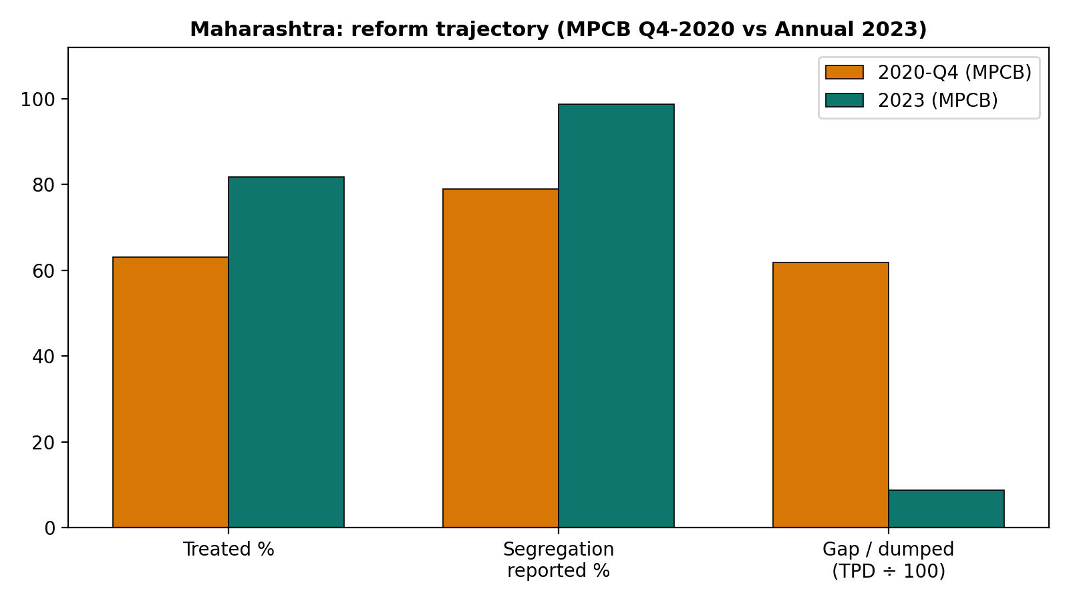
Figure F-4. Maharashtra trajectory. Sources: MPCB Q4-2020 report; MPCB Final Annual Report 2023. Gap/TPD scaled by 100.
Here the trend is genuinely encouraging. Treated share rises from 63.0% to 81.8%. Segregated-and-transported rises from 79% to 98.66% claimed. The gap collapses from 6,187 TPD to about 873 TPD dumped. Real hardware backs it: 456 composting plus 145 vermi plus 57 biomethanation plus 4 waste-to-energy plus 23 RDF plants, with 409 of 418 local bodies reporting source segregation. My one flag, stated plainly: 98.66% is ULB portal self-certification. Read it next to GFC-style field verification before declaring victory.

F-5. What waste actually is: the 4-stream reality
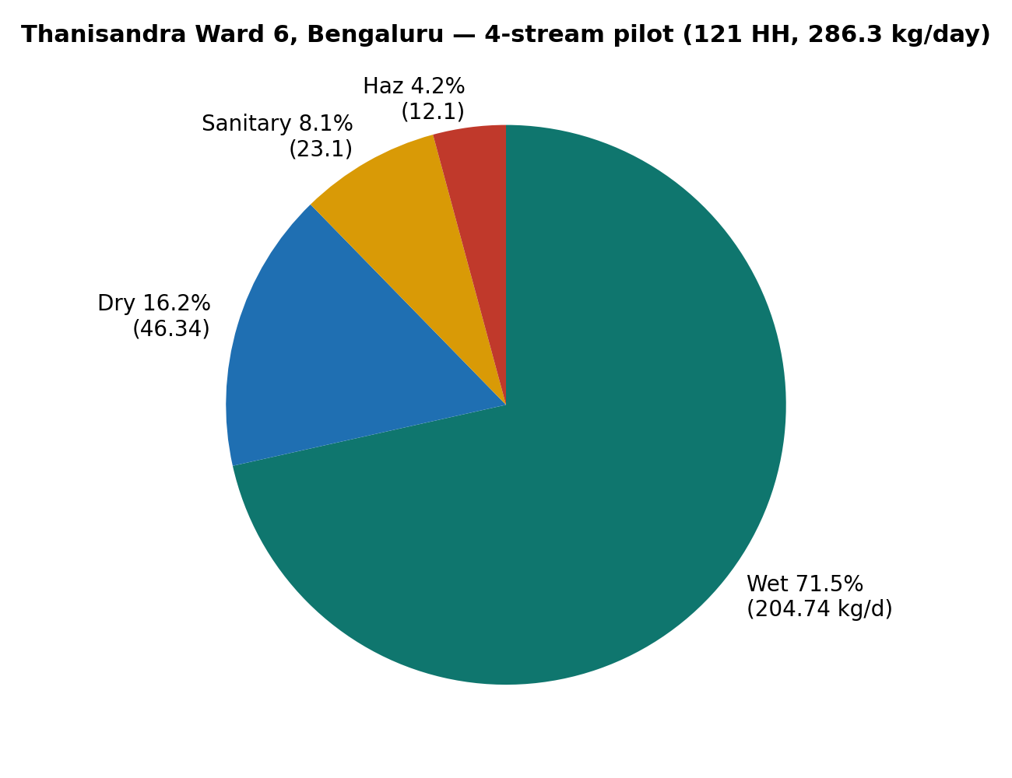
Figure F-5. Thanisandra Ward 6 pilot composition. Source: B.Tech field project (121 households).
Breaking it down: wet 204.74 kg/day (71.5%), dry 46.34 (16.2%), sanitary 23.1 (8.1%), hazardous 12.1 (4.2%). This lines up with Trivandrum's 60-65% biodegradable band and NITI's 50-60% wet band, and it settles the design question: collect four streams, not two. Sanitary plus hazardous is only about 12% of mass yet carries all of the handling risk (lead 12.03, cadmium 0.44, mercury 0.195 mg/kg). One weekly red-pouch round fixes what a thousand posters cannot. The lab logic follows naturally. Wet waste at 74% moisture and pH 5.9 goes to compost or biomethanation. Dry waste at 2,327 kcal/kg goes to recycling or waste-to-energy. Sanitary waste goes to deep burial. Hazardous waste goes to secure landfill.

F-6. What changes behaviour: lift, decay, and the hardware lesson
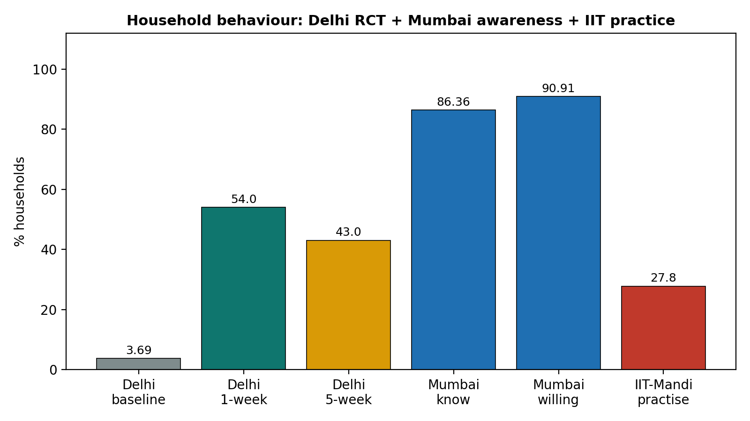
Figure F-6. Behavioural benchmarks. Sources: Delhi ISI trial; Mumbai-Mulund thesis; IIT-Mandi/WPI study.
Three results side by side. Delhi's bins-plus-brochure-plus-small-incentive pushed segregation from 3.69% to 54.0% (up 50.3 points) in a week, then it slipped to 43% (down 11 points) by week five. Information works fast, incentives work best, follow-up stops the slide. Mumbai is the mirror failure: 86.36% know wet-versus-dry and 90.91% are willing, yet nothing happens for want of separate bins and two-compartment trucks. IIT-Mandi offers the cheapest win I found: permanent labels plus engineered lids lifted correct sorting 11% in three days, from a baseline where 78% of students could not match waste to colours and only 27.8% separated regularly.
Pulling the threads together: societies need handover audits (Delhi's lesson applied at the maid and staff node), dense streets need slim hardware first (Mumbai's lesson: supply bins before slogans), informal points need reliable timing plus the cheapest nudge in the literature (IIT's lids and labels) with Trivandrum's maths-placed bins. And three independent trails agree on the scale of loss: CPCB's 53.7% treated, SBM's 60% processed, Factly's roughly 50% recycled. Roughly half of urban India's waste is still lost between the kitchen and the plant.

3.4.7 Triangulation: why independent sources agreeing matters
A fair question is whether mission dashboards, pollution-board returns and small student pilots can really tell one story. I think they do, and the agreement itself is a finding. Nationally, CPCB's 53.7% treated, SBM's 60% processed and Factly's roughly 50% recycled describe the same halfway mark from three different paper trails. On composition, Thanisandra's 71.5% wet, Trivandrum's 60-65% biodegradable and NITI's 50-60% wet band overlap within ten points across cities years apart. On behaviour, Delhi's 43-54% post-intervention practice sits between Mumbai's 91% willingness (no hardware) and IIT's 27.8% baseline practice (no labels), exactly where a hardware-plus-nudge explanation would place it. On reform speed, Maharashtra's 63% to 82% treated climb fits inside SBM's 18% to 60-75% national processing climb over the same mission years. Where sources disagree, the 90.1% MIS segregation claim against 48.8% GFC verification, or the 98.66% MPCB portal claim against handlers describing daily re-sorting, I side with the verified count and say so in the text. That is what makes the analysis checkable rather than decorative.

3.5 Conclusions
- Collection is largely solved while segregation lags: with 91.8% collected but 53.7% treated, the binding constraint is segregation quality at handover points, not truck coverage.
- Failure differs by housing type, and the data backs the field notes: delegation failure in societies, space failure in dense streets, timing-and-distance failure in informal settlements, against a verified national segregation rate near one-half rather than nine-tenths.
- The barriers rank clearly from evidence: (i) missing two-compartment transport and nearby bins; (ii) irregular timing with multi-hour delays; (iii) unreadable signage that excludes handlers; (iv) an invisible hazardous stream; (v) incentive decay without follow-up.
- Public willingness is plentiful and wasted: 91% willingness in Mumbai and a 50-point Delhi lift prove households respond within days when hardware plus a nudge arrive together.
- Timing pressure works both ways: evening beats matched to shop hours and visible scorecards can convert the same peer pressure that spreads rumours into compliance.
- Training needs are specific, not general: 30-minute demos on matching waste to colours, handling the red pouch, and reading the tipper alert, in Hindi or Marathi, at the bin point, with a 5-week re-check.
- The upside is measurable: closing the 41-point verification gap and lifting the six low-processing majors toward the 77-86% band would add roughly 25-30 points to national treatment without a single new landfill.

3.6 Recommendations
- R1: Report verified segregation (GFC/field audit) next to MIS claims in every ULB plan; make claimed-versus-verified a mandatory two-column table. (Owner: MoHUA/ULB: dashboard patch within one quarter)
- R2: Direct MRF plus compost investment to the six low-processing majors (WB, AP, Rajasthan, Punjab, Jharkhand, Assam). (Owner: State missions: count commissioned plants)
- R3: Run four-stream pickup with a separate weekly red-pouch round for sanitary/hazardous waste; weigh and publish the haz stream. (Owner: ULB plus SPCBs: track kg/week of red-pouch waste)
- R4: Put two-compartment trucks, nearby dual bins, permanent multilingual labels and engineered lids in place before any new awareness spending in high-awareness wards. (Owner: ULB engineering: check for 11% correct-sorting gain in 2 weeks)
- R5: Charge segregating households a lower user fee plus send 15-minute tipper SMS/WhatsApp alerts plus re-audit at 5 weeks to stop decay. (Owner: ULB revenue plus IT cell: track the 50-point lift and 11-point decay)
- R6: Copy the Trivandrum bin formula: bins equal (population times per-capita waste minus source-eliminated waste) divided by bin capacity, placed by least-distance mapping; publish per-ward fill data. (Owner: CS student prototype with ULB: track overflow hours)
- R7: Supply stackable dual-bins for sub-100-sq-ft homes plus an evening beat matched to shop hours in dense streets; QR scorecards for societies. (Owner: CSR plus society committees: measure contamination-rate change)
- R8: Re-survey this project's Google Form panel each quarter; merge under Annexure D; refresh Figures F-1 to F-6 yearly from CPCB/SBM releases. (Owner: Student plus guide: keep a living dataset)
- R9: Placed permanent bilingual (Marathi/Hindi) sorting labels on residential collection bins and monitored overflow and contamination rates over a 3-day observational window. (Owner: Student initiative: track 3-day bin contamination)

Chapter 4: References
- Government of India (2016). Solid Waste Management Rules, 2016. Ministry of Environment, Forest and Climate Change, New Delhi.
- CPHEEO / MoUD (2016). Municipal Solid Waste Management Manual. New Delhi.
- Central Pollution Control Board (2022). Annual Report 2021-22 on Implementation of Solid Waste Management Rules, 2016 (Table-1: 1,70,339 TPD generated). https://cpcb.nic.in/uploads/MSW/MSW_AnnualReport_2021-22.pdf
- CPCB: Municipal Solid Waste Rules page and status reports. https://cpcb.nic.in/municipal-solid-waste-rules/
- Maharashtra Pollution Control Board (2020). Quarterly Report Jan-Mar 2020 (23,607 TPD; 63% processed). https://mpcb.gov.in/sites/default/files/solid-waste/Jan20Mar2014012021.pdf
- Maharashtra Pollution Control Board (2024). Final MSW Annual Report 2023 (Revised): 24,299 TPD; 98.66% segregation claimed. https://www.mpcb.gov.in/sites/default/files/Establishment%20of%20MPCB/Seniority%20list/2014/FinalMSWAnnualReport2023Revised.pdf
- Swachh Bharat Mission Urban portal (MoHUA): mission progress, GFC-2023 dashboard, Swachh Survekshan 2023/2024 portals. https://sbmurban.org/ ; https://sbmurban.org/gfc-result-dashboard-2023 ; https://ss2023.sbmurban.org/ ; https://ss2024.sbmurban.org/
- Centre for Science and Environment: SEGREGATE knowledge paper (SBM 2014-2019 trends; GFC star ratings). https://sbmurban.org/storage/app/media/pdf/sbm_knowledge_center/segregate.pdf
- NITI Aayog (2021). Waste-Wise Cities: A Framework for Targeted Action. https://www.niti.gov.in/sites/default/files/2021-12/Waste-Wise-Cities.pdf
- Factly / Dataful: reporting gaps in CPCB solid-waste data (2015-2022 compilation). https://factly.in/data-reporting-of-solid-waste-generation-data-improves-but-still-inadequate/ ; https://dataful.in/datasets/19386/
- Thanisandra Ward 6 Bengaluru B.Tech field project (121 households, 4-bin pilot, 286.3 kg/day). https://www.scribd.com/document/1062267517/A-12-abhi-final-pdf
- Wadehra, S. & Mishra, A. (ISI Delhi). Segregation of waste at the household level: RCT across RWAs (3.69% to 54% to 43%). https://www.isid.ac.in/~epu/acegd2017/papers/ShivaniWadehra.pdf
- Shah thesis: Sustainable Waste Processing in Mumbai; Mulund resident survey (86.36% know, 90.91% willing). https://kingdombio.com/ShahThesis.pdf
- FOSSEE Fellowship: Solid Waste Management System, Thiruvananthapuram (aerobic-bin optimisation plus QGIS). https://static.fossee.in/fossee/fellowship2019/FOSSEE-Fellowship-reports-2019/R/R_SolidWasteManagementSystem_Thiruvananthapuram_Fellowship2019.pdf
- WPI (2016). Evaluating Waste Management Systems: Kataula and IIT-Mandi (27.8% practise; +11% with prototype lids).
- Open Government Data Platform India: CPCB solid-waste resources. https://www.data.gov.in/

Annexures

Annexure A : Google Form (supplementary primary survey)
Title: Waste Segregation Pipeline Survey : Mira Road Urban (5 minutes). Status: LIVE and circulating. Question list: Q1 Housing Type; Q2 Separate bins owned/used; Q3 Reason for non-segregation; Q4 Collection reliability; Q5 Separate vehicle compartments; Q6 Handler mixing observed; Q7 Separate hazardous/sanitary waste; Q8 Municipal fines awareness; Q9 15-minute arrival alert utility; Q10 Primary motivation to segregate.



Annexure B : Field response summary (primary, N=100)
Google Form file: form-1 - Form Responses 1.csv. Window: 10/2/2026 13:55:34 to 14:06:49 (about 71 minutes, 100 consecutive completions). No duplicates on Timestamp. Housing mix: Gated Society 40, Standalone Building or Chawl 33, Other 27. This annexure is generated from the CSV in this updated version; see Figures P-S1 to P-S5 for charts.

Annexure C : Photo log (as per field-project format)
Five geotagged photographs (waste room, street drum, community bin, collection vehicle, signage close-up) to be pasted below before printing. Columns: GPS | time | weather | zone | caption. Photos are evidence of visit per section 1.5 and are not replaced by charts.

Annexure D : Primary frequency tables (exact counts, N=100)
Source: form-1 - Form Responses 1.csv. Percentages = count (1 = 1.0%). Q6 has zero Not sure responses in this window.
Q | Option | Count | %
Q1 Housing | Gated Society | 40 | 40.0%
 | Standalone Building or Chawl | 33 | 33.0%
 | Other | 27 | 27.0%
Q2 Bins | Yes, Always | 19 | 19.0%
 | Sometimes | 28 | 28.0%
 | No, Single bin | 53 | 53.0%
Q3 Reason | No separate bins | 30 | 30.0%
 | Lack of kitchen space | 24 | 24.0%
 | Waste collector mixes them anyway | 23 | 23.0%
 | Forgetfulness | 23 | 23.0%
Q4 Reliability | Very regular | 14 | 14.0%
 | Delayed by 1 to 2 hours | 34 | 34.0%
 | Irregular | 26 | 26.0%
 | No door to door pickup | 26 | 26.0%
Q5 Vehicle | Yes | 21 | 21.0%
 | No, single chamber | 67 | 67.0%
 | Not sure | 12 | 12.0%
Q6 Mixing seen | Frequently | 60 | 60.0%
 | Occasionally | 27 | 27.0%
 | Never | 13 | 13.0%
 | Frequently+Occasionally | 87 | 87.0%
Q7 Hazardous | Yes, in separate bag | 20 | 20.0%
 | Mixed with wet | 42 | 42.0%
 | Mixed with dry | 38 | 38.0%
 | Mixed (wet+dry) | 80 | 80.0%
Q8 Fines known | Yes | 56 | 56.0%
 | No | 44 | 44.0%
Q9 Alert helps | Yes | 60 | 60.0%
 | No | 40 | 40.0%
Q10 Motive | Better bins | 28 | 28.0%
 | Clearer instructions | 26 | 26.0%
 | Strict fines | 24 | 24.0%
 | Lower municipal maintenance fee | 22 | 22.0%
Cross-tab highlight (for viva): among the 19 always-segregating homes, 13 (68.4%) still report frequently seeing handler mixing; among Gated (n=40) single-bin use is 23 (57.5%), Chawl (n=33) 14 (42.4%), Other (n=27) 16 (59.3%). Chawl reports highest no-door pickup at 14/33 (42.4%).

