Double inverted: errors encountered
1. on launch, rviz not subscribing to correct topic
soln: changed the config.rviz file, set the topic to double_pendulum_viz

2. buggy run at joints
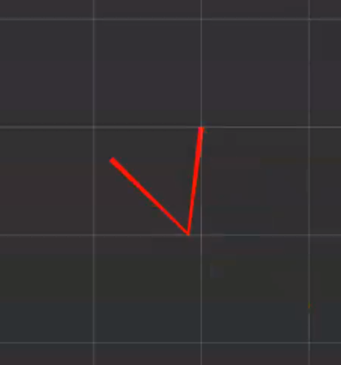

problem: the marker type was line strip
using line list solves the problem

3. was not building the custom_msgs directory
did not build the custom_msgs, just added it as a folder

DOUBTS:
1. confused in the math of single inverted and did not get the logic behind x_intermediate

