# Edunet Power BI Internship

# Sustainable Supply Chain Performance View





## Internship Week 1 Report

Submitted By: Pranjali Shukla  
Completion date: 22 January 2025 (Week 01)

**1. Introduction**

This document serves as a detailed record of the activities and accomplishments during the first week of the Edunet Power BI internship. The primary goal of this internship is to explore and analyze sustainable supply chain performance using the powerful data visualization and analytics capabilities of Power BI.

In today’s fast-paced business environment, supply chain sustainability has become a critical factor for organizational success and global impact. By examining key performance indicators (KPIs) related to inventory, manufacturing, suppliers, and the overall supply chain, this internship aims to provide insights that support data-driven decision-making and sustainable practices.

Week 1 was dedicated to foundational tasks, including loading and extracting data from CSV files, as well as transforming the data to make it analysis-ready. These tasks form the groundwork for subsequent weeks, where deeper analyses and visualizations will be performed to identify trends, inefficiencies, and opportunities for improvement. The structured approach taken during this week ensures the accuracy and reliability of insights to be derived in later stages.

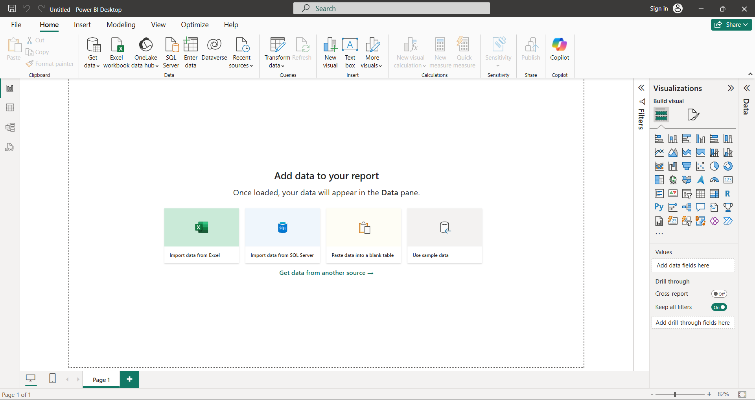

# 2. Week 1 Tasks

## 2.1 Loading and Extracting CSV Files in Power BI

- Imported the provided CSV file into Power BI Desktop.

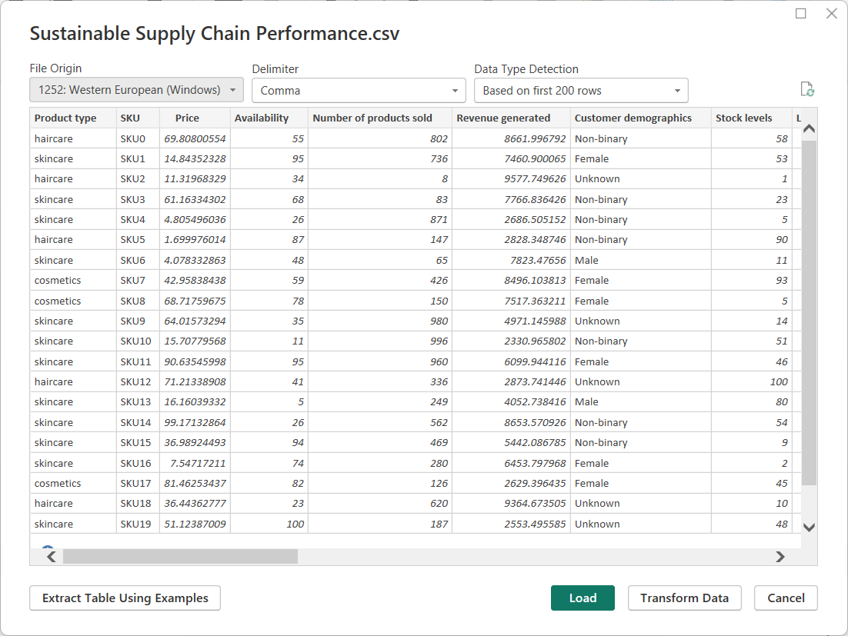

- Reviewed the structure and contents of the data.

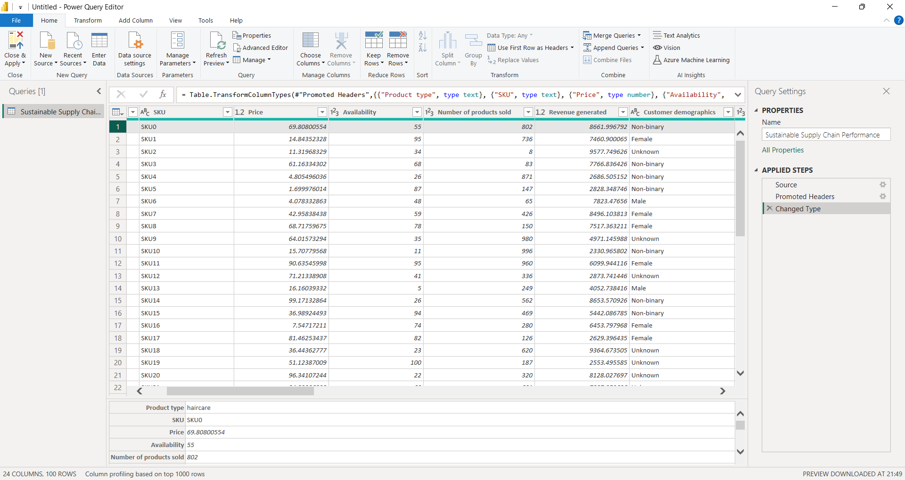- Verified data completeness and consistency.

## 2.2 Transformation of Data

### A. Inventory Table

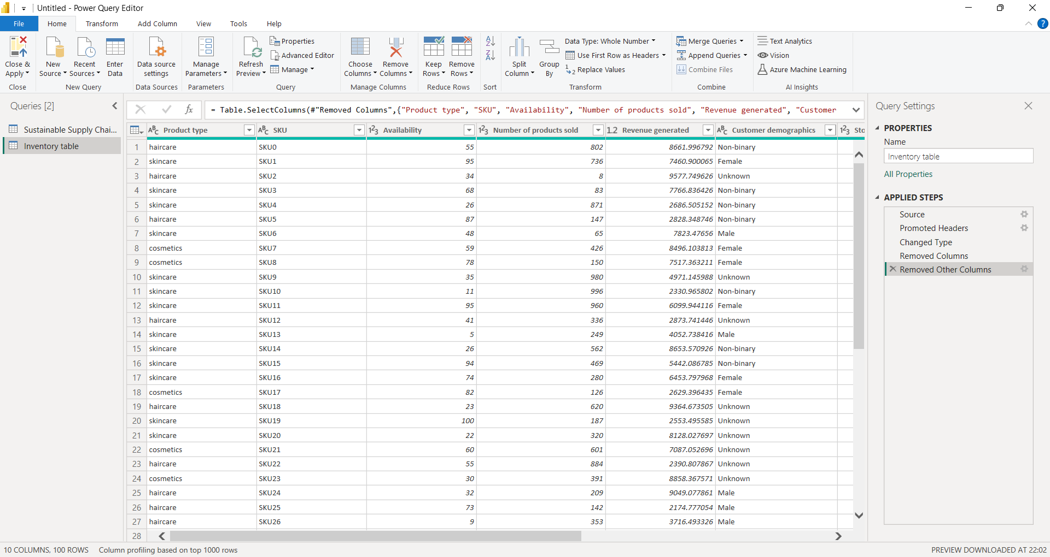Product Type: Categorized inventory by product type.  
SKU: Verified unique product identifiers.  
Availability: Checked product availability status.  
Number of Products Sold: Aggregated sales data.  
Customer Demographics: Segmented data by customer age, location, and preferences.  
Stock Levels: Analyzed current stock quantities.  
Lead Times: Measured delivery lead times.  
Order Quantities: Summarized order amounts.  
Revenue Generated: Calculated revenue per product.

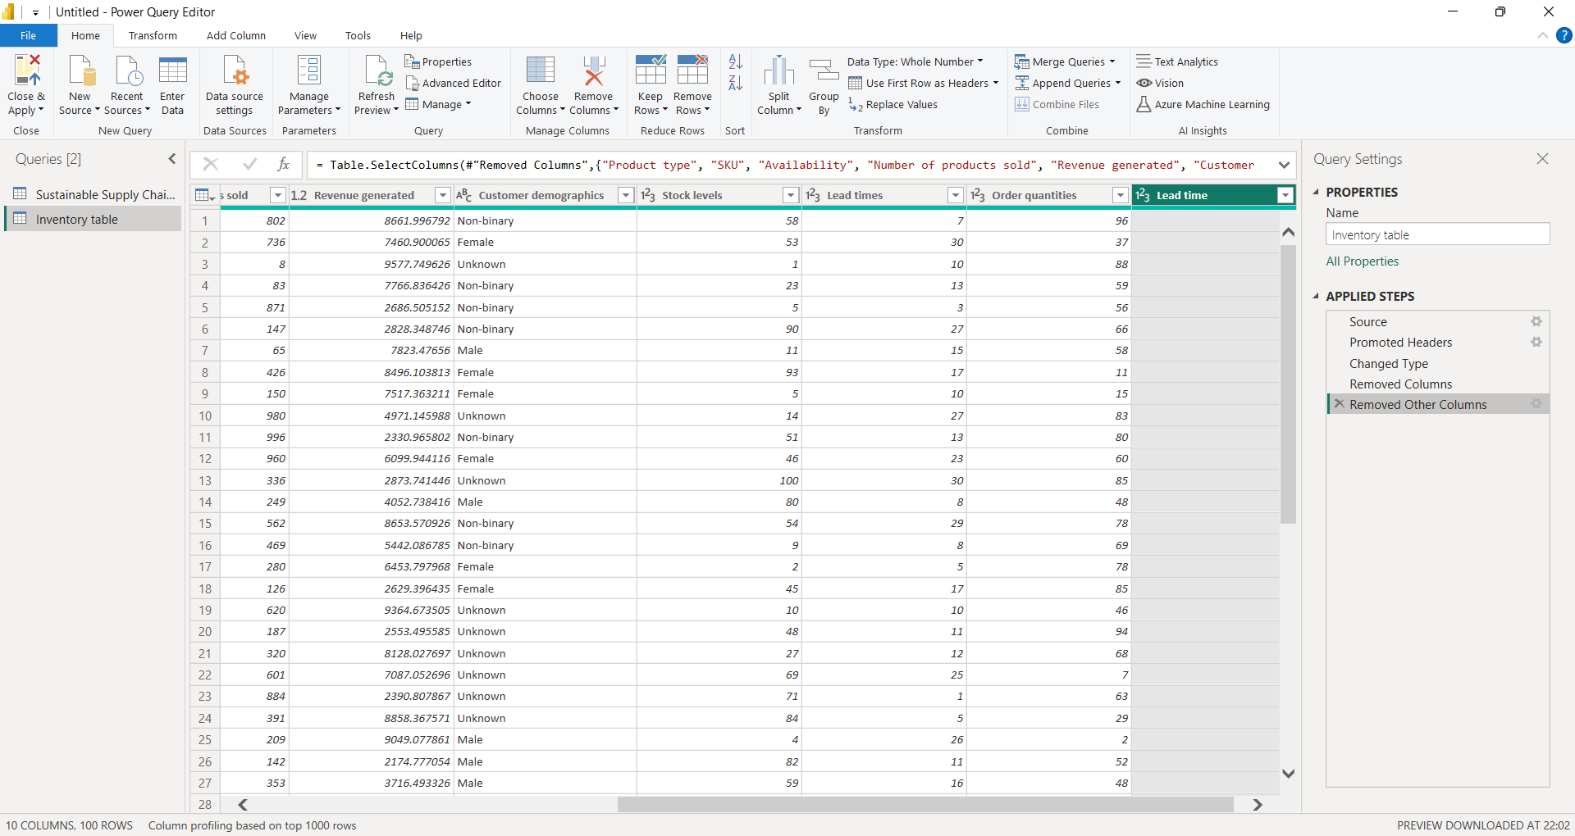

### B. Manufacturing Table

Product Type: Grouped production data by product type.  
SKU: Verified unique production identifiers.  
Production Volumes: Summarized daily and monthly production data.  
Manufacturing Lead Time: Assessed average production times.  
Manufacturing Costs: Analyzed cost per unit.  
Inspection Results: Recorded pass/fail results for quality checks.  
Defect Rates: Computed percentage of defective units.

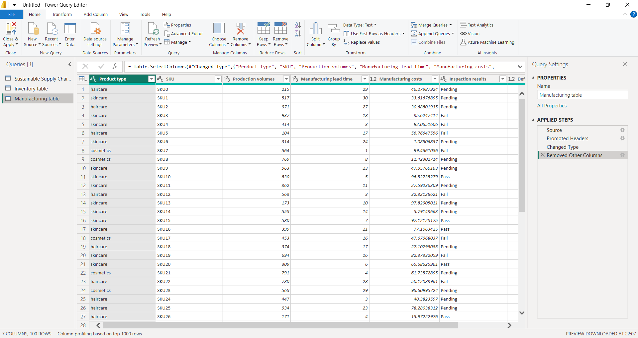

### 

### C. Supplier Table

Supplier Name: Cataloged all suppliers.  
Location: Mapped supplier locations.  
Lead Time: Evaluated supplier delivery times.  
Transportation Modes: Identified transportation methods used.  
Routes: Analyzed supply routes.

### 

### D. Supply Chain Table

Product Type: Classified supply chain data by product.  
SKU: Verified product identifiers.  
Price: Analyzed product pricing trends.  
Availability: Reviewed stock availability.  
Number of Products Sold: Summarized sales figures.  
Revenue Generated: Computed overall revenue.  
Customer Demographics: Assessed demographic trends.  
Stock Levels: Evaluated inventory levels.  
Lead Times: Analyzed delivery timelines.  
Order Quantities: Summarized order data.  
Shipping Times: Measured delivery durations.  
Shipping Carriers: Identified carriers used.  
Shipping Costs: Summarized cost trends.  
Supplier Name: Verified supplier information.  
Location: Mapped locations.  
Lead Time: Calculated supplier lead times.  
Transportation Modes: Summarized methods of transportation.  
Routes: Analyzed route efficiency.

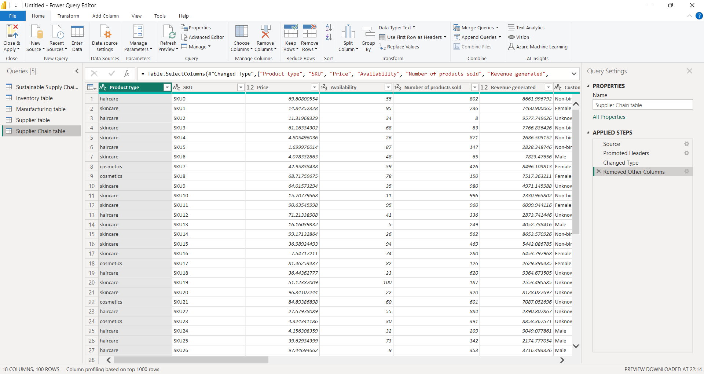

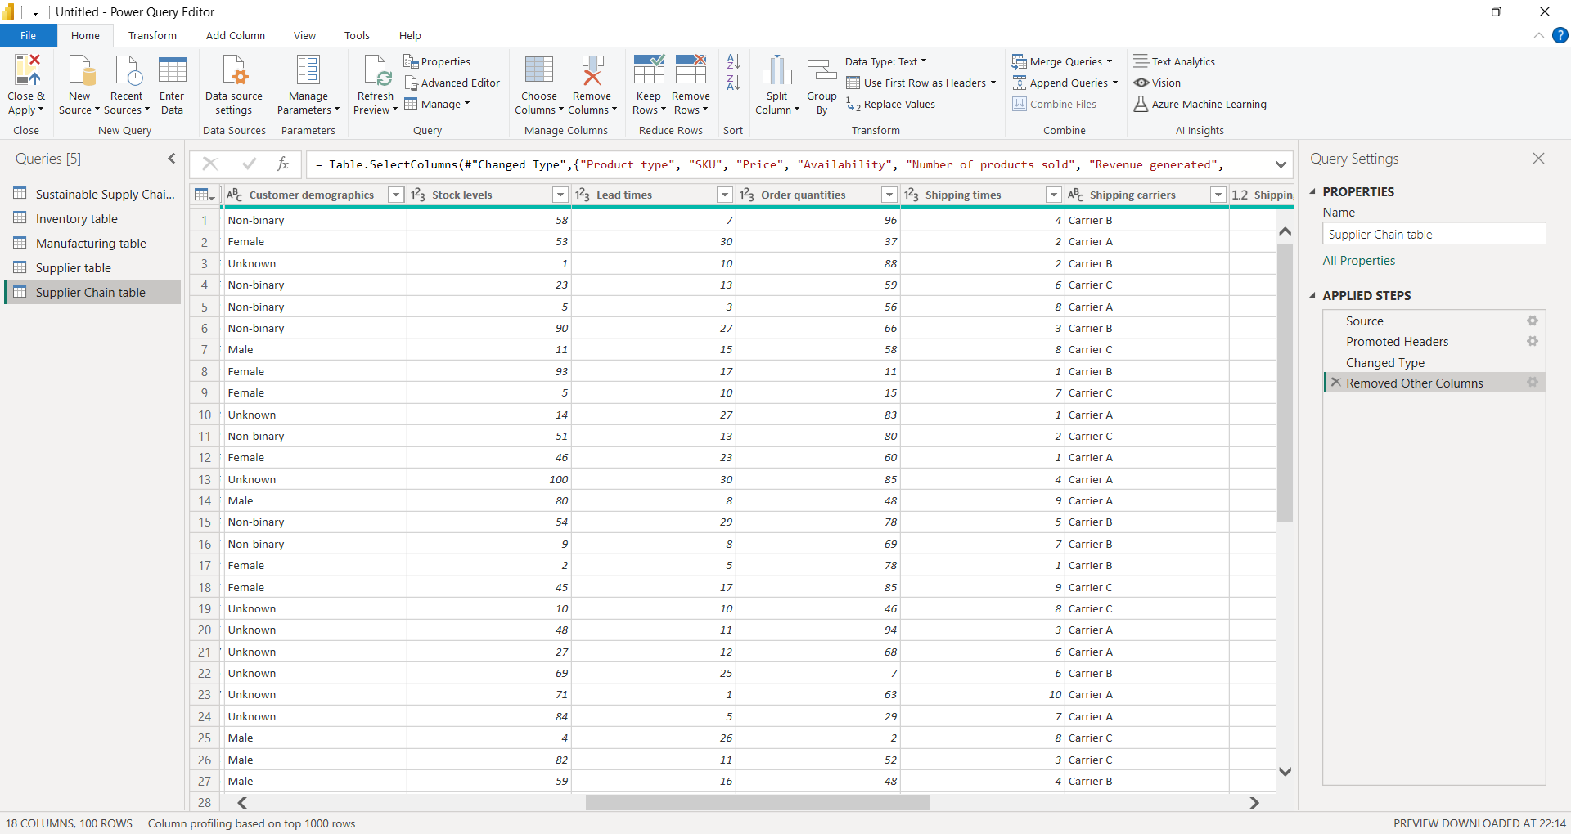

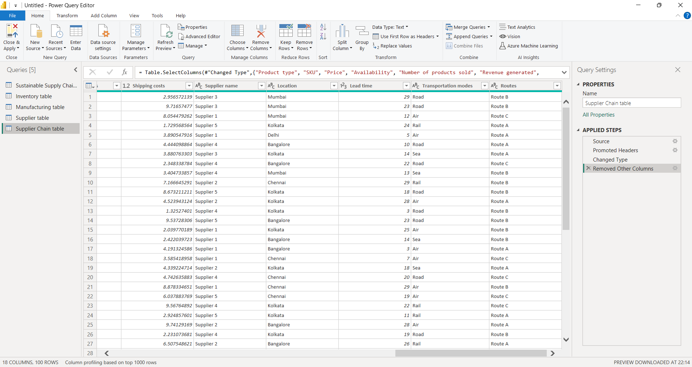

**2.3 Data Storage and Documentation**

All processed data was saved in Power BI project files (.pbix). Project files and additional notes have been uploaded to GitHub for reference and collaboration.

# GitHub Repository

Link to Csv file:

[Sustainable Supply Chain Performance.csv](Sustainable%20Supply%20Chain%20Performance.csv)

Link to Transformed csv file:

[Supply chain performance_week 01.pbix](Supply%20chain%20performance_week%2001.pbix)