VISVESVARAYA TECHNOLOGICAL UNIVERSITY
JNANA SANGAMA, BELAGAVI -590 018


Project Report

GRAIL-NAV: Generalization-Aware Deep Reinforcement Learning for Autonomous Robot Navigation in Unseen Obstacle Environments
Submitted by
Pranjali 1AY23AI085

Under the Guidance of
Prof. Jovin Deglus
Assistant Professor
Department of AIML


2025-2026

DEPARTMENT OF ARTIFICIAL INTELLIGENCE & MACHINE LEARNING
Acharya Institute of Technology
Acharya Dr. Sarvepalli Radhakrishnan Road, Soladevanahalli, Bengaluru-560107

Contents
Introduction
Chapter 1: Problem Statement and Research Objectives
1.1 Problem Statement
1.2 Core Research Hypothesis
1.3 Key Contributions of GRAIL-NAV
Chapter 2: Theoretical Framework
2.1 State Space
2.2 Action Space
2.3 Reward Function
2.4 Bellman Optimality and Target Synchronization
2.5 Loss Optimization and Gradient Clipping
Chapter 3: System Architecture and Methodology
3.1 Software Architecture
3.2 Environment Simulation and Solvability
3.3 Data Partitioning and Leakage Prevention
3.4 DQN Agent Implementation
3.5 Training Procedure
Chapter 4: Experimental Setup and Execution
4.1 Software Environment and Testing
4.2 Hyperparameter Configuration
4.3 Training, Evaluation and Visualization Workflow
Chapter 5: Results and Analysis
5.1 Training Behavior
5.2 Quantitative Benchmark
5.3 Generalization and Safety
5.4 Path Efficiency
5.5 Trajectory Case Studies
5.6 Decision Latency
5.7 Discussion
Chapter 6: Challenges, Limitations and Future Work
6.1 Challenges and Solutions
6.2 Limitations
6.3 Future Work
Conclusion
References
Appendix A: Solvability Check and Command-Line Reference
A.1 BFS Solvability Check
A.2 Command-Line Reference

Introduction
Autonomous mobile robots are now used in warehouses, logistics centers, search-and-rescue arenas and planetary exploration, and in every one of these settings the robot must reach an assigned goal without hitting anything on the way. Classical planners such as A*, Dijkstra's algorithm and Rapidly-exploring Random Trees (RRT) [1], [2], [3] solve this well when a complete map is available in advance. When the layout changes or has never been mapped, they have to replan from scratch, which costs time and gives the robot no reactive reflex of its own.
Deep reinforcement learning offers a different approach. A Deep Q-Network (DQN) [4] learns a direct mapping from what the robot senses to the motion command it should issue next, so it can react in a fraction of a millisecond. The weakness of this approach is spatial overfitting. An agent trained on a single static obstacle layout tends to memorize the coordinates of that layout instead of learning how to avoid obstacles, and its performance collapses as soon as it is placed on a layout it has not seen [5], [6].
This report presents GRAIL-NAV, a generalization-aware navigation framework built to test exactly this problem. Two DQN agents with identical architecture, hyperparameters and training length (600 episodes) are compared. The Fixed-Map agent trains on one layout only. The Diverse-Map agent trains on 600 procedurally generated layouts. Both are then evaluated on the familiar layout and on 50 held-out unseen layouts whose seeds were never used in training, which gives a 2 x 2 comparison of training regime against evaluation condition.
The report is organized into six chapters. Chapter 1 states the problem, the research hypothesis and the contributions. Chapter 2 sets out the Markov Decision Process, reward design and learning equations. Chapter 3 describes the simulator, the data partitioning and the DQN implementation. Chapter 4 covers the experimental setup and the commands used to reproduce it. Chapter 5 presents and interprets the results, and Chapter 6 lists the challenges met, the limitations and the future work. Every figure in Chapter 5 was produced by the project's own plotting scripts, and all benchmark figures come from deterministic greedy evaluation with exploration switched off.
Chapters Covered
Chapter | Content
Chapter 1 | Problem Statement and Research Objectives
Chapter 2 | Theoretical Framework (MDP, reward shaping, Bellman target, loss)
Chapter 3 | System Architecture and Methodology (simulator, seeds, DQN, training)
Chapter 4 | Experimental Setup and Execution (software, hyperparameters, workflow)
Chapter 5 | Results and Analysis (training curves, 2 x 2 benchmark, trajectories)
Chapter 6 | Challenges, Limitations and Future Work
Appendix A | Solvability check code and command-line reference

Chapter 1:

Problem Statement and Research Objectives

1.1 Problem Statement
Collision-free navigation toward a goal is a basic requirement for any autonomous robot. Classical global planners depend on a complete, pre-computed map. If an obstacle is missing from it, or the environment changes, the planner must be rerun and the robot has no behavior of its own to fall back on meanwhile.
A DQN avoids this by learning a reactive control policy, but standard DRL navigation suffers from a well-known failure mode that this project calls spatial overfitting:
• Memorization instead of avoidance: The agent can earn a high reward by memorizing a fixed sequence of coordinates, because nothing in the training signal forces it to use its sensors.
• Collapse on unseen layouts: If a memorized milestone is now occupied by an obstacle, the result is collisions, deadlock loops and failure to reach the target.

1.2 Core Research Hypothesis
Exposing a Deep Q-Network agent to diverse procedurally synthesized obstacle configurations during training cultivates spatial-invariant obstacle avoidance heuristics, preventing coordinate memorization and enabling successful zero-shot transfer to unseen layouts with zero fatal collisions.
The hypothesis has two parts that are tested separately: a safety claim (no fatal collisions on unseen maps) and a goal-reaching claim (successful zero-shot transfer). Chapter 5 shows that the data support the safety claim clearly and the goal-reaching claim only in part, so the aim is to make what a DQN learns survive a change of map.

1.3 Key Contributions of GRAIL-NAV
1. Lightweight custom simulator: A Python/NumPy 10 x 10 grid world with Breadth-First Search (BFS) checks that every layout is solvable.
2. Mnih et al. (2015) compliant DQN: A PyTorch implementation with a target network, a 20,000-transition replay memory and zero-bootstrap terminal Bellman targets [4].
3. Telescoping distance-potential rewards: Shaping terms that cancel over any closed loop, so cycling earns nothing [7].
4. Leakage-free seeds: Disjoint training (42, 1001 to 1600) and test (9000 to 9049) seeds.
5. 2 x 2 benchmark: Both policies tested on the familiar map and 50 unseen maps.

Chapter 2:

Theoretical Framework
GRAIL-NAV models robot navigation as a discrete-time Markov Decision Process (MDP) defined by the tuple (S, A, P, R, γ), where S is the state space, A the action space, P the transition dynamics of the grid world, R the reward function and γ the discount factor [8].

2.1 State Space

Case Study Analysis
At every time step t the state s_{t} is a vector of 33 continuous features, each normalized into a bounded interval. The first eight features describe where the robot is relative to the goal. The remaining 25 form the robot's only view of the obstacles.
Table 2.1. State vector layout (33 features)
Indices | Description | Range / values | Purpose
0:2 | Normalized robot position (x, y) | [0.0, 1.0] | Localization in the grid, computed as x / (N - 1)
2:4 | Normalized goal position (x, y) | [0.0, 1.0] | Target destination coordinates
4:6 | Relative goal displacement (Δx, Δy) | [-1.0, 1.0] | Heading vector toward the goal
6 | Normalized Manhattan distance | [0.0, 1.0] | Distance divided by 2(N - 1)
7 | Normalized Euclidean distance | [0.0, 1.0] | Straight-line distance divided by √2 (N - 1)
8:33 | Local 5 x 5 occupancy field (radius r = 2) | {-1.0, 0.0, 1.0} | 1.0 = obstacle or wall, -1.0 = goal, 0.0 = free space

The local perception window provides 25 sensory inputs centered on the robot. Any cell that falls outside the grid boundary is encoded as 1.0, so the edge of the world looks like an impenetrable wall. This window is the only information that generalizes between maps, because absolute coordinates mean something different on every layout. Whether the network relies on it or on the coordinates is the central question of the experiment.

2.2 Action Space
The robot executes orthogonal movements on the 2D grid, so the action space has four elements. A move into the boundary leaves the robot where it is.
Table 2.2. Action space
Action | Direction | Displacement (row, col) | Note
a = 0 | UP | (-1, 0) | Toward row 0
a = 1 | DOWN | (+1, 0) | Toward the goal row
a = 2 | LEFT | (0, -1) | Toward column 0
a = 3 | RIGHT | (0, +1) | Toward the goal column

2.3 Reward Function

Case Study Analysis
The scalar reward balances goal seeking, obstacle avoidance and speed. It has three parts: a constant step penalty, an event reward and a potential-based shaping term.
R(s, a, s') = R_{step} + R_{event} + R_{potential}(s, s') (2.1)
R_{potential}(s, s') = 1.5 × [ d_{M}(s, goal) − d_{M}(s', goal) ] (2.2)
Here d_{M} is the Manhattan distance to the goal. Moving one cell closer therefore earns +1.5 and moving one cell away costs 1.5. Potential-based shaping of this kind leaves the optimal policy unchanged while giving the agent a dense learning signal [7].
Table 2.3. Reward components
Component | Value | Role
Goal reached | +100.0 | Terminal state; main incentive
Obstacle collision | -100.0 | Fatal collision; terminal state
Wall boundary collision | -10.0 | Invalid move; robot stays in place
Time penalty (per step) | -1.0 | Penalizes lingering and non-optimal paths
Distance potential | 1.5 x change in Manhattan distance | Dense progress signal toward the goal

Loop Cancellation
A common weakness of shaped rewards is that an agent can farm them by cycling. Suppose the agent loops between two adjacent cells A and B. Stepping one cell closer to the goal gives +1.5 from the potential and -1.0 from the time penalty, a net of +0.5. Stepping back gives -1.5 and -1.0, a net of -2.5. One full cycle A to B to A therefore returns -2.0. For any closed loop of k states, the potential terms form a telescoping series that sums to zero:
Σ_{i=1}^{k} [ Φ(s_{i}) − Φ(s_{i+1}) ] = Φ(s₁) − Φ(s_{k+1}) = 0, s_{k+1} = s₁ (2.3)
with Φ(s) = 1.5 d_{M}(s, goal). The shaping term can therefore not be exploited, and a looping agent collects a net return of -k from the time penalty alone.

2.4 Bellman Optimality and Target Synchronization
The action-value function Q(s, a; θ) approximates the expected discounted return of taking action a in state s and acting optimally afterwards.
Q*(s, a) = E [ r + γ max_{a'} Q*(s', a') | s, a ] (2.4)
To remove the moving-target instability that appears when one network produces both the estimate and the target, a separate target network with frozen parameters θ⁻ is kept and synchronized with the online network every C = 10 episodes [4]. The learning target for a sampled transition i is
y_{i} = r_{i} + γ (1 − d_{i}) max_{a'} Q(s'_{i}, a'; θ⁻) (2.5)
where d_{i} is the terminal flag. If d_{i} = 1 (goal reached or fatal collision) the bootstrap term vanishes and y_{i} = r_{i}. If d_{i} = 0 the future return is discounted by γ = 0.99.

2.5 Loss Optimization and Gradient Clipping
Minibatches of B = 64 transitions are sampled uniformly from the replay buffer. The loss is the Huber (Smooth L1) loss [9], which behaves like a squared error for small residuals and like an absolute error for large ones, so a few extreme rewards such as -100 do not dominate the gradient.
L(θ) = (1 / B) Σ_{i=1}^{B} SmoothL1( Q(s_{i}, a_{i}; θ) − y_{i} ) (2.6)
SmoothL1(u) = 0.5 u² if |u| < 1, |u| − 0.5 otherwise (2.7)
The gradient norm is clipped before every step of the Adam optimizer [10]:
|| ∇_{θ} L(θ) ||₂ ≤ 10.0 (2.8)

Chapter 3:

System Architecture and Methodology

3.1 Software Architecture

Case Study Analysis
The project is organized as a small Python package with one folder per concern. A single command-line entry point, main.py, accepts four modes (train, evaluate, report and visualize), and every tunable value lives in config.py. Saved models, training logs and figures are written to the models and results folders, and an automated test suite in the tests folder covers the environment and the agent.
Table 3.1. Main modules and their responsibilities
File | Main classes / functions | Responsibility
config.py | EnvConfig, DQNConfig, TrainConfig, EvalConfig | Central configuration: environment, network, learning rates, seeds, directories
main.py | main(), parse_arguments() | CLI entry point with modes train, evaluate, report, visualize
environment/grid_world.py | GridWorldEnv, is_path_viable() | Grid physics, obstacle placement, local sensing, BFS reachability
agent/dqn_network.py | DQNNetwork | MLP 33 -> 128 -> 128 -> 4 with Kaiming Normal initialization
agent/replay_buffer.py | ReplayBuffer | Ring buffer of (s, a, r, s', d) tuples; uniform minibatch sampling
agent/dqn_agent.py | DQNAgent | Epsilon-greedy action selection, Bellman update, target sync, save and load
training/train.py | train_agent(), set_seed() | Fixed-Map and Diverse-Map training loops with CSV logging
evaluation/evaluate.py | evaluate_agent(), run_full_comparative_evaluation() | Deterministic greedy evaluation on familiar and held-out maps
evaluation/metrics.py | MetricsResult, compute_navigation_metrics() | Success, collision and timeout rates, reward, path length, latency
visualization/ | generate_all_plots(), render_navigation_episode() | Publication plots and 2D trajectory rendering

3.2 Environment Simulation and Solvability
The environment is a custom grid world with the following specification:
• Grid: 10 x 10, giving 100 discrete cells.
• Start and goal: The robot starts at (0, 0) in the top-left corner and must reach (9, 9) in the bottom-right corner.
• Obstacles: Static, with a density of 18 percent, which is about 18 obstacle cells per map.
• Episode length: At most 60 steps. If the goal has not been reached by then, the episode is truncated and counted as a timeout.
Randomly placed obstacles could in principle wall off the start or the goal and make a map impossible. To prevent this, every generated layout passes through a BFS rejection filter that searches for an unblocked 4-connected path from start to goal (the code is given in Appendix A). If a layout has no path, its seed is rejected and incremented until a solvable layout is found. Every map used in training and testing is therefore guaranteed to be solvable, so a timeout always reflects a failure of the agent and never an impossible map.

3.3 Data Partitioning and Leakage Prevention
To avoid train-test leakage, the pseudo-random seeds that define the maps are split into three strictly separate sets.
Table 3.2. Seed partition
Purpose | Seeds | Maps
Fixed-Map training | 42 | One static layout
Diverse-Map training | 1001 to 1600 | 600 unique procedural layouts
Held-out unseen test | 9000 to 9049 | 50 strictly isolated layouts

S_{train,fixed} ∩ S_{test} = {42} ∩ {9000, …, 9049} = ∅ (3.1)
S_{train,diverse} ∩ S_{test} = {1001, …, 1600} ∩ {9000, …, 9049} = ∅ (3.2)
This isolation is verified automatically by the test test_no_test_seed_leakage in tests/test_agent.py.

3.4 DQN Agent Implementation

Network Architecture
The value approximator DQNNetwork is a multi-layer perceptron implemented in PyTorch [11]. It takes the 33-dimensional state, passes it through two fully connected hidden layers of 128 units with ReLU activations, and outputs one Q-value per action. The hidden layers use Kaiming Normal initialization [12] and the output layer uses Xavier Uniform initialization [13]. Counting weights and biases, the network has 21,380 trainable parameters, which is small enough to run on a CPU.
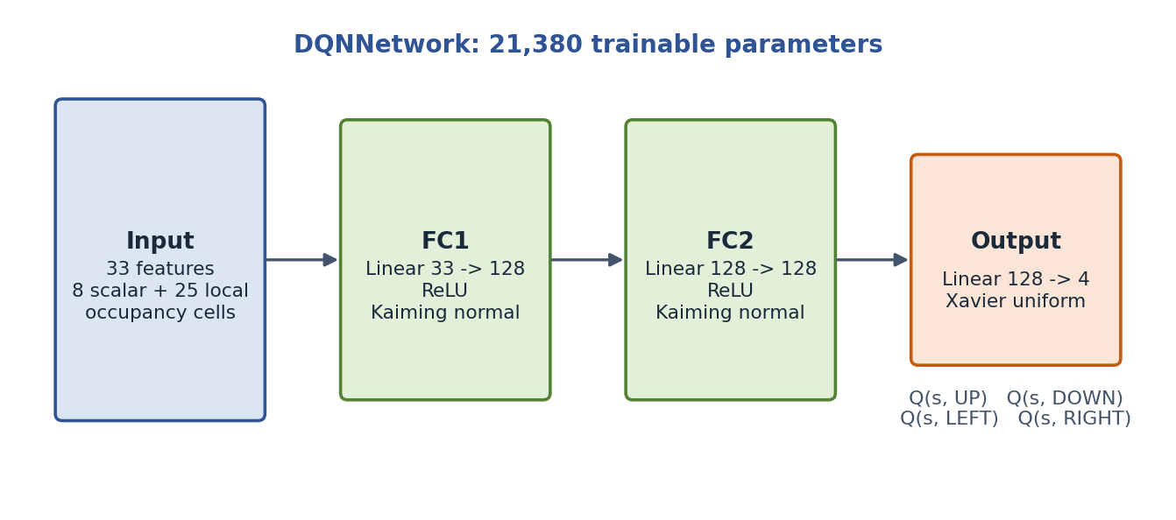
Figure 3.1. DQNNetwork architecture (33 -> 128 -> 128 -> 4)
Experience is held in a cyclic first-in first-out replay buffer with a capacity of 20,000 transitions. Minibatches are drawn uniformly at random, which breaks the strong temporal correlation between consecutive robot steps [14]. The DQNAgent class wraps the online network, the target network, the buffer and the optimizer, and exposes the methods act, remember, learn, sync, save and load.

3.5 Training Procedure

Diagram
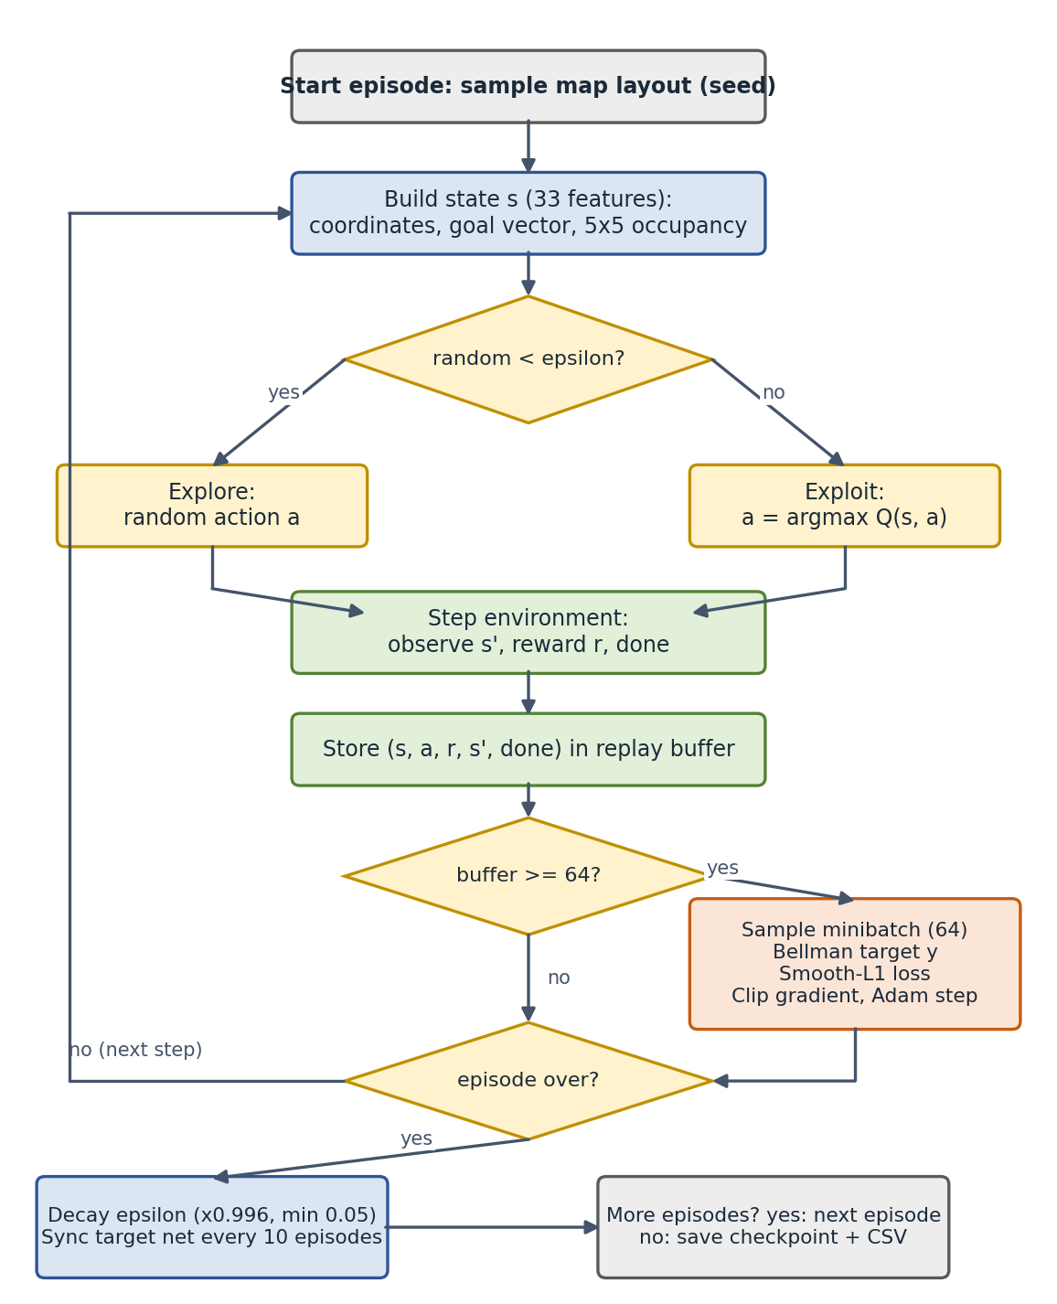
Figure 3.2. Training loop of the GRAIL-NAV DQN agent

Description of the Loop
1. At the start of each episode a map layout is chosen from the seed list: always seed 42 for the Fixed-Map agent, and a different seed from 1001 to 1600 for each episode of the Diverse-Map agent.
2. The 33-feature state is built from the robot position, the goal vector and the 5 x 5 occupancy window.
3. With probability ε the agent explores with a random action. Otherwise it exploits by choosing the action with the highest predicted Q-value.
4. The environment applies the action and returns the next state, the reward and the done flag. The transition is stored in the replay buffer.
5. Once the buffer holds at least 64 transitions, a minibatch is sampled, the Bellman target of Equation 2.5 is computed from the target network, the Smooth L1 loss is minimized, the gradient is clipped to norm 10 and one Adam step is taken.
6. When the episode ends, ε is decayed as ε ← max(0.05, 0.996 ε), and every 10 episodes the target network is synchronized with the online network.
With a decay of 0.996 per episode, ε falls from 1.0 to roughly 0.09 after 600 episodes, so it has not yet reached the 0.05 floor when training stops. The agent is therefore still exploring a little at the end of training. This matters when reading the training curves in Chapter 5, because they are recorded under exploration while the benchmark is recorded under greedy action selection.

Chapter 4:

Experimental Setup and Execution

4.1 Software Environment and Testing
The framework needs Python 3.10 or newer and the following packages: torch (2.0 or newer), numpy (1.24 or newer), matplotlib (3.7 or newer), pandas (2.0 or newer) and pytest (7.3 or newer). All experiments ran on a standard CPU with no GPU.
Before any training, the automated test suite checks the environment physics, BFS reachability, collision handling, Bellman terminal masking, the replay buffer and seed isolation. The suite contains 13 tests (7 for the agent and 6 for the environment), and all 13 passed in about 10 seconds. Training the Fixed-Map agent for 600 episodes took about 80 seconds and training the Diverse-Map agent took about 90 seconds.

4.2 Hyperparameter Configuration
Both agents use exactly the same settings, so that the training regime is the only difference between them. All values are defined in config.py.
Table 4.1. Environment and DQN configuration
Parameter | Value | Role
grid_size | 10 | Dimension of the N x N grid
obstacle_density | 0.18 | Proportion of obstacle cells
obs_radius | 2 | Sensor window of (2r + 1)² = 25 cells
max_steps | 60 | Steps before truncation as a timeout
reward_goal / reward_collision | +100.0 / -100.0 | Terminal rewards
reward_invalid_move / reward_step | -10.0 / -1.0 | Wall bump and per-step penalty
distance_reward_factor | 1.5 | Potential shaping multiplier
hidden_dims | [128, 128] | Two ReLU hidden layers
learning_rate | 0.001 | Adam learning rate
gamma | 0.99 | Discount factor
buffer_capacity / batch_size | 20,000 / 64 | Replay memory and minibatch size
epsilon_start / min / decay | 1.0 / 0.05 / 0.996 | Exploration schedule per episode
target_update_episodes | 10 | Episodes between target synchronizations
grad_clip_norm | 10.0 | Maximum L2 gradient norm
Training episodes | 600 | For both agents

4.3 Training, Evaluation and Visualization Workflow
The whole experiment is reproduced with five commands, each handled by main.py.
Table 4.2. Reproduction workflow
Step | Command | Output
Test | python -m pytest tests/ | 13 tests passed
Train fixed | python main.py --mode train --scenario fixed --episodes 600 | models/dqn_fixed.pt, results/training_fixed.csv
Train diverse | python main.py --mode train --scenario diverse --episodes 600 | models/dqn_diverse.pt, results/training_diverse.csv
Report | python main.py --mode report | evaluation_summary.csv and four comparison plots
Visualize | python main.py --mode visualize --seed 9005 | Trajectory plot for the chosen seed

Evaluation uses deterministic greedy action selection (ε = 0). The Fixed-Map agent is evaluated on its familiar layout (seed 42) and on the 50 held-out layouts (seeds 9000 to 9049). The Diverse-Map agent is evaluated on the same 50 held-out layouts and also on seed 42. The full command-line reference is given in Appendix A.

Chapter 5:

Results and Analysis

5.1 Training Behavior

Reward Progression
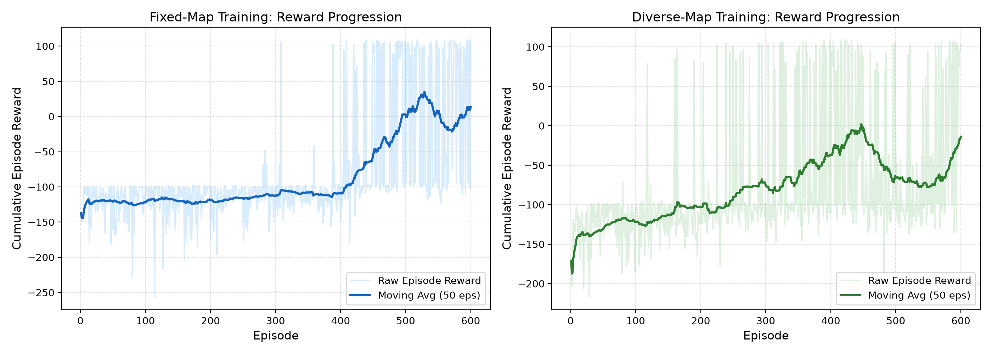
Figure 5.1. Episode reward and 50-episode moving average for both agents
The Fixed-Map agent stays close to a moving-average reward of about -120 for the first 400 episodes, which is the level of an agent that mostly wanders until the step limit. Once it finds the route through the single map, the average climbs steeply, peaks at roughly +35 near episode 530, and ends at about +14. The Diverse-Map agent starts lower, at around -185, but improves earlier and more gradually. It reaches an average near 0 around episode 445, falls back to about -80 by episode 540 and then recovers to about -13 at episode 600. The values in this paragraph are read from the plots and are approximate.

Success Progression
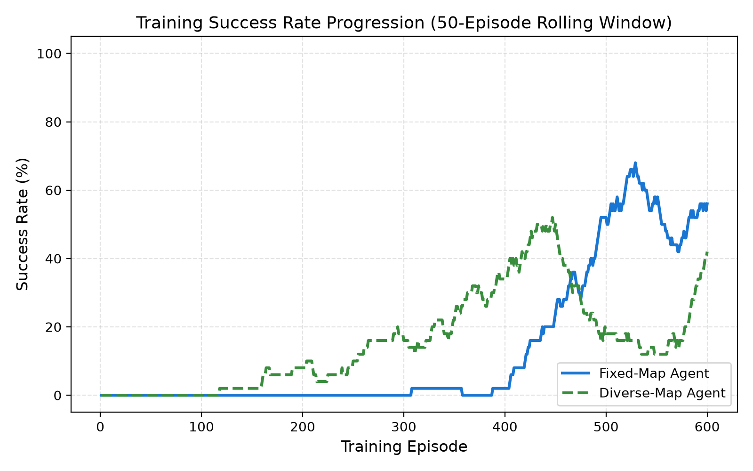
Figure 5.2. Training success rate over a 50-episode rolling window
The success curves tell the same story. The Fixed-Map agent records almost no successes until about episode 400, then reaches a peak of roughly 68 percent near episode 530 and finishes near 55 percent. The Diverse-Map agent begins to succeed from about episode 120, reaches about 52 percent near episode 445, drops to about 12 percent and finishes near 42 percent, still rising. The Diverse-Map curve is less smooth because every episode is played on a different layout, so the rolling success rate depends on how easy the recent maps happened to be. Both curves are measured while the agent still explores, so they are lower than the greedy results in the benchmark and should not be compared with them directly.

5.2 Quantitative Benchmark
Table 5.1 and Table 5.2 give the 2 x 2 benchmark. Unseen-map results are averaged over the 50 held-out layouts (seeds 9000 to 9049) under greedy action selection. The familiar-map result uses the single seed 42 layout, which is why its standard deviation is zero.
Table 5.1. Outcome rates
Agent policy | Evaluation condition | Success (%) | Collision (%) | Timeout (%)
Fixed-Map agent | Familiar map (seed 42) | 100.0 | 0.0 | 0.0
Fixed-Map agent | Held-out unseen maps | 0.0 | 18.0 | 82.0
Diverse-Map agent | Familiar map (seed 42) | 0.0 | 0.0 | 100.0
Diverse-Map agent | Held-out unseen maps | 14.0 | 0.0 | 86.0

Table 5.2. Reward, path length and latency
Agent policy | Condition | Avg reward | Std dev | Avg steps | Avg success path | Latency (ms)
Fixed-Map | Familiar map | +108.50 | 0.00 | 18.00 | 18.00 | 0.087
Fixed-Map | Unseen maps | -304.14 | 280.13 | 50.04 | N/A | 0.098
Diverse-Map | Familiar map | -48.00 | 0.00 | 60.00 | N/A | 0.085
Diverse-Map | Unseen maps | -20.99 | 52.41 | 54.12 | 18.00 | 0.089

5.3 Generalization and Safety
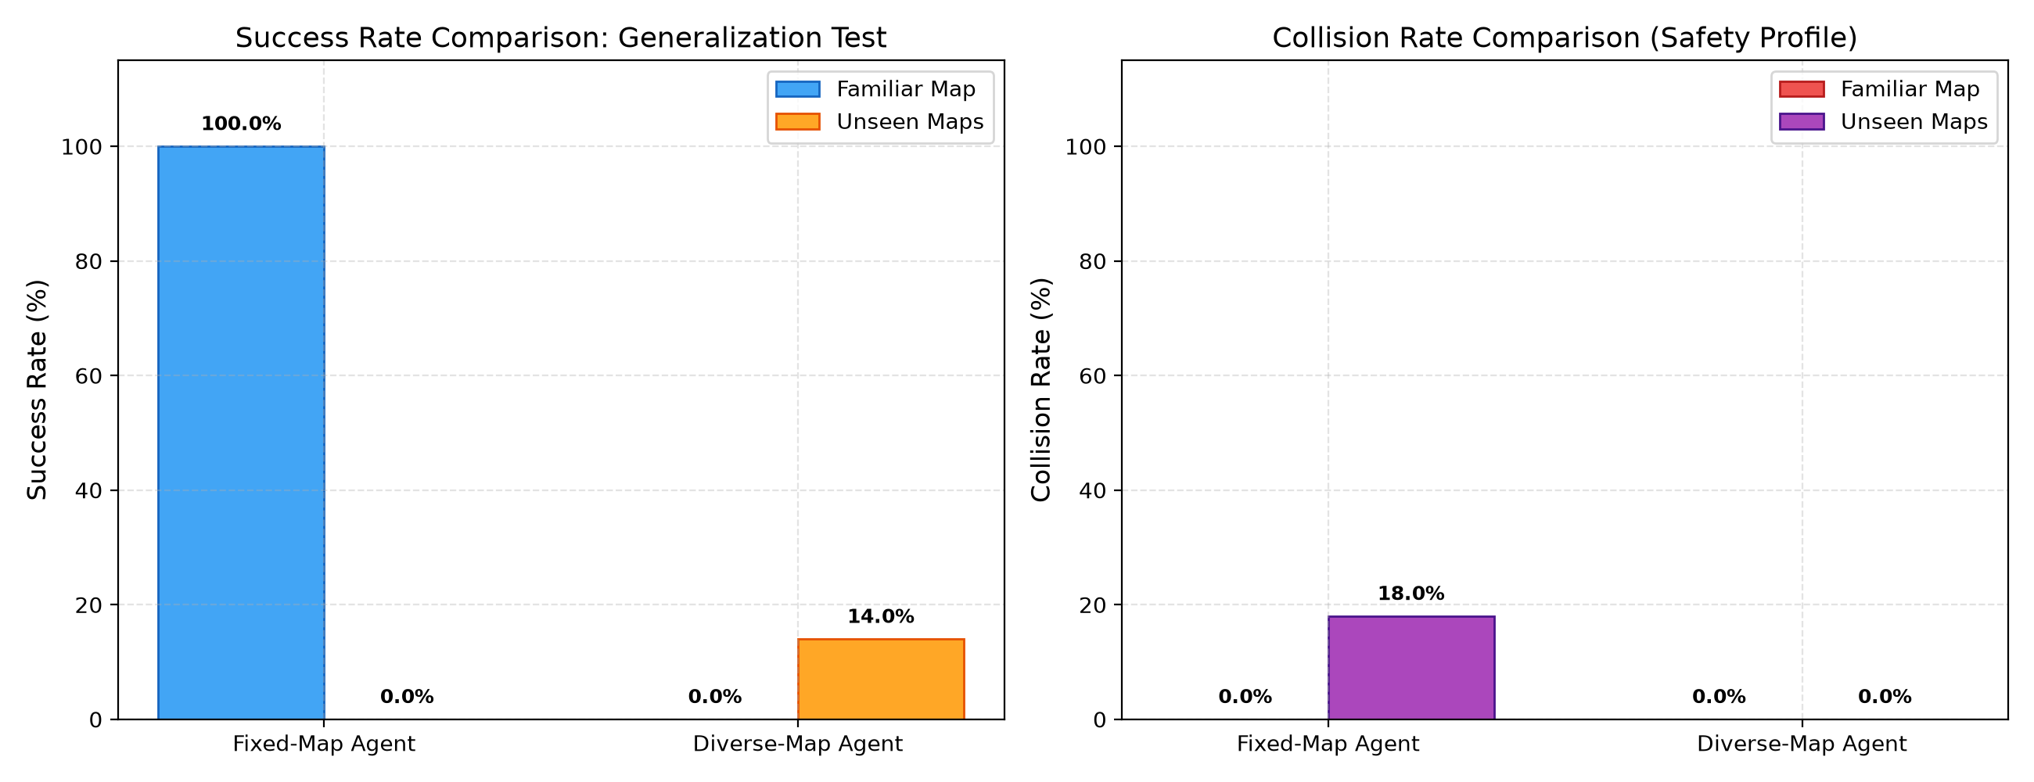
Figure 5.3. Success rate (left) and collision rate (right) for both agents

Memorization Collapse in Fixed-Map Training
• The Fixed-Map agent reached the goal on its training map in every run, with a 100 percent success rate and the shortest possible 18 steps.
• On the 50 unseen maps its success rate fell to 0.0 percent, with an 18.0 percent collision rate and an average reward of -304.14.
• The size of the average penalty and its large standard deviation (280.13) suggest that, besides the fatal collisions, the agent repeatedly bumped into walls at -10 each. This is an interpretation of the numbers and was not checked step by step.
• The pattern fits an agent that relies on absolute coordinates instead of the local occupancy window. When an unseen obstacle sits on a memorized milestone, the agent crashes or becomes stuck.

Safety and Limited Transfer in Diverse-Map Training
• The Diverse-Map agent had a 0.0 percent collision rate on all 50 unseen maps, so it never ended an episode by hitting an obstacle.
• It reached the goal on 14.0 percent of the unseen maps, which is seven of the fifty, without ever having seen them, and always in 18 steps.
• In the remaining 86 percent of episodes it timed out, but its average reward was -20.99 against -304.14 for the Fixed-Map agent. It stayed alive and avoided hazards even when it failed to finish.
• On the familiar map it timed out in every run (reward -48.00), so training on diverse layouts did not make it better on the layout the other agent had memorized.

5.4 Path Efficiency
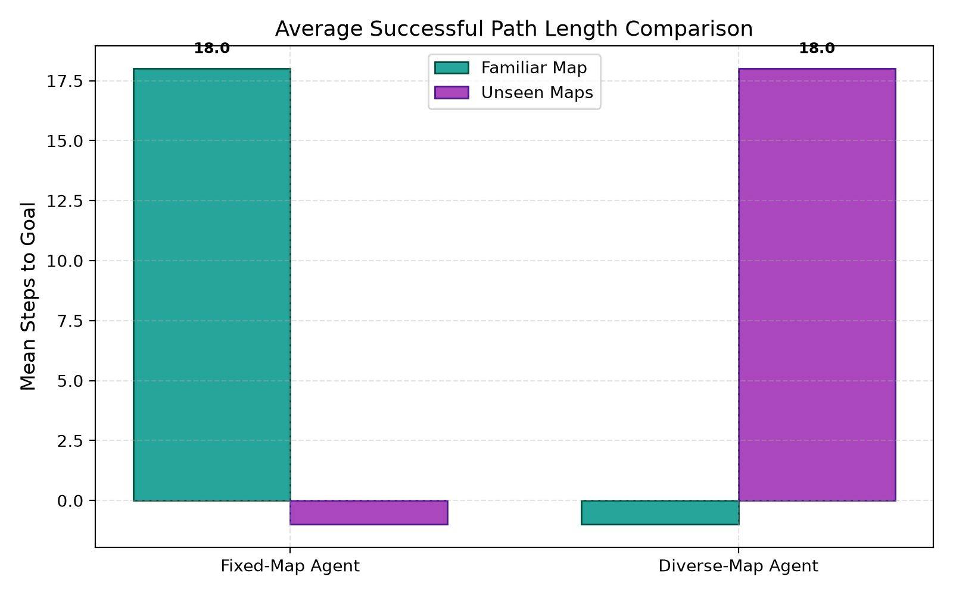
Figure 5.4. Average successful path length (steps to goal)
Every successful episode of both agents lasted exactly 18 steps. On a 10 x 10 grid with the start at (0, 0) and the goal at (9, 9), the shortest possible 4-connected path has 2(N - 1) = 18 steps, so all successful runs were optimal. The bars that dip just below zero in Figure 5.4 do not represent negative lengths. They mark conditions with no successful episode, which the plotting script stores as -1 and which appear as N/A in Table 5.2.

5.5 Trajectory Case Studies
Two greedy trajectories were rendered on the 10 x 10 grid to show what the numbers mean in practice. Dark cells are obstacles, the green box is the start and the red box is the goal. Positions below are written as (row, column).
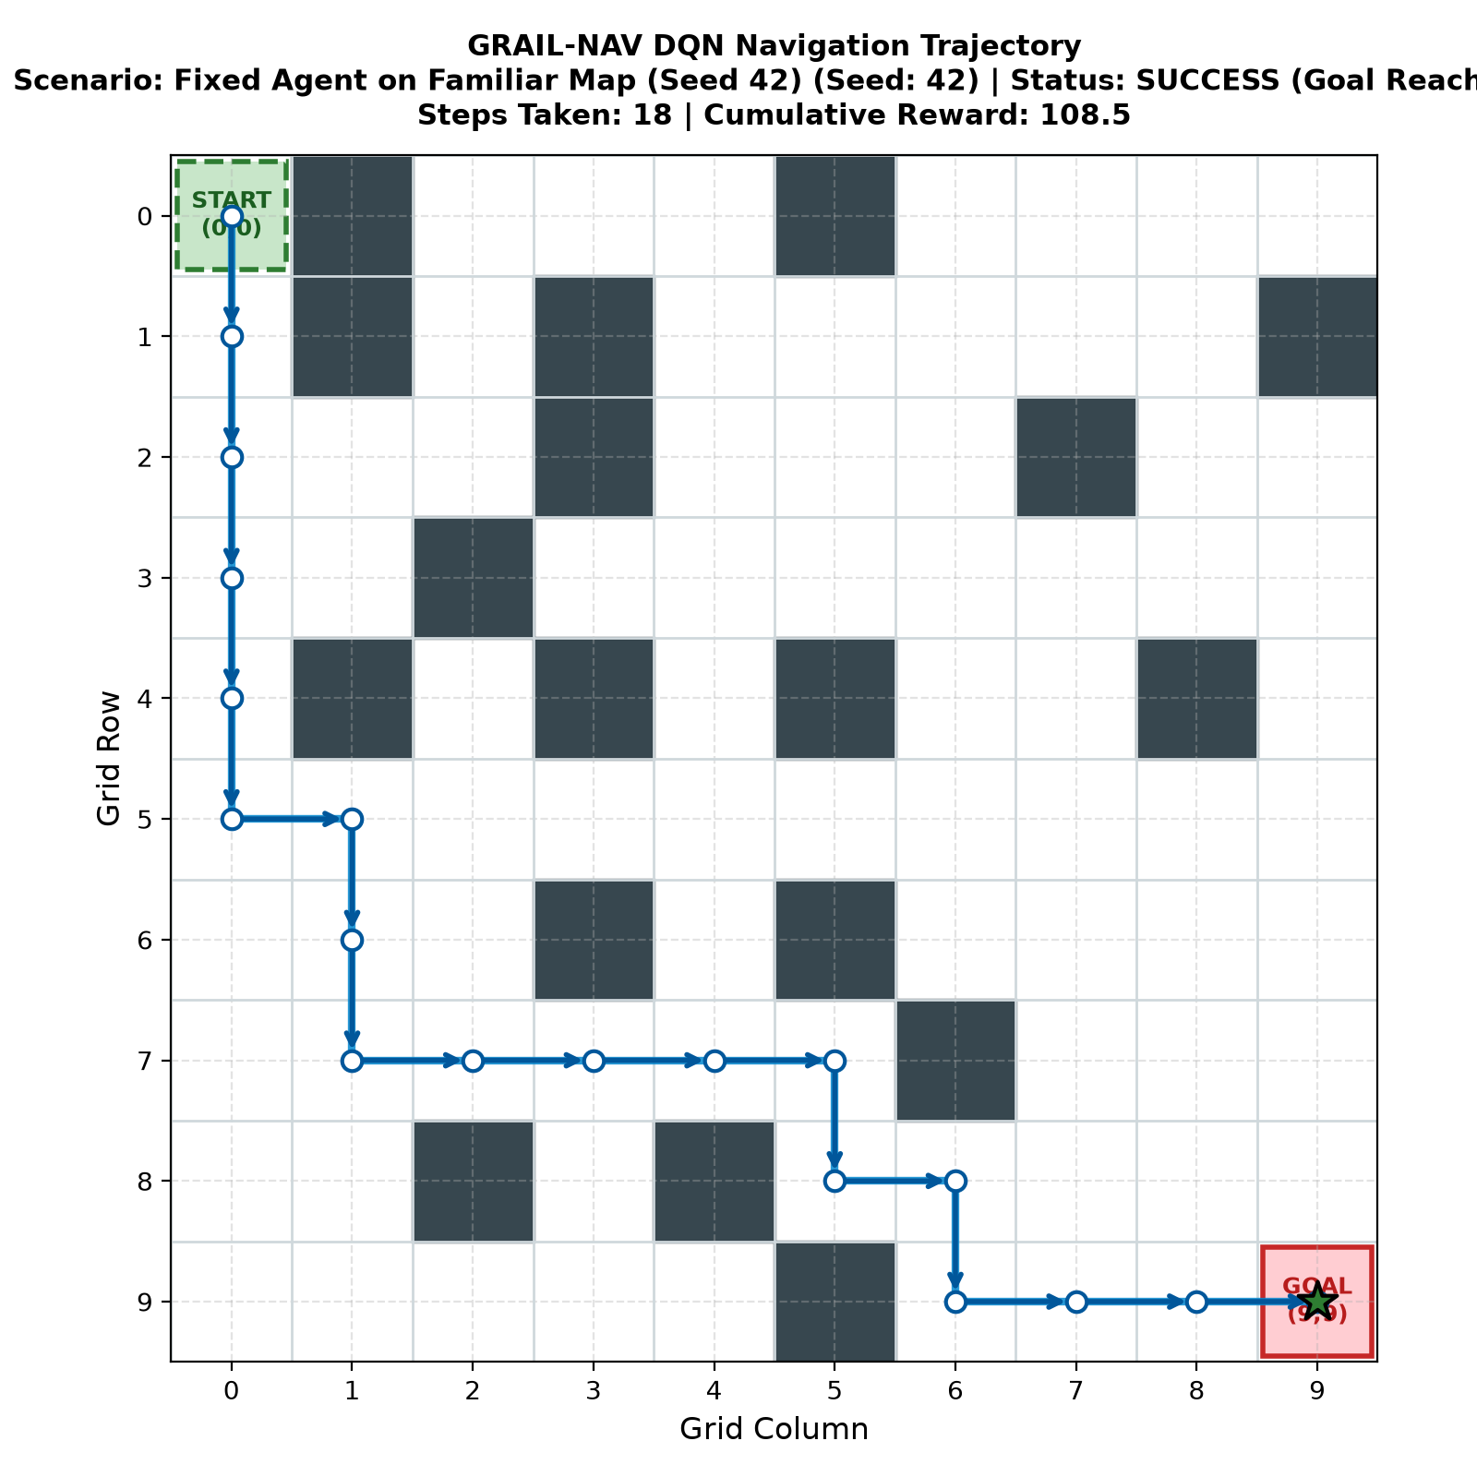
Figure 5.5. Fixed-Map agent on its familiar map (seed 42): success in 18 steps, reward +108.5
On its training map the Fixed-Map agent moves straight down column 0 to row 5, steps right, descends to row 7, crosses along row 7 to column 5, and then zigzags down and right to the goal at (9, 9). The route passes between obstacles without touching any of them, takes the minimum 18 steps and earns a cumulative reward of +108.5. This is the behavior that memorizing a single layout makes possible.
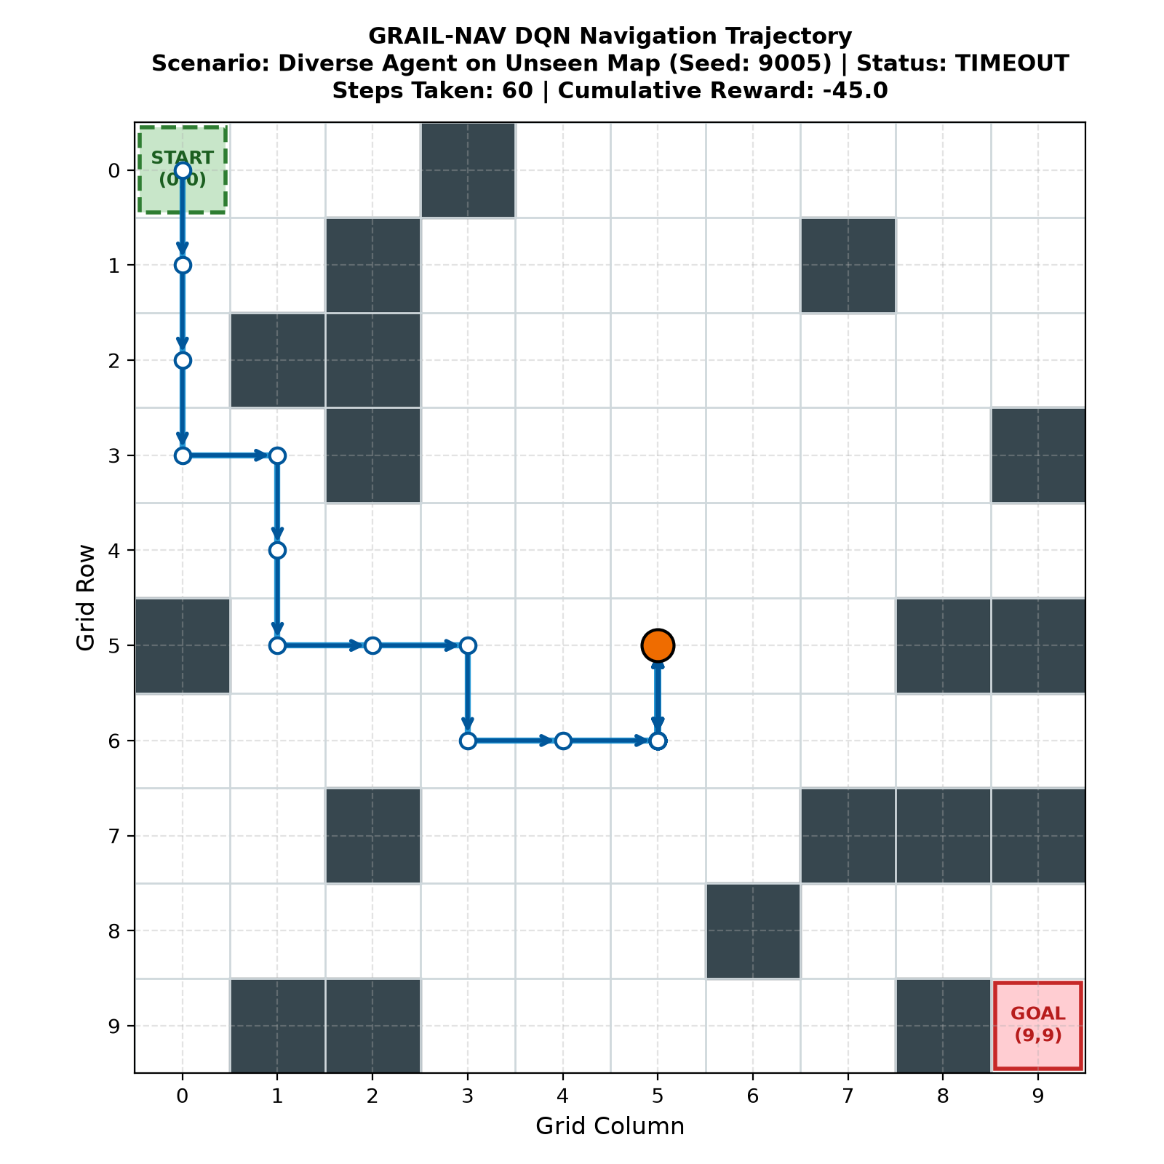
Figure 5.6. Diverse-Map agent on an unseen map (seed 9005): timeout after 60 steps, reward -45.0
On unseen map 9005 the Diverse-Map agent heads down and to the right in a sensible direction and avoids every obstacle on the way. Around position (6, 5) it stops making progress and, for the rest of the episode, oscillates between two neighboring cells in column 5 (the orange marker shows where it ended). It never collides, but it also never finds the way around the obstacle cluster in the lower right, and the episode ends at the 60-step limit with a reward of -45.0. This kind of local-minimum loop is what lies behind most of the 86 percent timeouts.

5.6 Decision Latency
Both policies decide in less than 0.1 ms per step on a standard commodity CPU (0.085 to 0.098 ms across the four conditions in Table 5.2). That is an inference throughput of more than 10,000 decisions per second, far faster than the control rates of typical mobile robots. Latency is therefore not a limiting factor for either policy.

5.7 Discussion
The experiment supports the hypothesis in one respect and only partly in the other.
• Safety claim, supported: Training on diverse layouts removed fatal collisions on unseen maps (0.0 percent against 18.0 percent for the Fixed-Map agent). This is the clearest effect in the data.
• Transfer claim, partly supported: Zero-shot success rose from 0.0 to 14.0 percent. This is a real improvement over memorization, but 86 percent of unseen maps still ended in a timeout, so the agent has not learned a general navigation policy.
• Trade-off: The Fixed-Map agent is the better choice only if the environment will never change. The Diverse-Map agent is better on any layout it has not trained on, and it gives up the perfect score on the familiar map.
Several factors may explain the modest transfer, though none of them was tested here: only 600 episodes of training, one pass over each map, a network that sees only a 5 x 5 window and has no memory of where it has been, and the fact that the Diverse-Map training curve was still rising when training stopped.

Chapter 6:

Challenges, Limitations and Future Work

6.1 Challenges and Solutions
The table below lists the main problems that arise when a DQN is trained for navigation and how the GRAIL-NAV design handles each of them. The last row records a problem that the results show is still open.
Table 6.1. Challenges and solutions
Challenge | Solution
Spatial overfitting to a single layout | Train on 600 procedural layouts and rely on the local 5 x 5 occupancy window
Randomly generated maps that cannot be solved | BFS rejection sampling; seeds are incremented until a path exists
Agent farms the shaped reward by cycling | Potential-based shaping telescopes to zero over loops; -1 step penalty makes loops costly
Moving-target instability in Q-learning | Separate target network synchronized every 10 episodes
Correlated consecutive transitions | Cyclic replay buffer (20,000) with uniform random minibatches
Bootstrapping past terminal states | Zero-bootstrap targets through the (1 - d) mask
Large reward outliers (-100, +100) | Huber loss and gradient-norm clipping at 10.0
Leakage between training and test maps | Disjoint seed ranges, checked by an automated test
Irreproducible results | Fixed random seeds and deterministic greedy evaluation (ε = 0)
Local-minimum loops on unseen maps (86 percent timeouts) | Open issue. Candidate remedies are a recurrent policy, richer sensing and longer training (Section 6.3)

6.2 Limitations
1. Grid discretization: The environment uses discrete grid moves. Physical robots move in continuous space with non-holonomic kinematics and acceleration limits.
2. Static obstacles: Obstacles do not move within an episode, whereas real logistics environments contain forklifts and people.
3. Global localization assumption: The state contains normalized (x, y) coordinates, equivalent to perfect GPS or odometry. In GPS-denied indoor spaces localization drifts.
4. Small evaluation scale: The unseen-map results come from 50 maps and one trained model per regime, so a 14 percent success rate (seven maps) carries considerable uncertainty. The familiar-map result is a single layout.

6.3 Future Work
• Continuous actor-critic control: Move to continuous actions with Soft Actor-Critic (SAC) [15] or Twin Delayed DDPG (TD3) [16], commanding linear and angular velocity directly.
• LiDAR emulation: Replace the local occupancy matrix with simulated 360-degree planar laser scan rays.
• Dynamic obstacles: Add moving obstacles and give the agent a memory through frame stacking or recurrent (LSTM) layers, which would also help against the oscillation seen in Figure 5.6.
• Sim-to-real transfer: Apply domain randomization of actuator noise, latency and friction [17] to deploy policies on platforms such as the TurtleBot.

Conclusion
This report examined whether training a DQN on many procedurally generated obstacle layouts, instead of one, improves its behavior on layouts it has never seen. A custom 10 x 10 grid-world simulator, a DQN with a target network and replay memory, a loop-proof shaped reward and a leakage-free seed split made it possible to compare the two training regimes fairly.
The Fixed-Map agent solved its training map perfectly, with 100 percent success in the optimal 18 steps, but it failed on all 50 unseen maps and collided on 18 percent of them. The Diverse-Map agent never collided on the unseen maps and reached the goal on 14 percent of them, again in 18 steps. The main benefit of diverse training in this experiment is therefore safety and a basic level of transfer, not a fully general navigation policy, and the high timeout rate shows that much remains to be done. Both policies decide in under 0.1 ms, so real-time use is feasible.
The most promising next steps are a policy with memory, richer range sensing and longer training. The simulator, tests and plotting scripts are already in place, so each of these can be tested against the benchmark reported here.

References
[1] P. E. Hart, N. J. Nilsson and B. Raphael, "A formal basis for the heuristic determination of minimum cost paths," IEEE Transactions on Systems Science and Cybernetics, vol. 4, no. 2, pp. 100-107, 1968.
[2] E. W. Dijkstra, "A note on two problems in connexion with graphs," Numerische Mathematik, vol. 1, pp. 269-271, 1959.
[3] S. M. LaValle, "Rapidly-exploring random trees: A new tool for path planning," Technical Report TR 98-11, Computer Science Department, Iowa State University, 1998.
[4] V. Mnih et al., "Human-level control through deep reinforcement learning," Nature, vol. 518, no. 7540, pp. 529-533, 2015.
[5] C. Zhang, O. Vinyals, R. Munos and S. Bengio, "A study on overfitting in deep reinforcement learning," arXiv:1804.06893, 2018.
[6] K. Cobbe, O. Klimov, C. Hesse, T. Kim and J. Schulman, "Quantifying generalization in reinforcement learning," Proc. ICML, 2019.
[7] A. Y. Ng, D. Harada and S. Russell, "Policy invariance under reward transformations: Theory and application to reward shaping," Proc. ICML, pp. 278-287, 1999.
[8] R. S. Sutton and A. G. Barto, Reinforcement Learning: An Introduction, 2nd ed. Cambridge, MA: MIT Press, 2018.
[9] P. J. Huber, "Robust estimation of a location parameter," The Annals of Mathematical Statistics, vol. 35, no. 1, pp. 73-101, 1964.
[10] D. P. Kingma and J. Ba, "Adam: A method for stochastic optimization," Proc. ICLR, 2015.
[11] A. Paszke et al., "PyTorch: An imperative style, high-performance deep learning library," Advances in Neural Information Processing Systems 32 (NeurIPS), 2019.
[12] K. He, X. Zhang, S. Ren and J. Sun, "Delving deep into rectifiers: Surpassing human-level performance on ImageNet classification," Proc. IEEE ICCV, 2015.
[13] X. Glorot and Y. Bengio, "Understanding the difficulty of training deep feedforward neural networks," Proc. AISTATS, 2010.
[14] L.-J. Lin, "Self-improving reactive agents based on reinforcement learning, planning and teaching," Machine Learning, vol. 8, pp. 293-321, 1992.
[15] T. Haarnoja, A. Zhou, P. Abbeel and S. Levine, "Soft actor-critic: Off-policy maximum entropy deep reinforcement learning with a stochastic actor," Proc. ICML, 2018.
[16] S. Fujimoto, H. van Hoof and D. Meger, "Addressing function approximation error in actor-critic methods," Proc. ICML, 2018.
[17] J. Tobin et al., "Domain randomization for transferring deep neural networks from simulation to the real world," Proc. IEEE/RSJ IROS, 2017.

Appendix A:

Solvability Check and Command-Line Reference

A.1 BFS Solvability Check
The function below is used by the environment to accept only layouts in which an unblocked 4-connected path from start to goal exists (Section 3.2).
def is_path_viable(grid, start=(0, 0), goal=(9, 9)):
# Standard BFS queue checking for an unblocked 4-connected path
queue = deque([start])
visited = {start}
while queue:
curr = queue.popleft()
if curr == goal:
return True
for dr, dc in [(-1, 0), (1, 0), (0, -1), (0, 1)]:
nr, nc = curr[0] + dr, curr[1] + dc
if (0 <= nr < 10 and 0 <= nc < 10
and grid[nr, nc] == 0 and (nr, nc) not in visited):
visited.add((nr, nc))
queue.append((nr, nc))
return False

A.2 Command-Line Reference
Table A.1. Arguments of main.py
Flag | Type | Allowed values | Default | Description
--mode | str | train, evaluate, visualize, report | Required | Execution mode
--scenario | str | fixed, diverse | fixed | Agent regimen to train or evaluate
--episodes | int | Any integer > 0 | Config default | Override the number of training episodes
--test-episodes | int | Any integer > 0 | 50 | Number of test maps for evaluation
--seed | int | Any integer | 9005 | Seed used for trajectory visualization

