WEEK 2 REPORT
Data Collection, Cleaning, and Preprocessing for Logistics Analysis
Internship Program Submission
Student: [Your Name]
Organization: [Internship Organization]
Mentor: [Mentor Name]
October 2026

Contents
1. Introduction and Objectives
2. Data Collection Simulation
3. Data Quality Issues Identified
4. Methodology: Cleaning and Preprocessing Steps
5. Python Implementation
6. Results and Verification
7. Limitations
8. Reflection: Data Quality and Decision-Making in Logistics
9. Conclusion
References

1. Introduction and Objectives
Analysis in logistics is only as reliable as the data behind it. Shipment records are usually produced by several systems (warehouse software, carrier APIs, manual dispatch logs), and each source introduces its own errors: duplicated posts, inconsistent labels, impossible timestamps, missing fields, and unit mistakes. This week I built and documented a preprocessing pipeline that detects these problems and corrects them before any forecasting or optimization work begins.
The objectives of this week were to:
- Describe a logistics dataset and its characteristics before any cleaning.
- Identify data quality issues, including missing values, outliers, and inconsistencies.
- Apply and justify cleaning techniques, and document how each one affects later analysis.
- Normalize the cleaned data so it is suitable for modeling.
- Verify the pipeline with checks and measure what each step changed.

2. Data Collection Simulation

2.1 Choice of reference data
The dataset used here is simulated. It was generated with a fixed random seed so the work can be reproduced exactly. I chose simulation for two reasons. First, the environment used to prepare this report cannot download public datasets directly, so I could not verify the characteristics of a real file. Second, a simulated dataset with known injected errors lets me check whether each cleaning step actually finds and fixes the problem it targets. With real data, you cannot tell whether a missed error is a pipeline failure or simply something absent from the file.
Recommended for submission: repeat this pipeline on a real public dataset such as the Kaggle DataCo Smart Supply Chain dataset, or on shipment data from your internship organization if it is shared with you. Check the dataset license first. The steps in Section 4 apply unchanged; only the column names and thresholds may need adjustment.

2.2 Dataset characteristics
The simulated extract represents one year (2024) of shipment records across three warehouses in a single metropolitan region. Table 1 lists the fields.
Field | Type | Description
shipment_id | Text | Unique shipment identifier
carrier | Text | Transport partner (five carriers)
warehouse | Text | Origin warehouse (three sites)
mode | Text | Road, Rail, or Air
dispatch_time | Timestamp | When the shipment left the warehouse
delivery_time | Timestamp | When the shipment was delivered
distance_km | Number | Route distance in kilometres
weight_kg | Number | Shipment weight in kilograms
freight_cost_inr | Number | Freight cost in Indian rupees
status | Text | Delivered, In Transit, Delayed, or Returned
destination_pin | Number | Destination postal code (stored as a number)
Table 1. Fields in the raw shipment extract
The raw file contained 5,060 rows and 11 columns, including 60 deliberately duplicated records. Distance, weight, and cost were right-skewed, which is typical of shipment data: most parcels are light and short-haul, with a long tail of heavy or long-distance shipments.

3. Data Quality Issues Identified
Before cleaning, I profiled the raw file. Table 2 summarizes the issues found, with counts measured from the raw data.
Issue | Field(s) | Count in raw data | Why it matters
Missing values | carrier, delivery_time, distance_km, weight_kg, freight_cost_inr | 102, 152, 203, 301, 255 cells | Most models cannot accept blanks; blanks silently drop rows
Exact duplicate rows | All fields | 56 rows | Double-counts shipments, inflating volume and cost totals
Duplicate shipment IDs with different formatting | All fields | 4 further rows | Exact-match deduplication misses these
Inconsistent case in labels | carrier | 297 rows in uppercase | Same carrier counted as two categories
Extra spaces and separators | warehouse | 150 rows | Same warehouse counted as several
Mixed date formats | dispatch_time | 200 rows in dd/mm/yyyy | Text parsing fails or silently swaps day and month
Delivery before dispatch | delivery_time | 20 rows | Negative transit time breaks any speed or delay metric
Negative distance | distance_km | 14 rows | Physically impossible; corrupts averages
Extreme weight values | weight_kg | 37 rows above 100 kg (median 1.6 kg) | Single values can dominate the mean (see Section 6)
Extreme cost values | freight_cost_inr | 21 rows above ₹5,000 (median ≈ ₹400) | Inflates cost averages and skews model training
Table 2. Data quality issues measured in the raw extract
A note on the timestamp check: a naive comparison of raw timestamps flagged 878 rows as delivered before dispatch. That count was wrong, because the comparison read dd/mm and yyyy-mm-dd strings with the same parser. Only after parsing each format correctly did the true count of 20 emerge. This is a useful lesson: a data check is only as good as the parsing behind it, so checks should be run after standardization and their counts confirmed by a second method.

4. Methodology: Cleaning and Preprocessing Steps
The pipeline runs in a fixed order. Each step below states what it does, why that technique was chosen, and how it affects the analysis that follows. Each step is logged with the row count and number of missing cells, so its effect can be checked.

4.1 Removing duplicates
What: Exact duplicates are removed first, then duplicates are removed by shipment_id after the timestamps are parsed. Why two passes: the first pass catches identical copies; the second catches copies whose formatting differs, such as a different date layout. Using shipment_id as the business key is standard for transactional data. Effect: Removed 56 exact duplicates and 4 ID-level duplicates, leaving 5,000 unique shipments. Without this step, shipment volumes and costs would be overstated.

4.2 Standardizing text labels
What: Whitespace is trimmed, carrier names are converted to a single case, and warehouse separators are unified to underscores. Why: Group-by operations treat "BLUEDART_SIM" and "BlueDart_Sim" as different groups. Standardizing before grouping avoids splitting one carrier into several. Effect: Carrier and warehouse each collapse to their canonical categories, which is required for any per-carrier or per-site KPI.

4.3 Parsing timestamps
What: Each timestamp is parsed against the known formats. Unparseable values are coerced to missing so they can be handled explicitly rather than causing a crash. Why: Mixed formats are a common source of silent errors. Explicit format strings are safer than letting the parser guess, because a guess can swap day and month. Effect: All dispatch times parsed correctly; no values needed to be discarded.

4.4 Logical validity checks
What: Two rules are applied. (a) If delivery is earlier than dispatch, the delivery time is set to missing, since the true delivery time cannot be known. (b) Negative distances are converted to positive values. Why: These rules encode physical facts that the data must obey. Judgment call: rule (b) assumes the sign was entered wrongly, which is the most likely cause. This should be confirmed against the source system; setting these values to missing would be the more cautious choice. The pipeline records the count so the decision is visible. Effect: 20 timestamps and 14 distances corrected.

4.5 Outlier detection
What: Outliers are detected with the interquartile range (IQR) rule, first described by Tukey (1977). The rule flags values more than k × IQR beyond the quartiles. The rule is applied on a log scale because weight and cost are right-skewed, which makes the distribution closer to symmetric before the rule is applied. Flagged values are set to missing and imputed in the next step, rather than deleted, so no records are lost. Why this method: IQR needs no assumption that data is normally distributed, and it is easy to explain to a non-technical reviewer. Threshold choice: I tested k = 1.5, 2, and 3 (Section 6.3). The final setting is k = 3 for weight and distance, and k = 2 for cost, because at k = 3 many high-cost errors survived.
Effect: 38 weight values and 16 cost values flagged and set aside for imputation. All remaining weights are below 100 kg.

4.6 Handling missing values
What: Numeric fields are filled with the median within each transport mode. Categorical fields (carrier, status) are filled with an explicit "Unknown" category. Why median rather than mean: the median is not moved by extreme values, which matters for skewed cost and weight data. Why group by mode: Air freight costs far more than Road, so a single overall median would understate Air costs and overstate Road costs. Why "Unknown" rather than the most common carrier: filling with the most common value invents a fact about the shipment and biases any carrier comparison toward the largest carrier. An explicit category keeps the uncertainty visible. Effect: Carrier and status blanks are all labelled "Unknown". Numeric blanks are filled with group medians.
Delivery time: Missing delivery times are rebuilt from dispatch time plus the imputed transit time. This keeps timestamps and transit durations consistent with each other.

4.7 Normalization
What: Cost and weight are log-transformed (log(1 + x)), then z-scored (mean 0, standard deviation 1). Distance is min-max scaled to the range 0 to 1. Why: Log transformation reduces the influence of the long tail, so the model does not focus on a few very large values. Z-scores put variables with different units on a common scale, which matters for distance-based and gradient-based methods. Min-max scaling keeps distance in a fixed bounded range, which is convenient for interpretation. Choice of scaler: a standard scaler is used rather than a robust scaler because the outliers have already been removed. Effect: Transformed variables have mean 0 and standard deviation 1, as verified in Section 6.

4.8 Final validation
The pipeline ends with assertions that stop the run if any requirement fails: shipment IDs are unique, no required field is missing, distance and transit time are non-negative, and transit times are consistent with timestamps. These assertions protect against silent regressions when the pipeline is changed later.

5. Python Implementation
The full scripts are provided with this report (clean_pipeline.py, generate_data.py, validate_and_figures.py). The excerpts below show the main techniques. They were run with pandas 3.0 and NumPy 2.4.

5.1 Duplicate removal
# Pass 1: exact duplicate rows
df = df.drop_duplicates()

# Pass 2: after timestamps are parsed, dedupe on the business key
df = df.drop_duplicates(subset=["shipment_id"], keep="first")

5.2 Label standardization
for col in ["carrier", "warehouse", "mode", "status"]:
df[col] = df[col].astype("string").str.strip()
df["carrier"] = df["carrier"].str.title()
df["warehouse"] = df["warehouse"].str.replace(" ", "_").str.upper()

5.3 Timestamp parsing with explicit formats
def parse_ts(s):
s = str(s)
try:
return pd.to_datetime(s, format="%Y-%m-%d %H:%M:%S")
except (ValueError, TypeError):
return pd.to_datetime(s, format="%d/%m/%Y %H:%M", errors="coerce")

df["dispatch_time"] = df["dispatch_time"].map(parse_ts)
df["delivery_time"] = df["delivery_time"].map(parse_ts)

5.4 Logical checks
invalid_ts = df["delivery_time"] < df["dispatch_time"]
neg_dist = df["distance_km"] < 0
df.loc[invalid_ts, "delivery_time"] = pd.NaT # cannot be trusted
df.loc[neg_dist, "distance_km"] = df.loc[neg_dist, "distance_km"].abs()

5.5 Outlier detection on the log scale
def iqr_bounds(s, k=3.0):
q1, q3 = s.quantile([0.25, 0.75])
iqr = q3 - q1
return q1 - k * iqr, q3 + k * iqr

K_BY_COL = {"weight_kg": 3.0, "freight_cost_inr": 2.0, "distance_km": 3.0}
for col, k in K_BY_COL.items():
logv = np.log1p(df[col].clip(lower=0))
lo, hi = iqr_bounds(logv.dropna(), k=k)
mask = (logv > hi) | (logv < lo)
df.loc[mask, col] = np.nan # set aside; imputed in the next step

5.6 Missing-value imputation
# Numeric: median within transport mode
for col in ["weight_kg", "distance_km", "freight_cost_inr", "transit_hours"]:
df[col] = df.groupby("mode")[col].transform(lambda s: s.fillna(s.median()))

# Categorical: explicit 'Unknown' category
df["carrier"] = df["carrier"].fillna("Unknown")
df["status"] = df["status"].fillna("Unknown")

5.7 Normalization
df["log_freight_cost"] = np.log1p(df["freight_cost_inr"])
df["log_weight"] = np.log1p(df["weight_kg"])
for col in ["log_freight_cost", "log_weight", "transit_hours"]:
df[col + "_z"] = (df[col] - df[col].mean()) / df[col].std()
df["distance_minmax"] = (df["distance_km"] - df["distance_km"].min()) / \
(df["distance_km"].max() - df["distance_km"].min())

5.8 Logging each step
log = []
def record(step, df, note=""):
log.append({"step": step, "rows": len(df),
"missing_cells": int(df.isna().sum().sum()), "note": note})

6. Results and Verification

6.1 Effect of each step
Table 3 shows the pipeline log. Row counts fall only where records were genuinely duplicated, and missing cells are removed by the imputation steps.
Step | Rows | Missing cells | Action taken
0. Raw load | 5,060 | 1,013 | Baseline
1. Remove exact duplicates | 5,004 | 999 | 56 rows removed
2. Standardize labels | 5,004 | 999 | Case, whitespace, separators unified
3. Parse timestamps | 5,004 | 999 | 0 unparseable
3b. Deduplicate on shipment_id | 5,000 | 999 | 4 rows removed
4. Logical checks | 5,000 | 1,019 | 20 timestamps and 14 distances corrected
5. Outlier detection | 5,000 | 1,242 | Outliers set to missing for imputation
6. Impute missing values | 5,000 | 169 | Group medians; "Unknown" for categories
7. Normalization | 5,000 | 0 | Log, z-score, and min-max transforms added
Final validation | 5,000 | 0 | All assertions passed
Table 3. Pipeline log. The missing-cell count rises at step 4 and 5 because values are deliberately set to missing before imputation.
The 169 missing cells at step 6 are delivery times. They are filled in step 8 from the dispatch time and imputed transit time, so the final dataset has no missing values.

6.2 Before and after cleaning
Table 4 compares summary statistics on the raw non-missing values with the cleaned values. The largest change is in weight: the raw mean is about nine times the cleaned mean, because a small number of values entered in grams rather than kilograms dominated the average. The median barely changes, which shows that the cleaning removed the tail without distorting typical shipments.
Field | Raw median | Clean median | Raw mean | Clean mean
Weight (kg) | 1.64 | 1.62 | 19.24 | 2.20
Distance (km) | 190.30 | 189.40 | 252.13 | 253.69
Freight cost (₹) | 402.15 | 398.02 | 638.43 | 573.58
Table 4. Summary statistics before and after cleaning
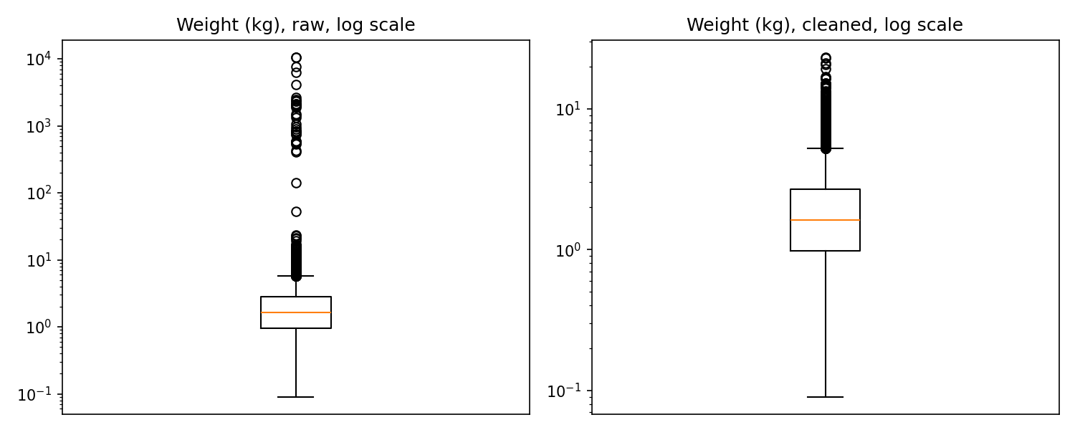
Figure 1. Shipment weight before cleaning (left) and after (right), on a log scale. Extreme values above 100 kg are removed.

6.3 Sensitivity of outlier detection to the threshold
Outlier rules are sensitive to the chosen threshold, so I tested three values on the raw data. Table 5 shows the results.
Threshold k | Weight values flagged | Cost values flagged | Interpretation
1.5 | 95 | 53 | Too aggressive: flags many legitimate heavy and expensive shipments
2.0 | 59 | 16 | Balanced for cost; some heavy but genuine shipments flagged
3.0 | 38 | 5 | Conservative: values above ₹5,000 remain after cleaning (see Section 7)
Table 5. Outlier flags at three thresholds, measured on raw data
The threshold for weight was kept at 3, because at k = 2 the rule flagged 59 values, many of which are plausible heavy shipments. The threshold for cost was tightened to 2, because at k = 3 the rule missed errors that were clearly far above the typical range. Choosing a threshold on one dataset should always be justified and rechecked on another.

6.4 Normalization check
After transformation, the log-cost z-score has mean 0.000 and standard deviation 1.000, confirming the scaling is correct. Figure 2 shows the effect of the log transform on the cost distribution.
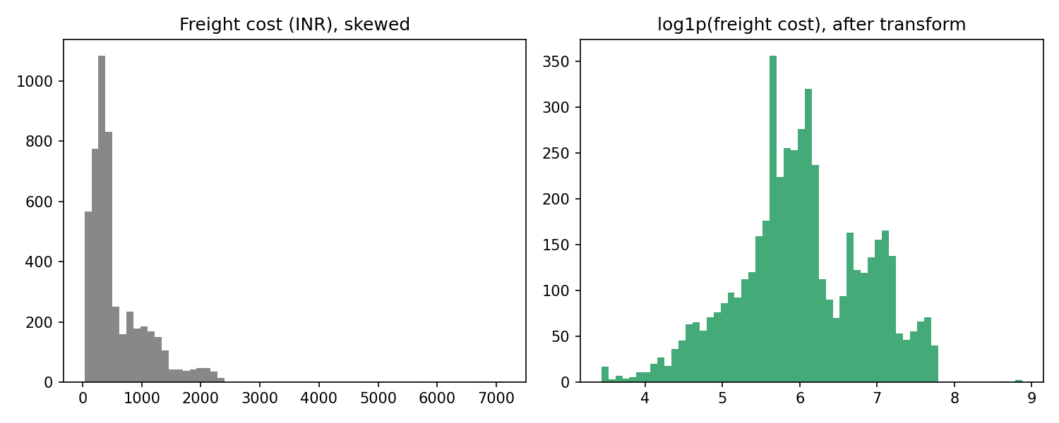
Figure 2. Freight cost before (left) and after (right) the log transform. The transform makes the distribution far more symmetric.

6.5 Data profile of the cleaned dataset
Category | Counts after cleaning
Carriers | Bluedart_Sim 996; Delhivery_Sim 1,038; Ecomexpress_Sim 951; Ekart_Sim 968; Xpresslite_Sim 947; Unknown 100
Warehouses | WH_BLR_01 2,221; WH_BLR_02 1,786; WH_MYS_01 993
Mode | Road 2,999; Rail 1,271; Air 730
Status | Delivered 4,094; Delayed 507; In Transit 239; Returned 160
Table 6. Category counts in the cleaned dataset
The category counts confirm that standardization worked: each carrier and warehouse appears under a single label, with no uppercase or padded duplicates remaining.
Caution on the patterns: the simulator sets transport speeds and costs by mode, so the average transit times (Air 5.0 hours, Rail 10.6 hours, Road 7.2 hours) and the median costs by mode (Air ₹1,377, Rail ₹775, Road ₹289) reflect the simulation's own assumptions. They show that the pipeline preserves structure, not that these are real-world logistics findings. Real analysis would need to discover these patterns from real data.

7. Limitations
- Simulated data. Results describe the pipeline's behaviour on data I generated. Real data will contain error types not represented here.
- Residual cost errors. Five cleaned records still exceed ₹5,000 (maximum ₹7,150), while the median is about ₹400. These are probably errors, but I have not confirmed this against a ground-truth record. On real data, they would need manual review before any cost model is trained.
- Sign correction assumption. Converting negative distances to positive values assumes a sign-entry error. This is probable, but unverified. A real project should confirm with the data owner.
- Imputation uncertainty. Median imputation understates variability. Any model trained on imputed values should be evaluated with this in mind, and imputation flags could be kept as features in the modeling stage.
- Threshold dependence. The outlier thresholds were chosen by inspection on this dataset. They should be tested on another dataset before being treated as general rules.
- No external validation. I have not compared these cleaned values with an independent source such as carrier invoices or GPS logs.

8. Reflection: Data Quality and Decision-Making in Logistics
This exercise made clear how much analytical output depends on preparation. Three examples from this week show the point.
Averages mislead without cleaning. The raw mean weight is nearly nine times the cleaned mean. A planner reading the raw average would overestimate vehicle load requirements and might buy or book more capacity than needed. A few mis-keyed records can change a capacity decision. Median-based reporting and outlier review are therefore decision-relevant, not just technical niceties.
Duplicates and labels distort operational counts. If the same carrier appears under two spellings, a carrier-performance review will show two smaller carriers instead of one large one, and may recommend the wrong contract changes. Consistent labels and deduplication are preconditions for any honest comparison between partners or sites.
Checks are only as trustworthy as their parsing. The timestamp error described in Section 3 shows that a plausible-looking check can produce a wrong number. A decision based on the wrong count would have led to the wrong conclusion about delivery reliability. Every quality metric should be validated by a second method before it informs a decision.
More broadly, the choices made during cleaning (median versus mean, "Unknown" versus a guessed value, deleting versus imputing) affect every model and KPI built afterward. Documenting those choices, and logging their effect, is what allows a manager to trust the analysis and a colleague to reproduce it. In logistics, where decisions about stock levels, routes, and carrier contracts carry real cost, that traceability is part of the analysis itself.

9. Conclusion
This week I designed, implemented, and verified a preprocessing pipeline for shipment data. The pipeline removed 60 duplicate records, corrected 34 logically invalid values, standardized labels, handled 1,000+ missing cells, flagged and corrected extreme values, and normalized the variables for modeling. The result is a clean dataset of 5,000 unique shipments with no missing values and consistent categories.
The work also surfaced an important limitation. A single outlier threshold was not adequate for both weight and cost, and checking sensitivity revealed errors that a default setting would have missed. The next step in the project is to use this cleaned dataset for exploratory analysis and forecasting, and to repeat the pipeline on a real dataset to test whether these methods hold outside simulation.

References
Tukey, J. W. (1977). Exploratory Data Analysis. Addison-Wesley. [Source of the interquartile range rule used in Section 4.5.]
The pandas development team. pandas documentation: Working with missing data and Time series / date functionality. https://pandas.pydata.org/docs/ [Used for drop_duplicates, groupby transforms, fillna, and to_datetime.]
Kaggle. DataCo Smart Supply Chain dataset. https://www.kaggle.com/ [Suggested real dataset for repeating this pipeline. Verify license and terms before use.]

