**MYSQL ASSIGNMENT 3**

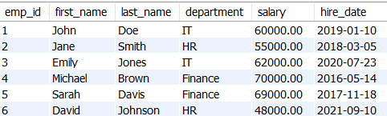

**1.Find the average salary of employees in each department.**

**select department , avg(salary) as "average salary " from employee group by department;**

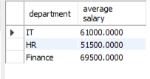

**2. Find the total number of employees hired after 2019.**

**select distinct count(hire_date) as "employees hired after 2019" from employee where hire_date > "2019-01-10";**



**3. List the departments and the total salary of all employees in each department, ordered by the total salary.**

**select department , sum(salary) as " total salary in each department" from employee group by department order by sum(salary) asc;**

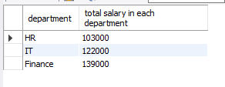

**4. Find the highest salary in the Finance department.**

**SELECT department , max(salary) as "highest salary" from employee where department="finance" ;**

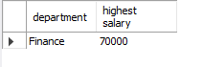

**5. Get the top 3 highest-paid employees.**

**select first_name , max(salary) as "highest paid employee " from employee group by first_name order by max(salary) desc limit 3;**

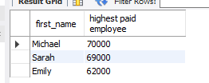

**6. Find the department with the minimum average salary.**

**select department , avg(salary) as "minimum average salary" from employee group by department order by avg(salary) asc limit 1;**

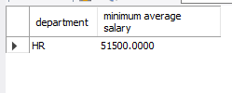

**7. Display the total number of employees in each department, ordered by the number of employees.**

**select department , count(emp_id) as "total no. of employee in each department" from employee group by department order by count(emp_id) asc;**

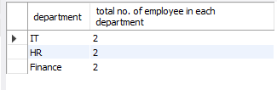

**8. Find the average salary of employees who were hired before 2020.**

**select hire_date, avg(salary) as "employees hired after 2020" from employee group by hire_date having hire_date < "2020-01-01" ;**

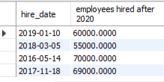

**9. List the names of employees in the IT department ordered by hire date, with the most recently hired employees first.**

**select first_name , hire_date as "most recently hired employee in it department " from employee where hire_date IN (select max(hire_date ) from employee where department ="IT");**

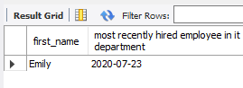

**10. Find the sum of salaries for all employees hired after January 1, 2019, ordered by salary.**

**select sum(salary) as " sum of salary hired after 1 januaury" from employee where hire_date >"2019-01-01" order by sum(salary) asc;**

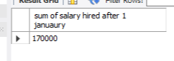

**11. Get the employee with the lowest salary in the HR department.**

**SELECT first_name, last_name, salary FROM employee where salary IN ( SELECT MIN(salary) FROM employee where department="HR");**

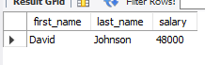

**12. Find the total salary paid to employees in each department, but limit the result to the top 2 highest-paying departments.**

**select department , sum(salary) as " total salary paid " from employee group by department order by sum(salary) desc limit 2;**

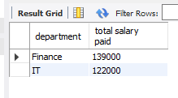

**13. List all employees hired after 2018, ordered by salary, and show only the first 4 employees.**

**select first_name ,last_name ,hire_date as "employees hired after 2018" from employee where hire_date > "2018-01-01" order by salary asc limit 4;**

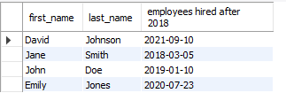

**14. Find the highest salary in the IT department, but limit the results to the top 1 result.**

**select max(salary) as "highest salary" from employee where department="IT" order by max(salary) desc limit 1;**

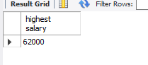

**15. Get the average salary of employees in each department and list only departments with an average salary greater than $60,000.**

**select department , avg(salary) as "avg salary in each department" from employee group by department having avg(salary) >60000;**

