**📊 PhonePe Transaction Insights Report**

# 1. Decoding Transaction Dynamics on PhonePe

**📌 Scenario:**  
PhonePe, a leading digital payments platform, has observed fluctuating transaction patterns across states, quarters, and transaction categories (e.g., recharge, peer-to-peer, merchant payments). While some regions and payment types show steady growth in both transaction count and value, others display inconsistency or saturation. To improve market penetration and service optimization, the leadership team seeks a detailed understanding of how transaction types perform across time and geography. This analysis aims to guide future decisions related to promotions, merchant onboarding, and feature enhancement.

**📷 Charts:**

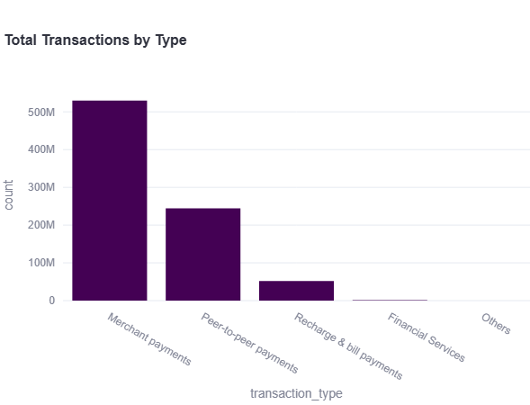

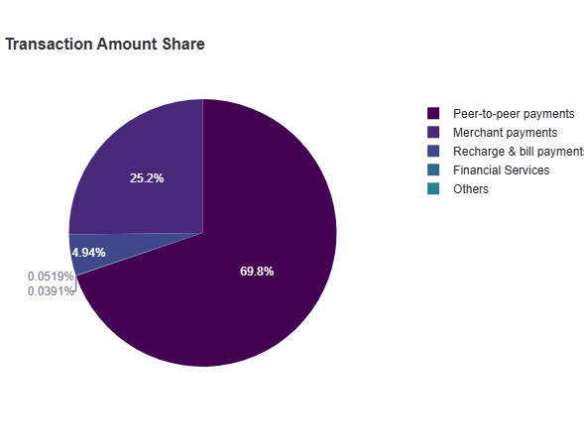**📈 Summary Insight:**

* 💳 **Total Transactions:** 827,374,966
* 💰 **Total Transaction Amount:** ₹ 1,076,014,501,422.00
* 🔁 **Most Frequent Transaction Type:** **Merchant payments** (530M+ transactions)
* 💵 **Highest Value Transaction Type:** **Peer-to-peer payments** (₹ 750B+)
* 📊 **Transaction Share Breakdown:**
* **69.8%** of total value comes from **peer-to-peer payments**
* **25.2%** from **merchant payments**
* Minimal contribution from recharge, bills, and financial services

**💡 Business Finding:**

* Users **prefer peer-to-peer transactions** for large-value transfers but **engage more frequently** in merchant payments.
* Merchant payments are the **backbone of user engagement**, even though they contribute less to transaction value.
* Recharge, bill payments, and financial services are **underutilized**, indicating either low demand or poor user awareness in Gujarat.

✅ **Strategic** **Recommendation:**

1. **Boost P2P Monetization:**
   * Introduce value-added services or micro-fees for high-volume P2P users to leverage the high transaction value.
2. **Strengthen Merchant Ecosystem:**
   * Incentivize local merchants in Gujarat through cashback offers, QR campaigns, and app integrations to further increase volume.
3. **Promote Low-Contribution Services:**
   * Launch promotional campaigns or discounts for underutilized categories like bill payments and financial services.
4. **Localize Product Strategies:**
   * Customize transaction campaigns by focusing on dominant types (e.g., P2P in Gujarat) for targeted regional engagement.

# 2. Device Dominance and User Engagement Analysis

📌 Scenario:  
With smartphone usage being the primary medium for digital payments, PhonePe aims to understand how user engagement varies by device brand and region. The company’s focus is to identify which device ecosystems offer the highest potential for app adoption, usage frequency, and targeted marketing efforts.

**📷 Charts:**

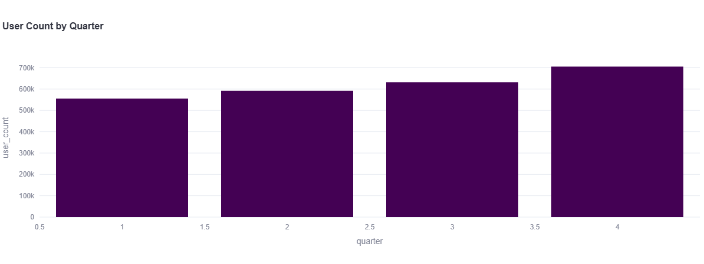

**📈 Summary Insight:**

* 📱 **Device Brand:** **Apple**
* 🌍 **Location:** **Delhi**
* 📆 **Year:** **2021**
* 👥 **Total App Registrations:** 2,484,548 Apple users across all quarters
* 📈 Apple demonstrates consistent user acquisition in urban metros like Delhi, highlighting its strong market presence.

**💡 Business Finding:**

* **Premium device users like Apple show high app registration rates**, signaling a loyal and high-value customer base in urban regions.
* Engagement with PhonePe is strong among Apple users, which may correlate **with higher transaction volume per user** due to better purchasing power.
* Regional concentration (Delhi) suggests **urban skewness** in brand adoption — rural or semi-urban zones might be underpenetrated by high-end devices.

✅ **Strategic Recommendations:**

1.**Partnership with Apple India:**

* Collaborate for exclusive in-app offers, UPI integration on iOS, and bundled promotions for new iPhone buyers.

**2.Segmented Targeting:**

* Launch premium financial services (e.g., insurance, investments) tailored for Apple users in metro cities to maximize transaction value.

**3. Expand to Android Ecosystem:**

* While Apple dominates in metros, run mass adoption campaigns on Android to penetrate Tier-2 and Tier-3 cities.

**4. Location-Device Based Campaigns:**

* Use heatmap-based targeting to push contextual notifications/offers in cities where high-end brand usage is dense (like Delhi).

# 3. Transaction Analysis for Market Expansion

**📌 Scenario:**  
PhonePe operates in a highly competitive market, and understanding transaction dynamics at the state level is crucial for strategic decision-making. With a growing number of transactions across different regions, the company seeks to analyze its transaction data to identify trends, opportunities, and potential areas for expansion.

**📷 Charts:**

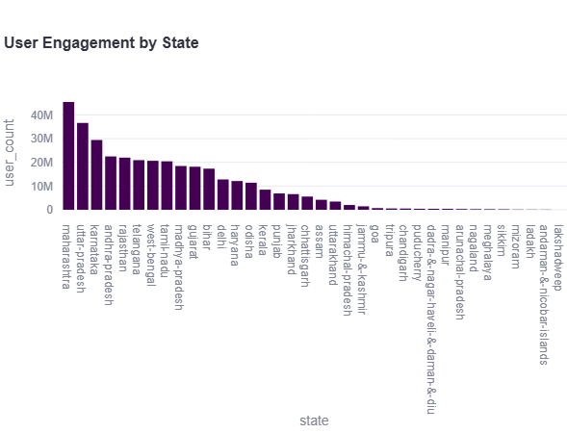

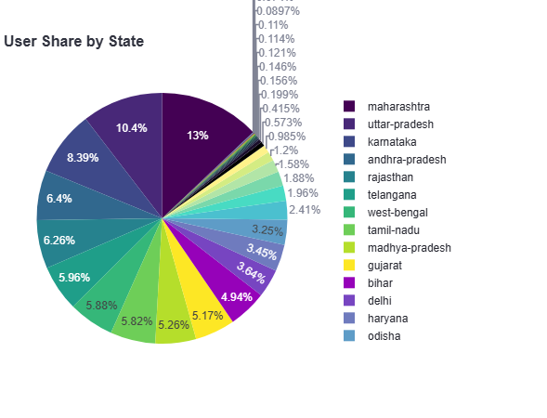

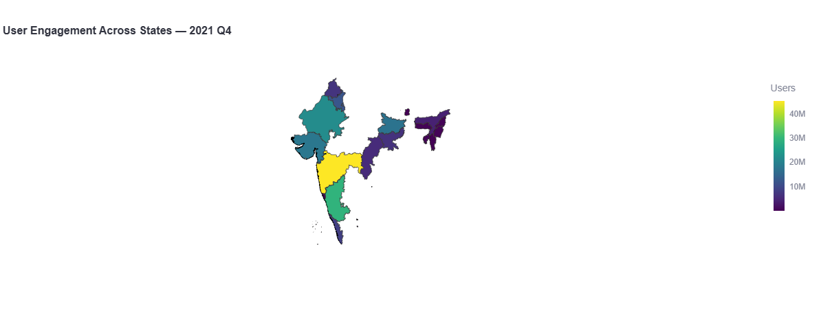

**📈 Summary Insight:**

* **Top state by user engagement**: Maharashtra with **45.4 million** users in **2021 Q4**.
* Other high-engagement states include **Uttar Pradesh, Karnataka, Tamil Nadu, Andhra Pradesh**, and **Rajasthan**, each contributing significantly to PhonePe’s user base.
* Engagement shows a **concentrated distribution**, with the **top 5 states** accounting for a major share of users.

**💡 Business Finding:**

* Maharashtra not only leads in user count but serves as a **prime market for transaction volume and high-value digital activity**.
* High user engagement correlates with economic density and urbanization—suggesting that **urban states with strong infrastructure** see greater adoption.
* Several **under-engaged states** like Bihar, Odisha, and Assam have medium-to-large populations but lower user penetration—highlighting potential **untapped markets**.
* There's a noticeable **North-South divide**, with southern and western states dominating in engagement compared to the northeast and some central regions.

✅ **Strategic Recommendation:**

1. **Hyperlocal Campaigns in High-Engagement States**  
   • Partner with local businesses and state governments in Maharashtra & Karnataka for exclusive digital payment incentives.  
   • Introduce utility bill cashback offers, public transport integration, and local UPI boosts.
2. **Regional Expansion Strategy**  
   • Launch multilingual campaigns in states like Bihar, Odisha, and Assam to build trust and awareness.  
   • Offer referral bonuses and zero KYC onboarding for rural and semi-urban populations.
3. **Engage Rural Markets via Agent-Based Model**  
   • Deploy digital literacy kiosks and PhonePe agents in Tier-3 towns to promote assisted transactions.
4. **Leverage Seasonal Trends**  
   • Use festive seasons in high-user states for promotional offers (e.g., Diwali in Maharashtra, Pongal in Tamil Nadu) to drive engagement spikes.

# 4. User registration and growth strategy

**📌 Scenario:**  
PhonePe aims to sustain its competitive advantage and expand its user base by tracking trends in app opens and registered users across different years and quarters. By analyzing how user engagement has evolved from 2018 to 2024, the platform can identify peak engagement periods, understand the adoption lifecycle, and design data-driven strategies to increase retention, enhance app usability, and deepen user involvement.

**📷 Charts:**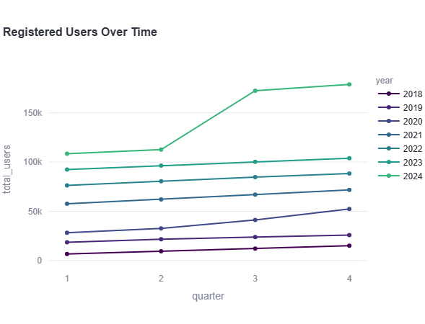

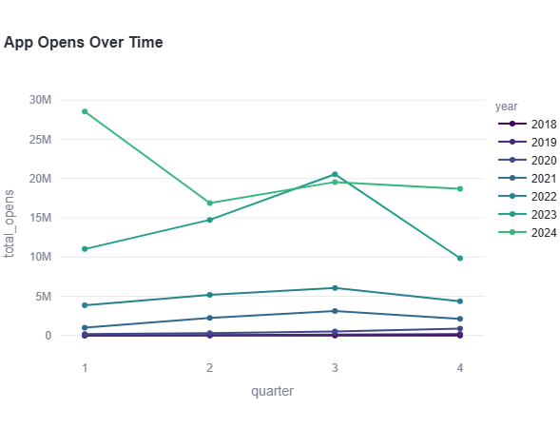

**📈 Summary Insight:**

* In the latest quarter (Q4, 2024), PhonePe recorded **178,788 registered users** and **18.69 million app opens**.
* A steady rise in registered users has been observed from 2018 to 2024 across all quarters, indicating **consistent user base expansion**.
* App opens peaked in **Q1 2024 (28.5M)** but showed **fluctuations in subsequent quarters**, suggesting varied engagement levels despite growing registrations.

**💡 Business Finding:**

* The significant growth in **user registrations** over time highlights **strong adoption**, possibly driven by marketing efforts, partnerships, or ease of use.
* The **disparity between user registration growth and app opens** suggests that **user activation and engagement** may not always follow sign-up trends.
* The platform is entering a **mature phase**, where user growth is strong, but maintaining regular usage will require deeper engagement strategies.

✅ **Strategic Recommendation:**

1. **Boost Active Engagement**: Introduce in-app nudges, loyalty programs, or gamification features to convert registered users into active users.

2. **Quarterly Campaigns**: Use insights from peak quarters (like Q1 2024) to run targeted campaigns during slower quarters to maintain app open rates.

3. **Behavioral Segmentation**: Analyze app open frequency and usage behavior to tailor personalized experiences for different user cohorts.

4. **Monitor Drop-offs**: Investigate why app opens dropped after Q1 2024 to address friction points in UX or engagement funnels.

----------------------------------------------------------------------------------------------------

# 5. Transaction Analysis Across States and Districts

**📌 Scenario:**  
PhonePe is examining transaction patterns across Indian states and districts to uncover regional performance, adoption levels, and potential market gaps. This analysis helps identify where the app is thriving and where strategic improvements or investments are needed, enabling tailored growth initiatives across urban and rural areas.

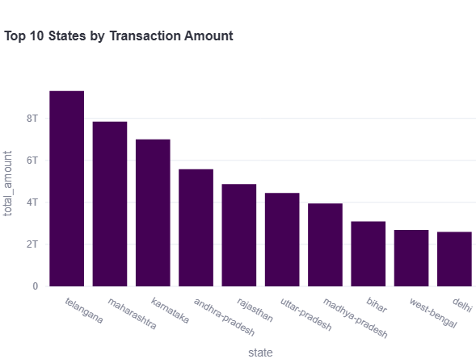

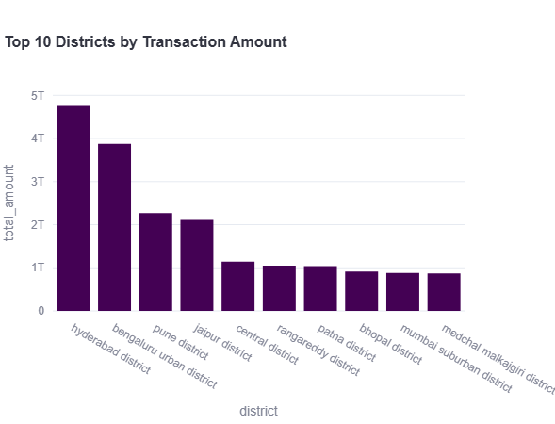

**📈 Summary Insight:**

* **Top State:** Telangana leads with the highest total transaction amount: ₹ **9.3 trillion**.
* **Top District:** Hyderabad district alone contributes approximately ₹ **4.77 trillion**, making it the highest among all districts.
* Other high-performing states include **Maharashtra, Karnataka, and Andhra Pradesh**, while **Bengaluru Urban, Pune, and Jaipur** districts show significant transaction volume.

**💡 Business Finding:**

* The southern and western regions dominate digital transaction activity, indicating **stronger adoption of digital payments** in these regions.
* A few urban districts (like Hyderabad and Bengaluru) are **economic epicenters**, contributing disproportionately higher transaction volumes.
* The presence of multiple high-ranking districts within a single state (e.g., Telangana: Hyderabad, Rangareddy, Medchal) suggests **concentrated economic activity** and urban digital maturity.

✅ **Strategic Recommendation:**

**1. Hyperlocal Campaigns:**

* Launch **localized marketing campaigns** and partnerships in top districts (e.g., Hyderabad, Bengaluru, Pune) to capitalize on existing high transaction engagement.

**2. State-level Enterprise Tie-ups:**

* Strengthen **state-level alliances** in Telangana, Maharashtra, and Karnataka with local merchants and businesses to scale digital financial services.

**3.** **Tier-2 City Focus:**

* Expand strategic focus to **emerging districts** just below the top 10 (e.g., Surat, Nagpur, Lucknow) to **diversify revenue** and reduce regional dependency.

**4. Infrastructure Investments:**

* Consider enhancing infrastructure support and UPI ecosystem readiness in fast-growing districts to sustain and **scale transaction volumes**.