Python project

ADVENTURE SPORTS IN GOA

NAME-PRANJAL SAKARGAYAN
ERNO.-161b147
BATCH- b5
Code-

SUBMITTED TO-
Dr.mahesh kumar

- Introduction
This project is on “Adventure Sports” in Goa. This gives us a brief idea of various adventure sports in Goa. A proper list of all the sports is provided,a short discription of particular sport is written over there. It further tells you the price of the sport you selected for. Hereafter if you are ready to take part in the sport of your choice then a new window appears on your screen which will be for your registration and payment purpose. This will consist of details of your card and your one time password(OTP). After entering your card details,you need to enter OTP. The transaction will be completed just after you enter your OTP. And now,you are ready for your adventure trip.

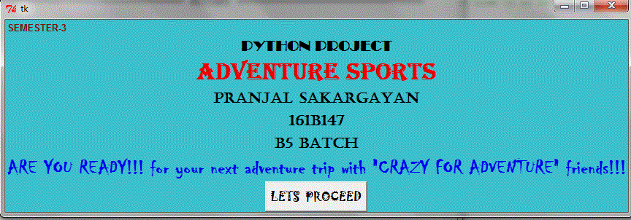
Click on ‘LETS PROCEED’ for next step.
- Go Goa

Now click on ‘GO’ button to see the list of adventure sport in Goa.
- List of sports

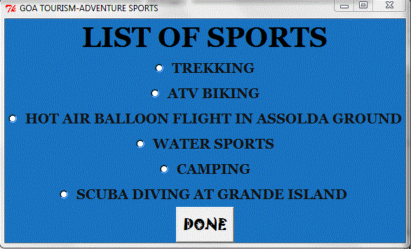
Select any option of your choice to see the description and details related to payment.
- Checking and payment
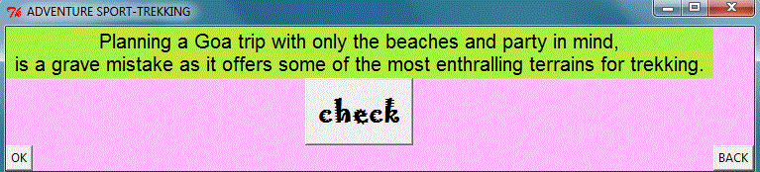
Check the amount. And if satisfactory then proceed with payment..
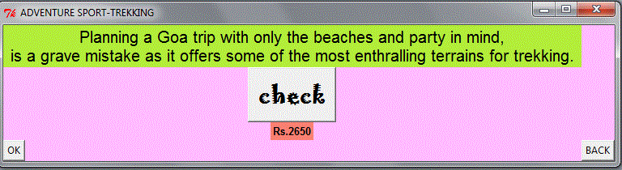
Proceed for payment by clicking on ‘ok’.Or if you don’t want to proceed then select ‘Back’ to go to the list..
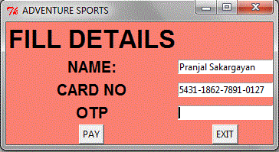
Enter details and click on’PAY’ button..

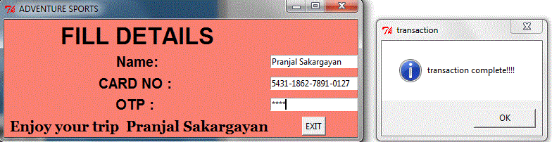

Transaction Complete!!!!
Now exit button will lead you to the list of sports..
Now ,as you are done with everything just click on ‘DONE’ to exit..

THANKYOU!!!

