**Project: Pizza Sales Analysis**

**Table of Contents:**

* [Problem Statement](https://github.com/yogeshkasar778/Sales_insights_of_data_analysis-AtliQ_Hardware/edit/main/README.md#problem-statement-)
* Data Analysis Using SQL Express
* Data Cleaning
* [Build Dashboard Or a Report](https://github.com/yogeshkasar778/Sales_insights_of_data_analysis-AtliQ_Hardware/edit/main/README.md#build-dashboard-or-a-report) using Tableau
* [Tools, Software and Libraries](https://github.com/yogeshkasar778/Sales_insights_of_data_analysis-AtliQ_Hardware/edit/main/README.md#tools-software-and-libraries-)
* [References](https://github.com/yogeshkasar778/Sales_insights_of_data_analysis-AtliQ_Hardware/edit/main/README.md#references-)

**Problem Statement**

**KPI’s REQUIREMENT**

We need to analyze key indicators for our pizza sales data to gain insights into our business performance. Specifically, we want to calculate the following metrics:

1. Total Revenue: The sum of the total price of all pizza orders.
2. Average Order Value: The average amount spent per order, calculated by dividing the total revenue by the total number of orders.
3. Total Pizzas Sold: The sum of the quantities of all pizzas sold.
4. Total Orders: The total number of orders placed.
5. Average Pizzas Per Order: The average number of pizzas sold per order, calculated by dividing the total number of pizzas sold by the total number of orders.

**CHARTS REQUIREMENT**

We would like to visualize various aspects of our pizza sales data to gain insights and understand key trends. We have identified the following requirements for creating charts:

**1. Hourly Trend for Total Pizzas Sold:** Create a stacked bar chart that displays the hourly trend of total orders over a specific time period. This chart will help us identify any patterns or fluctuations in order volumes on a hourly basis.

**2. Weekly Trend for Total Orders:** Create a line chart that illustrates the weekly trend of total orders throughout the year. This chart will allow us to identify peak weeks or periods of high order activity.

**3. Percentage of Sales by Pizza Category:** Create a pie chart that shows the distribution of sales across different pizza categories. This chart will provide insights into the popularity of various pizza categories and their contribution to overall sales.

**4. Percentage of Sales by Pizza Size:** Generate a pie chart that represents the percentage of sales attributed to different pizza sizes. This chart will help us understand customer preferences for pizza sizes and their impact on sales.

**5. Total Pizzas Sold by Pizza Category:** Create a funnel chart that presents the total number of pizzas sold for each pizza category. This chart will allow us to compare the sales performance of different pizza categories.

**6. Top 5 Best Sellers by Revenue, Total Quantity and Total Orders:** Create a bar chart highlighting the top 5 best-selling pizzas based on the Revenue, Total Quantity, Total Orders. This chart will help us identify the most popular pizza options.

**7. Bottom 5 Best Sellers by Revenue, Total Quantity and Total Orders:** Create a bar chart showcasing the bottom 5 worst-selling pizzas based on the Revenue, Total Quantity, Total Orders. This chart will enable us to identify underperforming or less popular pizza options.

**Data Analysis using SQL Express**

Utilized SQL Express for data extraction and calculation of key metrics such as Total Revenue, Average Order Value, Total Pizzas Sold, Total Orders, and Average Pizzas Per Order.

ANALYSIS OF DIFFERENT SQL STATEMENT ON DATA BASE

1. **KPI’s**
2. **Total Revenue:**

SELECT SUM(total_price) AS total_revenue FROM pizza_sales;

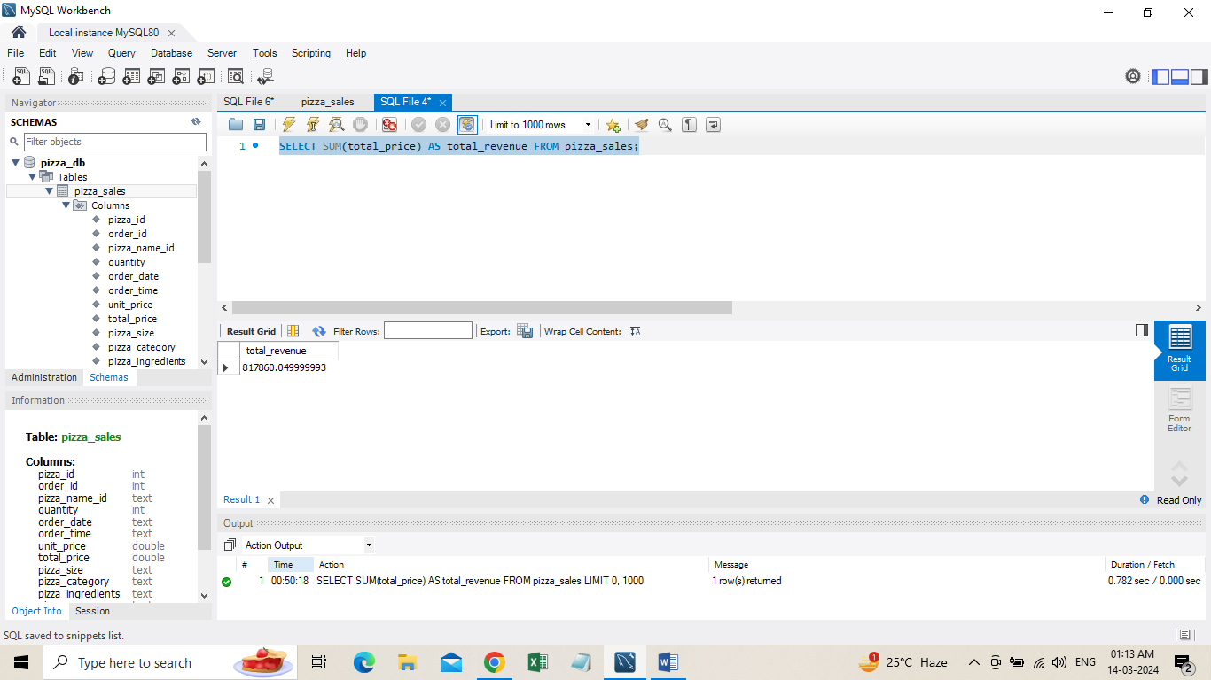

**2**. **Average Order Value:**

SELECT SUM(total_price) / COUNT(DISTINCT order_id) AS avg_order_value FROM pizza_sales;

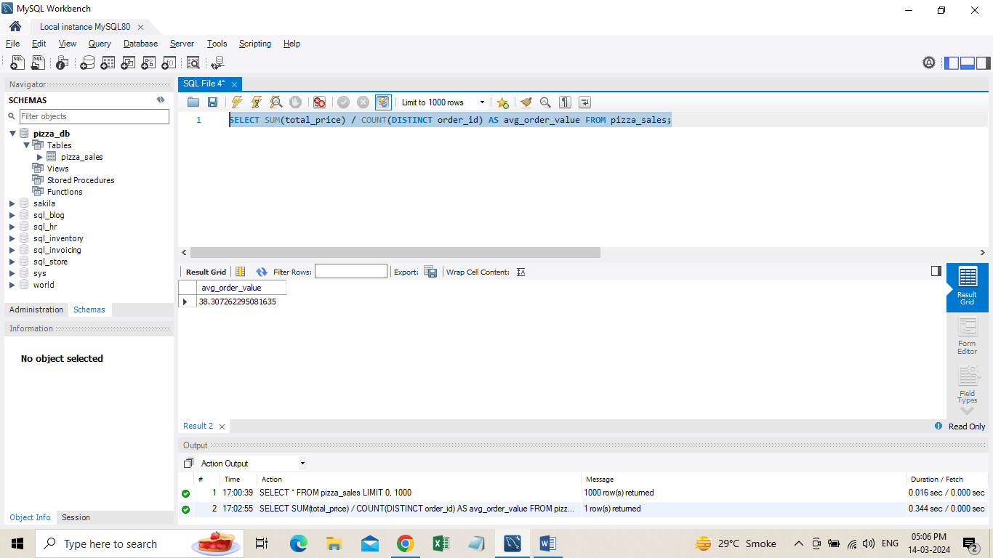

1. **Total Pizza Sold**

SELECT SUM(quantity) AS total_pizza_sold FROM pizza_sales;

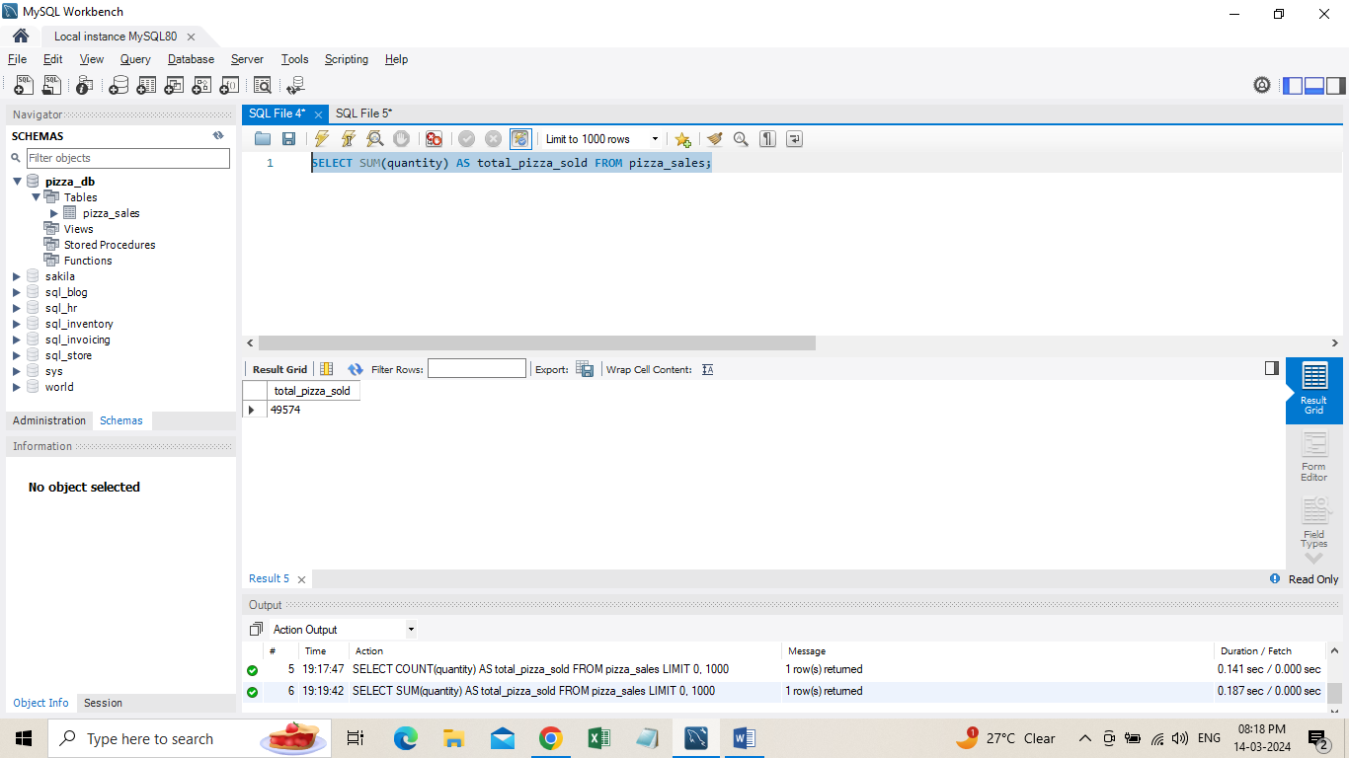

1. **Total Orders**

SELECT COUNT(DISTINCT order_id) AS total_order FROM pizza_sales;

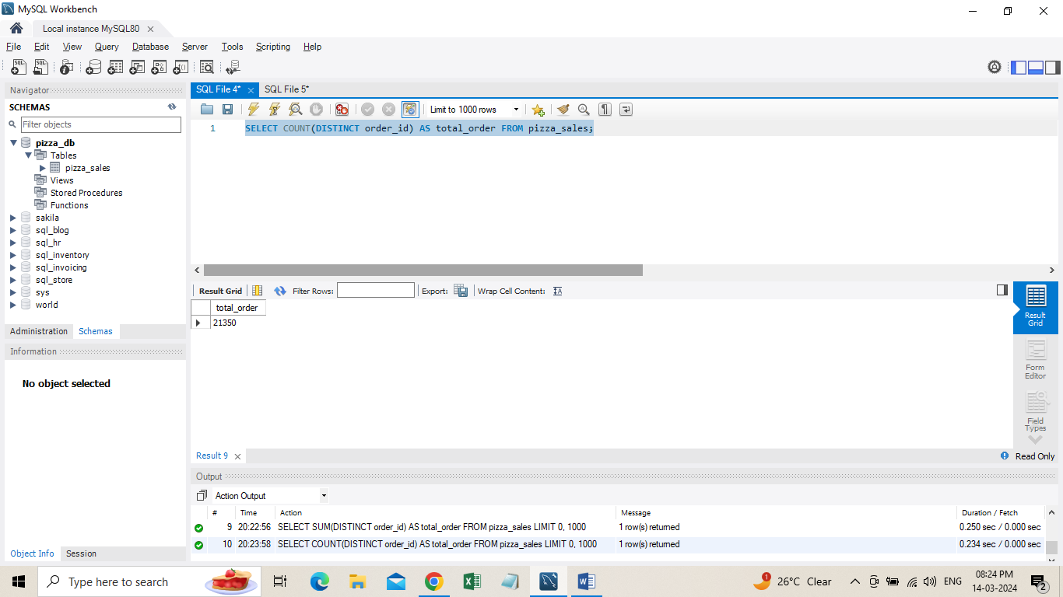

1. **Average Pizzas Per Order**
2. SELECT CAST(CAST(SUM(quantity) AS DECIMAL(10,2)) /
3. CAST(COUNT(DISTINCT order_id) AS DECIMAL(10,2)) AS DECIMAL(10,2)) AS Avg_Pizza_Per_order FROM pizza_sales;

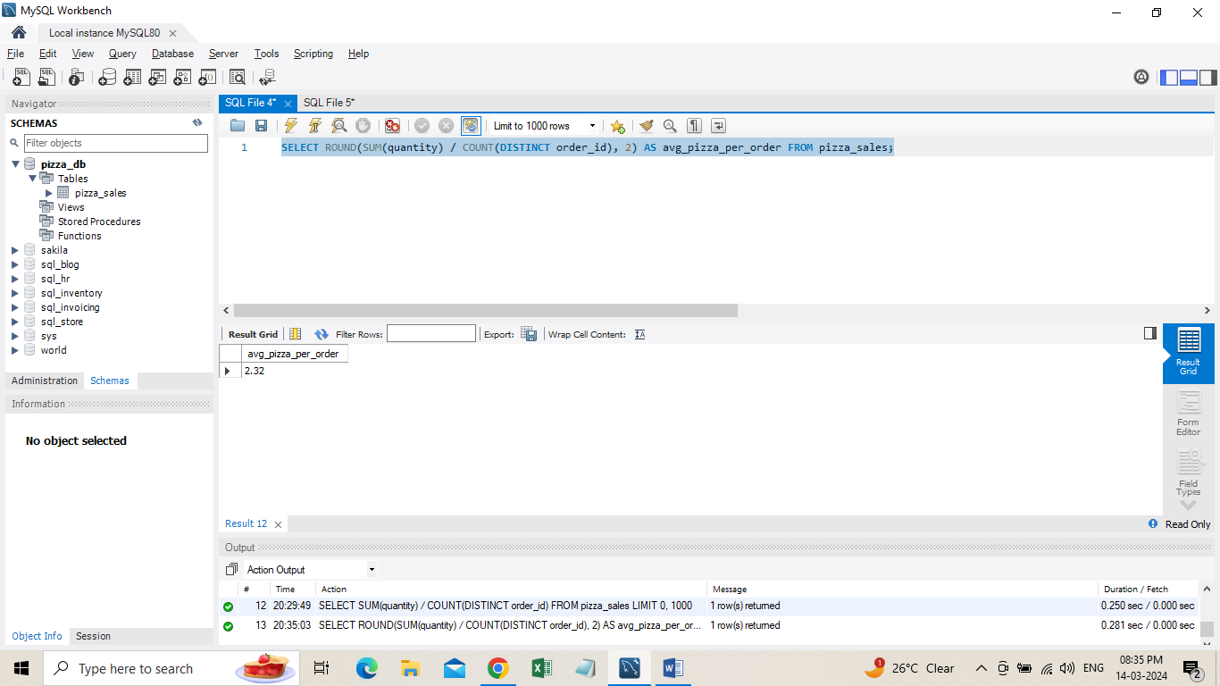

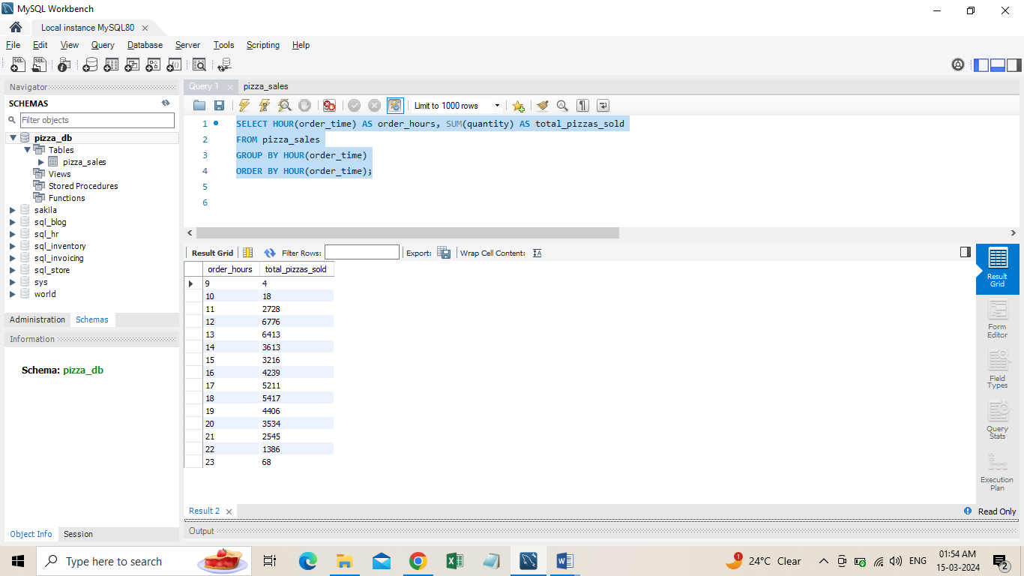**B. Hourly Trend for Total Pizzas Sold**SELECT DATEPART(HOUR,order_time) AS order_hours, SUM(quantity) AS total_pizzas_sold  
FROM pizza_sales GROUP BY DATEPART(HOUR,order_time) ORDER BY DATEPART(HOUR,order_time)

1. **Weekly Trend for Orders**

SELECT DATEPART (ISO_WEEK,order_date) AS week_number, YEAR(order_date) AS Order_year,COUNT(DISTINCT order_id) AS Total_orders FROM pizza_sales

GROUP BY DATEPART (ISO_WEEK,order_date), YEAR(order_date)

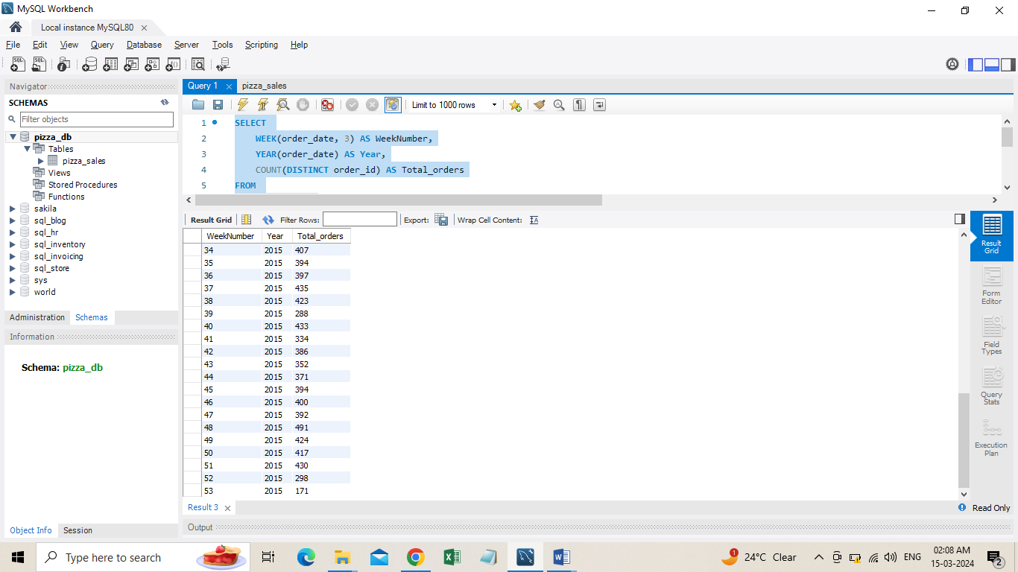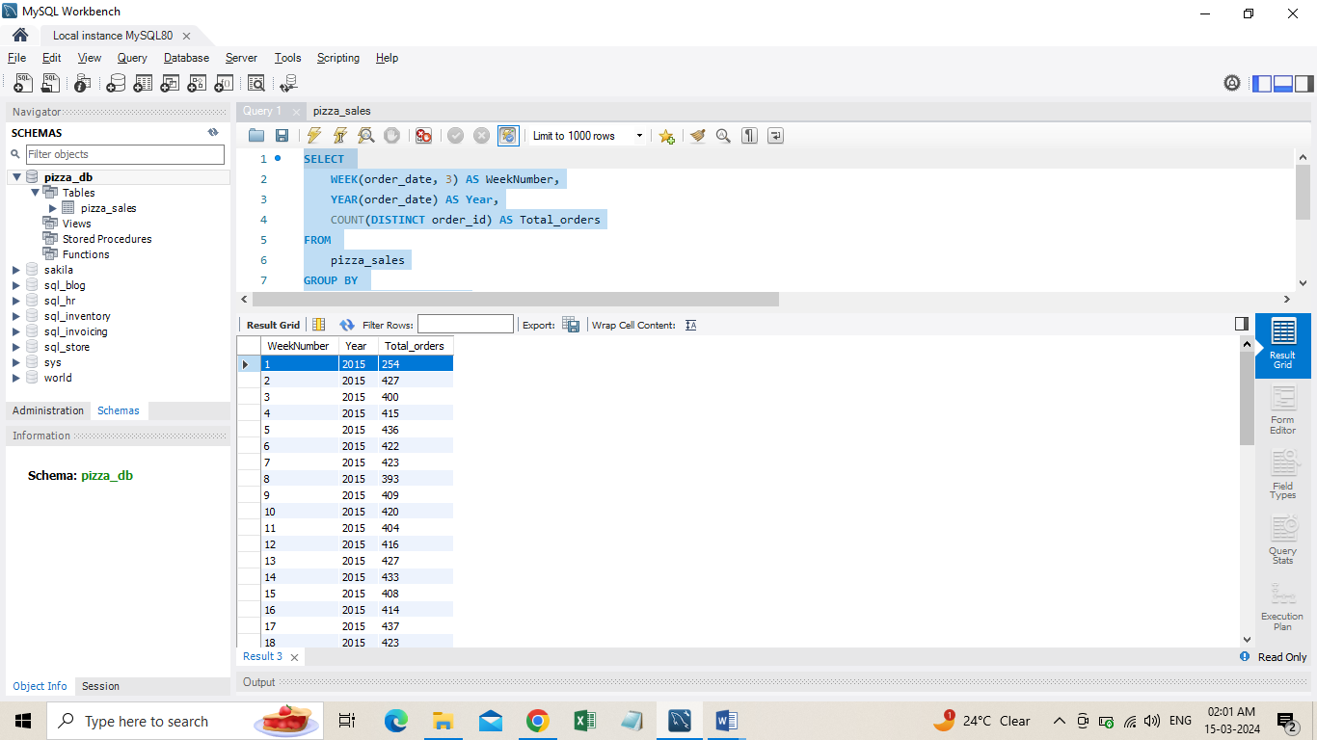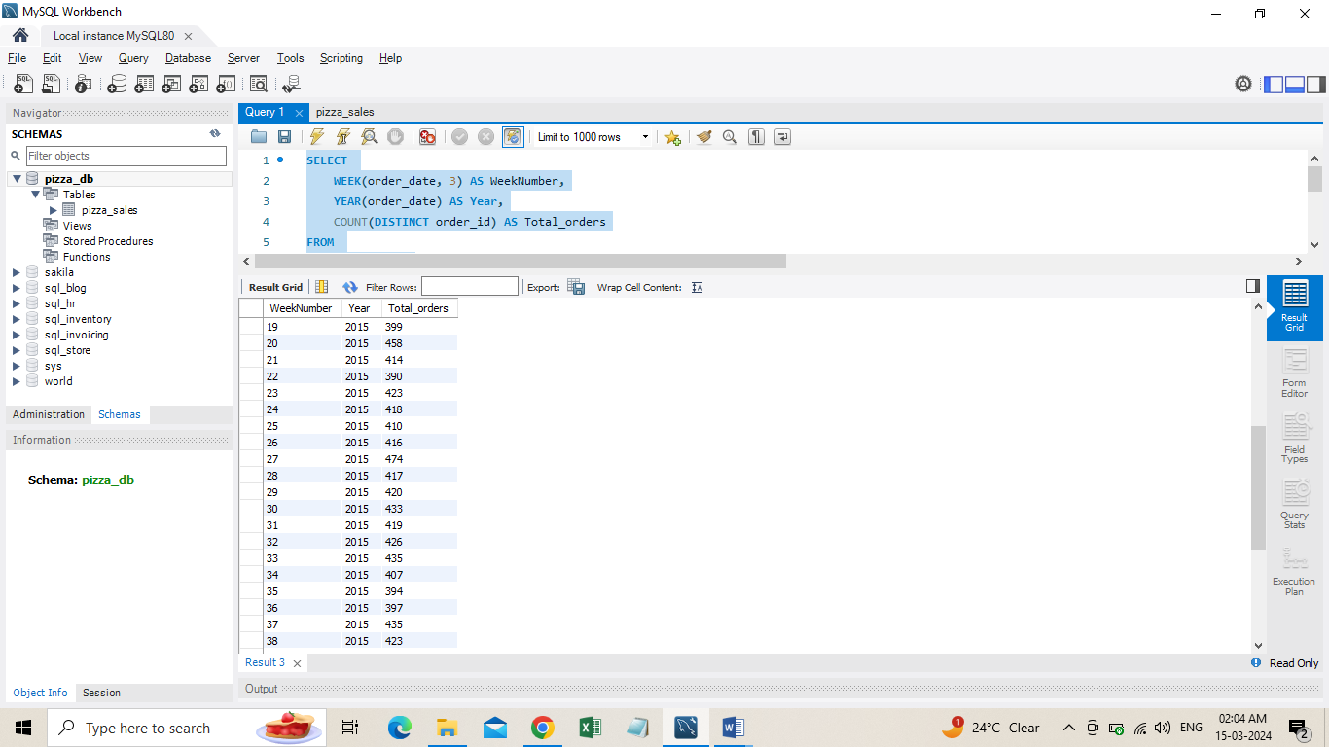ORDER BY DATEPART (ISO_WEEK,order_date),Year(order_date);

1. **% of Sales by Pizza Category**

SELECT pizza_category,

ROUND(SUM(total_price), 2) AS total_revenue,

ROUND(SUM(total_price) * 100 / (SELECT SUM(total_price) FROM pizza_sales), 2) AS PCT

FROM pizza_sales

GROUP BY pizza_category;

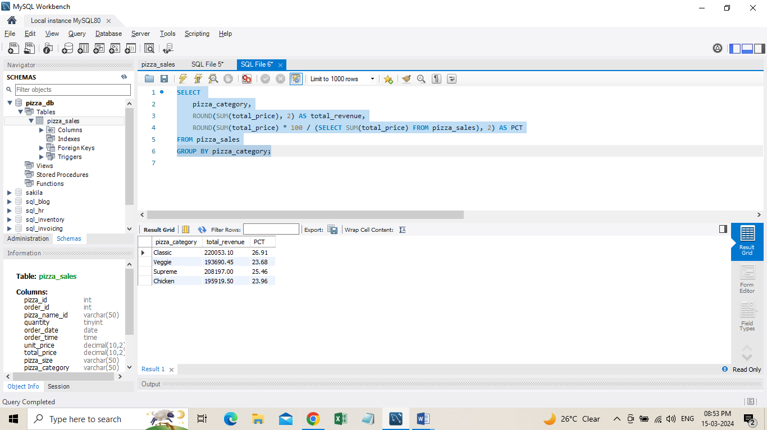

**OR**

SELECT pizza_category,

ROUND(SUM(total_price), 2) AS total_revenue,

ROUND(SUM(total_price) * 100 / (SELECT SUM(total_price) FROM pizza_sales

WHERE MONTH(order_date) = 1), 2) AS PCT

FROM pizza_sales

WHERE MONTH(order_date) = 1

GROUP BY pizza_category;

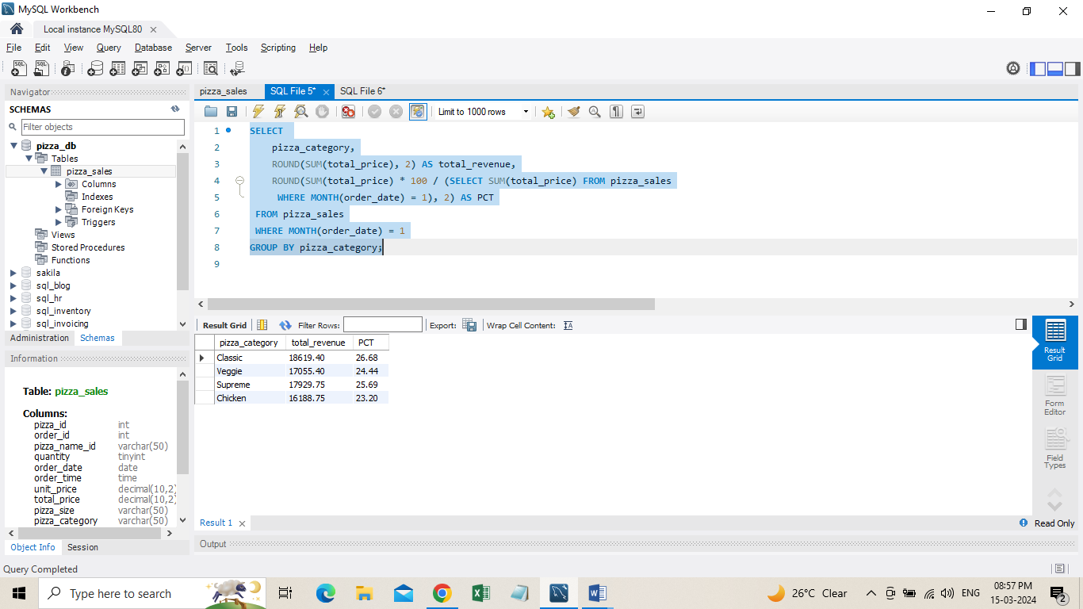

1. **% of Sales by Pizza Size**

SELECT pizza_size,

ROUND(SUM(total_price), 2) AS total_revenue,

ROUND(SUM(total_price) * 100 / (SELECT SUM(total_price) FROM pizza_sales), 2) AS PCT

FROM pizza_sales

GROUP BY pizza_size

ORDER BY pizza_size;

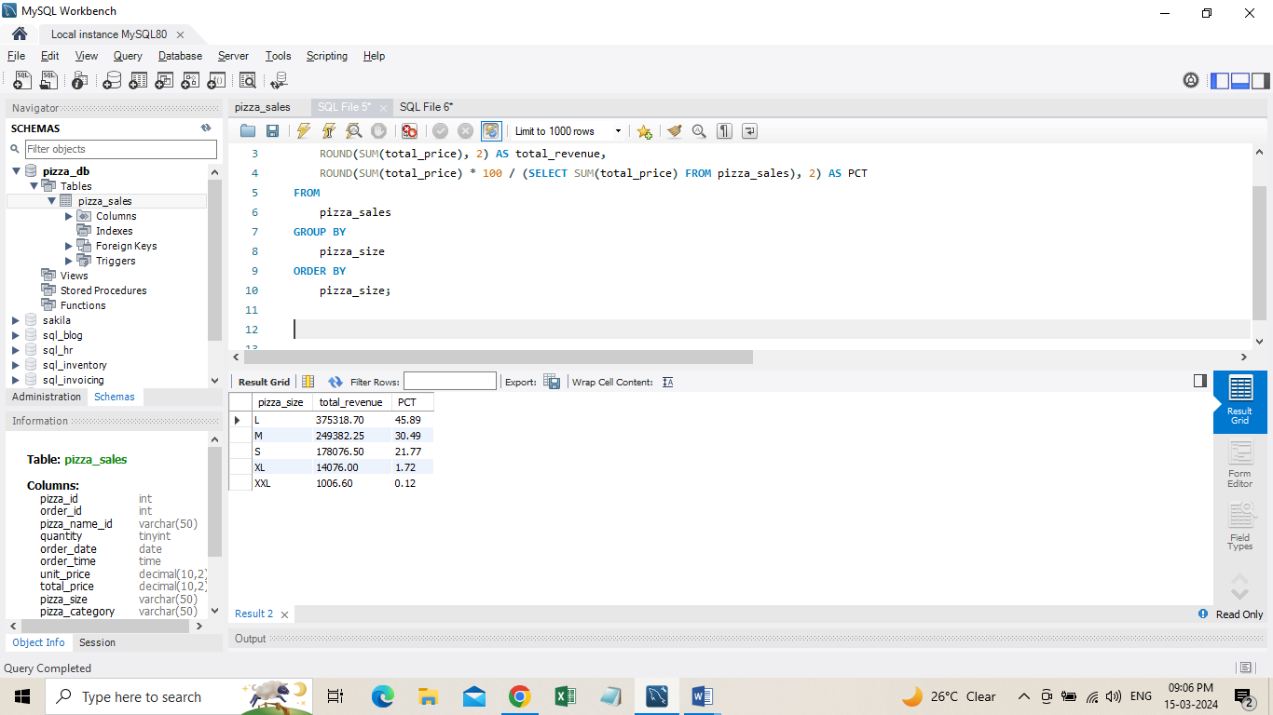

1. **Total Pizzas Sold by Pizza Category**

SELECT pizza_category, SUM(quantity) AS Total_Quantity_Sold

FROM pizza_sales

-- WHERE MONTH(order_date) = 2

GROUP BY pizza_category

ORDER BY Total_Quantity_Sold DESC;

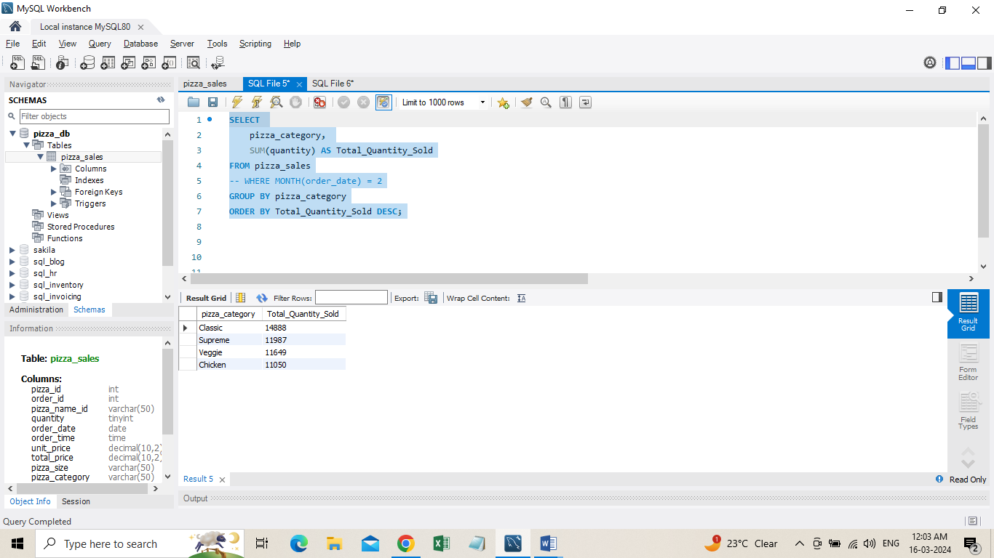

1. **Top 5 Pizzas by Revenue**

SELECT pizza_name, SUM(total_price) AS Total_Revenue

FROM pizza_sales

GROUP BY pizza_name

ORDER BY Total_Revenue DESC LIMIT 5;

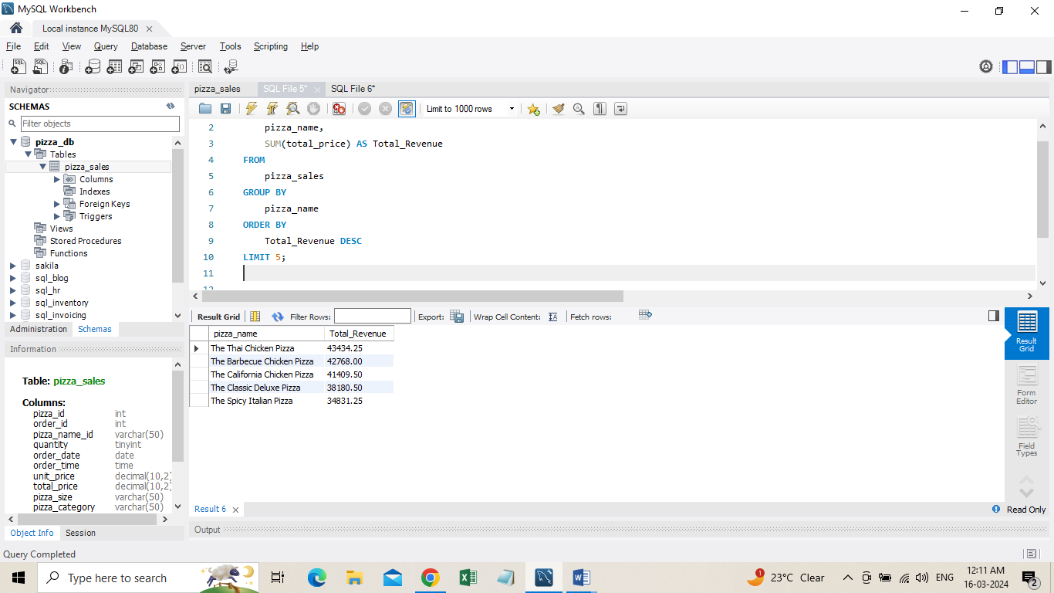

**H. Bottom 5 Pizzas by Revenue**

SELECT pizza_name, SUM(total_price) AS Total_Revenue

FROM pizza_sales

GROUP BY pizza_name

ORDER BY Total_Revenue ASC LIMIT 5;

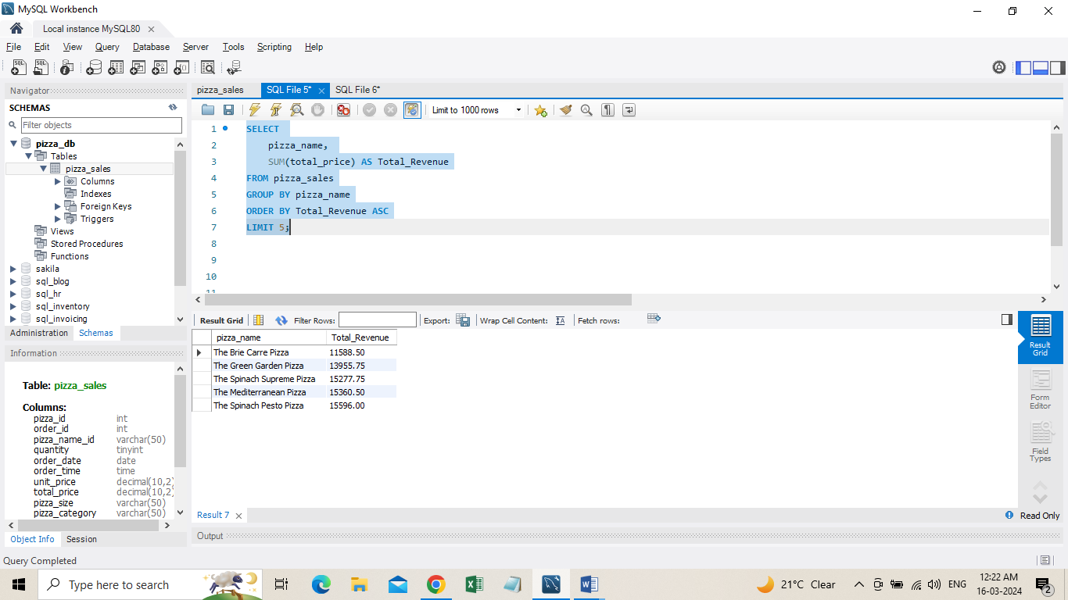

1. **Top 5 Pizzas by Quantity**

SELECT pizza_name, SUM(quantity) AS Total_Pizza_Sold

FROM pizza_sales

GROUP BY pizza_name

ORDER BY Total_Pizza_Sold ASC

LIMIT 5;

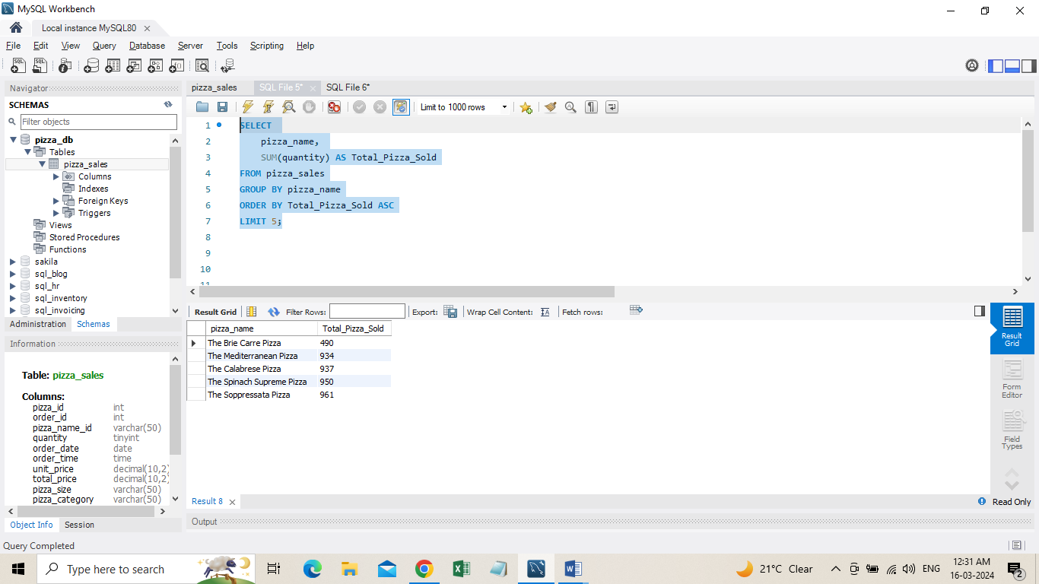

**K. Top 5 Pizzas by Total Orders**

SELECT pizza_name, COUNT(DISTINCT order_id) AS Total_Orders

FROM pizza_sales

GROUP BY pizza_name

ORDER BY Total_Orders DESC

LIMIT 5;

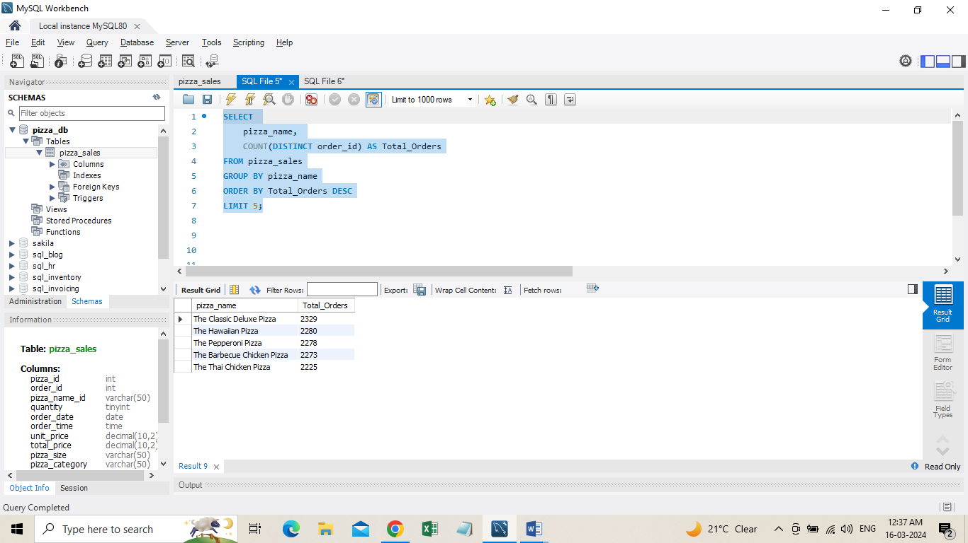

**L. Borrom 5 Pizzas by Total Orders**

SELECT

pizza_name,

COUNT(DISTINCT order_id) AS Total_Orders

FROM pizza_sales

GROUP BY pizza_name

ORDER BY Total_Orders ASC

LIMIT 5;

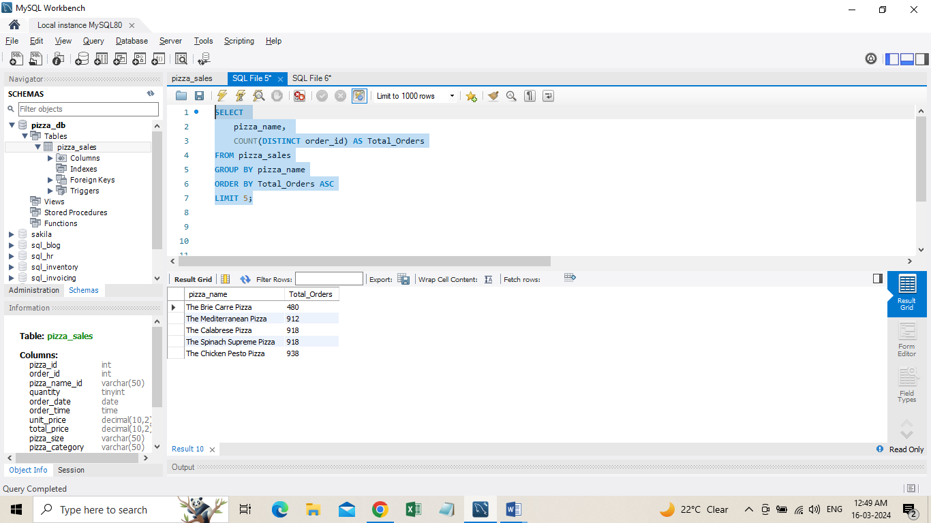

***NOTE***

If you want to apply the pizza_category or pizza_size filters to the above queries you can use WHERE clause. Follow some of below examples

SELECT pizza_name, COUNT(DISTINCT order_id) AS Total_Orders FROM pizza_sales

WHERE pizza_category = 'Classic' GROUP BY pizza_name ORDER BY Total_Orders ASC LIMIT 5;

**Data Cleaning**

Pizza size category we have in our database is abbreviated and for dashboard we need it in full expanded form. For eg. L= large, M= medium etc, so we will create an alias to temporary change its name in required format.

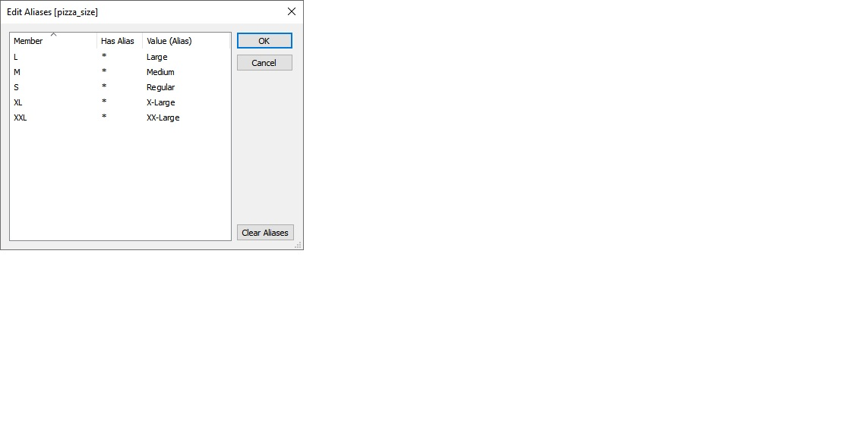

**Build Dashboard or a Report using Tableau**

Created a comprehensive dashboard in Tableau featuring key metrics and charts, including Hourly Trend, Weekly Trend, Sales by Category, Sales by Size, Total Pizzas Sold by Category, Top 5 Best Sellers, and Bottom 5 Worst Sellers.

KPI’S

* **Total Revenue** SUM([order id])
* **Total Orders** COUNTD([order id])
* **Average Order Value** [total revenue] / [total orders]
* **Total Pizzas Sold** SUM([quantity])
* **Average Pizzas Per Order** [total pizzas sold] / [total orders]

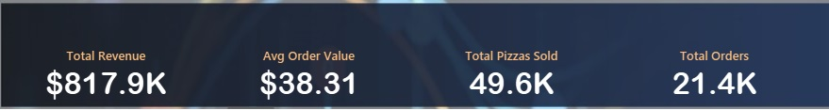

KEY INSIGHTS

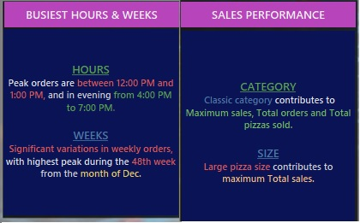

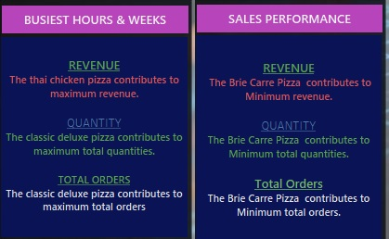

DASHBOARD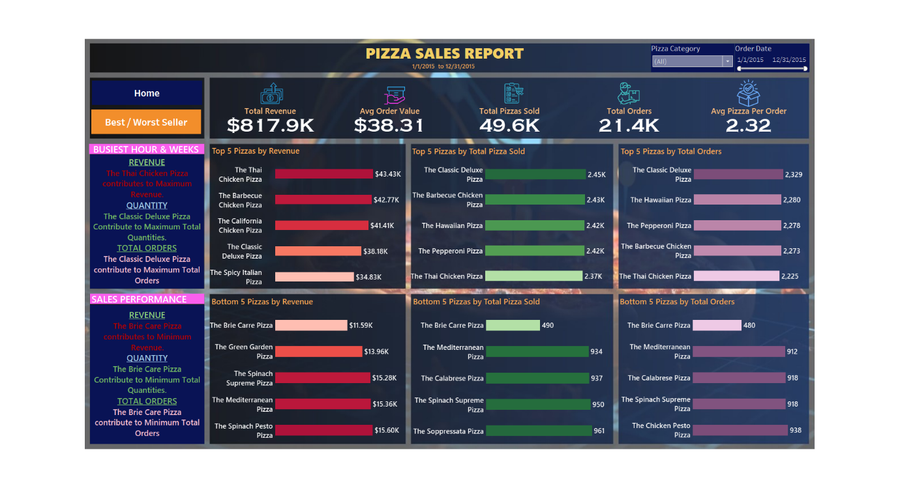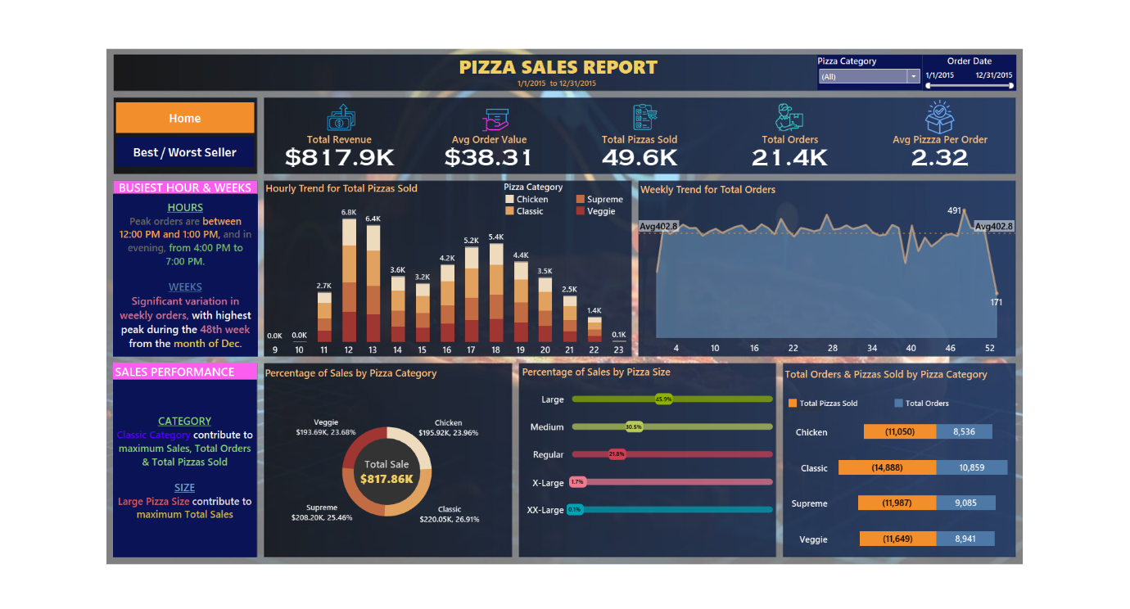

**Tools, Software, and Libraries**

**SQL Server Express (Latest version as of 2025)**Used for structured data storage, efficient querying, and relational database management.  
*(Accessed through SQL Server Management Studio 20.1)*

**Tableau Desktop 2024.1.0**Utilized to design interactive dashboards, perform data visualization, and derive insights from structured datasets.

**Microsoft Excel 2021 (Latest updates applied)**Employed during initial data exploration and preprocessing, including sorting, filtering, and formatting raw data.

**References**

* **Maven Analytics**. (n.d.). *Pizza Sales Data for Dashboard Project*. Kaggle.  
  <https://www.kaggle.com/datasets/mysarahmadbhat/pizza-sales>
* **Tableau Software**. (n.d.). Tableau Product Help.  
  <https://help.tableau.com/>
* **Microsoft**. (n.d.). SQL Server Express Documentation.  
  <https://learn.microsoft.com/en-us/sql/sql-server/editions-and-components-of-sql-server>
* **Microsoft**. (n.d.). SQL Server Management Studio (SSMS) Documentation.  
  <https://learn.microsoft.com/en-us/sql/ssms/sql-server-management-studio-ssms>
* **Tableau Software**. (n.d.). Connecting Tableau to SQL Server.  
  <https://help.tableau.com/current/pro/desktop/en-us/examples_sqlserver.htm>