# Power BI Assignment

## Question 1:

Define Power BI and What are the key components of the Power BI ecosystem? Briefly explain:  
• Power BI Desktop  
• Power BI Service  
• Power BI Mobile  
• Power BI Gateway

### Answer1 :

Power BI is a business analytics tool by Microsoft used to analyze data and share insights. It provides interactive visualizations and business intelligence capabilities with an interface simple enough for end users to create reports and dashboards.  
  
Key Components:  
1. Power BI Desktop: A Windows-based application for creating reports and data models. It allows connecting to multiple data sources, transforming data, and creating visuals.  
2. Power BI Service: A cloud-based service used to publish, share, and collaborate on Power BI reports and dashboards.  
3. Power BI Mobile: Mobile applications for Android and iOS to access and interact with reports on the go.  
4. Power BI Gateway: A bridge for connecting on-premises data to cloud Power BI services, enabling automatic data refresh.

## Question 2:

Compare the following Power BI visuals:  
• Pie Chart vs Donut Chart  
• Bar Chart vs Column Chart  
When would you prefer one over the other? Give one example for each pair.

### Answer:

Pie Chart vs Donut Chart:  
- Pie Chart shows the contribution of each category to the whole using slices.  
- Donut Chart is similar but has a blank center, making it easier to compare multiple values or display total values.  
Example: Use a Pie Chart to show percentage of sales by category; use a Donut Chart to show percentage of regional sales with a total value in the center.  
  
Bar Chart vs Column Chart:  
- Bar Chart displays data horizontally, suitable when category names are long.  
- Column Chart displays data vertically, ideal for comparing values over time or categories.  
Example: Use a Bar Chart to compare sales by product name; use a Column Chart to show monthly revenue trends.

## Question 3:

Explain the significance of:  
• Star schema vs Snowflake schema  
• Primary key vs Foreign key in relationships (Power BI)  
Why is cardinality important?

### Answer:

Star Schema vs Snowflake Schema:  
- Star Schema: Contains a central fact table connected directly to dimension tables. It is simple and efficient for querying.  
- Snowflake Schema: A more complex version where dimension tables are normalized into multiple related tables. It reduces redundancy but increases query complexity.  
  
Primary Key vs Foreign Key:  
- Primary Key: A unique identifier for each record in a table.  
- Foreign Key: A field that links one table to another, maintaining referential integrity in relationships.  
  
Cardinality Importance:  
Cardinality defines the relationship type between tables (one-to-one, one-to-many, many-to-one). It ensures accurate data aggregation and filtering across tables.

## Question 4:

Differentiate between:  
• Calculated column vs Measure  
Also, define Row context and Filter context with simple examples.

### Answer:

Calculated Column vs Measure:  
- Calculated Column: A new column created in a table using DAX formulas, calculated for each row (e.g., Total = Quantity * Price).  
- Measure: A calculation evaluated at query time, based on filters and aggregations (e.g., Total Sales = SUM(Sales[Amount])).  
  
Row Context: Refers to the current row when a formula is calculated (e.g., in a calculated column, each row's calculation is done individually).  
Filter Context: Refers to filters applied from visuals or slicers affecting calculation results (e.g., SUM filtered by region in a report).

## Question 5:

What is the difference between a report and a dashboard in Power BI?

### Answer:

Report:  
- A multi-page, detailed view containing various visuals, tables, and charts created in Power BI Desktop.  
- It allows in-depth data exploration, filtering, and interaction.  
  
Dashboard:  
- A single-page summary view created in Power BI Service that combines visuals from multiple reports.  
- It provides high-level insights and key metrics at a glance.  
  
In short, reports are detailed and multi-page, while dashboards are concise and single-page visual summaries.

**Question 6:**

Using the Sample Superstore dataset:

● Create a Clustered Bar Chart to display Total Sales by Sub-Category

● Create a Donut Chart for Sales % by Region Provide screenshots of both visuals.

**Answer 6**

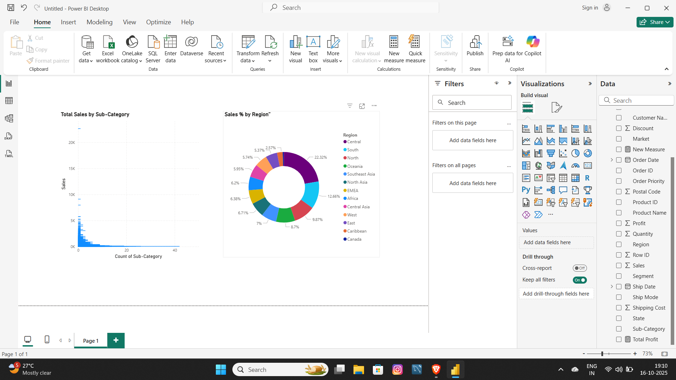

**Question 7 :**

Write and apply the following measures:

● Total Profit = SUM([Profit])

● Average Discount = AVERAGE([Discount]) Display both in a KPI Card, and use a Line Chart to show profit trend over months. Add visuals and DAX formulas.

**Answer 7**

**Question 8** : Implement a DAX measure that calculates the percentage of total sales by product category.

**Answer 8**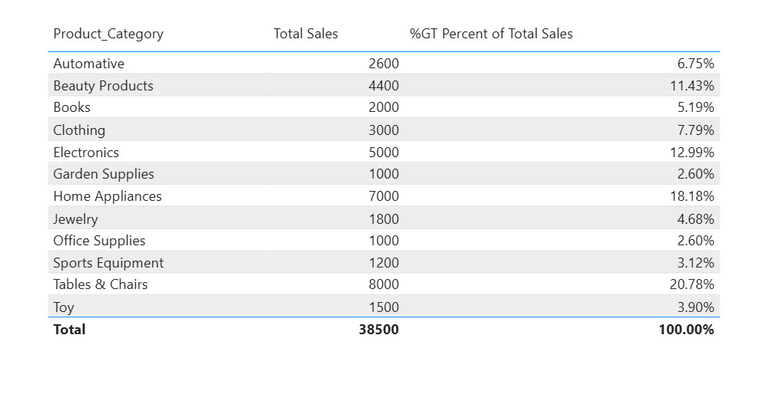

**Question 9 :** ● Create a DAX Measure for Total Profit ● Use it in a Waterfall Chart to analyze how different Sub-Categories contribute to overall profit ● Add a Slicer for Region to filter the visual ● Write brief business insights (4–5 lines) from the chart and provide 2–3 data-driven recommendations to improve profit. Provide a steps, screenshot of the Waterfall chart and the DAX formula

**Answer 9:**

1. Import Dataset: Load the dataset Global_Superstore2 into Power BI Desktop. 2. Create a DAX Measure for Total Profit: DAX Formula: Total Profit = SUM(Global_Superstore2[Profit]) 3. Build a Waterfall Chart: - Visual: Waterfall Chart - Category: Sub-Category - Values: Total Profit 4. Add a Slicer for Region to filter the visual dynamically.

**Waterfall Chart Screenshot**

**Business Insigts**

1. The Copiers and Phones sub-categories are the top profit drivers, contributing the highest positive margins. 2. Other sub-categories like Binders, Machines, and Chairs also show steady profit growth. 3. Tables are the only sub-category showing a negative profit (loss of around 0.06M). 4. Overall profit totals around 1.47M, with the majority coming from Office Supplies and Technology-related items. 5. Region slicer reveals that profit varies regionally, indicating opportunities for improvement.

**Data-Driven Recommendations**

1. Focus on high-performing products like Copiers and Phones — increase stock availability and marketing spend.
2. Investigate loss-making sub-categories (e.g., Tables) — re-evaluate pricing and supplier costs. 3. Use regional insights to replicate successful strategies in low-performing regions

Question 10 : Scenario: VitaTrack Wellness, a digital health company in FitZone, has collected data on users’ daily habits and health vitals. The analytics team is tasked with drawing actionable insights from this data to improve lifestyle suggestions and prevent heart-related risks.

**Your Task:** Using the provided dataset (includes Age, Gender, BMI, Steps, Calories, Sleep, Heart Rate, Blood Pressure, Smoking, Alcohol, Exercise, Diabetic & Heart Disease status): Build a one-page Power BI dashboard that answers: 1. Are users maintaining a balanced lifestyle (Steps, Sleep, Calories) 2. What lifestyle patterns (Smoking, Alcohol, BMI, etc.) indicate heart disease risk? 3. Is there any visible relationship between Sleep and Physical Activity? 4. How does BMI vary across Age Groups and Genders? 5. What is the impact of smoking and alcohol on heart rate and blood pressure? 6. Segment people based on their health activity to suggest lifestyle changes

**Answer10** 