Databricks Milestone 2 Sample Questions

Airline Delay Analytics

Problem Statement
You are given airline flight records containing flight timing, airline, route, and status information.
Your task is to:
- Load flight records from a CSV file
- Filter records with valid flight details
- Add delay minutes for each flight
- Filter flights delayed above a threshold
- Calculate average delay by airline
- Identify the busiest flight route

Objective
Implement 6 pure PySpark functions.

Import Statements
Import SparkSession, DataFrame, col, to_date, avg, count, desc, and anything else needed.
Function Specifications
Task 1: Load Flight Data
Function Name: load_flight_data
Parameters:
● spark: SparkSession
● path: str
Returns:
● DataFrame
Description:
Loads flight records from a CSV file and converts flight_date to DateType.
Function Signature:
def load_flight_data(spark: SparkSession, path: str) -> DataFrame:
Implementation Flow:
- Read the CSV file using header and inferSchema.
- Convert flight_date using to_date.
- Return the loaded DataFrame.
Expected Columns:
flight_id | airline | origin | destination | flight_date | scheduled_minutes | actual_minutes | status
Task 2: Filter Valid Flights
Function Name: filter_valid_flights
Parameters:
● df: DataFrame
Returns:
● DataFrame
Description:
Keeps only records with a valid flight id and positive scheduled duration.
Function Signature:
def filter_valid_flights(df: DataFrame) -> DataFrame:
Implementation Flow:
- Filter rows where flight_id is not null.
- Filter rows where scheduled_minutes is greater than 0.
- Return the filtered DataFrame.

Task 3: Add Delay Minutes
Function Name: add_delay_minutes
Parameters:
● df: DataFrame
Returns:
● DataFrame
Description:
Adds a new column delay_minutes using scheduled and actual flight duration.
Function Signature:
def add_delay_minutes(df: DataFrame) -> DataFrame:
Implementation Flow:
- Use withColumn to create delay_minutes.
- Calculate delay_minutes as actual_minutes - scheduled_minutes.
- Return the updated DataFrame.

Task 4: Filter Delayed Flights
Function Name: filter_delayed_flights
Parameters:
● df: DataFrame
● threshold: int
Returns:
● DataFrame
Description:
Filters flights whose delay is greater than the given threshold.
Function Signature:
def filter_delayed_flights(df: DataFrame, threshold: int) -> DataFrame:
Implementation Flow:
- Filter rows where delay_minutes is greater than threshold.
- Select only flight_id, airline, and delay_minutes columns.
- Return the filtered DataFrame.
Example Output Columns:
flight_id | airline | delay_minutes
Task 5: Average Delay By Airline
Function Name: avg_delay_by_airline
Parameters:
● df: DataFrame
Returns:
● DataFrame
Description:
Calculates the average flight delay for each airline.
Function Signature:
def avg_delay_by_airline(df: DataFrame) -> DataFrame:
Implementation Flow:
- Group by airline.
- Calculate average of delay_minutes and rename it as avg_delay.
- Return the aggregated DataFrame.
Example Output Columns:
airline | avg_delay
Task 6: Busiest Route
Function Name: busiest_route
Parameters:
● df: DataFrame
Returns:
● Tuple[str, int]
Description:
Returns the route with the highest number of flights.
Function Signature:
def busiest_route(df: DataFrame) -> Tuple[str, int]:
Implementation Flow:
- Group by origin and destination.
- Count flights for each route.
- Return the top route as origin-destination and count as a Python tuple.
Retail Revenue Intelligence

Problem Statement
You are given a retail orders dataset containing customer orders from different cities and product categories.
Your task is to:
- Load retail order data from a CSV file
- Filter records with valid order details
- Add order amount for each order
- Calculate total revenue by product category
- Filter orders by selected status
- Identify the city with the highest total revenue

Objective
Implement 6 pure PySpark functions.

Import Statements
Import SparkSession, DataFrame, col, to_date, sum, desc, and anything else needed.

Function Specifications
Task 1: Load Retail Orders
Function Name: load_orders_data
Parameters:
● spark: SparkSession
● path: str
Returns:
● DataFrame
Description:
Loads retail order records from a CSV file and converts order_date to DateType.
Function Signature:
def load_orders_data(spark: SparkSession, path: str) -> DataFrame:

Implementation Flow:
- Read the CSV file using header and inferSchema.
- Convert order_date using to_date.
- Return the loaded DataFrame.

Example Columns:
order_id | customer_id | city | order_date | product_category | quantity | unit_price | status

Task 2: Filter Valid Orders
Function Name: filter_valid_orders
Parameters:
● df: DataFrame
Returns:
● DataFrame

Description:
Keeps only records with a valid order id and positive quantity.
Function Signature:
def filter_valid_orders(df: DataFrame) -> DataFrame:

Implementation Flow:
- Filter rows where order_id is not null.
- Filter rows where quantity is greater than 0.
- Return the filtered DataFrame.

Task 3: Add Order Amount
Function Name: add_order_amount
Parameters:
● df: DataFrame
Returns:
● DataFrame
Description:
Adds a new column order_amount using quantity and unit price.

Function Signature:
def add_order_amount(df: DataFrame) -> DataFrame:

Implementation Flow:
- Use withColumn to create order_amount.
- Calculate order_amount as quantity * unit_price.
- Return the updated DataFrame.

Task 4: Revenue By Category
Function Name: revenue_by_category
Parameters:
● df: DataFrame
Returns:
● DataFrame
Description:
Calculates total revenue for each product category.
Function Signature:
def revenue_by_category(df: DataFrame) -> DataFrame:

Implementation Flow:
- Group by product_category.
- Sum order_amount and rename the column as total_revenue.
- Return the aggregated DataFrame.

Example Output Columns:
product_category | total_revenue

Task 5: Filter Orders By Status
Function Name: filter_orders_by_status
Parameters:
● df: DataFrame
● status_value: str
Returns:
● DataFrame
Description:
Filters orders for the selected order status.

Function Signature:
def filter_orders_by_status(df: DataFrame, status_value: str) -> DataFrame:

Implementation Flow:
- Filter rows where status is equal to status_value.
- Select only order_id, status, and city columns.
- Return the filtered DataFrame.

Example Output Columns:
order_id | status | city

Task 6: Top City By Revenue
Function Name: top_city_by_revenue
Parameters:
● df: DataFrame
Returns:
● Tuple[str, float]
Description:
Returns the city with the highest total order revenue.
Function Signature:
def top_city_by_revenue(df: DataFrame) -> Tuple[str, float]:
Implementation Flow:
- Group by city and sum order_amount.
- Order by total revenue descending and city ascending.
- Return the top city and revenue as a Python tuple.
Gold Market Price Analysis

Problem Statement

- You are working as a data analyst for a commodity market research firm.
- Your team tracks daily gold prices across different cities.
- A dataset contains daily gold price records including the date, city, price per gram, and trading volume.
- Your task is to analyze this dataset using PySpark DataFrame operations to derive useful insights about gold prices.
- Each function in this assessment is independent and will be evaluated separately.

Dataset:
Column Name Type
record_id string
city string
trade_date string
gold_price_per_gram double
trade_volume int

Objective:
Implement 5 pure functions to perform analysis on the gold price dataset.

Required Imports:
Import SparkSession, DataFrame and Functions/Types From pyspark.sql as Required.

Task 1 — Load Gold Price Dataset:
Description:
Load the gold prices CSV file and convert trade_date to DateType.

Function Name:
load_gold_prices
Function Signature:
def load_gold_prices(spark: SparkSession, path: str) -> DataFrame:
Sample Input :
def load_gold_prices(spark: SparkSession, data/gold_prices.csv) -> DataFrame:
Expected Output:
+---------+-----------+----------+-------------------+------------+
|record_id|city |trade_date|gold_price_per_gram|trade_volume|
+---------+-----------+----------+-------------------+------------+
|G501 |Hyderabad |2025-03-10|5420.0 |95 |
|G502 |Bangalore |2025-03-11|6150.0 |130 |
|G503 |Pune |2025-03-12|4890.0 |105 |
|G504 |Ahmedabad |2025-03-13|5720.0 |120 |
|G505 |Jaipur |2025-03-14|6340.0 |88 |
+---------+-----------+----------+-------------------+------------+

Implementation Flow:
- Read the CSV file . Take the first row as Header and infer the Schema.
- Convert trade_date Column to DateType using to_date.
- Return the DataFrame.

Task 2 — Filter High Gold Prices:
Description:
Return rows where gold_price_per_gram is greater than the given threshold.

Function Name:
filter_high_gold_prices
Function Signature:
def filter_high_gold_prices(df: DataFrame, price_threshold: float) -> DataFrame:
Sample Input:
def filter_high_gold_prices(df: DataFrame, 5000.0 :float) -> DataFrame:
+---------+-----------+----------+-------------------+------------+
|record_id|city |trade_date|gold_price_per_gram|trade_volume|
+---------+-----------+----------+-------------------+------------+
|G501 |Hyderabad |2025-03-10|5420.0 |95 |
|G502 |Bangalore |2025-03-11|6150.0 |130 |
|G503 |Pune |2025-03-12|4890.0 |105 |
|G504 |Ahmedabad |2025-03-13|5720.0 |120 |
|G505 |Jaipur |2025-03-14|6340.0 |88 |
+---------+-----------+----------+-------------------+------------+

Expected Output:
+---------+-----------+----------+-------------------+------------+
|record_id|city |trade_date|gold_price_per_gram|trade_volume|
+---------+-----------+----------+-------------------+------------+
|G501 |Hyderabad |2025-03-10|5420.0 |95 |
|G502 |Bangalore |2025-03-11|6150.0 |130 |
|G504 |Ahmedabad |2025-03-13|5720.0 |120 |
|G505 |Jaipur |2025-03-14|6340.0 |88 |
+---------+-----------+----------+-------------------+------------+

Implementation Flow:
- Return rows where gold_price_per_gram is greater than the given threshold.
- Return the filtered DataFrame.

Task 3 — Add Price Category Column:
Description:
Add a new column price_category based on gold price.

Function Name:
add_price_category
Function Signature:
def add_price_category(df: DataFrame) -> DataFrame:
Sample Input:
def add_price_category (df: DataFrame)-> DataFrame:
+---------+-----------+----------+-------------------+------------+
|record_id|city |trade_date|gold_price_per_gram|trade_volume|
+---------+-----------+----------+-------------------+------------+
|G501 |Hyderabad |2025-03-10|5420.0 |95 |
|G502 |Bangalore |2025-03-11|6150.0 |130 |
|G503 |Pune |2025-03-12|4890.0 |105 |
|G504 |Ahmedabad |2025-03-13|5720.0 |120 |
|G505 |Jaipur |2025-03-14|6340.0 |88 |
Expected Output:
+---------+-----------+----------+-------------------+------------+--------------+
|record_id |city |trade_date|gold_price_per_gram |trade_volume |price_category|
+---------+-----------+----------+-------------------+------------+--------------+
|G501 |Hyderabad |2025-03-10|5420.0 |95 |Medium |
|G502 |Bangalore |2025-03-11|6150.0 |130 |High |
|G503 |Pune |2025-03-12|4890.0 |105 |Low |
|G504 |Ahmedabad |2025-03-13|5720.0 |120 |Medium |
|G505 |Jaipur |2025-03-14|6340.0 |88 |High |
+---------+-----------+----------+-------------------+------------+--------------+

Logic:
Condition Category
price >= 6000 High
price >= 5000 and < 6000 Medium
price < 5000 Low

Implementation Flow:
- Add a new Column price_category
- If gold_price_per_gram >= 6000 → "High",
- If gold_price_per_gram >= 5000 and gold_price_per_gram < 6000 → "Medium"
- Otherwise → "Low"
- Return the Updated dataframe

Task 4 — Average Gold Price by City:
Description:
Calculate the average gold price per gram for each city.
Function Name:
avg_price_by_city
Function Signature:
def avg_price_by_city(df: DataFrame) -> DataFrame:
Sample input:
def avg_price_by_city(df: DataFrame) -> DataFrame:

+---------+-----------+----------+-------------------+------------+
|record_id|city |trade_date|gold_price_per_gram|trade_volume|
+---------+-----------+----------+-------------------+------------+
|G501 |Hyderabad |2025-03-10|5420.0 |95 |
|G502 |Bangalore |2025-03-11|6150.0 |130 |
|G503 |Pune |2025-03-12|4890.0 |105 |
|G504 |Ahmedabad |2025-03-13|5720.0 |120 |
|G505 |Jaipur |2025-03-14|6340.0 |88 |

Expected Output :
+-----------+--------------+
|city |avg_gold_price|
+-----------+--------------+
|Hyderabad |5420.0 |
|Bangalore |6150.0 |
|Pune |4890.0 |
|Ahmedabad |5720.0 |
|Jaipur |6340.0 |
+-----------+--------------+

Implementation Flow:
- Calculate average gold_price_per_gram by city.
- Rename the result column as avg_gold_price.
- Return the updated Dataframe .

Task 5 — City with Highest Average Gold Price:
Description:
From a DataFrame containing city and avg_gold_price, return the city with the highest average gold price

Function Name:
highest_avg_gold_price_city
Function Signature:
def highest_avg_gold_price_city(df: DataFrame) -> Tuple[str, float]:
Sample Input:
def highest_avg_gold_price_city(df: DataFrame) -> Tuple[str, float]:
+-----------+--------------+
|city |avg_gold_price|
+-----------+--------------+
|Hyderabad |5420.0 |
|Bangalore |6150.0 |
|Pune |4890.0 |
|Ahmedabad |5720.0 |
|Jaipur |6340.0 |
+-----------+--------------+

Expected Output :
("Jaipur", 6340.0)
Implementation Flow:
- Order the Dataframe By avg_gold_price in descending and then By city in ascending.
- Select the top row
- Extract the city and avg_gold_price values.
- Return the result as a tuple
Insurance Claims Performance Analytics

Import Statements
Import SparkSession and anything else needed.
Import Tuple, List or any other required libraries from Typing as needed

Problem Statement
You are analyzing claim data from an insurance company. Each record contains information about a customer's claim, such as claim amount, region, status, and settlement date. Your task is to:
- Load the claim data using an explicit schema
- Replace missing promised settlement dates with claim_date + 30
- Filter approved claims filed within a user-specified date range
- Determine the region with the highest total claim amount
- Identify the customer who filed the highest claim
These insights will help the insurance company manage settlements and monitor regional trends.

Objective: Implement 5 Pure Functions
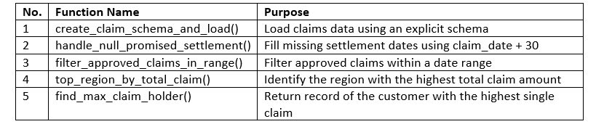

Function Specifications
1. Function: create_claim_schema_and_load
Parameters:
• spark: SparkSession
• path: str
Returns:
• DataFrame
Description:
Load claims data from a CSV using a predefined StructType schema. The schema should define correct data types for all columns.
Function Signature:
def create_claim_schema_and_load(spark: SparkSession, path: str) -> DataFrame:
Example Input:
create_claim_schema_and_load(spark, "data/claims.csv")
Expected Output (Representative Preview):

Implementation Flow:
- Define StructType with 7 fields - claim_id, customer_id, region, claim_date, claim_amount, status, promised_settlement
- Use relevant data types for struct creation, all fields are nullable
- Create Spark Dataframe using input csv and defined schema
- Return the loaded DataFrame

2. Function: handle_null_promised_settlement
Parameters:
• df: DataFrame
Returns:
• DataFrame
Description:
Fill missing values in promised_settlement with claim_date + 30.
Function Signature:
def handle_null_promised_settlement(df: DataFrame) -> DataFrame:
Example Input:
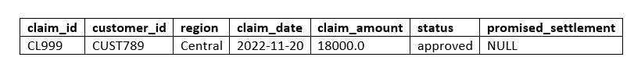
Example Output:
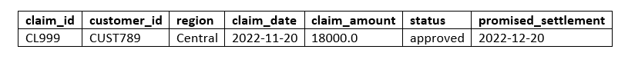
Implementation Flow:
- Use coalesce() on promised_settlement to handle null values
- If null, use formula: promised_settlement = claim_date+30 days
- Return updated DataFrame

3. Function: filter_approved_claims_in_range
Parameters:
• df: DataFrame
• start_date: str
• end_date: str
Returns:
• DataFrame
Description:
Return only claims that are "approved" and whose claim_date lies in the specified range.
Function Signature:
def filter_approved_claims_in_range(df: DataFrame, start_date: str, end_date: str) -> DataFrame:
Example Input:
filter_approved_claims_in_range(df, "2020-01-01", "2022-12-31")
Expected Output:
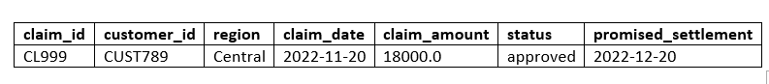
Implementation Flow:
- Apply filter condition for "approved" status
- And claim_date between start_date and end_date
- Return the result dataframe

4. Function: top_region_by_total_claim
Parameters:
• df: DataFrame
Returns:
• DataFrame
Description:
Return the region with the highest total claim amount.
Function Signature:
def top_region_by_total_claim(df: DataFrame) -> DataFrame:
Example Output
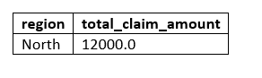
Implementation Flow:
- Calculate total claim_amount per region
- Rename column as "total_claim_amount"
- Sort descending and get top entry
- Return result

5. Function: find_max_claim_holder
Parameters:
• df: DataFrame
Returns:
• DataFrame
Description:
Return the row with the highest claim_amount.
Function Signature:
def find_max_claim_holder(df: DataFrame) -> DataFrame:
Example Output:
Implementation Flow:
- Sort Dataframe by claim_amount column and get top entry
- Return result
Consignment Delivery Monitoring

🎯 Problem Statement
You are analyzing consignment delivery performance using an inline dataset.
Your objectives are to:
- Load consignment delivery records
- Compute delivery delays
- Identify delayed orders
- Determine the most delayed delivery partner
- Calculate the percentage of significant delays
- Return the most delayed consignment’s order ID and delay value

🎯 Objective: Implement 6 Pure Functions

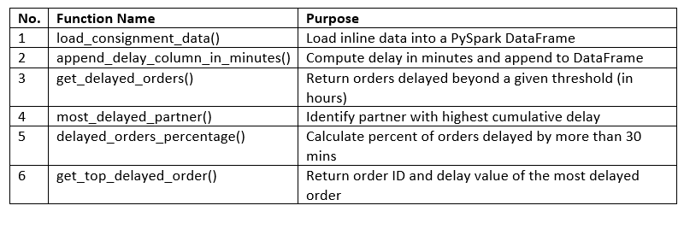

Import Statements

Import SparkSession, unix_timestamp, sum
Import Tuple, List or any other required libraries from Typing as needed

✅ Function Specifications
✅ 1. Function: load_consignment_data
Parameters:
• spark: SparkSession
Returns:
• DataFrame
Description:
Create an inline DataFrame with columns matching consignment records.
🔁 Function Signature:
def load_consignment_data(spark: SparkSession) -> DataFrame:
📥 Example Input:
load_consignment_data(spark)
📤 Expected Output (Preview using different data):

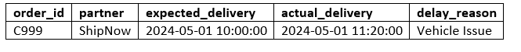

🔁 Implementation Flow:
- Define column names list - "order_id", "partner", "expected_delivery", "actual_delivery", "delay-reason"
- Create DataFrame using given data andcolumns
- Return the DataFrame.

✅ 2. Function: append_delay_column_in_minutes
Parameters:
• df: DataFrame
Returns:
• DataFrame
Description:
Add column delay representing delivery delay in minutes.
🔁 Function Signature:
def append_delay_column_in_minutes(df: DataFrame) -> DataFrame:
📥 Example Input (Different from real data):



📥 Example Output:

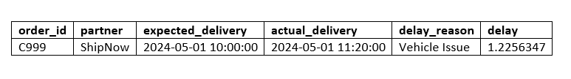

🔁 Implementation Flow:
- Use .withColumn("delay", ...) to add delay column.
- Use unix_timestamp to get difference between actual and expected delivery.
- ensure that delay is calculated in minutes
- Return the new DataFrame.

✅ 3. Function: get_delayed_orders
Parameters:
• df: DataFrame
• threshold: int (in hours)
Returns:
• DataFrame
Description:
Return only those orders whose delay exceeds the given threshold in hours.
🔁 Function Signature:
def get_delayed_orders(df: DataFrame, threshold: int) -> DataFrame:
📥 Example Input:



📥 Example Output:
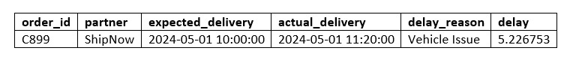

🔁 Implementation Flow:
- Use unix_timestamp to get difference between actual and expected delivery.
- ensure that delay is calculated in hours
- Use .withColumn("delay", ...) to add delay column.
- Filter the data frame for value of column "delay" greater than threshold
- Return the dataframe

✅ 4. Function: most_delayed_partner
Parameters:
• df: DataFrame
Returns:
• DataFrame
Description:
Return the partner with the highest total delay in minutes.
🔁 Function Signature:
def most_delayed_partner(df: DataFrame) -> DataFrame:
📥 Example Input:


📥 Example Ouput:
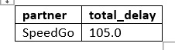

🔁 Implementation Flow:
- Groupby partner and calculate total delay. Save the column name as total_delay
- Sort by desc and get top entry
- Return the dataframe

✅ 5. Function: delayed_orders_percentage
Parameters:
• df: DataFrame
Returns:
• float
Description:
Return percentage of orders delayed more than 30 minutes.
🔁 Function Signature:
def delayed_orders_percentage(df: DataFrame) -> float:
📥 Example Input:


Expected Output:
5.6624545

🔁 Implementation Flow:

- Calculate total_orders by using count on input dataframe
- Filter and Count records with delay > 30.
- Use Formula (delayed_orders / total_orders) * 100 to calculate percentage of delayed orders
- and return as float.

Wildlife Conservation Insights

Problem Statement
You are given biodiversity records of species surveyed across different habitats and regions. Each record includes population estimates and protection statuses such as "Endangered" or "Critically Endangered".
Your task is to:
- Load the dataset with appropriate schema inference
- Rank habitats by total species population
- Filter only critically endangered species
- Identify the most recently surveyed endangered species
This analysis supports conservation efforts by helping prioritize regions and species needing urgent attention.

Objective: Implement 4 Pure Functions
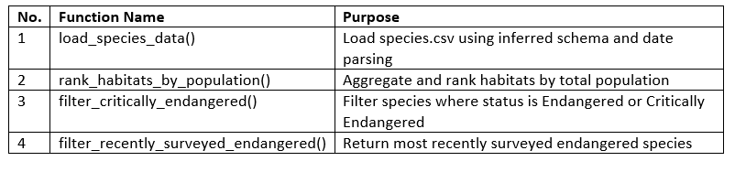
Import Statements
Import col, SparkSession, to_date

Function Specifications
1. Function: load_species_data
Parameters:
• spark: SparkSession
• path: str
Returns:
• DataFrame
Description:
Loads the species dataset from the given CSV file, inferring the schema and converting the Last_Surveyed column to DateType.
Function Signature:
def load_species_data(spark: SparkSession, path: str) -> DataFrame:
Example Input:
load_species_data(spark, "data/species.csv")
Expected Output (Representative):
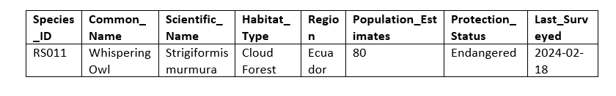
Implementation Flow:
- Load dataframe from csv using inferschema
- Convert Last_Surveyed to DateType using to_date(col("Last_Surveyed")).
- Return the resulting DataFrame.

2. Function: rank_habitats_by_population
Parameters:
• df: DataFrame
Returns:
• DataFrame
Description:
Ranks habitats by their total population estimates and returns the top habitat.
Function Signature:
def rank_habitats_by_population(df: DataFrame) -> DataFrame:
Example Input:

Example Output
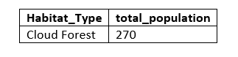
Implementation Flow:
- Group by "Habitat_Type" and compute sum of "Population_Estimate".
- Rename the result as "total_population".
- Order by desc
- get the top row.
- Return the resulting DataFrame.

3. Function: filter_critically_endangered
Parameters:
• df: DataFrame
Returns:
• DataFrame
Description:
Filters and returns all rows where Protection_Status is either "Endangered" or "Critically Endangered".
Function Signature:
def filter_critically_endangered(df: DataFrame) -> DataFrame:
Example Output:
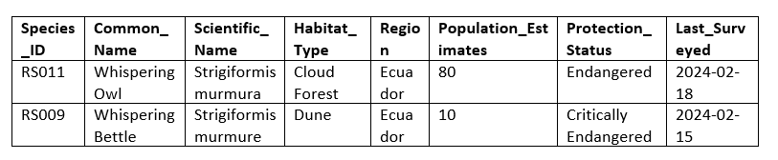
Implementation Flow:
- Create a constant list: ["Endangered", "Critically Endangered"].
- Filter the DataFrame using .filter(col("Protection_Status").isin(...)).
- Return the filtered result.

4. Function: filter_recently_surveyed_endangered
Parameters:
• df: DataFrame
Returns:
• DataFrame
Description:
Returns the most recently surveyed record where Protection_Status is exactly "Endangered".
Function Signature:
def filter_recently_surveyed_endangered(df: DataFrame) -> DataFrame:
Example Output

Implementation Flow:

- Filter using protection_status=="Endangered"
- Sort the result by Last_Surveyed in descending order using .orderBy(desc(...)).
- get top entry
- Return the resulting DataFrame.

User Profile Engagement Analysis

Problem Statement
You are given a CSV file containing dating profile information. Your goal is to:
- Load the profiles with correct data types
- Filter recent registrations
- Identify popular age groups
- Find the most preferred profession and rank cities with active users

Objective: Implement 4 Pure Functions
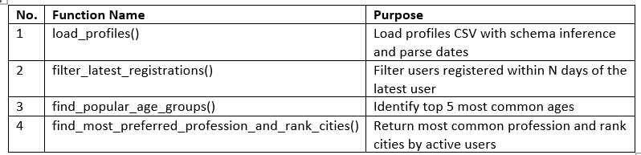

Import Statements
Import col, SparkSession, DataFrame, lit, datediff, and anything else needed
Import Tuple, List or any other required libraries from Typing as needed

Function Specifications
1. Function: load_profiles
Parameters:
• spark: SparkSession
• path: str
Returns:
• DataFrame
Description:
Load the profile data from a CSV file and parse registration_date as a DateType.
Function Signature:
def load_profiles(spark: SparkSession, path: str) -> DataFrame:
Example Input:
load_profiles(spark, "data/dating_profiles.csv")
Expected Output (Preview):
Implementation Flow:
- Create DataFrame from csv using inferschema method
- Convert registration_date to DateType
- Return the DataFrame

2. Function: filter_latest_registrations
Parameters:
• df: DataFrame
• days_threshold: int
Returns:
• DataFrame
Description:
Filter users whose registration date is within the specified number of days from the latest registration.
Function Signature:
def filter_latest_registrations(df: DataFrame, days_threshold: int) -> DataFrame:
Example Input:
filter_latest_registrations(df, 30)
Expected Output:
Implementation Flow:
- Compute latest date by fetching max value from registration date column. Use indexing to get the first element from dataframe. Store as a variable latest date
- Use datediff() with latest date and registration_column to compute days difference. Filter records with diff ≤ days_threshold
- Output dataframe should not include column diff_days
- Return the resultant Dataframe

3. Function: find_popular_age_groups
Parameters:
• df: DataFrame
Returns:
• List[int]
Description:
Return a list of top 5 most frequent ages sorted by age descending.
Function Signature:
def find_popular_age_groups(df: DataFrame) -> list:
Example Input:
find_popular_age_groups(df)
Expected Output:
[28, 27, 26, 25, 24]
Implementation Flow:
- Find count of entries per age (groupby age and count)
- Order by age descending
- Limit to top 5 and collect
- Return list of integers

4. Function: find_most_preferred_profession_and_rank_cities
Parameters:
• df: DataFrame
Returns:
• Tuple[str, DataFrame]
Description:
Return the most common profession overall and a DataFrame ranking cities with the most active users.
Function Signature:
def find_most_preferred_profession_and_rank_cities(df: DataFrame) -> Tuple[str, DataFrame]:
Example Input:
find_most_preferred_profession_and_rank_cities(df)
Expected Output:
"Engineer", DataFrame with columns [city, users]
Implementation Flow:
- Group by profession, count, sort by count, get top entry. Use indexing to get first element from profession column.
- Filter users with active_status == 'Active'
- Group by city, count, and sort descending.
- Return profession (string) and DataFrame of city rankings

Pharmacy Purchase Analytics

Import Tuple, List or any other required libraries from Typing as needed
### 1. `define_medicine_schema` function:
def define_medicine_schema() -> StructType:
#### Steps:
1. Create a new instance of `StructType()`.

2. Add `StructField` definitions for the following fields:
* `purchase_id`
* `medicine_name`
* `category`
* `purchase_date`
* `purchase_amount`
All fields are nullable﻿

3. Return the `StructType` object with the defined schema.

### 2. `load_purchase_data` function:

def load_purchase_data(spark: SparkSession, path: str, schema: StructType) -> DataFrame:
Example Output
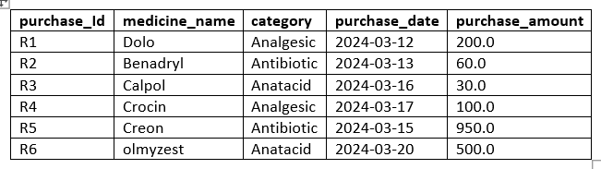
#### Steps:
1. Load the CSV file using the provided schema.
2. After loading, convert the `purchase_date` column to a `DateType` using the `to_date()
3. Return the loaded DataFrame with the converted `purchase_date` column.

### 3. `filter_by_purchase_date_range` function:
def filter_by_purchase_date_range(df: DataFrame, start: str, end: str) -> DataFrame:
Example Input

Expected output
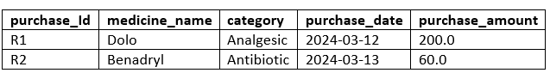

#### Steps:
1. Use the `filter()` function on the DataFrame.
2.Use .between(start, end) or equivalent inclusive filter
3. Return the filtered DataFrame.

### 4. `total_purchase_by_category` function:
def total_purchase_by_category(df: DataFrame) -> DataFrame:
Example Input
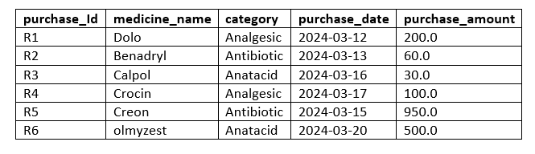
Example Output
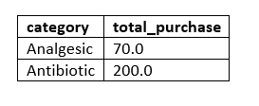
#### Steps:
1. Use the `groupBy()` function on the `category` column.
2. Apply Sum and rename the resulting column `total_purchase`
3. Return the DataFrame containing the total purchases by category.

### 5. `compute_days_since_purchase` function:

def compute_days_since_purchase(df: DataFrame) -> DataFrame:
Example Input
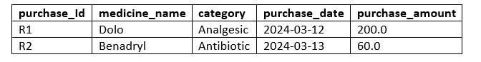
Expected Output
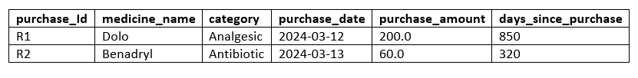

#### Steps:
1. Use `datediff to compute the difference in days between the current date and the `purchase_date`.
2. Add the computed difference as a new column `days_since_purchase`
3. Return the updated DataFrame.

### 6. `get_top_medicine_by_sales` function:
def get_top_medicine_by_sales(df: DataFrame) -> Tuple[str, float]:
Example Input
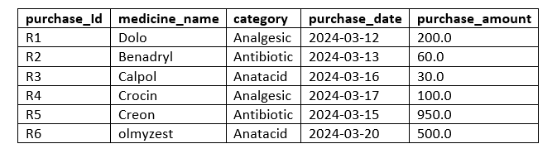
Expected Output
('Creon', '950')

#### Steps:
1. Sort the DataFrame by `purchase_amount` in descending order.
2. Select the first row
3. Extract the `medicine_name` and `purchase_amount` values from the first row.
4. Return the extracted values as a tuple: `(medicine_name, purchase_amount)`.

Tsunami Impact Assessment

Function Specifications
1. Load Tsunami Data
Function Name: load_tsunami_data
Parameters: spark: SparkSession, path: str
Returns: DataFrame
Description: Loads CSV tsunami event data.
Function Signature:
def load_tsunami_data(spark: SparkSession, path: str) -> DataFrame:
Expected Columns:
● event_id
● region
● impact_value
● alert_issued
Steps:
- Reads the CSV file with headers and infers the schema for data types.
- Returns the loaded DataFrame.

2. Filter Significant Events
Function Name: filter_significant_events
Parameters: df: DataFrame
Returns: DataFrame
Description: Filters events with magnitude >= 6.0.
Function Signature:
def filter_significant_events(df: DataFrame) -> DataFrame:
Example Input:
+---------+----------+---------+
|event_id |region |impact_value| alert_issued|
+---------+----------+---------+
|E001 |RegionA |3.8 | false |
|E002 |RegionB |6.2 | true |
|E003 |RegionA |3.8 | false |
|E004 |RegionB |3.2 | false |
+---------+----------+---------+
Expected Output:
+---------+----------+---------+
|event_id |region |impact value|
+---------+----------+---------+
|E002 |RegionB |6.2 |
+---------+----------+---------+
Steps:
- Filters rows where impact_value >= 4.0
- Returns the filtered DataFrame.

3. Compute Impact Statistics
Function Name: compute_impact_statistics
Parameters: df: DataFrame
Returns: dict
Description: Computes min, max, avg impact_score.
Function Signature:
def compute_impact_statistics(df: DataFrame) -> dict:
Example Input:
+---------+----------+---------+
|event_id |region |impact_value| alert_issued|
+---------+----------+---------+
|E001 |RegionA |3.8 | false |
|E002 |RegionB |6.2 | true |
|E003 |RegionA |3.8 | false |
|E004 |RegionB |3.2 | false |
+---------+----------+---------+
Expected Output:
{"min_impact": 30, "max_impact": 70, "avg_impact": 50.0}
Steps:
- calculates the min, max, and avg of the impact_value column.
- Returns the statistics as a dictionary with keys: min_impact, max_impact, and avg_impact.
- Hint: Incase of TC Failure check datatype of values

4. Count Alert Issued Events
Function Name: count_alert_issued_events
Parameters: df: DataFrame
Returns: int
Description: Counts events where alert_issued = True.
Function Signature:
def count_alert_issued_events(df: DataFrame) -> int:
Example Input:
+---------+----------+---------+
|event_id |region |impact_value| alert_issued|
+---------+----------+---------+
|E001 |RegionA |3.8 | false |
|E002 |RegionB |6.2 | true |
|E003 |RegionA |3.8 | false |
|E004 |RegionB |3.2 | false |
+---------+----------+---------+
Expected Output: 2
Steps:
- Filters the DataFrame for rows where alert_issued == True.
- Returns the count of such rows.

5. Region with Highest Average Impact
Function Name: region_highest_avg_impact
Parameters: df: DataFrame
Returns: str
Description: Returns the region with the highest average impact_score.
Function Signature:
def region_highest_avg_impact(df: DataFrame) -> str:
Example Input:
+---------+----------+---------+
|event_id |region |impact_value| alert_issued|
+---------+----------+---------+
|E001 |RegionA |3.8 | false |
|E002 |RegionB |6.2 | true |
|E003 |RegionA |3.8 | false |
|E004 |RegionB |3.2 | false |
+---------+----------+---------+

Expected Output: "RegionB"
Steps:
- Groups the data by region and computes the average impact_value for each region.
- Sort descending and take top 1 record.
- Returns the region with the highest average impact.

Podcast Listening Behavior Analysis

Problem Statement
You are analyzing listening sessions for a podcast platform. Each session records the user, episode, start time, duration (in minutes), and device used. Your goal is to parse the data, keep only valid sessions, aggregate listening minutes per episode, summarize device usage, and find the most-listened episode.
Note: The first function (data loading) is mandatory. Without a valid DataFrame, no test case will pass.

Objective
Implement five pure functions to perform:
• CSV data loading
• Valid-session filtering
• Episode-level total minutes
• Device-level session counts
• Most-listened episode retrieval

Function Specifications
Import SparkSession, DataFrame, and functions/types from pyspark.sql as required.
Import Tuple, List or any other required libraries from Typing as needed

1) Load Listening Data
Function Name: load_listens_data
Parameters:
• spark: SparkSession
• path: str
Returns: DataFrame
Description:
Loads listening sessions from CSV using header and schema inference. Changes the datatype of start_time to DateType for daily rollups.
Function Signature:
def load_listens_data(spark: SparkSession, path: str) -> DataFrame:
Implementation Flow:
• Use spark.read.csv() with header and inferSchema
• Cast start_time using to_date
Expected Columns:
user_id | episode_id | start_time | duration_min | device_type

2) Filter Valid Sessions
Function Name: filter_valid_sessions
Parameters:
• df: DataFrame
Returns: DataFrame
Description:
Keeps only rows where episode_id is not null.
Function Signature:
def filter_valid_sessions(df: DataFrame) -> DataFrame:
Implementation Flow:
•Use filter with episode_id not null condition

3) Episode Total Minutes
Function Name: episode_minutes
Parameters:
• df: DataFrame
Returns: DataFrame
Description:
Aggregates total minutes listened per episode_id.
Function Signature:
def episode_minutes(df: DataFrame) -> DataFrame:
Implementation Flow:
• groupby episode_id and take sum of duration_minute column. ensure output format matches below sample.
Example Output:
episode_id total_min
E101 742
E205 519

4) Device Session Counts
Function Name: device_counts
Parameters:
• df: DataFrame
Returns: DataFrame
Description:
Counts total sessions by device type.
Function Signature:
def device_counts(df: DataFrame) -> DataFrame:
Implementation Flow:
• groupby device type and count no of devices. Ensure output format matches below sample.
Example Output:
device_type sessions
mobile 1245
web 803
tv 112

5) Most-Listened Episode
Function Name: top_episode
Parameters:
• df: DataFrame (expects the output of episode_minutes)
Returns: Tuple[str, int]
Description:
Returns the (episode_id, total_min) pair of the most-listened episode.
Function Signature:
def top_episode(df: DataFrame) -> Tuple[str, int]:
Implementation Flow:
• Order by total_min desc
• Take the first row and return as a Python tuple
Expected Output:
("E101", 742)
Smart Grid Load Monitoring

Import Tuple, List or any other required libraries from Typing as needed
Problem Statement
You support analytics for a regional electricity grid. A time-series log records substation loads. A separate station reference lists each station’s region and rated capacity. Your tasks are to parse both datasets, clean invalid records, compute averages, enrich with station metadata, and identify the highest-peak stations to aid dispatch planning.
Note: The first two functions (loading both datasets) are mandatory. Without valid DataFrames, no test case will pass.

Objective
Implement six pure functions to perform:
• Load grid load readings (CSV)
• Load station reference (CSV)
• Filter non-negative loads
• Find the station with the highest average load
• Join readings with station metadata
• Return the top-2 stations by peak load

Function Specifications
Import SparkSession, DataFrame, and functions/types from pyspark.sql as required.

1) Load Grid Readings
Function Name: load_grid_data
Parameters:
• spark: SparkSession
• path: str
Returns: DataFrame
Description:
Loads grid readings with header & schema inference. Casts timestamp to TimestampType.
Function Signature:
def load_grid_data(spark: SparkSession, path: str) -> DataFrame:
Expected Columns:
station_id | timestamp | load_mw

2) Load Station Reference
Function Name: load_stations_ref
Parameters:
• spark: SparkSession
• path: str
Returns: DataFrame
Description:
Loads station metadata (region, rated_capacity_mw). Implementation may use explicit schema via StructType.
Function Signature:
def load_stations_ref(spark: SparkSession, path: str) -> DataFrame:
Expected Columns:
station_id | region | rated_capacity_mw

Implementation Flow:

Create a new instance of struct type with the following fields
- station_id
- region
- rated_capacity_mw
Ensure relevant datatypes are declared.
All fields are nullable

3) Filter Non-Negative Loads
Function Name: filter_nonneg
Parameters:
• df: DataFrame (grid readings)
Returns: DataFrame
Description:
Keeps only rows with load_mw >= 0 and non-null station_id.
Function Signature:
def filter_nonneg(df: DataFrame) -> DataFrame:

4) Highest Average Load (by Station)
Function Name: with_rolling_avg
Parameters:
• df: DataFrame
• window_minutes: int
Returns: str
Description:
Returns the single station_id with the highest average load across the dataset.
Function Signature:
def with_rolling_avg(df: DataFrame, window_minutes: int) -> str:
Implementation Flow:
• Groupby Station Id and take average of load_mw column
• orderBy avg descending, take first row
• and return station_id as a Python string

5) Join Station Metadata
Function Name: join_station_meta
Parameters:
• grid_df: DataFrame (filtered/augmented readings)
• ref_df: DataFrame (station reference)
Returns: DataFrame
Description:
Inner-join readings with station metadata on station_id.
Function Signature:
def join_station_meta(grid_df: DataFrame, ref_df: DataFrame) -> DataFrame:
Expected Output Columns (subset):
station_id | timestamp | load_mw | region | rated_capacity_mw

6) Top Peak Stations
Function Name: top_peak_stations
Parameters:
• df: DataFrame (expects output of join_station_meta)
• n: int
Returns: DataFrame
Description:
Computes peak load per station as max(load_mw) and returns the top-2 stations ordered by peak descending.
Function Signature:
def top_peak_stations(df: DataFrame, n: int) -> DataFrame:
Implementation Flow:
• groupBy station id and take max of load_mw, set aggregation column name as peak
• orderBy peak desc. limit entries to n(input) and return the resultant dataframe
Example Output:
station_id | peak
ST-014 | 213.5
ST-003 | 158.2
Coffee Sales Revenue Optimization

Import SparkSession, DataFrame, and required functions from pyspark.sql.
Import Tuple, List or any other required libraries from Typing as needed

Problem Statement
You are a data engineer working for a nationwide coffee chain.
The company tracks its daily sales across multiple cities and drink categories.
Your goal is to clean invalid records, compute total daily sales per drink type,
and identify the top-performing drinks by revenue share.
These analytics help the business team optimize pricing, promotions,
and demand forecasting across store locations.
Note: The first function (data loading) is mandatory;
without a valid DataFrame, no test cases will execute successfully.

Objective
Implement four pure PySpark functions to:
- Load sales data
- Drop invalid records
- Aggregate daily drink-level metrics
- Compute overall revenue share and return drinks ordered by share

Function Specifications
Load Sales Data
Function Name: load_sales
Parameters:
- spark: SparkSession
- path: str
Returns: DataFrame
Description:
Loads coffee sales data from a CSV file using a manually defined schema.
Uses StructType and StructField to explicitly define column data types.
The revenue column must be read as a floating-point type.
Function Signature:
def load_sales(spark: SparkSession, path: str) -> DataFrame:
Implementation Flow:
- Define StructType with 6 fields - store_id | city | date | drink_type | quantity | revenue
- Use relevant data types for struct creation, all fields are nullable
- Create Spark Dataframe using input csv and defined schema
- Return the loaded DataFrame
- Ensure revenue is of floating type as part of the schema
Expected Output:
A DataFrame with columns:
store_id | city | date | drink_type | quantity | revenue

2. Drop Bad Rows
Function Name: drop_bad_rows
Parameters:
• df: DataFrame
Returns: DataFrame

Description:
Removes rows where either date or drink_type is null.

Implementation Flow:
• Drop values from date and drink_type columns. Hint : dropna

3. Daily Drink Metrics
Function Name: daily_drink_metrics
Parameters:
• df: DataFrame
Returns: DataFrame
Description:
Aggregates total quantity and revenue per drink per day.

Implementation Flow:
• Groupby date and drink type and find total quantity and total revenue
Example Output:
date | drink_type | qty | rev
2025-12-10 | Latte | 120 | 5400
2025-12-10 | Espresso | 95 | 4275
﻿
4. Compute Revenue Share
Function Name: with_share
Parameters:
• df: DataFrame (expects the output of daily_drink_metrics)
Returns: List[str]
Description:
Compute overall revenue share by drink: share = revenue_per_drink / total_revenue.
Order by revenue share (descending) and return the list of drink names in that order.
Implementation Flow:
• Aggregate per drink_type from the input: groupby drink type and sum rev → rev_by_drink
• Compute total_rev = sum(rev_by_drink)
• Use withcolumn to add "share" with formula share = rev_by_drink / total_rev
• Order by share desc
• Return List[str] of drink_type
﻿
Example Output:
["Latte", "Espresso", "Cappuccino"]

