DATABASES SESSION DATED 5 FEB 2020
SHIVAM AGARWAL(JVM)

Q1. Create Database
Create database <database-name>
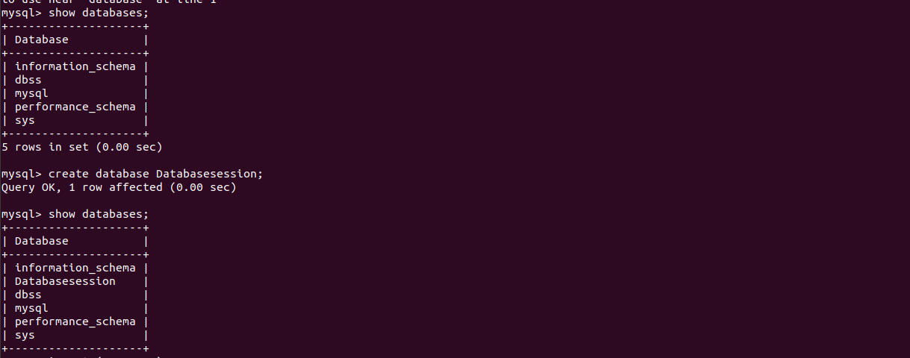

Q2. Design Schema
CUSTOMER
SALEPERSON
ORDERS
cid bigint() <<PK>>
cname varchar

1
sid bigint <<PK>>
sname varchar

2
oid bigint <<PK>>
qty bigint
cidt bigint <<FK1>>
sidt bigint <<FK2>>

Q2. Create tables
create table customer(cid bigint(10) AUTO_INCREMENT,cname varchar(50) NOT NULL,primary key(cid));
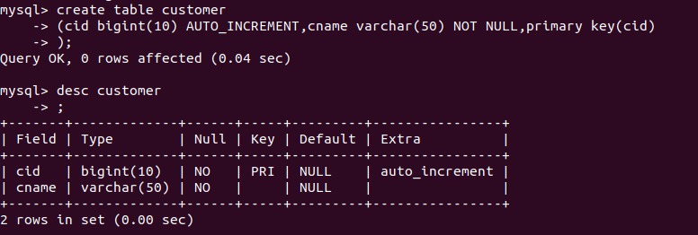
create table customer(cid bigint(10) AUTO_INCREMENT,cname varchar(50) NOT NULL,primary key(cid));
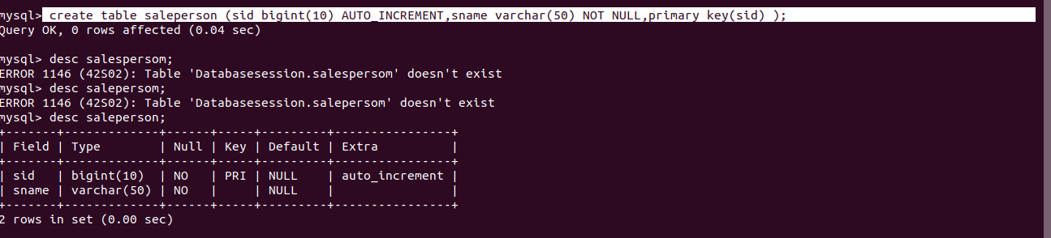

create table orders (oid bigint(10) primary key AUTO_INCREMENT,cidt bigint(10) NOT NULL,sidt bigint(10) NOT NULL,foreign key(cidt) references customer(cid),foreign key(sidt) references saleperson(sid));
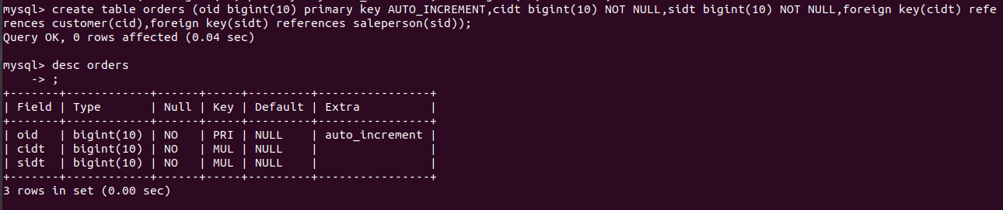
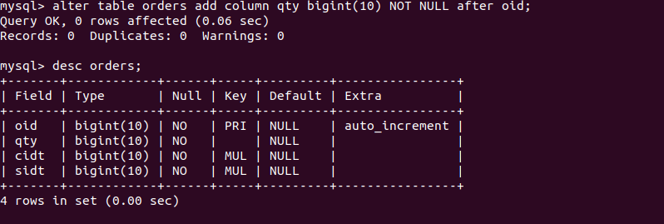

Q3. Insert sample data
Inserting in saleperson and customer table--
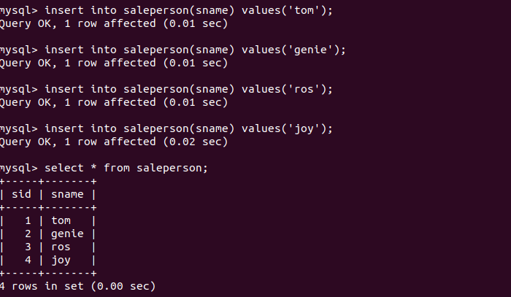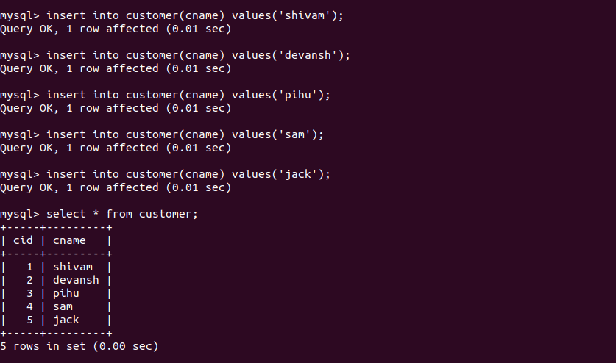
Inserting in orders table--
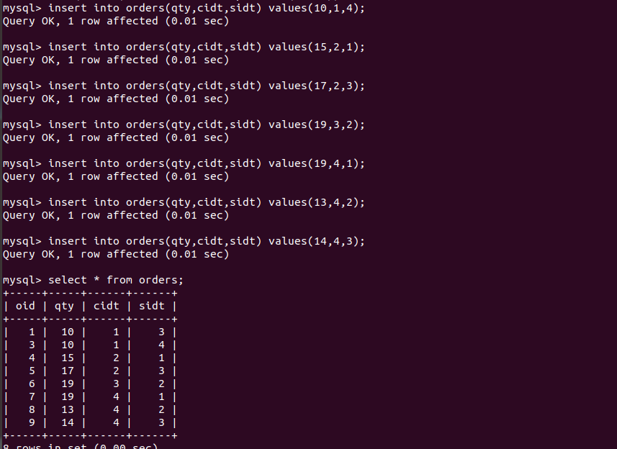
Q4.Find the sales person have multiple orders.
select * from saleperson where sid in (select sidt from orders group by sidt having count(sidt)>1);
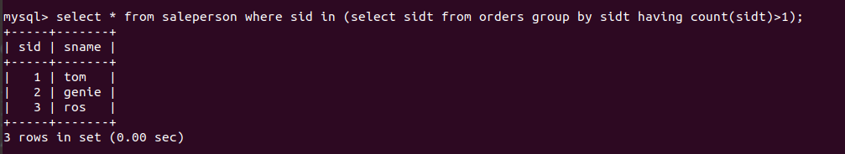
Q5. Find the all sales person details along with order details.
select * from saleperson left join orders on saleperson.sid=orders.sidt left join customer on orders.cidt=customer.cid;
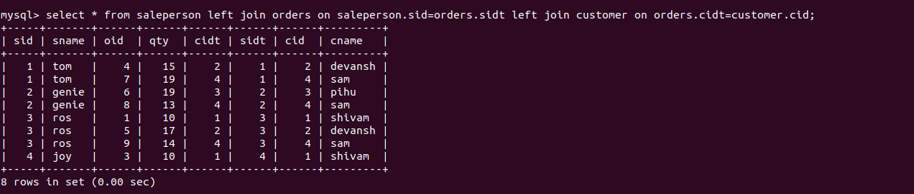

Q6.Create index
Q7.How to show index on a table

Q8.Find the order number, sale person name, along with the customer to whom that order belongs to.
select oid,cname,sname from orders left join customer on orders.cidt=customer.cid left join saleperson on orders.sidt=saleperson.sid;
