**DATABASES SESSION DATED 5 FEB 2020**

**SHIVAM AGARWAL(JVM)**

**Q1. Create Database**

**Create database <database-name>**

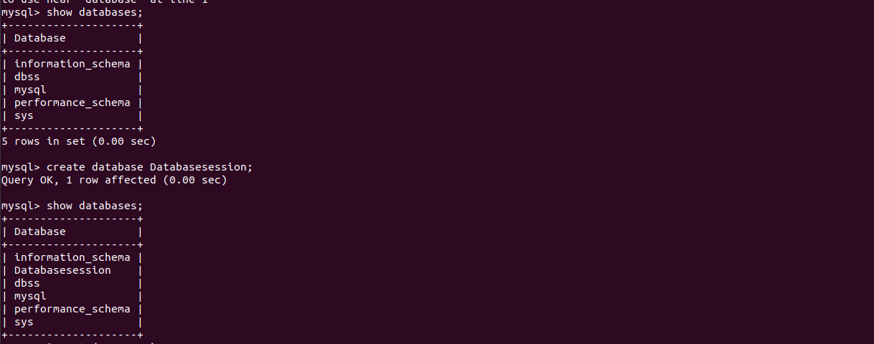

**Q2. Design Schema**



**Q2. Create tables**

**create table customer(cid bigint(10) AUTO_INCREMENT,cname varchar(50) NOT NULL,primary key(cid));**

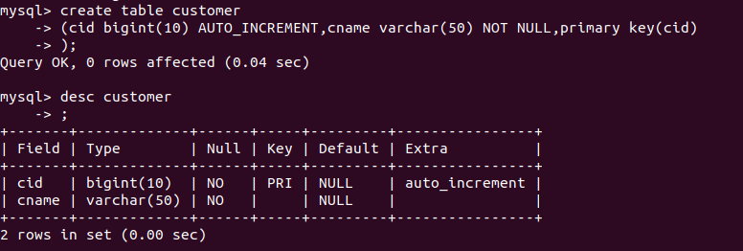

**create table customer(cid bigint(10) AUTO_INCREMENT,cname varchar(50) NOT NULL,primary key(cid));**

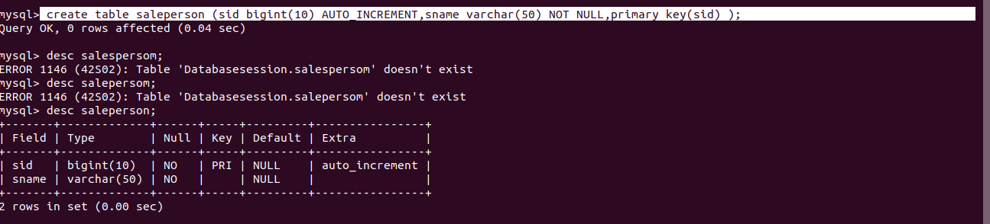

**create table orders (oid bigint(10) primary key AUTO_INCREMENT,cidt bigint(10) NOT NULL,sidt bigint(10) NOT NULL,foreign key(cidt) references customer(cid),foreign key(sidt) references saleperson(sid));**

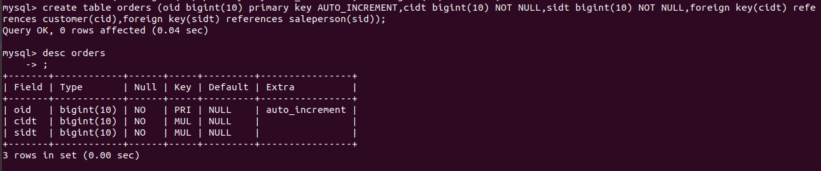

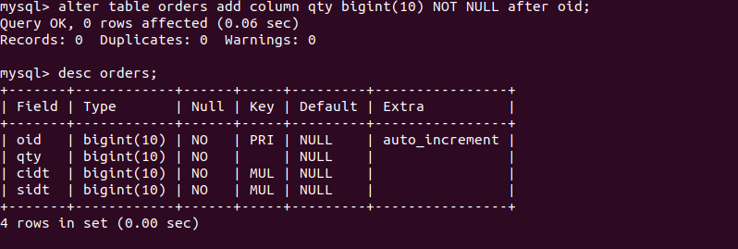

**Q3. Insert sample data**

**Q4. Inserting in saleperson and customer table--**

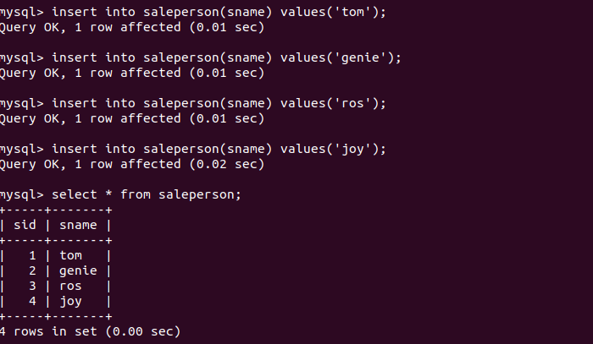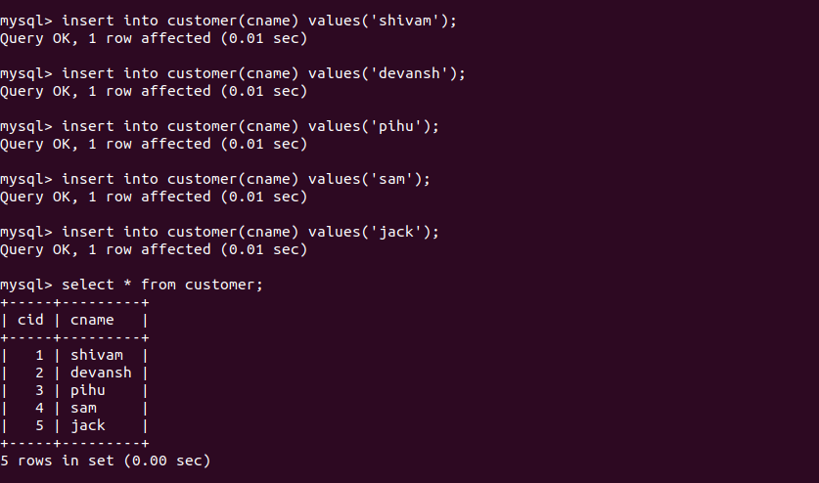

**Inserting in orders table--**

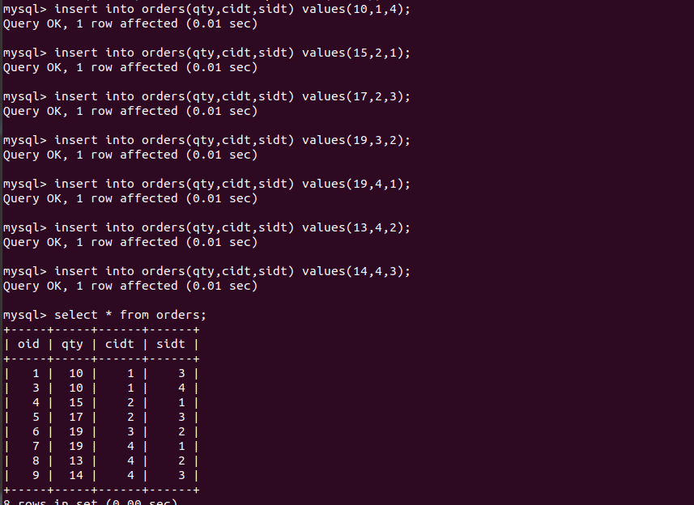

**Q4.Find the sales person have multiple orders.**

**select * from saleperson where sid in (select sidt from orders group by sidt having count(sidt)>1);**

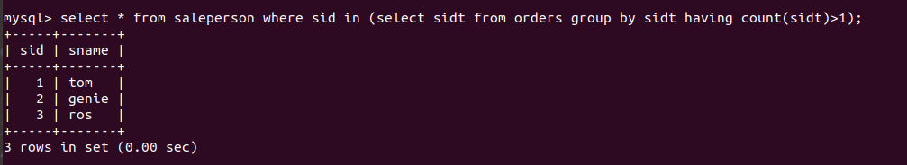

**Q5. Find the all sales person details along with order details.**

**select * from saleperson left join orders on saleperson.sid=orders.sidt left join customer on orders.cidt=customer.cid;**

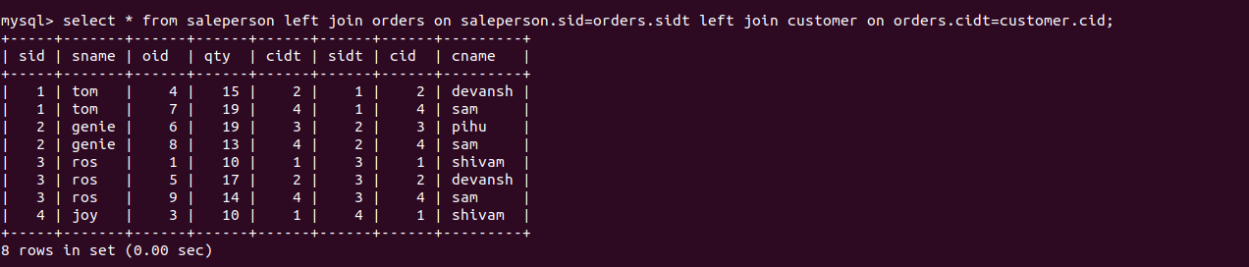

**Q6.Create index**

**Q7.How to show index on a table**

**Q8.Find the order number, sale person name, along with the customer to whom that order belongs to.**

**select oid,cname,sname from orders left join customer on orders.cidt=customer.cid left join saleperson on orders.sidt=saleperson.sid;**

