**Assignment 2: Using GEM5 with a "Hello World" Program for the x86 ISA**

1. **Introduction to gem5 and x86:**

Gem5 is a popular open-source platform for simulating problems on computer architecture. It is widely used among various institutions and researchers for its modularity and community support. This simulator can study and design computer architectures that are supported by various ISAs like x86, ARM, RISC-V, SPARC, and MIPS. With the help of this simulator, customisation of CPU models, memory hierarchy and peripherals, the understanding of ILP within the x86 ISA is effective.

1. **Environment Setup:**

In the beginning, all of the necessary dependency software like Python, SCons, and GCC compilers are installed to build and run gem5.

Once the prerequisites were satisfied, the Gem5 repository was cloned.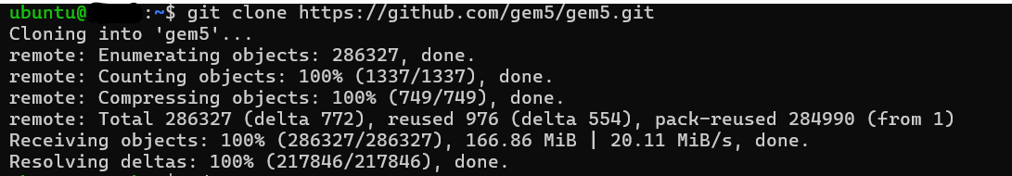

1. **Building gem5 for x86:**

Once the successful cloning of the repository is done, the building of Gem5 for x86 has been started and after a certain period of time, it is successfully completed.

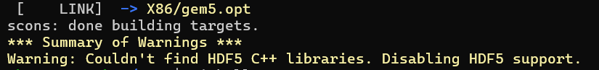

1. **Writing the "Hello World" Program:**

In the very next stage, a C program has been created with the file name ‘hello.c’.

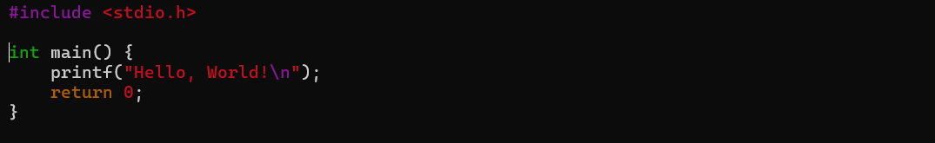

1. **Compiling the Program:**

Then the written C program was compiled with the GCC compiler.



1. **Running the Program in gem5:**

To run the compiled C program a Python program was created with the name ‘run_hello.py’.

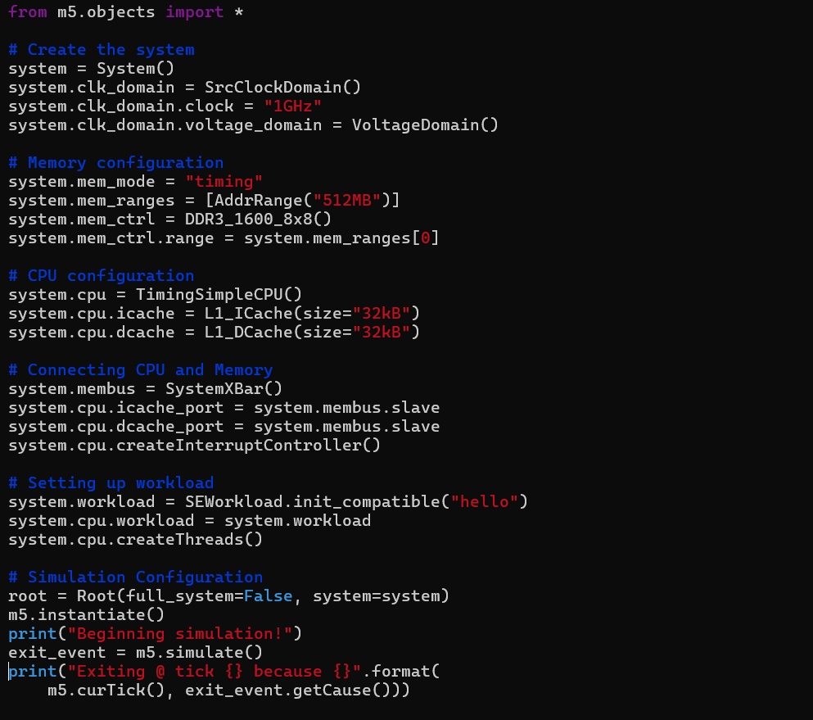

1. **Run gem5 Simulation:**

Once the program was saved it was executed with the following command.

./build/X86/gem5.opt configs/deprecated/example/se.py -c hello

1. **Analysing the Output:**

After successful completion of the execution of the above-mentioned command, the following output was observed where it will successfully print ‘Hello, World!’.

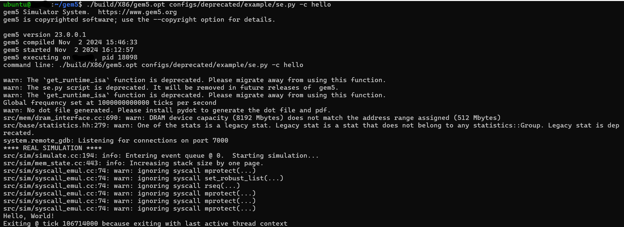

All the steps mentioned are successfully compiled within the Gem5 simulator using x86. But at the final stage of the execution of the written Python script was not working as the 'configs/example/se.py' script had been deprecated which was found in 'configs/deprecated/example'. This change was done to the successful execution of the given script to get the desired outcome.