Insights based on data visualization

* Patients with cardio vascular diseases are generally older than those without the disease.
* Higher values of systolic blood pressure are strongly associated with cardio vascular diseases.
* Risk increases with increase in cholesterol level.
* Patients with higher glucose values are more likely to have heart diseases.
* Slight positive correlation between higher weight and cardiovascular disease but not as strong as blood pressure or cholesterol.
* Height is less correlated with cardiovascular diseases.

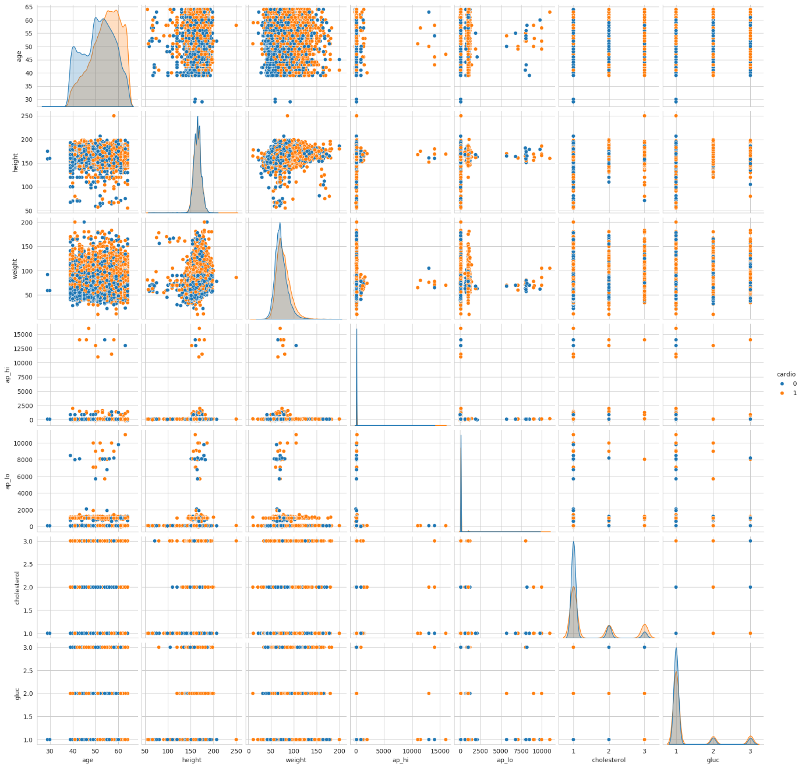

Correlation matrix

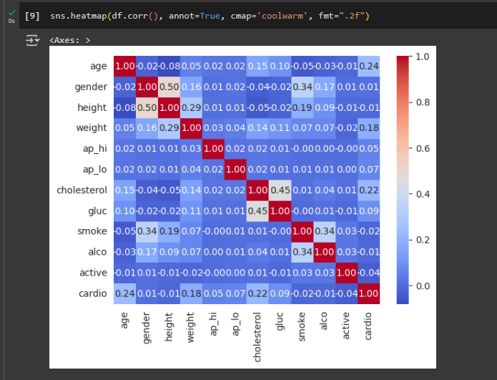

0 to +1: Positive correlation  
Around 0: No correlation  
0 to –1: Negative correlation

Accuracy levels of various machine learning techniques:

Support Vector Machine: 0.7229  
K-Nearest Neighbour: 0.6846  
Logistic Regression: 0.7235  
Decision Tree: 0.6339  
Random Forest: 0.7057

Highest accuracy: Logistic Regression