 

**Online Restaurant Billing System**

Submitted to-Sagar Pande

Submitted by-

* Rahul Yadav(11910090)
* Riya(11910138)
* Pranshi Dwivedi(11910153)

Date-30/10/2020



Abstract

This project resulted in the formation of a smooth billing system where we just have to give input of the things which are ordered from the menu card of the restaurant after which the total bill automatically will get calculated. The bill will include the amount to be paid including the taxes applicable to that particular payment. The bill will get generated alonwith the details of the customer and a serial no. on the bill receipt to maintain all the transactions at the billing counter of the restaurant.

Acknowledgement

We would like to express our special thanks of gratitude to our faculty **Mr. Sagar Pande** who gave us the golden opportunity to do this wonderful and insightful project on the topic **Restaurant Billing System**, which also helped us to improve on python language as well as having the practical of the knowledge whatever we learnt in this language.We also got the clear idea of the fact that in how many ways we can use this particular language. We got to know so many new facts and we are really thankful to him. Secondly, we would like to thank our parents, friends and all those peoples who helped in finalizing this project within the limited time frame.

Contents

* Name of the restaurant
* Customer details
* Items available at the restaurant
* Calculate bill section
* Section containing options like total bill, generate bill, exit etc.
* Bill area
* All transaction

Introduction

We made this project using purely python language where we used GUI through tkinter library, we used other libraries to bring different functionalities in the project like messagebox, random, PIL. We used sqlite3 to maintain all the transactions made till date for which we used sqlite3 library. We used file handeling for saving the bills. We also used exception handeling to connect with database.Using all these concepts of python language we successfully made this billing application.

Contribution

* Rahul Yadav (**Team Leader**) (11910090)-Worked with buttons and all its functionalities, worked with sqlite3 and also on bill area and transaction area.
* Pranshi Dwivedi (11910153)-Handeled the layout,designing and framework of the application.
* Riya (11910138)-Worked on putting the quantities and orders placed by the customer in the drinks and fast food section

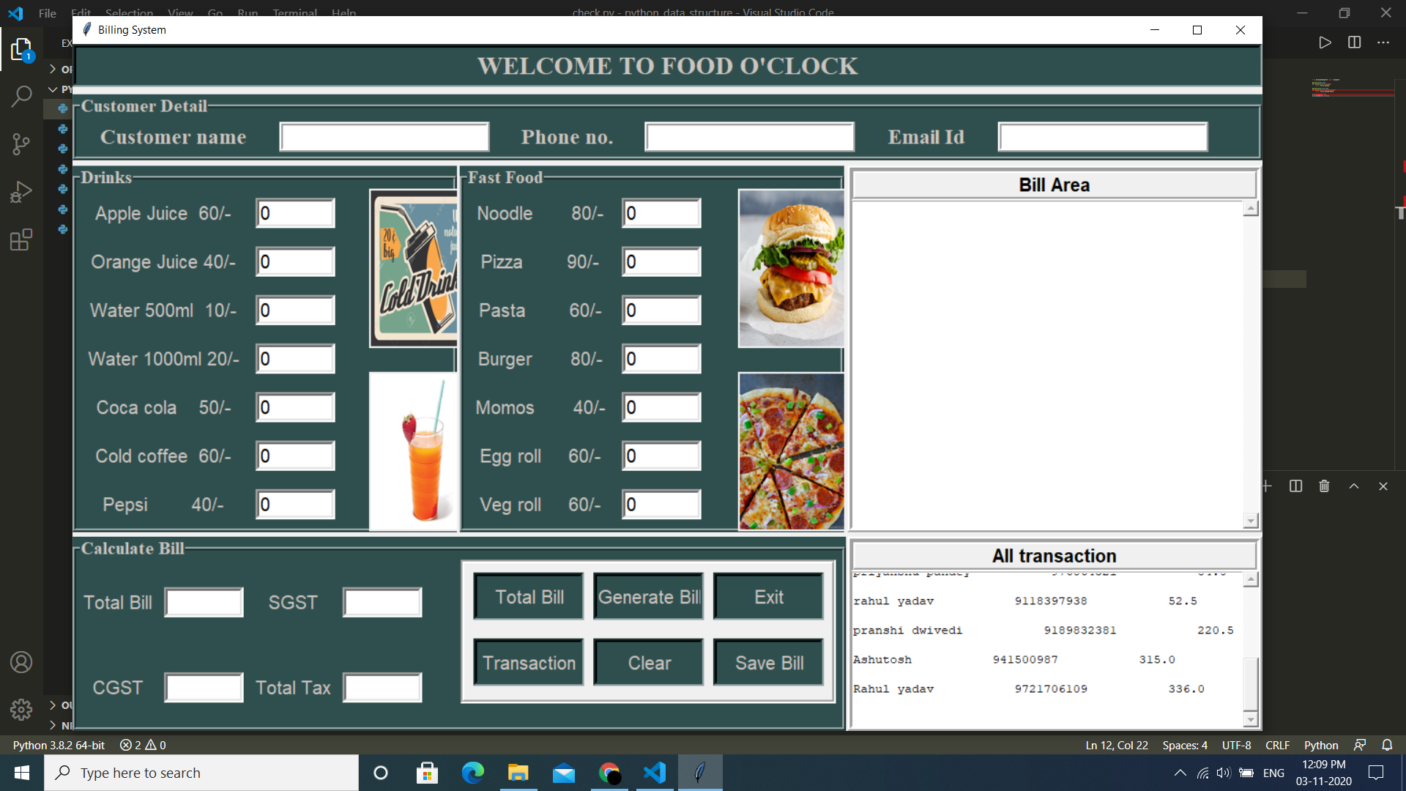

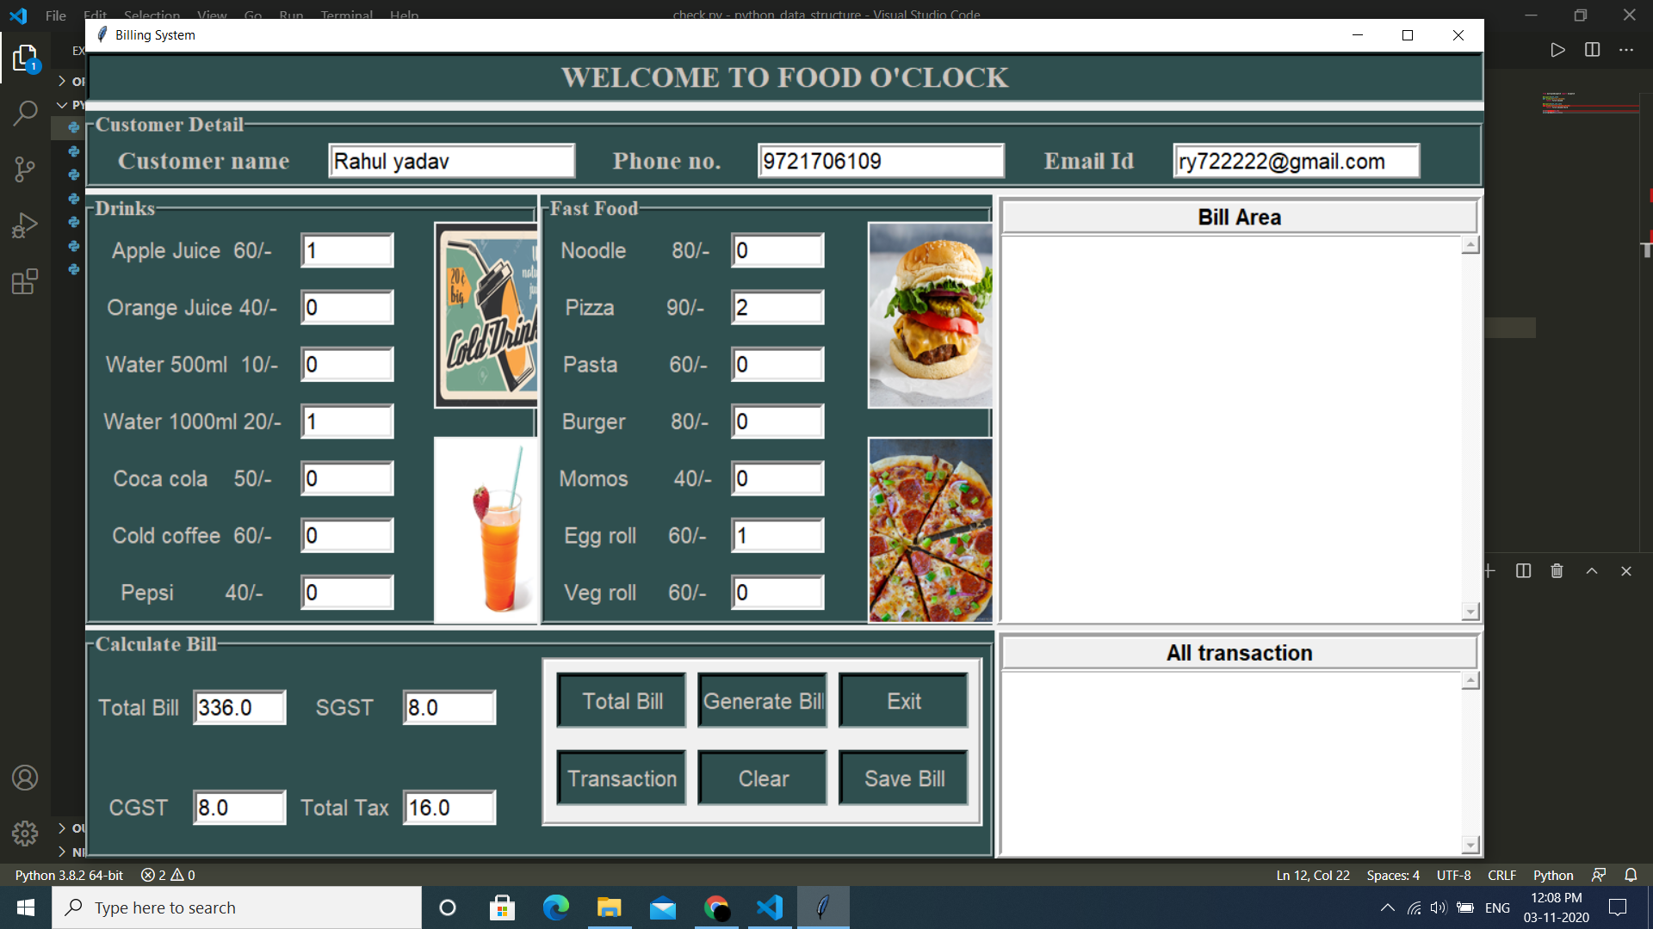

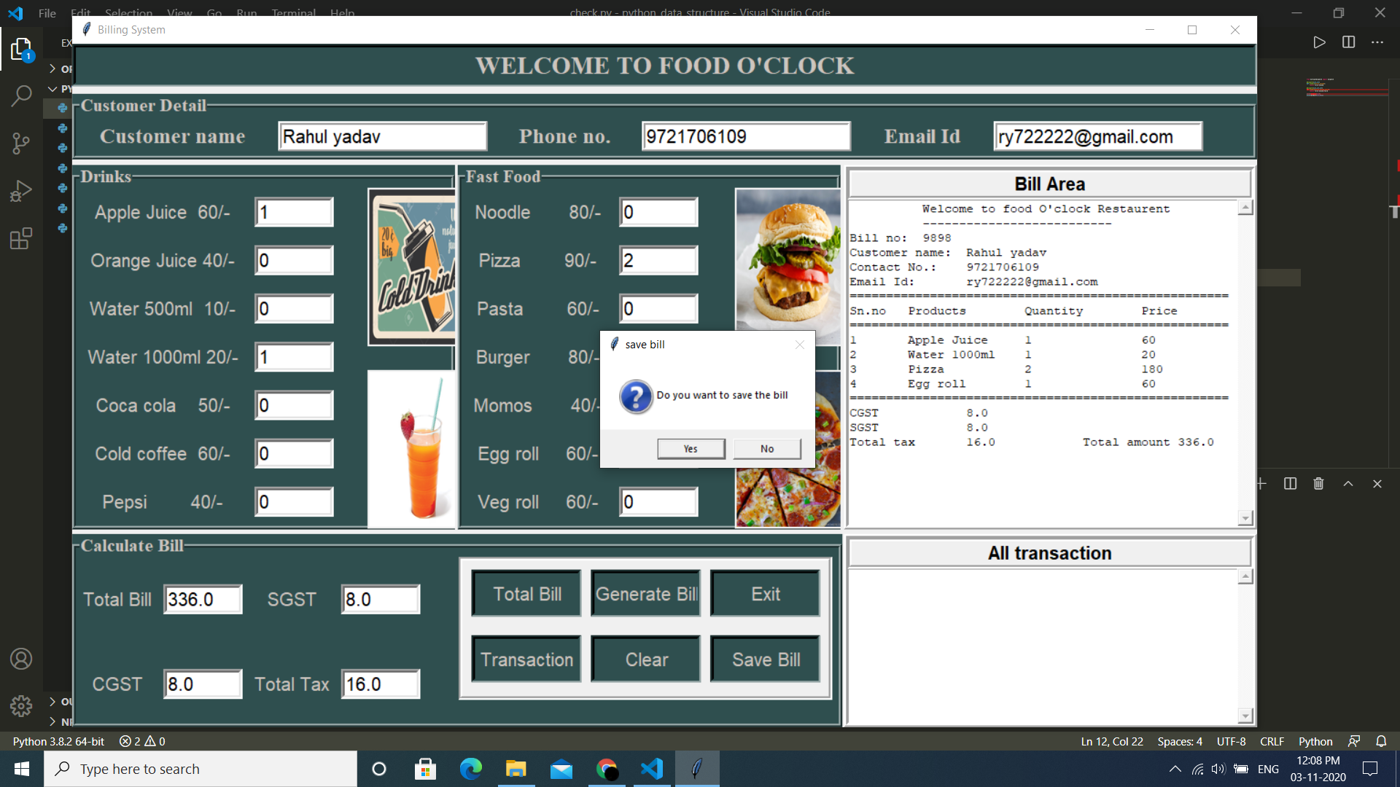

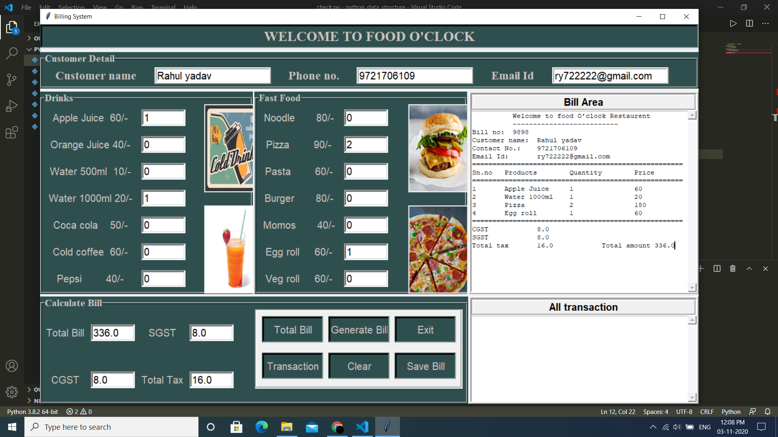

Reference

* <https://www.tutorialspoint.com/python/python_gui_programming.htm>
* <https://docs.python.org/3/tutorial/>
* <https://www.geeksforgeeks.org/python-gui-tkinter/#:~:text=Python%20offers%20multiple%20options%20for,to%20create%20the%20GUI%20applications>