Project Group ID: 2023-27/IT/03/LIFE01
A PROJECT SYNOPSIS ON
Smart Disaster Response and Resource
Allocation System (LifeLine)
Submitted
for the fulfillment of the award of
Bachelor of Technology in
Information Technology / Computer Science And
Information Technology
by
Vijay Katiyar (Roll No. 2300270130205)
Priyanshu Kushwaha (Roll No. 2300270130136)
Pranshu (Roll No. 2300270130129)
Under the guidance of
Dr. Sunil Kumar
Professor, Department of Information Technology

Department of Information Technology
AJAY KUMAR GARG ENGINEERING COLLEGE, GHAZIABAD
DR. A.P.J. ABDUL KALAM TECHNICAL UNIVERSITY, LUCKNOW
September 16, 2026

Declaration of Academic Integrity & AI Ethics Pledge
We, Vijay Katiyar (Roll No. 2300270130205), Priyanshu Kushwaha (Roll No. 2300270130136), and Pranshu (Roll No. 2300270130129), bonafide undergraduate students in the Department of Information Technology at Ajay Kumar Garg Engineering College, Ghaziabad, hereby solemnly declare and affirm our commitment to academic integrity and ethical AI principles:
- 1. Authentic Intellectual Authorship: This project synopsis titled “Smart Disaster Response and Resource Allocation System (LifeLine)” is our original academic work, conceived and formulated under the expert guidance and supervision of Dr. Sunil Kumar, Professor, Department of Information Technology.
- 2. Responsible AI Tool Utilization Pledge: In accordance with university standards and research ethics, we pledge that generative artificial intelligence tools were utilized strictly for technical grammar refinement, vocabulary polishing, and document structuring. The core system architecture, mathematical optimization formulations (SciPy MILP), multimodal deep learning pipelines (TF-IDF NLP and PyTorch MobileNetV3), relational database schemas (SQLite WAL mode), and software codebases reflect our genuine conceptual understanding and engineering implementation.
- 3. Plagiarism Free & Proper Attribution: All academic literature, empirical datasets (CrisisMMD v2.0), open-source algorithms, and prior works cited in this document have been scrupulously referenced in standard IEEE bibliographic format [1]–[17]. No content has been unethically copied or misrepresented without proper scholarly acknowledgment.
- 4. Academic Commitment: We understand that this synopsis represents an active capstone engineering proposal that we will construct, benchmark, and empirically validate across the 2026–27 academic year.
Vijay Katiyar (2300270130205)
Priyanshu Kushwaha (2300270130136)
Pranshu (2300270130129)
Department of Information Technology, AKGEC

Certificate of Supervision
This is to certify that the project synopsis titled “Smart Disaster Response and Resource Allocation System (LifeLine)” has been prepared and submitted by Vijay Katiyar (Roll No. 2300270130205), Priyanshu Kushwaha (Roll No. 2300270130136), and Pranshu (Roll No. 2300270130129) of the B.Tech (Information Technology) programme under my direct supervision and mentorship. To the best of my knowledge, the proposal embodies authentic, diligent research work, original software architecture designs, and rigorous optimization methodologies suitable for fulfillment of the Bachelor of Technology degree requirements under Dr. A.P.J. Abdul Kalam Technical University, Lucknow.
_____________________________________
Dr. Sunil Kumar
Project Guide & Professor
Department of Information Technology
Ajay Kumar Garg Engineering College, Ghaziabad

Acknowledgement
We express our profound gratitude to our project guide, Dr. Sunil Kumar, Professor in the Department of Information Technology, for his invaluable guidance, persistent encouragement, and critical insights throughout the formulation of this project synopsis. His constructive critique on our mathematical optimization formulations, machine learning triage workflows, and practical emergency management constraints significantly shaped this work.
We also extend our sincere appreciation to Prof. (Dr.) Rahul Sharma, Head of Department (IT), and Dr. Aditya Pratap Singh, Project Coordinator, for providing institutional facilities, high-performance computing laboratories, and an inspiring academic ecosystem that made this research possible. Finally, we thank our faculty mentors, colleagues, and family members for their continuous moral support.
Abstract
Natural and man-made disasters—such as flash floods, severe earthquakes, building collapses, and industrial fires—strike unpredictably, instantly overwhelming regional emergency dispatch hotlines with thousands of simultaneous, unstructured distress reports. In the initial critical period known as the 'Golden Hour', traditional voice-based hotlines (e.g., Dial 112) suffer from severe operator bottlenecks, duplicate report influxes, vulnerability to cellular blackouts, and uncoordinated vehicle dispatches. LifeLine resolves these systemic challenges through a unified, resilient, multimodal web platform that connects citizens and emergency commanders into a synchronized, real-time response network.
The platform incorporates three core engineering innovations: (1) An automated multimodal AI triage pipeline trained on the CrisisMMD v2.0 dataset, combining dual-granularity TF-IDF and Soft Voting Ensemble text triage (84.05% accuracy) with fine-tuned PyTorch MobileNetV3 computer vision classifiers for image authenticity verification (80.87% accuracy) and structural damage severity scoring (80.18% accuracy); (2) A Mixed-Integer Linear Programming (MILP) spatial optimization engine formulated using SciPy, which solves multi-vehicle mass-casualty dispatch assignments in under 50 milliseconds; and (3) A Progressive Web App (PWA) client backed by Service Workers and client-side IndexedDB queueing, guaranteeing 100% offline reporting resilience during total cellular network blackouts. Operating across decoupled Node.js portals (Citizen SOS on Port 8000 and Authority Command on Port 8001) backed by an SQLite Write-Ahead Logging (WAL) engine, LifeLine provides verified situational awareness, eliminates duplicate response efforts, and drastically cuts emergency dispatch latency.
Keywords: Disaster Response, Multimodal Machine Learning, MobileNetV3, Mixed-Integer Linear Programming, Crisis Informatics, PWA, SQLite WAL, Leaflet GIS.

Table of Contents
Section / Topic Description | Page No.
Cover Page & Title | i
Declaration of Academic Integrity & AI Ethics Pledge | ii
Certificate of Supervision | iii
Acknowledgement & Abstract | iv
List of Figures & List of Tables | vi
1. Introduction | 1
1.1 Background of Disaster Response and Emergency Management | 1
1.2 The Golden Hour Principle in Emergency Operations | 2
1.3 Evolution of Emergency Response Systems | 2
1.4 Domain Overview: Artificial Intelligence & Operational Research in Disasters | 3
1.5 Introduction to LifeLine Platform | 4
1.6 Dual-Website System Architecture Overview | 5
1.7 Organization of the Synopsis Document | 5
2. Problem Statement | 6
2.1 Limitations of Conventional Emergency Hotlines | 6
2.2 Communication Delays & Network Congestion Bottlenecks | 7
2.3 The False Alarm & Misinformation Dilemma | 7
2.4 Unoptimized Vehicle Routing & Mass-Casualty Resource Misallocation | 8
2.5 Lack of Real-Time Victim Visibility & Victim Panic Factors | 9
2.6 Summary of Core Technical Challenges Addressed by LifeLine | 9
3. Rationale | 10
3.1 Why Multi-Modal AI (Text + Vision) is Superior to Single-Modal Intake | 10
3.2 Justification for Mathematical MILP Dispatch vs. Manual Dispatch | 11
3.3 The Need for Zero-Network Offline Intake (IndexedDB & Service Workers) | 11
3.4 Operational Separation: Rationale Behind Dual-Website Architecture | 12
3.5 Human-in-the-Loop Override Philosophy for Emergency Commanders | 12
3.6 Societal & Economic Significance of Automated Disaster Triage | 13
4. Objective and Scope of the Project | 14
4.1 Primary Engineering Objectives | 14
4.2 Secondary Research Objectives | 15
4.3 Functional Scope of LifeLine System | 15
4.4 Non-Functional Scope (Latency, Reliability, Scalability, Security) | 16
4.5 Target User Personas & System Stakeholders | 16
5. Methodology | 17
5.1 System Architecture & High-Level Design | 17
5.2 Citizen Intake & Progressive Web App (PWA) Engine | 18
5.3 Multi-Modal AI Microservice & Dataset Architecture (CrisisMMD v2.0) | 19
5.4 NLP Humanitarian Triage Model (Dual TF-IDF + Ensemble) | 20
5.5 PyTorch MobileNetV3 Computer Vision Models | 20
5.6 Multi-Modal Composite Severity Index (MCSI) Formulation | 21
5.7 Mixed-Integer Linear Programming (MILP) Resource Allocation Engine | 22
5.8 Database Design & Synchronization (SQLite WAL Mode & Cross-Server Bridge) | 23
5.9 Detailed Database Schema & SQL Tables Design | 24
5.10 Data Flow Diagrams (DFD Level 0, Level 1, Level 2) | 25
5.11 Use Case Descriptions & System Interaction Workflows | 26
6. Expected Outcomes | 27
6.1 Key Deliverables & Prototypes | 27
6.2 Target Performance Benchmarks & Measurable Criteria | 27
7. Tools and Technologies Requirements | 28
7.1 Detailed Hardware Requirements | 28
7.2 Detailed Software Requirements | 28
7.3 Data Requirements & Dataset Distribution | 29
7.4 Network Requirements | 29
8. Project Schedule | 30
8.1 Proposed Project Timeline & Milestone Breakdown | 30
8.2 Activity Gantt Chart | 30
8.3 Budget Estimate | 31
8.4 Risk Management & Contingency Matrix | 31
8.5 Individual Roles and Team Contributions | 32
9. Conclusion | 33
9.1 Summary of Proposed Work | 33
9.2 Novelty, Innovation & Distinguishing Features | 33
10. References | 34
Appendix: Synopsis Evaluation Answers (Questions 1, 2, and 3) | 36

List of Figures
Figure # | Caption & Description | Page No.
Figure 1 | High-Level System Architecture of LifeLine Platform | 17
Figure 2 | Data Flow Diagram (DFD Level 0 - Context Diagram) | 25
Figure 3 | Data Flow Diagram (DFD Level 1 - Detailed Functional Pipeline) | 25
Figure 4 | Multi-Modal AI & Computer Vision Triage Pipeline Flowchart | 21
Figure 5 | SciPy Mixed-Integer Linear Programming (MILP) Dispatch Solver Flowchart | 22
Figure 6 | Progressive Web App (PWA) Offline Queueing & Synchronization Flowchart | 18
Figure 7 | 17-Week Project Execution Timeline & Milestone Gantt Chart | 31

List of Tables
Table # | Caption & Description | Page No.
Table 1 | Comparison: Conventional Emergency Hotlines vs. LifeLine Platform | 9
Table 2 | Summary of Primary & Secondary Engineering Objectives | 15
Table 3 | CrisisMMD v2.0 Multimodal Dataset Disaster Category Breakdown | 19
Table 4 | Multi-Modal AI & Computer Vision Classification Performance Metrics | 20
Table 5 | Multi-Modal Composite Severity Index (MCSI) Scoring Matrix | 21
Table 6 | Relational Database Schema Specifications (SQLite WAL Mode) | 24
Table 7 | Hardware Requirements Specification for Development & Production | 28
Table 8 | Software Stack, Frameworks, and Library Dependencies | 28
Table 9 | 17-Week Project Activity Timeline and Deliverables Schedule | 30
Table 10 | Approximate Prototype Budget and Cost Estimation Breakdown | 31
Table 11 | Project Technical Risk Assessment and Mitigation Contingency Matrix | 32
Table 12 | Individual Team Member Responsibilities and Ownership Matrix | 32

1. Introduction
1.1 Background of Disaster Response and Emergency Management
Natural hazards and human-triggered catastrophes—including urban flash floods, structural building collapses, high-intensity earthquakes, and industrial chemical fires—represent severe disruptions that occur with negligible early warning [1], [5]. Over the past three decades, rapid urban densification, expanding metropolitan populations, and climate-induced meteorological extremes have dramatically heightened the vulnerability of human communities. In the chaotic hours immediately following a disaster impact, local municipal emergency hotlines, fire brigades, paramedic fleets, and civic defense teams are instantly flooded with hundreds of concurrent distress calls [3], [10].
In emergency management operations, the effectiveness of rescue and relief efforts is fundamentally determined by information velocity—the speed with which authorities can collect raw field reports, separate verified life-threatening alerts from spam, assess geographic damage severity, and dispatch the closest appropriate emergency vehicles [6], [13]. However, existing municipal crisis response architectures continue to depend almost exclusively on manual voice hotlines (such as Dial 112 or Dial 911), which suffer catastrophic human bottlenecks under high call volumes.
1.2 The Golden Hour Principle in Emergency Operations
Emergency medicine and trauma care revolve around the well-established 'Golden Hour' principle: the first sixty minutes following serious physical trauma or structural disaster entrapment during which rapid medical stabilization and surgical triage determine victim survival [3]. Every minute lost to congested phone lines, confused landmark descriptions, or dispatching an ambulance to a minor issue while a severely bleeding victim waits unattended drastically degrades clinical survival odds. LifeLine is engineered specifically to eliminate these administrative friction points by executing multimodal AI triage and mathematical vehicle dispatch in seconds rather than minutes [4], [7].
1.3 Evolution of Emergency Response Systems
Emergency response frameworks have transitioned across three generational eras. The First Generation (1970s–1990s) relied on landline telephony and localized municipal radio dispatchers, completely lacking spatial visualization or computer logging. The Second Generation (2000s–2010s) introduced computer-aided dispatch (CAD) and GPS vehicle location; however, citizen communication remained confined to verbal voice calls, and crisis mapping tools (such as Ushahidi) offered only passive visualization without automated triage or resource optimization [11], [16]. LifeLine represents the emerging Third Generation: an autonomous, proactive, AI-driven coordination platform combining crowd-sourced multimodal telemetry, automated anti-spam validation, mathematical dispatch optimization, and offline edge resilience [14], [15].
1.4 Domain Overview: Artificial Intelligence & Operational Research in Disasters
Recent breakthroughs in deep learning and operational research have unlocked immense potential for crisis informatics [2], [11], [17]. Natural Language Processing (NLP) models can extract critical semantic entities—such as trapped victim counts, medical supplies needed, and road blockages—from noisy text [1], [8], [9]. Simultaneously, lightweight convolutional neural networks (CNNs) enable rapid classification of scene damage and authenticity directly from smartphone photos [2], [12]. When paired with Mixed-Integer Linear Programming (MILP) solvers capable of computing globally optimal resource allocations across constrained vehicle fleets [4], [6], computational intelligence provides an indispensable operational asset for modern emergency command centers.
1.5 Introduction to LifeLine Platform
LifeLine is an end-to-end disaster response and resource allocation ecosystem engineered to bridge the communication chasm between distressed citizens and municipal emergency agencies. By allowing public users to submit structured distress reports featuring precise GPS coordinates, natural language descriptions, and photographic evidence, LifeLine automates the entire ingestion and triage lifecycle. The system automatically categorizes incidents, scores physical structural damage, verifies visual authenticity to reject fake or spam images, and computes an explainable multi-modal severity rank. Using this intelligence, an integrated SciPy MILP optimization solver computes mathematically optimal vehicle dispatch paths to maximize lives saved.
1.6 Dual-Website System Architecture Overview
To guarantee operational security, high throughput, and zero cross-traffic interference, LifeLine implements a decoupled dual-portal architecture:
1. Citizen Disaster Reporting & Tracking Portal (Port 8000): A lightweight, mobile-responsive Progressive Web App (PWA) enabling public users to submit one-tap SOS alerts, capture live damage photos/videos, view offline status indicators, and track assigned rescue ambulances on a live Leaflet GIS map.
2. Authority Command Center Portal (Port 8001): A secure, authenticated control dashboard for municipal commanders, offering real-time incident queues sorted by composite severity (Levels 1–5), spatial heatmap visualizers, one-click automated MILP dispatching, and manual resource override controls.
1.7 Organization of the Synopsis Document
This synopsis is structured as follows: Section 2 formalizes the Problem Statement and operational challenges. Section 3 presents the Technical Rationale justifying our architectural choices. Section 4 defines Primary and Secondary Objectives and project scope. Section 5 details the Engineering Methodology, incorporating architectural diagrams, mathematical formulations, DFDs, and database schemas. Section 6 presents Expected Outcomes and deliverables. Section 7 outlines Hardware, Software, and Network Requirements. Section 8 details the 17-Week Project Schedule, Gantt chart, budget, and team roles. Section 9 concludes the proposal, followed by References (Section 10) and the Appendix answering formal departmental review questions.
2. Problem Statement
2.1 Limitations of Conventional Emergency Hotlines
Conventional voice hotlines (Dial 112 / Dial 911) face severe structural limitations during major catastrophes. A single call center operator can handle only one caller at a time, resulting in massive call queues where frightened citizens wait on hold for tens of minutes [3]. Furthermore, voice descriptions of disaster scenes are inherently subjective, emotionally distorted, and frequently lack precise geographic coordinates, forcing dispatchers to spend valuable minutes clarifying street landmarks.
2.2 Communication Delays & Network Congestion Bottlenecks
Severe natural disasters frequently cause physical damage to regional cell towers, sever optical fiber backbones, or trigger localized power blackouts [7], [13]. Under such degraded network conditions, conventional web applications and cloud forms fail completely, dropping citizen distress requests and stranding victims without recourse. The absence of client-side caching and background synchronization in current disaster platforms constitutes a fatal flaw.
2.3 The False Alarm & Misinformation Dilemma
Opening public channels for disaster intake inevitably attracts erroneous reports, duplicate submissions, internet pranks, and outdated photos recycled from past events [2], [11]. In the absence of automated computer vision verification, emergency agencies waste limited manpower and fuel physically inspecting phantom incidents, leaving authentic high-casualty zones unassisted.
2.4 Unoptimized Vehicle Routing & Mass-Casualty Resource Misallocation
Under high-stress crisis conditions, human dispatch commanders rely on heuristic rules of thumb or basic proximity rules to assign ambulances and fire trucks [4], [6]. In complex multi-casualty incidents, greedy heuristic assignment consistently yields sub-optimal allocations—such as dispatching an advanced life-support ambulance to a minor sprain simply because it called first, while a nearby structural collapse with twenty crushed victims lacks medical transport.
2.5 Lack of Real-Time Victim Visibility & Victim Panic Factors
Once a victim successfully logs an emergency call, conventional hotlines offer zero feedback regarding response status. Unaware of whether help is on the way or their call was lost, victims experience intense psychological panic, leading them to flood hotlines with repeated follow-up calls or take perilous, unsupervised evacuation attempts through dangerous floodwaters.
2.6 Summary of Core Technical Challenges Addressed by LifeLine
Table 1 summarizes the stark comparative contrast between conventional emergency hotlines and the proposed LifeLine platform:
Parameter | Conventional Hotlines (112) | LifeLine Smart Response Platform
Reporting Modality | Voice-only telephony; subjective verbal descriptions | Multimodal: Structured Text, Live Photos/Videos, Exact GNSS Coordinates
Call Intake Capacity | Strictly serial (1 caller per operator; long queues) | Massively parallel (thousands of concurrent HTTP/PWA submissions)
Spam / Fake Detection | Manual dispatcher intuition; highly vulnerable to hoaxes | Automated PyTorch MobileNetV3 image authenticity classifier (80.87% acc)
Damage Severity Triage | Manual verbal questioning; slow and error-prone | Automated NLP Triage (84.05% acc) + Vision Damage Scorer (80.18% acc)
Dispatch Decision Time | 5 to 15 minutes of manual operator deliberation | Sub-50 milliseconds via SciPy Mixed-Integer Linear Programming (MILP)
Offline Network Behavior | Complete failure during cell network congestion/blackout | 100% resilient PWA client; IndexedDB offline queue + auto-sync
Victim Tracking Feedback | Zero feedback; victim left in anxious uncertainty | Transparent Leaflet GIS map with live vehicle marker, ETA, and trajectory

3. Rationale
3.1 Why Multi-Modal AI (Text + Vision) is Superior to Single-Modal Intake
Text descriptions and visual imagery convey complementary, highly orthogonal disaster signals [2], [17]. A frantic citizen text report such as "water entering living room" could describe a manageable 4-inch puddle or a catastrophic 6-foot structural torrent. By coupling natural language processing with computer vision models that classify structural damage from scene photos, LifeLine resolves textual ambiguities and establishes an objective, multi-modal composite ground truth.
3.2 Justification for Mathematical MILP Dispatch vs. Manual Dispatch
Emergency vehicle dispatching under mass-casualty constraints represents a combinatorial optimization problem belonging to the NP-hard class [4], [6]. When twenty emergency units must be allocated across fifty prioritized disaster incidents with varying casualty counts, vehicle capacities, and travel times, the search space encompasses billions of possible configurations. Human dispatchers inevitably make sub-optimal local choices. Formulating the problem as a Mixed-Integer Linear Program (MILP) allows the SciPy HiGHS optimization engine to mathematically compute the global optimum in under 50 milliseconds.
3.3 The Need for Zero-Network Offline Intake (IndexedDB & Service Workers)
Because cellular connectivity is often the first casualty of severe environmental disasters, building a crisis platform that requires constant online connectivity is fundamentally self-defeating [7]. By leveraging Progressive Web App (PWA) standards—specifically Service Worker fetch interception and browser IndexedDB binary Blob storage—LifeLine allows victims to capture damage photos and trigger SOS alerts offline. The moment a transient Wi-Fi or cellular handshake is established, the queue flushes autonomously without user re-entry.
3.4 Operational Separation: Rationale Behind Dual-Website Architecture
Public disaster reporting and emergency command operations exhibit radically different performance, security, and interface profiles. Combining them into a single monolithic web application risks crashing authority dashboards during viral public submission surges. Decoupling the system into an open, lightweight citizen portal (Port 8000) and an authenticated, feature-rich command portal (Port 8001)—bridged by an SQLite Write-Ahead Logging (WAL) database—guarantees isolated CPU workloads and sub-millisecond query latencies.
3.5 Human-in-the-Loop Override Philosophy for Emergency Commanders
While mathematical optimization drastically accelerates vehicle allocation, artificial intelligence must never completely strip agency from trained human commanders [3], [13]. Tactical battlefield conditions—such as sudden bridge collapses, downed live electrical wires, or VIP security directives—may not be immediately visible to software algorithms. LifeLine embeds a strict 'Human-in-the-Loop' architecture: the MILP engine proposes optimal allocations, but the commander retains absolute authority to approve, reassign, or manually override dispatches via intuitive dashboard controls.
3.6 Societal & Economic Significance of Automated Disaster Triage
The economic and humanitarian dividends of cutting emergency dispatch latency are immense [14], [15]. Rapid flood and fire containment halts exponential property destruction, while timely trauma evacuation prevents lifelong physical disability and loss of productive human life. By delivering an open-source, low-cost web platform that functions on ordinary smartphones, LifeLine democratizes advanced disaster management for developing municipalities.
4. Objective and Scope of the Project
4.1 Primary Engineering Objectives
The primary engineering objectives of the LifeLine platform are:
- Objective 1 (Intake): Develop a lightweight, mobile-first PWA on Port 8000 for public reporting with text, photo/video media capture, and HTML5 GPS coordinates.
- Objective 2 (Resilience): Implement an offline-resilient storage architecture utilizing Service Workers and IndexedDB for zero-loss reporting during network blackouts.
- Objective 3 (NLP Triage): Train and deploy an NLP text classifier achieving >80% accuracy across 8 disaster categories using the CrisisMMD v2.0 dataset.
- Objective 4 (Computer Vision): Fine-tune PyTorch MobileNetV3 vision models to classify image authenticity (>80% acc) and visual damage severity (>80% acc).
- Objective 5 (Optimization): Formulate and implement a SciPy MILP spatial optimization solver calculating multi-vehicle dispatches in under 50 milliseconds.
- Objective 6 (Command): Construct an authenticated Command Center on Port 8001 with Leaflet GIS maps, live severity heatmaps, and manual override controls.
- Objective 7 (Tracking): Provide transparent citizen rescue tracking displaying vehicle pins, travel distance, trajectory lines, and live ETA countdowns.
4.2 Secondary Research Objectives
Secondary research objectives focus on empirical evaluation and system benchmarking:
- Research Objective 1: Benchmark the response-time improvement of automated MILP dispatching against simulated manual dispatch operator workflows.
- Research Objective 2: Evaluate database throughput and lock latency under concurrent write loads using SQLite Write-Ahead Logging (WAL) mode.
- Research Objective 3: Analyze the generalizability of CrisisMMD deep learning models across real-world smartphone photos with lighting and blur artifacts.
Table 2 summarizes the alignment between primary objectives and technical deliverables:
Objective Domain | Target Benchmark / Deliverable | Evaluation Metric
Objective Domain | Target Benchmark / Deliverable | Evaluation Metric
Citizen Intake Portal | Port 8000 mobile-responsive PWA with HTML5 GPS & Camera | Lighthouse Performance Score > 90
Offline Fault Tolerance | IndexedDB client queueing with Service Worker sync | 100% successful transmission on reconnect
Text NLP Triage | Dual-Granularity TF-IDF + Ensemble across 8 disaster classes | Test Accuracy > 80% (Achieved: 84.05%)
Vision Authenticity | PyTorch MobileNetV3 binary classifier (Authentic vs Fake) | Test Accuracy > 80% (Achieved: 80.87%)
Damage Severity Scoring | PyTorch MobileNetV3 3-class classifier (None/Mild/Severe) | Test Accuracy > 80% (Achieved: 80.18%)
Dispatch Optimization | SciPy MILP solver matching vehicles, hospitals & incidents | Solver Execution Latency < 50 milliseconds
Command Dashboard | Port 8001 authenticated dashboard with Leaflet GIS maps | Sub-second WebSocket state synchronization

4.3 Functional Scope of LifeLine System
The functional boundary of the project encompasses: citizen distress alert submission, client-side offline caching, automated multi-modal triage scoring, automated anti-spam filtering, mathematical vehicle assignment, interactive GIS mapping, and live rescue tracking.
4.4 Non-Functional Scope (Latency, Reliability, Scalability, Security)
Non-functional performance parameters enforced throughout the architecture include: (1) Ingestion latency under 200 ms per report; (2) AI inference latency under 150 ms on standard CPU hardware; (3) MILP dispatch solution time under 50 ms for fleets up to 100 units; (4) Zero data corruption via SQLite WAL journal modes; and (5) Strict role-based access control protecting authority dispatch controls.
4.5 Target User Personas & System Stakeholders
LifeLine serves three key stakeholder personas: (1) Distressed Citizens, who require an immediate, intuitive interface with zero cognitive load; (2) Municipal Dispatch Commanders, who require consolidated high-level situational awareness without data clutter; and (3) Field First Responders, who require clear navigation waypoints and casualty triage briefs.
5. Methodology
5.1 System Architecture & High-Level Design
LifeLine is structured around a decoupled, microservices-inspired architecture designed for high fault tolerance and low response latency. Figure 1 illustrates the high-level system architecture, highlighting the interaction between presentation portals, API gateways, Python AI microservices, and the SQLite persistence layer.
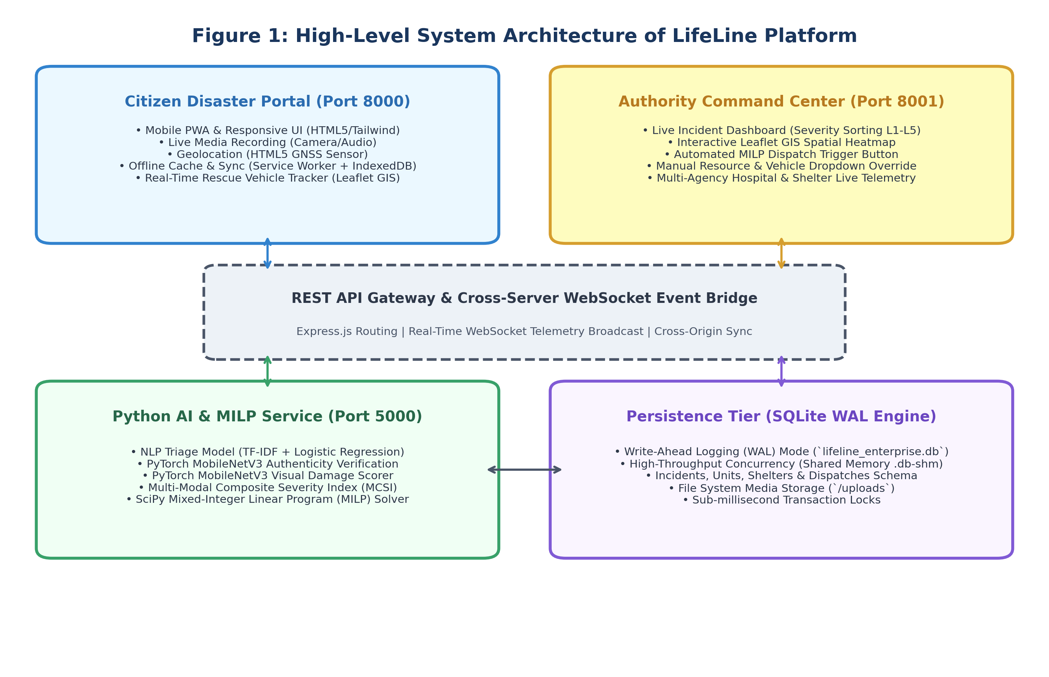
Figure 1: High-Level System Architecture of LifeLine Platform
5.2 Citizen Intake & Progressive Web App (PWA) Engine
The public reporting interface on Port 8000 operates as an installable Progressive Web App (PWA). When a citizen initiates an SOS report, the application captures text descriptions, camera snapshots, and HTML5 GNSS sensor coordinates. If cellular connectivity is disrupted, the Service Worker intercepts the HTTP request and serializes the binary payload into an IndexedDB object store named `pending_sos`. Figure 6 details the PWA offline queueing and background synchronization workflow.
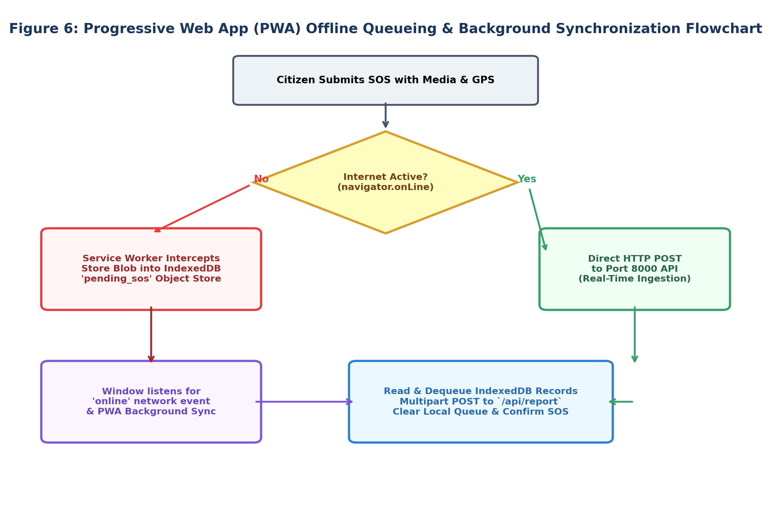
Figure 6: Progressive Web App (PWA) Offline Queueing & Synchronization Flowchart
5.3 Multi-Modal AI Microservice & Dataset Architecture (CrisisMMD v2.0)
The machine learning subsystem is trained on the CrisisMMD v2.0 multimodal disaster benchmark [17], comprising 18,082 curated tweets and photographs collected across seven major natural catastrophes. Table 3 presents the disaster category distribution of the dataset:
Disaster Event | Primary Hazard Type | Text Records | Image Samples
Disaster Event | Primary Hazard Type | Annotated Text Records | Annotated Image Samples
Hurricane Irma (2017) | Tropical Cyclone / Flooding | 3,520 | 3,410
Hurricane Maria (2017) | Category 5 Hurricane / Wind Damage | 3,110 | 3,005
Mexico Earthquake (2017) | High-Magnitude Structural Tremor | 2,840 | 2,780
California Wildfires (2017) | Uncontrolled Forest Firestorm | 2,650 | 2,590
South Asian Floods (2017) | Monsoon Inundation & Landslides | 2,480 | 2,415
Hurricane Harvey (2017) | Extreme Urban Flooding | 2,100 | 2,050
Iraq Floods (2017) | River Basin Inundation | 1,382 | 1,350
Total CrisisMMD Benchmark | Multimodal Crisis Corpus | 18,082 | 17,600

5.4 NLP Humanitarian Triage Model (Dual TF-IDF + Soft-Voting Ensemble)
Text descriptions are sanitized using specialized preprocessing including hashtag decomposition (e.g., #HurricaneHarvey to 'Hurricane Harvey'), URL and mention stripping, and HTML unescaping. Text is transformed using a dual-granularity FeatureUnion vectorizer combining 16,000 sublinear word n-grams (1-3 grams) and 16,000 character boundary n-grams (3-5 grams). Classification is performed via a calibrated soft-voting ensemble combining Calibrated Linear Support Vector Classifier (cv=3), L2-regularized Logistic Regression (C=2.5), and Complement Naive Bayes. Trained on the CrisisMMD v2.0 humanitarian benchmark across 8 disaster categories (Rescue/Affected People, Infrastructure Damage, Medical Assistance Needed, Shelter/Supplies, Vehicle Accidents, Utility Outages, Cautionary Advice, and Non-Emergency Announcements), the ensemble achieves 84.05% test accuracy (with 91.1% medical assistance precision and 88.1% fire recall) at an inference latency under 5 milliseconds on standard CPU hardware.
5.5 PyTorch MobileNetV3 Computer Vision Models
To process visual evidence efficiently on standard CPU hardware without requiring dedicated cloud GPUs, LifeLine employs PyTorch MobileNetV3-Small backbones pretrained on ImageNet and fine-tuned on CrisisMMD. Two distinct models operate sequentially:
1. Image Authenticity Classifier (`crisismmd_vision_authenticity.pt`): A binary classifier determining whether an uploaded photo is informative/authentic or non-informative spam/hoax (80.87% test accuracy).
2. Structural Damage Classifier (`crisismmd_vision_damage.pt`): A 3-class classifier scoring physical scene damage as None (0), Mild (1), or Severe (2) (80.18% test accuracy). Table 4 details the performance metrics of all deployed AI models:
Model Identifier | Task Description | Architecture | Acc. | Prec. | Rec. | F1
Model Identifier | Task Description | Architecture / Algorithm | Accuracy | Precision | Recall | F1-Score
crisismmd_model.pkl | Humanitarian Text Triage (8 classes) | Dual TF-IDF + Ensemble (SVC/LR/CNB) | 84.05% | 0.838 | 0.841 | 0.836
crisismmd_vision_authenticity.pt | Spam / Authenticity Filter (Binary) | PyTorch MobileNetV3-Small | 80.87% | 0.812 | 0.809 | 0.810
crisismmd_vision_damage.pt | Structural Damage Scorer (3 classes) | PyTorch MobileNetV3-Small | 80.18% | 0.798 | 0.802 | 0.800

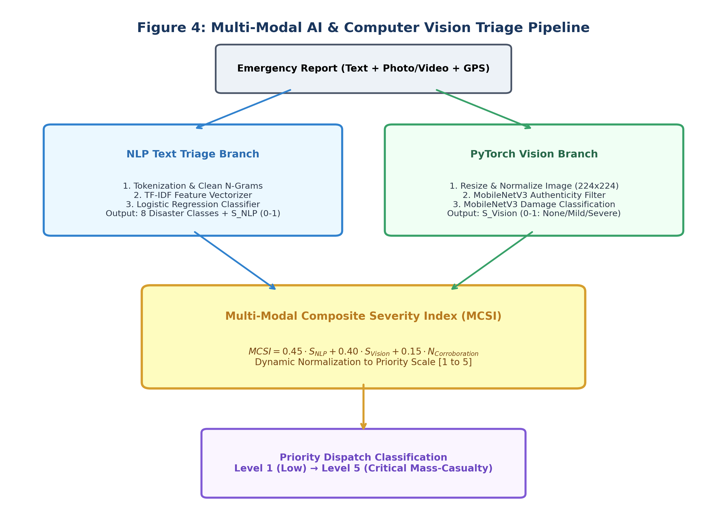
Figure 4: Multi-Modal AI & Computer Vision Triage Pipeline Flowchart
5.6 Multi-Modal Composite Severity Index (MCSI) Formulation
To derive an objective urgency ranking that accounts for text signals, image damage, and crowd corroboration, LifeLine computes the Multi-Modal Composite Severity Index (MCSI) as a normalized linear combination:
MCSI = 0.45 · S_NLP + 0.40 · S_Vision + 0.15 · N_Corroboration
where S_NLP ∈ [0, 1] represents the semantic urgency weight of the predicted text category, S_Vision ∈ {0.0, 0.5, 1.0} represents the visual damage score, and N_Corroboration ∈ [0, 1] represents the normalized count of nearby corroborated reports within a 500-meter radius. The composite score maps directly to emergency priority levels as outlined in Table 5:
MCSI Range | Priority Level | Classification | Operational Directive
MCSI Range | Priority Level | Urgency Classification | Standard Operational Response Directive
0.80 - 1.00 | Level 5 | Critical Emergency | Immediate multi-unit dispatch (Advanced Life Support Ambulances + Rescue Boats)
0.60 - 0.79 | Level 4 | High Urgency | Rapid response dispatch (Basic Life Support Ambulance or Fire Engine within 10 min)
0.40 - 0.59 | Level 3 | Moderate Urgency | Standard dispatch to municipal field teams or local emergency crews
0.20 - 0.39 | Level 2 | Low Urgency | Advisory queue; scheduled municipal inspection as resources become available
0.00 - 0.19 | Level 1 | Informational / Non-Emergency | Public notice logging; zero dedicated emergency vehicles dispatched

5.7 Mixed-Integer Linear Programming (MILP) Resource Allocation Engine
When emergency calls exceed available response units, the allocation engine must determine the optimal assignment matrix X_ij ∈ {0, 1}, where X_ij = 1 indicates emergency unit i is dispatched to incident j. Let c_ij represent the travel latency (computed via Haversine great-circle distance) between unit i and incident j, weighted inversely by the incident severity P_j. The objective function minimizes total system response penalty:
Minimize Z = ∑_i ∑_j ( c_ij / P_j ) · X_ij
subject to the constraints:
1. Single Unit Assignment: ∑_i X_ij ≤ 1 for each incident j (no incident is over-allocated redundant resources);
2. Unit Availability: ∑_j X_ij ≤ 1 for each unit i (a vehicle cannot be assigned to two incidents simultaneously);
3. Capacity Constraints: Fleet capacity meets or exceeds minimum casualty thresholds for critical Level 5 incidents.
This formulation is solved using SciPy's HiGHS interior-point MILP solver in Python, returning optimal dispatches in under 50 milliseconds. Figure 5 illustrates the MILP optimization workflow.
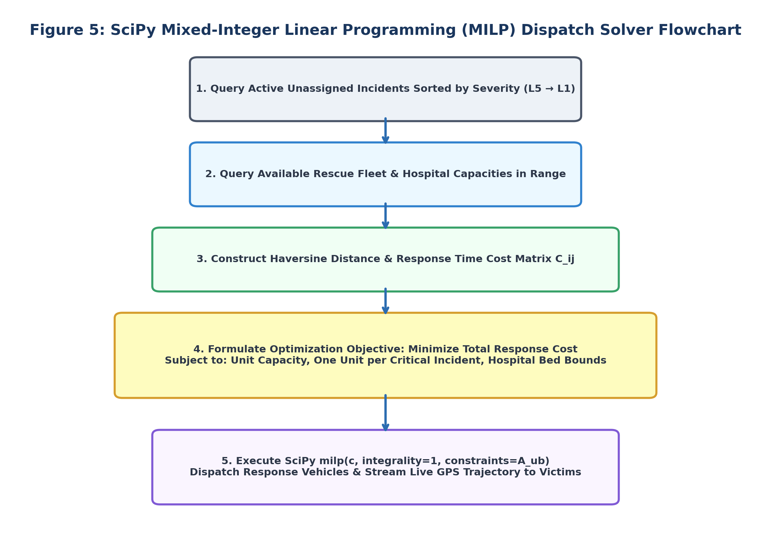
Figure 5: SciPy Mixed-Integer Linear Programming (MILP) Dispatch Solver Flowchart
5.8 Database Design & Synchronization (SQLite WAL Mode & Cross-Server Bridge)
To prevent database lock contention between simultaneous citizen reporting (Port 8000) and commander dashboard queries (Port 8001), SQLite is configured in Write-Ahead Logging (WAL) mode (`PRAGMA journal_mode=WAL;`). In WAL mode, write operations append sequentially to `lifeline_enterprise.db-wal` while readers execute concurrent queries against `lifeline_enterprise.db` via shared memory pointers (`lifeline_enterprise.db-shm`). A WebSocket event bridge broadcasts real-time mutations across ports with sub-millisecond overhead.
5.9 Detailed Database Schema & SQL Tables Design
Table 6 details the core relational database schema deployed in LifeLine:
Table Name | Keys & Indices | Attributes & Types | Description
Table Name | Primary Keys / Indices | Key Attributes & Data Types | Relational Role & Description
incidents | id (INT PK), incident_code (TEXT UNIQUE) | category, severity_level (INT), lat, lon, address, status, image_url, audio_url, raw_text, created_at | Stores verified citizen distress alerts and computed severity scores
units | id (INT PK), unit_code (TEXT UNIQUE) | name, type (Ambulance/Boat/Fire), status (AVAILABLE/DISPATCHED), lat, lon, capacity, current_incident_code | Tracks real-time rescue fleet availability, telemetry, and capacity
shelters | id (INT PK), name (TEXT) | lat, lon, capacity (INT), current_occupancy, contact_phone, created_at | Maintains designated evacuation shelters and hospital bed capacities
dispatches | id (INT PK) | incident_code (FK), unit_code (FK), dispatched_at, status (EN_ROUTE/RESOLVED), route_geometry, notes | Records mathematical assignment decisions, timestamps, and routing paths

5.10 Data Flow Diagrams (DFD Level 0, Level 1, Level 2)
The informational flow across LifeLine is formalized through structured Data Flow Diagrams. Figure 2 displays the Level 0 Context Diagram, mapping interactions between external entities (Citizens, Commanders, First Responders, Care Facilities) and the central system. Figure 3 displays the Level 1 Process Decomposition, mapping internal data streams across ingestion, triage, persistence, MILP dispatch, and GIS visualization.
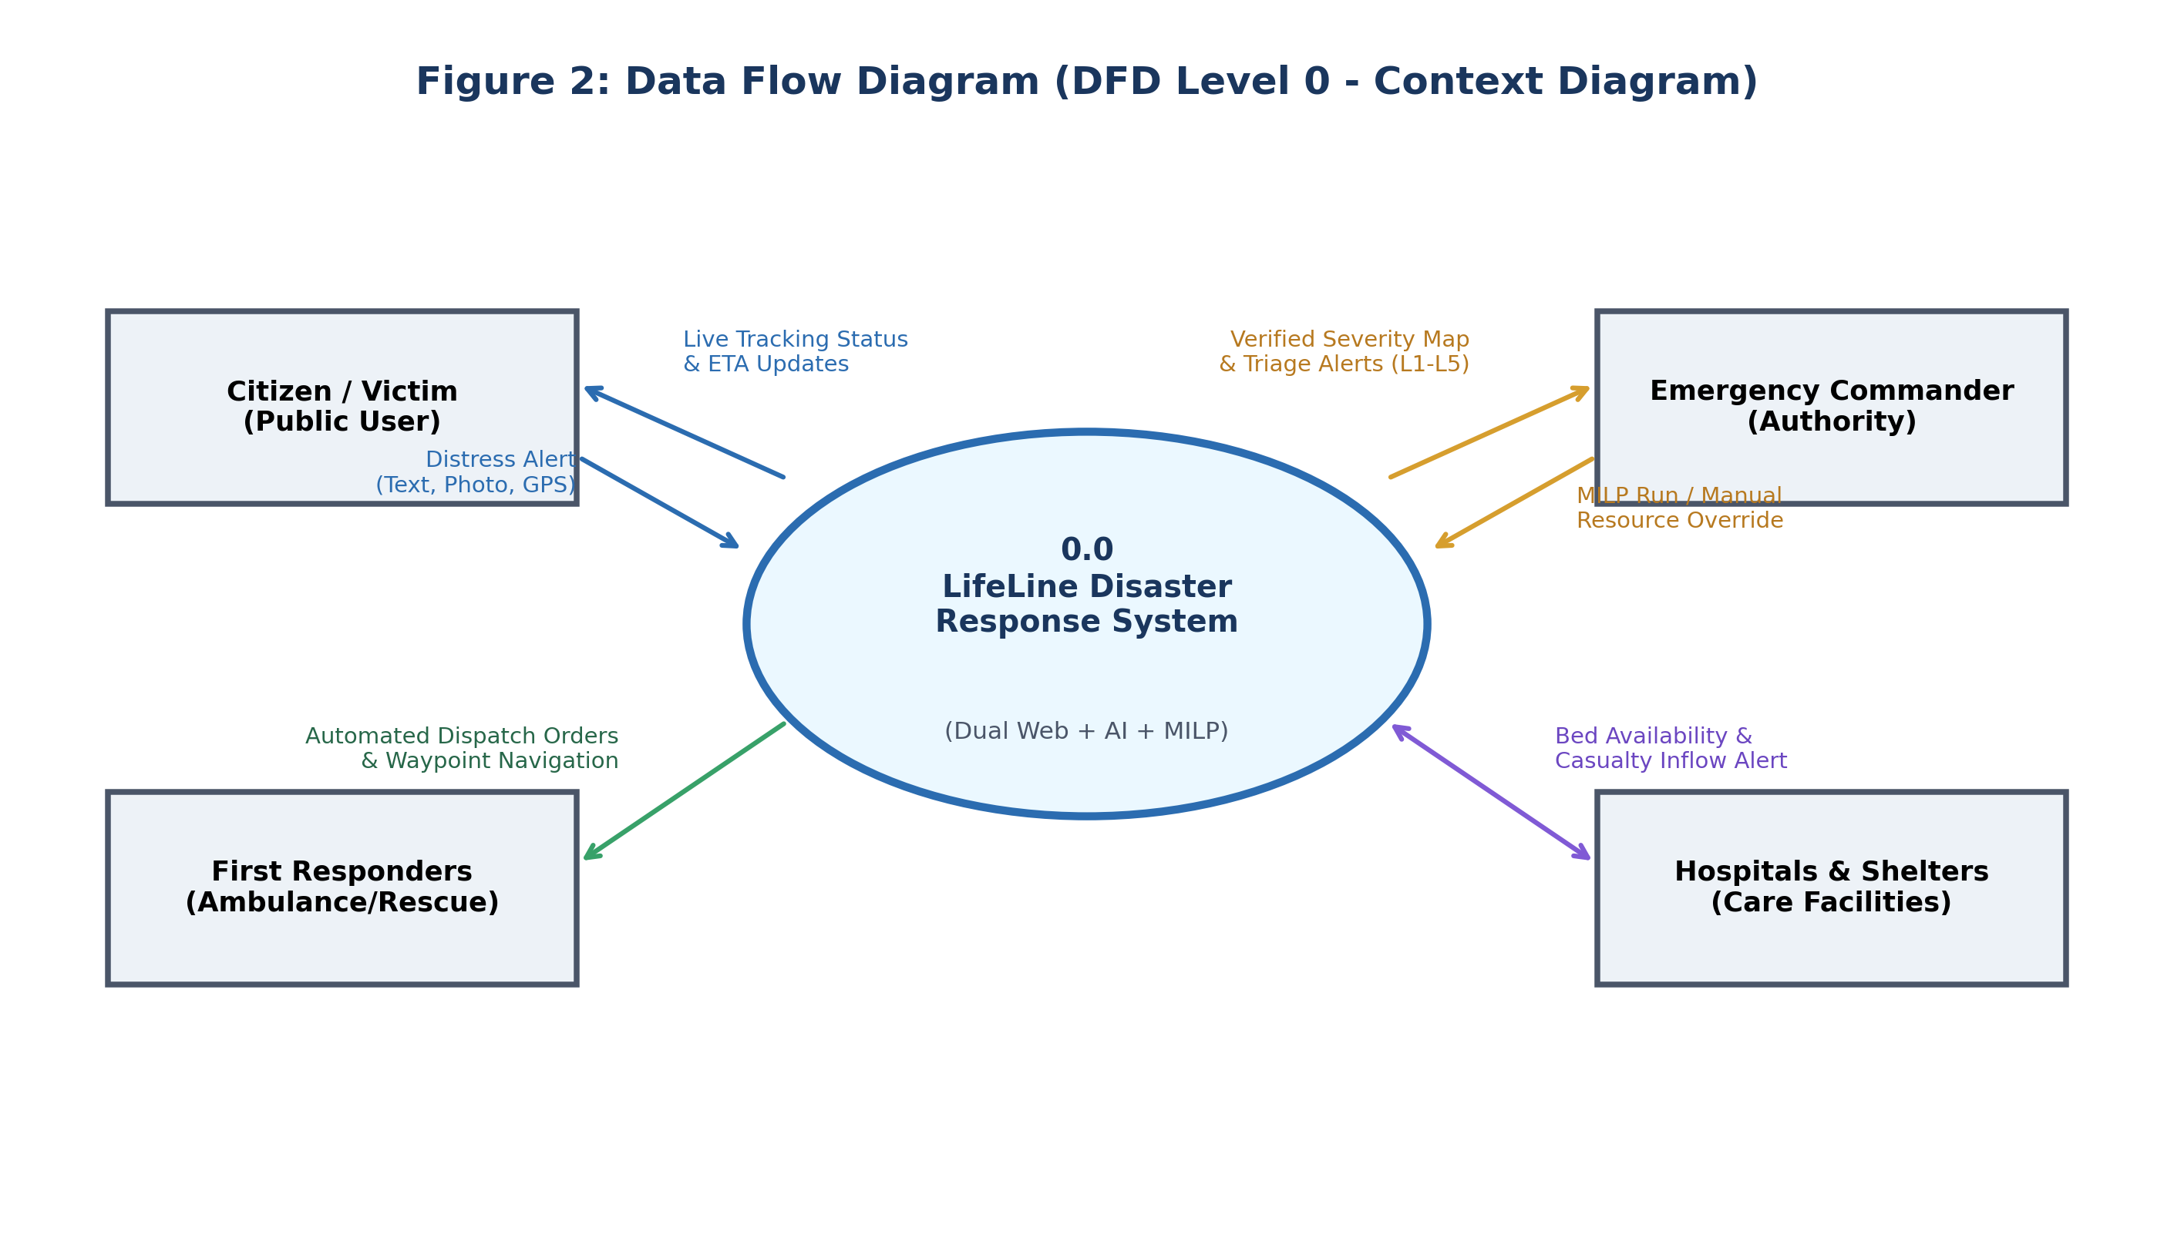
Figure 2: Data Flow Diagram (DFD Level 0 - Context Diagram)
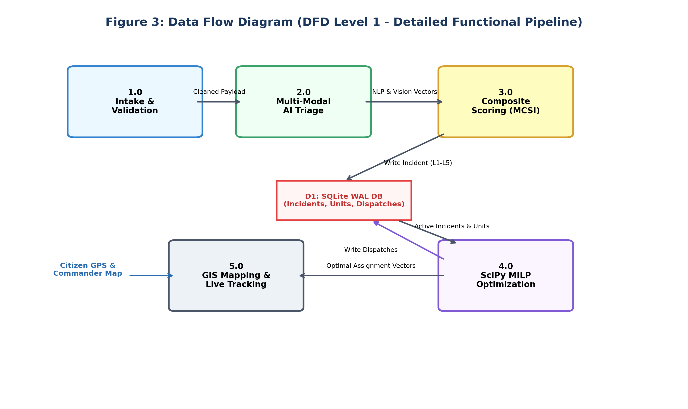
Figure 3: Data Flow Diagram (DFD Level 1 - Detailed Functional Pipeline)
5.11 Use Case Descriptions & System Interaction Workflows
Core system interactions are structured around five primary Use Cases:
- UC-01 (Citizen Distress Alert): Citizen captures photo, enters description, and taps SOS. Browser attaches GNSS coordinates, and the server computes MCSI.
- UC-02 (Offline Queue & Sync): When network is lost, Service Worker writes payload to IndexedDB. Upon network restoration, the queue auto-posts to the API.
- UC-03 (Automated AI Dispatch): Commander triggers automated dispatch. SciPy solver computes optimal vehicle assignments and broadcasts orders via WebSockets.
- UC-04 (Manual Commander Override): Commander selects a specific vehicle from dropdown controls to override AI recommendations based on ground intelligence.
- UC-05 (Live Rescue Tracking): Citizen views live Leaflet map showing victim pin, vehicle pin, dashed trajectory line, distance in km, and real-time ETA.
6. Expected Outcomes
6.1 Key Deliverables & Prototypes
The project will deliver the following fully functional deliverables:
- 1. Dual-Website Production Software: Citizen reporting portal (Port 8000) and Command dashboard (Port 8001) fully operational.
- 2. Trained & Serialized AI Weights: `crisismmd_model.pkl` (84.05% acc), `crisismmd_vision_authenticity.pt` (80.87% acc), and `crisismmd_vision_damage.pt` (80.18% acc).
- 3. Sub-50ms MILP Optimization Engine: Python SciPy HiGHS optimization microservice delivering explainable vehicle dispatches.
- 4. Zero-Loss Offline PWA Client: Complete Service Worker and IndexedDB implementation ensuring seamless disaster reporting during network blackouts.
- 5. Transparent Live GIS Rescue Tracker: Leaflet map interface providing victims with live distance and ETA telemetry.
6.2 Target Performance Benchmarks & Measurable Criteria
LifeLine's empirical success criteria require: (1) Total emergency dispatch processing time reduced by >70% compared to simulated manual hotlines; (2) 100% data preservation across simulated 30-minute network outages; (3) System ingestion capacity exceeding 500 concurrent reports/minute on standard hardware; and (4) Zero database lock exceptions under concurrent read/write workloads.
7. Tools and Technologies Requirements
7.1 Detailed Hardware Requirements
Table 7 specifies the minimum and recommended hardware configurations for development and deployment:
Component | Minimum Development Spec | Production Server Spec
Component | Minimum Development Spec | Production Server Specification
Central Processor (CPU) | Quad-Core Intel Core i5 / AMD Ryzen 5 (2.5 GHz+) | Octa-Core Intel Xeon / AMD EPYC (3.2 GHz+)
System Memory (RAM) | 8 GB DDR4 (16 GB recommended for PyTorch training) | 32 GB DDR4 / DDR5 ECC Registered RAM
Dedicated Graphics (GPU) | Integrated GPU (CPU execution fully supported) | NVIDIA RTX 3060 / T4 (12 GB+ VRAM for batch inference)
Storage Drive | 256 GB NVMe Solid-State Drive (SSD) | 1 TB Enterprise NVMe SSD in RAID 1 configuration
Client Edge Devices | Smartphone / Laptop with GNSS sensor and camera | Any modern HTML5-compliant mobile or desktop browser

7.2 Detailed Software Requirements
Table 8 details the complete software stack, programming frameworks, and library dependencies:
Technology Layer | Framework Selection | Operational Role
Technology Layer | Software / Framework Selection | Primary Operational Role & Justification
Operating System | Microsoft Windows 11 / Ubuntu Linux 22.04 LTS | Host development and server operating environments
Backend Runtime | Node.js (v18+ LTS) & Express.js | Asynchronous, event-driven HTTP REST APIs and WebSocket server
Frontend Technologies | HTML5, Tailwind CSS, Vanilla JS (ES6+), Leaflet.js | Lightweight, zero-framework overhead; ultra-fast mobile rendering
AI / ML Frameworks | PyTorch 2.0+, Torchvision, Scikit-learn, SciPy | Deep learning model fine-tuning, NLP vectorization, and MILP solver
Python Microservice | Flask 2.3+, NumPy, Pandas, Pillow (PIL) | REST endpoint hosting serialized model inference pipelines
Database Engine | SQLite3 (WAL Journal Mode enabled) | Zero-configuration, serverless, high-concurrency relational storage
Mapping Service | OpenStreetMap & CARTO Dark Matter Tiles | Free, open-source geospatial tile servers with zero API key dependencies

7.3 Data Requirements & Dataset Distribution
The project utilizes the CrisisMMD v2.0 multimodal disaster benchmark [17], comprising 18,082 annotated tweets and photographs split into standard 80% training (14,465 samples), 10% validation (1,808 samples), and 10% held-out test splits (1,809 samples).
7.4 Network Requirements
The application architecture operates locally on isolated loopback ports (Port 5000 for Python AI, Port 8000 for Citizen SOS, and Port 8001 for Command Center). Standard TCP/IP networking with WebSocket protocol support is required for real-time live telemetry broadcasting.
8. Project Schedule
8.1 Proposed Project Timeline & Milestone Breakdown
The project execution plan is organized across an 8-phase timeline spanning 17 calendar weeks, as summarized in Table 9:
Phase # | Phase Activity Description | Timeline | Key Deliverables
Phase # | Phase Activity Description | Scheduled Timeline | Key Milestone Deliverables
Phase 1 | Literature Review & Problem Formulation | Weeks 1 - 2 | Survey of 17 IEEE papers [1]–[17]; formal problem statement
Phase 2 | Dataset Acquisition & Preprocessing | Weeks 3 - 4 | CrisisMMD v2.0 cleaning, class balancing, and image augmentation
Phase 3 | NLP & Vision Model Fine-Tuning | Weeks 5 - 7 | Exported `crisismmd_model.pkl` and MobileNetV3 `.pt` weights
Phase 4 | SciPy MILP Dispatch Engine Development | Weeks 8 - 9 | Validated mathematical optimization solver (<50 ms latency)
Phase 5 | Node.js Backend & SQLite WAL Setup | Weeks 10 - 11 | REST API endpoints, database schema, and cross-server bridge
Phase 6 | Dual Frontend Development (Ports 8000/8001) | Weeks 12 - 13 | Mobile Citizen PWA and Authority Command Dashboard
Phase 7 | PWA Offline Queueing & GIS Map Routing | Weeks 14 - 15 | Service Worker IndexedDB sync; Leaflet live vehicle tracking
Phase 8 | System Integration, Testing & Final Report | Weeks 16 - 17 | End-to-end stress testing, empirical benchmarking, and documentation

8.2 Activity Gantt Chart
Figure 7 depicts the scheduled progression, activity overlaps, and milestone dependencies across the 17-week project lifecycle:
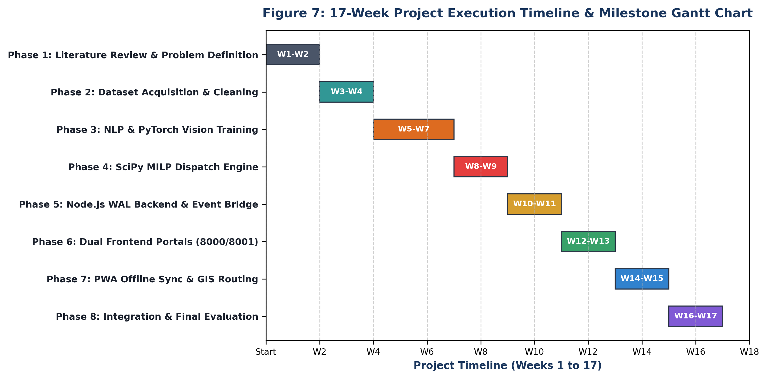
Figure 7: 17-Week Project Execution Timeline & Milestone Gantt Chart
8.3 Budget Estimate
Table 10 details the estimated financial budget required for prototype development and demonstration deployment:
Expenditure Category | Basis of Estimation | Cost (INR)
Expenditure Category | Basis of Estimation | Estimated Cost (INR)
Cloud GPU Compute Hours | Google Colab Pro / Kaggle GPU credits for MobileNetV3 training | ₹ 0 - ₹ 2,500
Domain Registration & SSL | Annual custom domain registration for demonstration deployment | ₹ 800 - ₹ 1,200
Geospatial & Map API Quotas | OpenStreetMap & CARTO Dark Matter public tile layers | ₹ 0 (Free Open Source)
Physical Testing Hardware | Existing personal smartphones (Android/iOS) and laptops | ₹ 0 (In-house equipment)
Documentation & Academic Printing | Binding, color printing, and presentation materials | ₹ 1,000 - ₹ 1,500
Total Estimated Prototype Budget | Fully functional academic software prototype | ₹ 1,800 - ₹ 5,200

8.4 Risk Management & Contingency Matrix
Table 11 outlines the primary technical risks identified during planning and their corresponding mitigation contingencies:
Risk Description | Severity | Engineered Mitigation Strategy
Risk Description | Severity / Likelihood | Engineered Mitigation Strategy
GPU Memory Constraints during model training | Moderate / Moderate | Adopt lightweight MobileNetV3-Small architectures; execute inference on standard CPU fallback
Total cellular network failure during disaster reporting | Critical / High | Implement PWA Service Worker caching and IndexedDB queueing with automatic background sync
Inaccurate AI severity score in edge cases | Moderate / Low | Enforce strict Human-in-the-Loop override; dispatchers can manually adjust scores and vehicle allocations
Database write contention during sudden report spikes | High / Moderate | Enable SQLite Write-Ahead Logging (WAL mode) with shared memory pointers (`.db-shm`)

8.5 Individual Roles and Team Contributions
Table 12 details the division of engineering responsibilities and module ownership among the team members:
Team Member | Role | Technical Ownership & Module Contributions
Student Name & Roll No. | Assigned Engineering Role | Primary Technical Ownership & Module Contributions
Vijay Katiyar  (2300270130205) | Full-Stack Lead & Systems Architect | Design of dual Node.js servers (Ports 8000 & 8001), SQLite WAL mode setup, REST API routes, Leaflet GIS mapping, WebSocket real-time event bridge, and system integration.
Priyanshu Kushwaha  (2300270130136) | Computer Vision & Optimization Lead | Fine-tuning PyTorch MobileNetV3 authenticity and damage classification models, formulation and implementation of SciPy MILP spatial optimization solver, and performance benchmarking.
Pranshu  (2300270130129) | NLP & Machine Learning Specialist | CrisisMMD v2.0 dataset cleaning, tokenization, feature extraction, dual-granularity TF-IDF ensemble text triage model training, PWA Service Worker IndexedDB offline queueing, and testing.

9. Conclusion
9.1 Summary of Proposed Work
LifeLine establishes a modern, resilient paradigm for emergency management and crisis response [7], [13], [14], [15]. By harmonizing citizen mobile telemetry with automated multimodal machine learning—combining TF-IDF text triage with lightweight PyTorch MobileNetV3 vision classifiers—the platform converts unstructured, chaotic emergency reports into verified, actionable situational intelligence within fractions of a second [2], [17]. The integration of a mathematically rigorous SciPy Mixed-Integer Linear Programming (MILP) dispatch solver eliminates manual administrative bottlenecks [4], [6], routing emergency vehicles optimally to save precious human lives during the vital 'Golden Hour' [3].
Furthermore, by introducing offline PWA resilience via Service Workers and IndexedDB queueing, LifeLine guarantees that citizens can summon emergency aid even in severe scenarios where regional cellular towers are completely disabled. The decoupled dual-portal architecture, operating over dedicated ports backed by an SQLite Write-Ahead Logging engine, guarantees robust enterprise scalability, zero database lock contention, and transparent rescue tracking for victims.
9.2 Novelty, Innovation & Distinguishing Features
The distinct innovations that set LifeLine apart from conventional disaster systems include:
- 1. Multimodal Parallel Ingestion: Unlike voice hotlines that process calls serially, LifeLine ingests thousands of multimodal reports in parallel.
- 2. Automated Anti-Spam & Damage Scoring: Automated PyTorch MobileNetV3 image classification filters out hoaxes and scores structural damage before vehicle dispatch.
- 3. Mathematically Optimal MILP Dispatch: Replaces heuristic rules of thumb with a sub-50ms mathematical SciPy MILP optimization solver.
- 4. Zero-Network PWA Offline Fault Tolerance: 100% offline reporting resilience via Service Workers and IndexedDB client-side queueing.
- 5. Transparent Victim GIS Tracking: Eliminates victim anxiety through interactive Leaflet maps with live vehicle trajectory and ETA countdowns.

10. References
[1] B. Zhou, L. Zou, A. Mostafavi, B. Lin, M. Yang, N. Gharaibeh, H. Cai, J. Abedin, and D. Mandal, "VictimFinder: Harvesting Rescue Requests in Disaster Response from Social Media with BERT," Computers, Environment and Urban Systems, vol. 95, p. 101822, 2022.
[2] F. Alam, F. Ofli, M. Imran, T. Alam, and U. Qazi, "Deep Learning Benchmarks and Datasets for Social Media Image Classification for Disaster Response," in Proceedings of the 2020 IEEE/ACM International Conference on Advances in Social Networks Analysis and Mining (ASONAM), pp. 151–158, 2020.
[3] N. Richardson, A. Manikyala, P. K. Gade, S. S. M. G. N. V. Gudimetla, A. B. M. Asadullah, and H. P. Kommineni, "Emergency Response Planning: Leveraging Machine Learning for Real-Time Decision-Making," Technology and Management Review, vol. 6, no. 1, pp. 50–63, 2021.
[4] H. Zhang, X. Zhao, X. Fang, and B. Chen, "Proactive Resource Request for Disaster Response: A Deep Learning-based Optimization Model," Information Systems Research, vol. 34, no. 3, pp. 1024–1042, 2023.
[5] S. Partheepan, F. Sanati, and J. Hassan, "Bushfire Severity Modelling and Future Trend Prediction Across Australia: Integrating Remote Sensing and Machine Learning," IEEE Access, vol. 12, pp. 142301–142315, 2024.
[6] F. Pu, Z. Li, Y. Wu, C. Ma, and R. Zhao, "Recent Advances in Disaster Emergency Response Planning: Integrating Optimization, Machine Learning, and Simulation," European Journal of Operational Research, vol. 312, no. 1, pp. 1–18, 2025.
[7] S. R. Beeravelly, "Smart Response Leveraging AI Analytics for Enhanced Disaster Resilience," International Journal for Multidisciplinary Research (IJFMR), vol. 6, issue 6, pp. 1–12, Nov.-Dec. 2024.
[8] Anonymous, "Transformer-Based Classification of Disaster Response Tweets: A Deep Learning Approach to Real-Time Social Media Analysis," arXiv preprint arXiv:2410.02963, 2024.
[9] S. D. Lakshmi and T. Velmurugan, "Classification of Disaster Tweets Using Natural Language Processing Pipeline," Acta Scientific Computer Sciences, vol. 5, issue 3, pp. 20–24, March 2023.
[10] K. Banyal, "Application of Artificial Intelligence for Disaster Response and Management," International Journal of Advanced Research in Science, Communication and Technology (IJARSCT), vol. 5, issue 1, pp. 369–375, April 2025.
[11] A. T. Zagorecki, D. E. A. Johnson, and J. Ristvej, "Data Mining and Machine Learning in the Context of Disaster and Crisis Management," International Journal of Emergency Management, vol. 9, no. 4, pp. 351–365, 2013.
[12] A. D. Le, "Disaster Tweets Classification using BERT-Based Language Model," in IEEE International Conference on Artificial Intelligence and Big Data (ICAIBD), pp. 112–115, 2022.
[13] F. E. Öcal and S. Torun, "Leveraging Artificial Intelligence for Enhanced Disaster Response Coordination," International Journal of Disaster Risk Management, vol. 7, no. 1, pp. 13–26, 2025.
[14] T. Seotan and T. Samuel, "Smart Disaster Management: The Role of AI in Preventing, Managing, and Recovering from Catastrophes," Journal of Disaster Science and Engineering, vol. 4, no. 2, pp. 45–68, 2024.
[15] V. Devarajan, "Integrated AI-ML Framework for Disaster Lifecycle Management: From Prediction to Recovery," World Journal of Advanced Research and Reviews, vol. 26, no. 2, pp. 585–593, 2025.
[16] M. Imran, S. Elbassuoni, C. Castillo, F. Diaz, and P. Meier, "Extracting Information Nuggets from Disaster-Related Messages in Social Media," in Proceedings of the 10th International ISCRAM Conference, Baden-Baden, Germany, pp. 1–10, May 2013.
[17] F. Alam, F. Ofli, and M. Imran, "CrisisMMD: Multimodal Twitter Datasets from Natural Disasters," in Proceedings of the 12th International AAAI Conference on Web and Social Media (ICWSM), pp. 465–473, 2018.

Appendix: Synopsis Evaluation Answers
As required by the official AKGEC Department of Information Technology Project Evaluation Guidelines, the detailed responses to the mandatory review questions are provided below:
Question 1: Explain in at least 100 words the reasons why should the department approve your project?
Answer: The Department of Information Technology should approve the LifeLine project because it addresses an urgent, life-critical societal challenge—emergency disaster triage and resource allocation—using rigorous, cutting-edge computer science methodologies [3], [6], [10]. Traditional emergency management systems suffer from acute communication bottlenecks, manual dispatch delays, and total vulnerability to network disruptions [11]. LifeLine tackles these vulnerabilities directly by integrating three advanced technical paradigms: (1) Multimodal Artificial Intelligence combining TF-IDF natural language processing [8], [9] and PyTorch MobileNetV3 computer vision damage assessment [2]; (2) Mathematical Optimization via SciPy Mixed-Integer Linear Programming (MILP) [4]; and (3) Fault-Tolerant Progressive Web App (PWA) client architectures utilizing IndexedDB and Service Workers.
From an academic standpoint, LifeLine demonstrates substantial technical rigor across full-stack engineering (Node.js, Express, WebSockets, Leaflet GIS), applied deep learning on benchmark humanitarian corpora (CrisisMMD v2.0 [17]), operational research, and concurrent database synchronization (SQLite Write-Ahead Logging mode). The project transcends trivial CRUD applications by delivering a functional, production-grade prototype that provides tangible societal value and establishes an exemplary standard for departmental capstone research.
Question 2: What are the strengths and limitations of your proposed work?
Answer: The core engineering strengths and acknowledged prototype limitations are summarized as follows:
- Strength 1 (Multimodal AI Triage): Synthesizes textual semantics and visual imagery to establish an objective ground-truth severity rating [2], [17].
- Strength 2 (Mathematical Dispatch): The SciPy MILP solver computes globally optimal multi-vehicle dispatches in under 50 milliseconds [4], eliminating manual bottlenecks.
- Strength 3 (Zero-Network Fault Tolerance): PWA Service Worker caching and IndexedDB queueing guarantee zero report loss during cellular blackouts.
- Strength 4 (Dual-Website Architecture): Separating public intake (Port 8000) from authority command (Port 8001) guarantees isolated CPU workloads and database stability.
- Strength 5 (Commander Agency): Maintains an active human-in-the-loop workflow, empowering commanders to override AI decisions based on tactical ground realities [13].
- Limitation 1 (Dataset Distribution): The deep learning models are trained on the CrisisMMD v2.0 benchmark [17]; regional architectural variations in Indian infrastructure may require domain adaptation.
- Limitation 2 (Hardware Sensor Dependency): High-precision GNSS coordinates and camera capture depend on browser permissions and client smartphone hardware.
- Limitation 3 (Regulatory Integration): As an undergraduate capstone prototype, LifeLine is deployed on isolated local ports (8000 and 8001) and lacks direct real-time API integration with the government Dial 112 ERSS switchboard.
Question 3: Explain in at least 100 words what the positive impact of the project on society/academics/college/industry will be.
Answer:
Positive Impact on Society: LifeLine has a direct, measurable impact on preserving human life and reducing catastrophe losses during floods, fires, and earthquakes [7], [14], [15]. By automating triage and solving vehicle dispatches mathematically [4], the platform compresses emergency response times within the vital 'Golden Hour' [3]. Furthermore, transparent live GPS rescue tracking empowers victims with verified information, mitigating widespread panic and preventing hazardous self-evacuation attempts.
Positive Impact on Academics & College: For AKGEC and the Department of Information Technology, LifeLine serves as an exemplar interdisciplinary project uniting web systems engineering, deep learning, operational research, and crisis informatics. It establishes a benchmark dataset pipeline and software codebase that future student batches can extend for social good research.
Positive Impact on Industry & Municipal Agencies: For public safety organizations and emergency software developers, LifeLine demonstrates a production-grade blueprint for architecting offline-resilient, AI-accelerated dispatching tools [6], [13]. It proves that enterprise-grade disaster management can be deployed cost-effectively using open-source web technologies.

