**Exercise 1: Control Structures**

## **Scenario1:**

The bank wants to apply a discount to loan interest rates for customers above 60 years old.

**Question:**

Write a PL/SQL block that loops through all customers, checks their age, and if they are above 60, apply a 1% discount to their current loan interest rates

## **CODES:**

### BEGIN

FOR rec IN (SELECT CustomerID, Age, LoanInterestRate FROM Customers)

LOOP

IF rec.Age > 60 THEN

UPDATE Customers

SET LoanInterestRate = LoanInterestRate - (LoanInterestRate * 0.01)

WHERE CustomerID = rec.CustomerID;

END IF;

END LOOP;

COMMIT;

END;

SELECT * FROM Customers;

* **OUTPUT**

**Before PL/SQL Block Execution:**

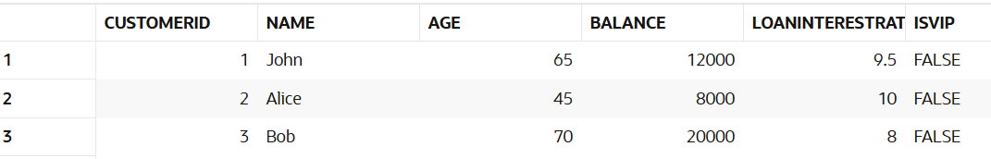

**After PL/SQL Block Execution:**

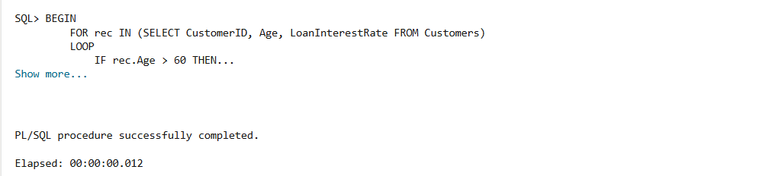

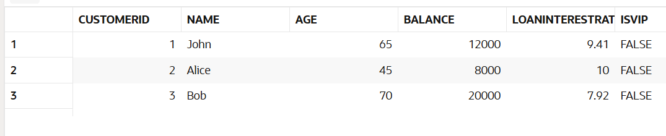

## **Scenario2:**

A customer can be promoted to VIP status based on their balance.

**Question:**

Write a PL/SQL block that iterates through all customers and sets a flag IsVIP to TRUE for those with a balance over $10,000.

## **CODES:**

### BEGIN

FOR rec IN (SELECT CustomerID, Balance FROM Customers)

LOOP

IF rec.Balance > 10000 THEN

UPDATE Customers

SET IsVIP = 'TRUE'

WHERE CustomerID = rec.CustomerID;

END IF;

END LOOP;

COMMIT;

END;

SELECT * FROM Customers;

* **OUTPUT:**

**Before PL/SQL Block Execution:**



**After PL/SQL Block Execution:**

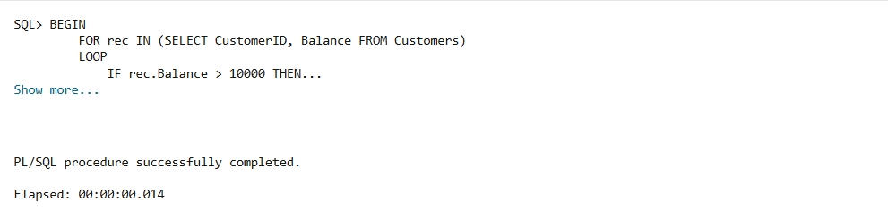

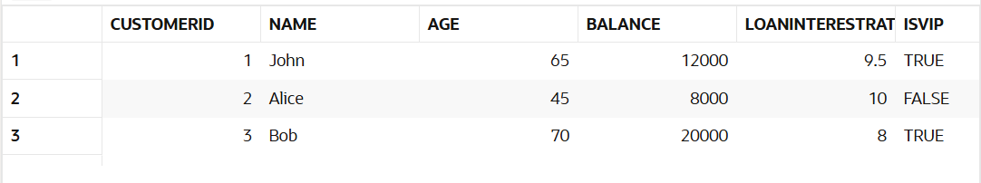

## **Scenario3:**

The bank wants to send reminders to customers whose loans are due within the next 30 day

**Question:**

Write a PL/SQL block that fetches all loans due in the next 30 days and prints a reminder message for each customer.

## **CODES:**

DECLARE

    v_due_date DATE;

    v_name     VARCHAR2(100);

BEGIN

    FOR rec IN (

        SELECT c.CustomerID, c.Name, l.DueDate

        FROM Customers c

        JOIN Loans l ON c.CustomerID = l.CustomerID

        WHERE l.DueDate BETWEEN SYSDATE AND SYSDATE + 30

    )

    LOOP

        DBMS_OUTPUT.PUT_LINE('Reminder: Loan for ' || rec.Name ||

                             ' (Customer ID: ' || rec.CustomerID ||

                             ') is due on ' || TO_CHAR(rec.DueDate, 'DD-MON-YYYY'));

    END LOOP;

END;

* **OUTPUT:**

