**Exercise 3: Stored Procedure**

## **Scenario1:**

The bank needs to process monthly interest for all savings accounts.

**Question:**

Write a stored procedure **ProcessMonthlyInterest** that calculates and updates the balance of all savings accounts by applying an interest rate of 1% to the current balance.

## **CODES:**

### 

CREATE OR REPLACE PROCEDURE ProcessMonthlyInterest IS

BEGIN

UPDATE SavingsAccounts

SET Balance = Balance + (Balance * 0.01); -- 1% interest

COMMIT;

END;

BEGIN

ProcessMonthlyInterest;

END;

SELECT * FROM SavingsAccounts;

* **OUTPUT**

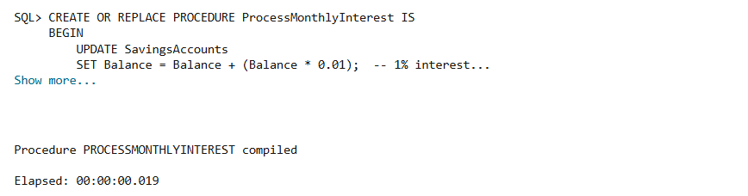

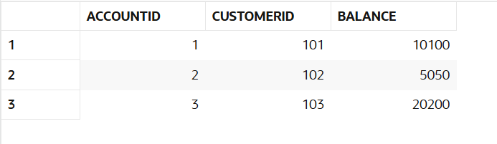

## **Scenario2:**

The bank wants to implement a bonus scheme for employees based on their performance.

**Question:**

Write a stored procedure **UpdateEmployeeBonus** that updates the salary of employees in a given department by adding a bonus percentage passed as a parameter.

## **CODES:**

CREATE OR REPLACE PROCEDURE UpdateEmployeeBonus (

p_department IN VARCHAR2,

p_bonus_pct IN NUMBER

) IS

BEGIN

UPDATE Employees

SET Salary = Salary + (Salary * p_bonus_pct / 100)

WHERE Department = p_department;

COMMIT;

END;

BEGIN

UpdateEmployeeBonus('Tech', 10); -- 10% bonus to Tech department

END;

SELECT * FROM Employees;

* **OUTPUT**

**Before PL/SQL Block Execution:**

**After PL/SQL Block Execution:**

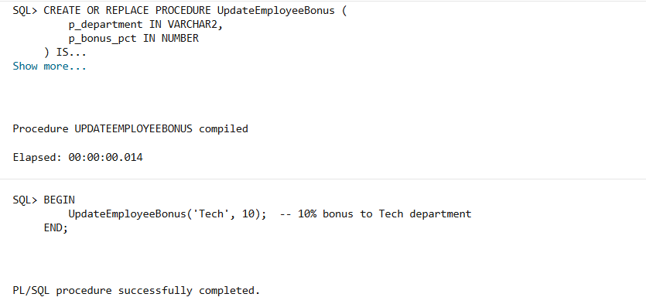

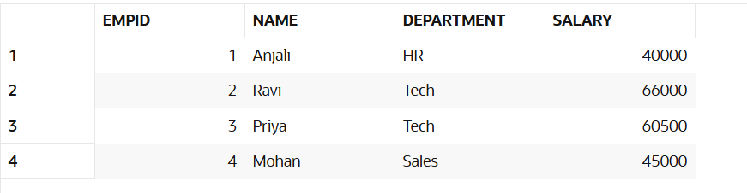

## **Scenario3:**

Customers should be able to transfer funds between their accounts.

**Question:**

Write a stored procedure **TransferFunds** that transfers a specified amount from one account to another, checking that the source account has sufficient balance before making the transfer.

## **CODES:**

CREATE OR REPLACE PROCEDURE TransferFunds (

    p_from_account IN INT,

    p_to_account IN INT,

    p_amount IN NUMBER

) IS

    v_balance NUMBER;

BEGIN

    SELECT Balance INTO v_balance

    FROM Accounts

    WHERE AccountID = p_from_account;

    IF v_balance < p_amount THEN

        RAISE_APPLICATION_ERROR(-20001, 'Insufficient balance in source account');

    ELSE

        UPDATE Accounts

        SET Balance = Balance - p_amount

        WHERE AccountID = p_from_account;

        UPDATE Accounts

        SET Balance = Balance + p_amount

        WHERE AccountID = p_to_account;

        COMMIT;

    END IF;

END;

BEGIN

    TransferFunds(101, 102, 2000);  -- Transfer ₹2000 from Account 101 to 102

END;

SELECT * FROM Accounts;

* **OUTPUT:**

**Before PL/SQL Block Execution:**

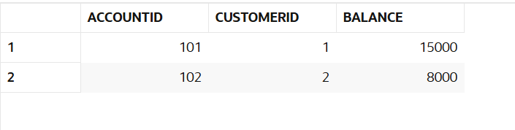

**After PL/SQL Block Execution:**

