**Creating Your First React App**

**Objective:**

Build a basic React application named **myfirstreact** that displays a heading message:  
**"Welcome to the first session of React"**

**Steps:**

* **Install Node.js and npm**
* **Install create-react-app CLI Tool**
* **Create a New React Application**
* **Navigate to the Project Directory**
* Open the Project in Visual Studio Code

We obtain the following structure after creating and editing of the program.

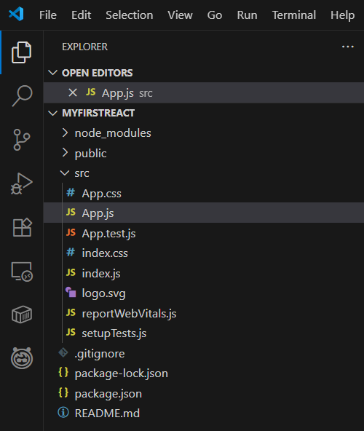

**Edit the App.js File**

* Navigate to: src/App.js and edit accordingly

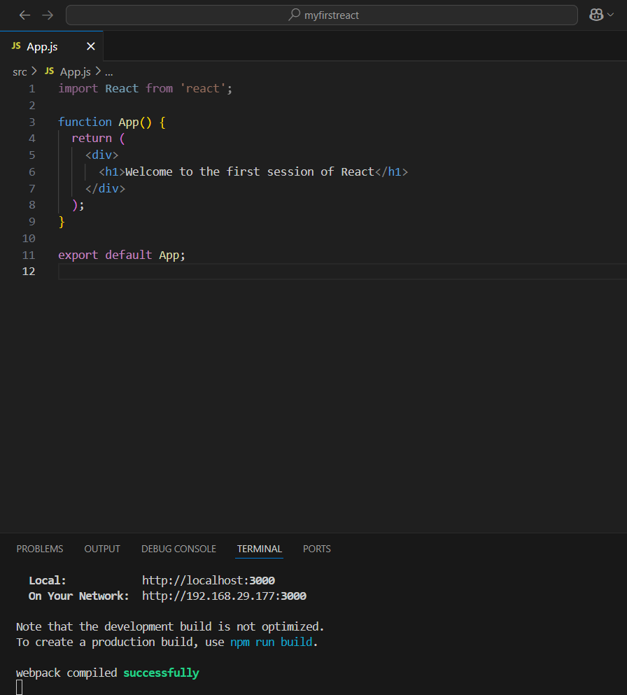

**OUTPUT:**

On running the application we get:

