**Summary: Student Management Portal**

**Objectives**

* Explain React components
* Identify the differences between components and JavaScript functions
* Identify the types of components
* Explain class component
* Explain function component
* Define component constructor
* Define render() function

**Create a New React Project**

npx create-react-app scorecalculatorapp

On creating we obtain the following structure

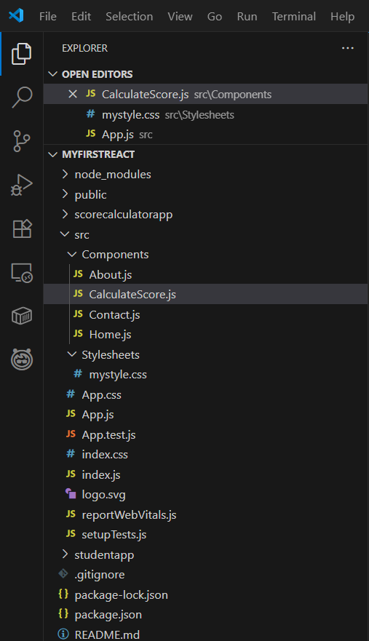

**Create CalculateScore.js**

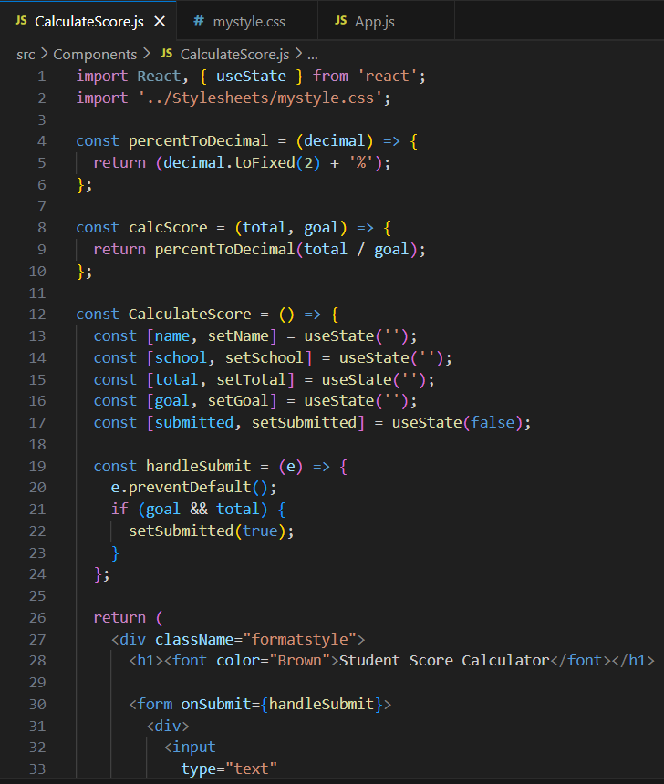

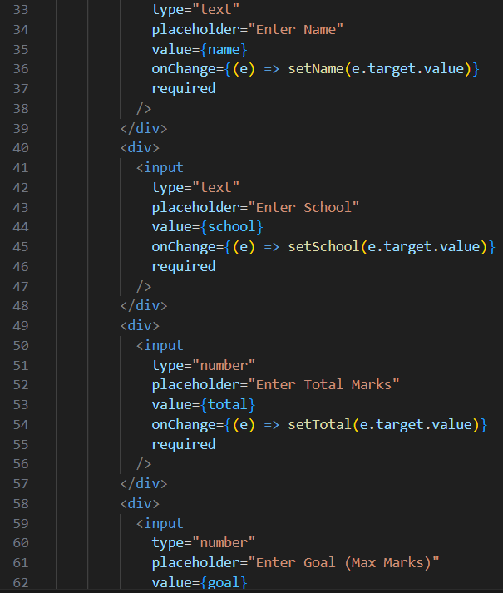

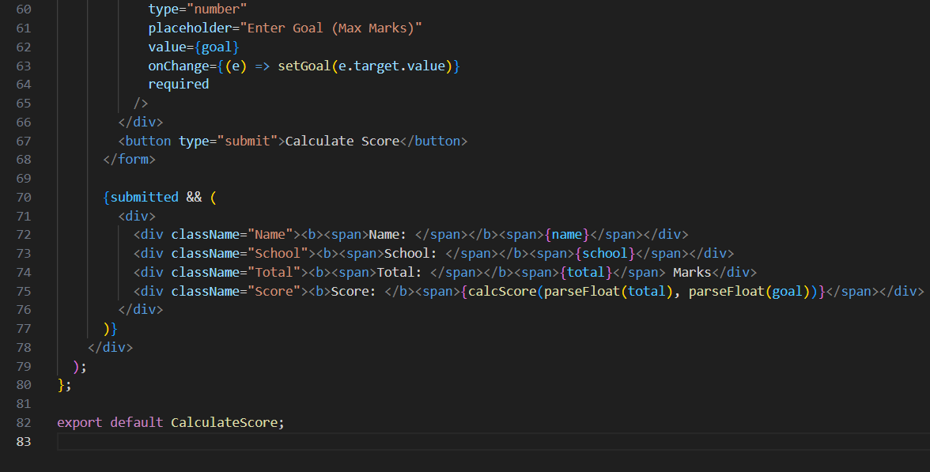

**Create CSS File for Styling**

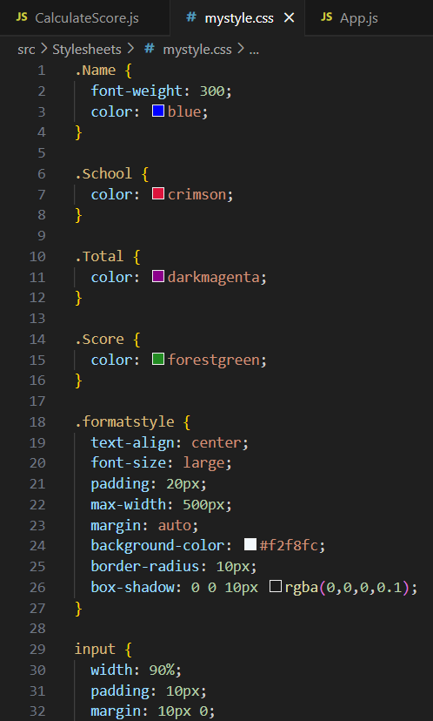

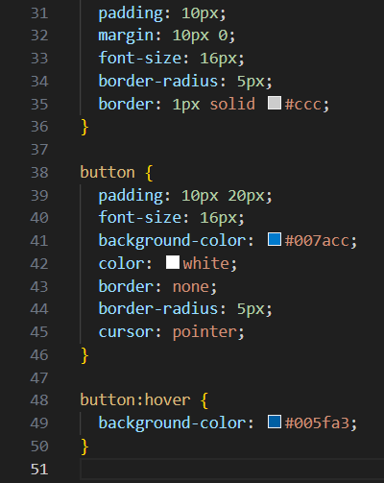

**Update App.js**

In src/App.js, import and render the CalculateScore component:

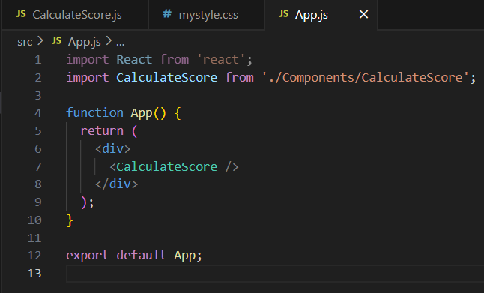

**OUTPUT:**

On performing the above steps we get the desired output.

