**Styling the Cohort Tracker React Application**

**Objectives**

* Understanding the need for styling react component
* Working with CSS Module and inline styles

My Academy team at Cognizant want to create a dashboard containing the details of ongoing and completed cohorts. A react application is created which displays the detail of the cohorts using react component. You are assigned the task of styling these react components.

**Setup & Preparation:**

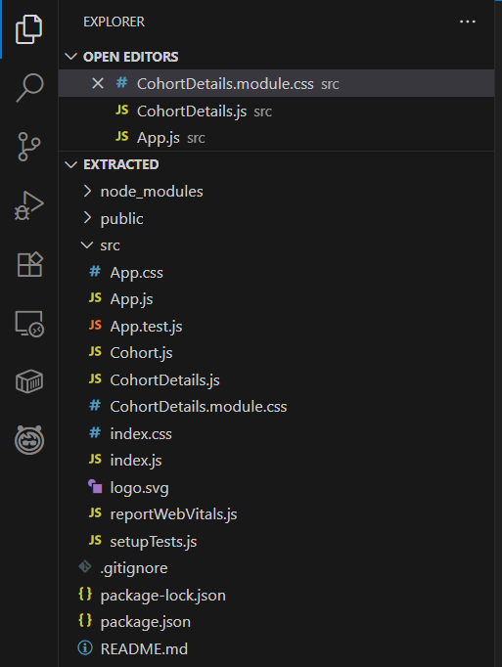The required setup was done by command line interface and the following project structure was obtained after extraction.

**Styling with CSS Modules:**

Create a new file:  
 *src/CohortDetails.module.css*

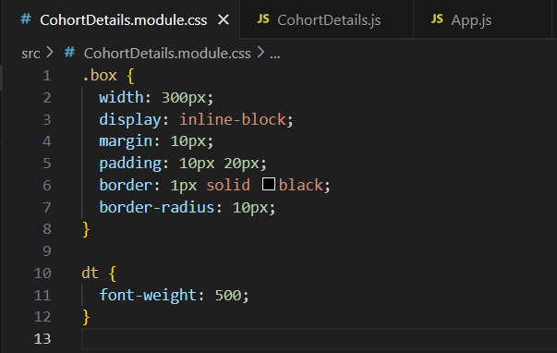

**Update CohortDetails.js**

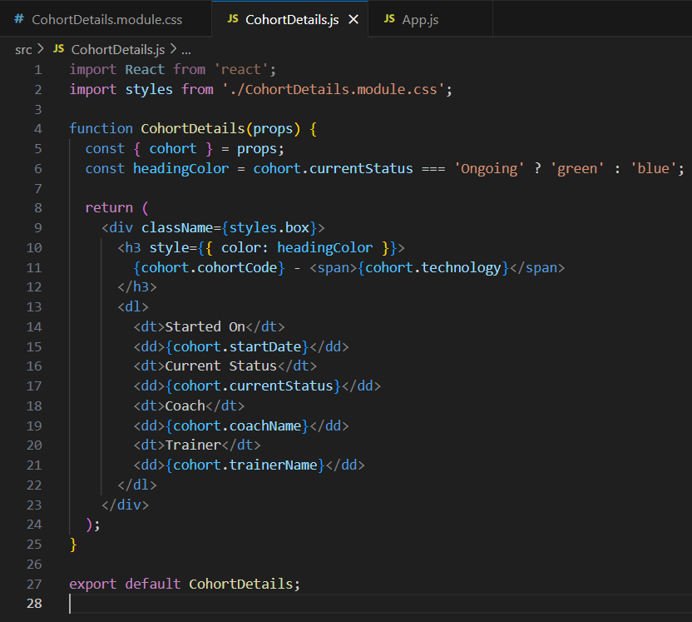

**Render Data**

Ensure App.js Renders All Cohorts:

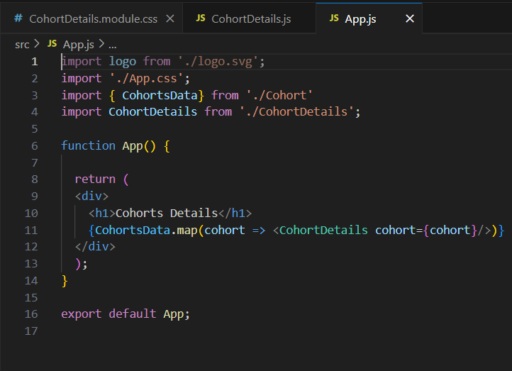

**OUTPUT**

On performing the steps and running the app we obtain React Cohort Tracker which displays well-formatted and visually distinct cohort details, improving readability and professional appearance.

