**Experiment-3**

**Student Name: Pranshu Muthreja UID: 23MCA20164**

**Branch: UIC Section/Group: 3/B**

**Semester: 3 Date of Performance: 24/08/2024**

**Subject Name: Back End Technologies Subject Code: 23CAH-705**

1. **Aim/Overview of the practical:**

Create a signup page and store the inputted data by user in file

1. **Task to be done :**

Initialize a signup page and store the inputted data by the user in file

1. **Code for experiment/practical:**

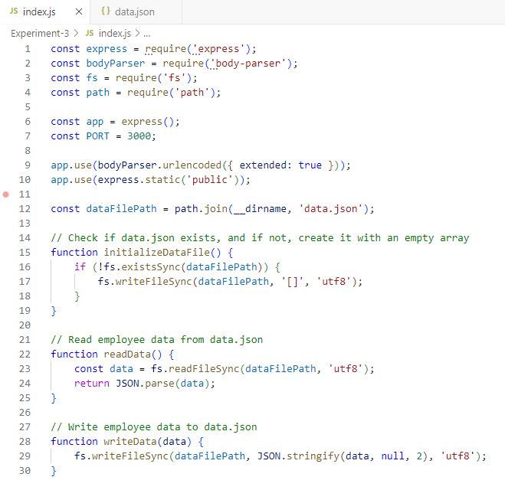

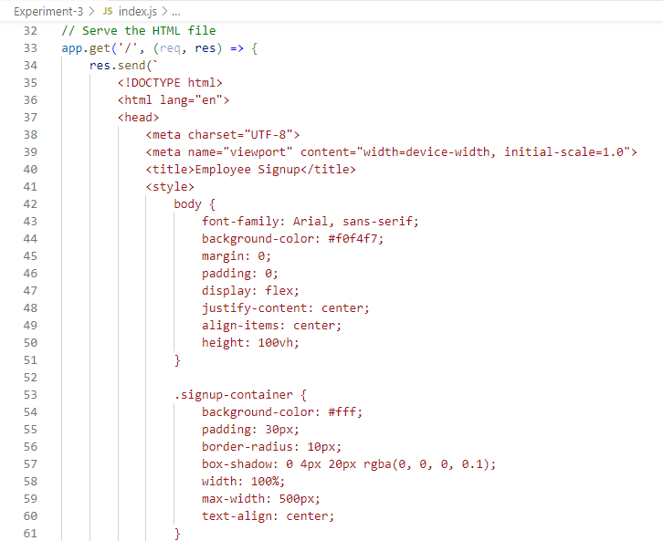

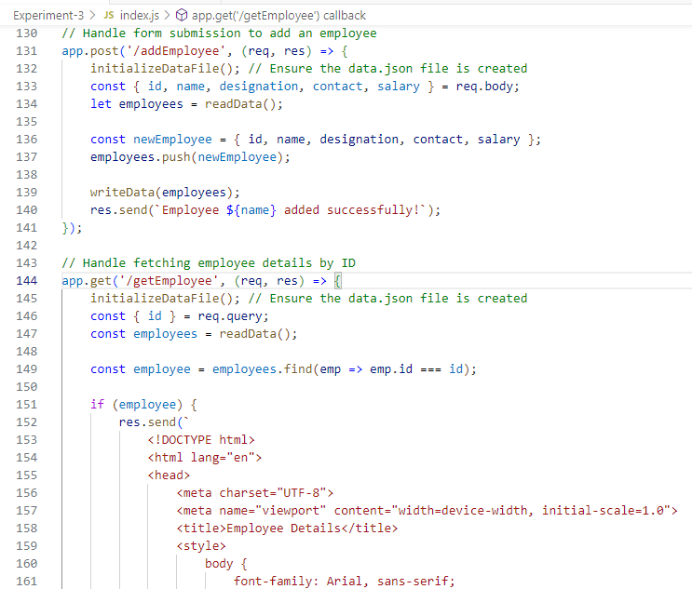

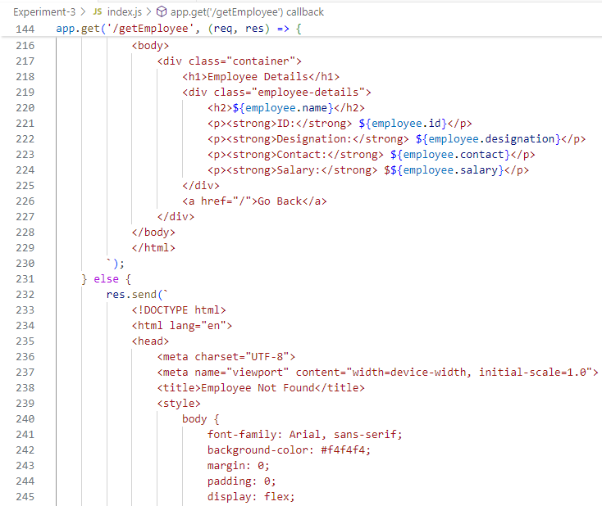

1. **Result/Output/Writing Summary:**

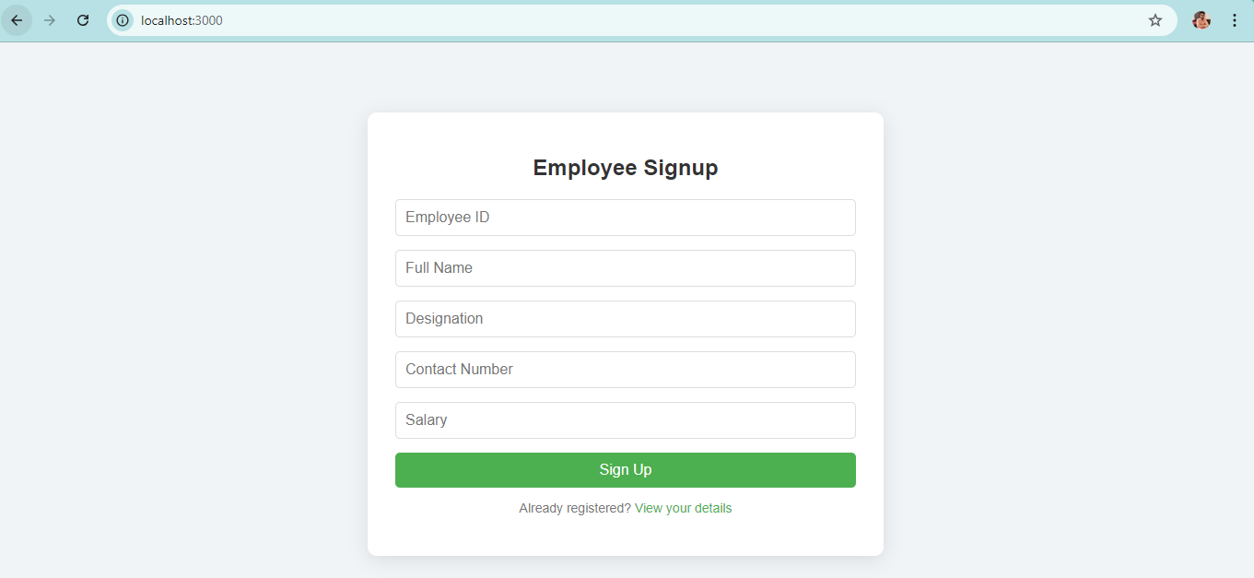

**Learning outcomes (What I have learnt):**

1. I have learnt to set up and configure routes for handling HTTP requests and serving files.

2. I have learnt to implement form validation to ensure required fields are filled out correctly.

3. I have learnt to interact with the file system using Node.js fs module.

4. I have learnt to organize code and project structure for maintainability and scalability.

5. I have gained experience in running and debugging a Node.js server application.