**Defect_ID#** 1

**Title:** Error Message is not displayed when user submit the form without entering the message on contact us form.

**Description:** As per the functionality of contact us form, the message field is mandatory to submit the form, in the latest build version(1.2.1) , we have observed that a contact us form can be saved without entering the message.

**Env:** Dev/test

**Build Version Number:** 1.2.1

**Reproducible:** Yes

**Steps To Reproduce:**

1. Navigate to <https://www.tendable.com/>
2. Click on contact Us
3. Select Marketing
4. Update the form , leave the message field blank
5. Click on agree the agreement and submit the form

**Expected Result**: Form should not be submitted and error message should be displayed

**Actual result:** Form is submitted without any error message

**Screenshot:**

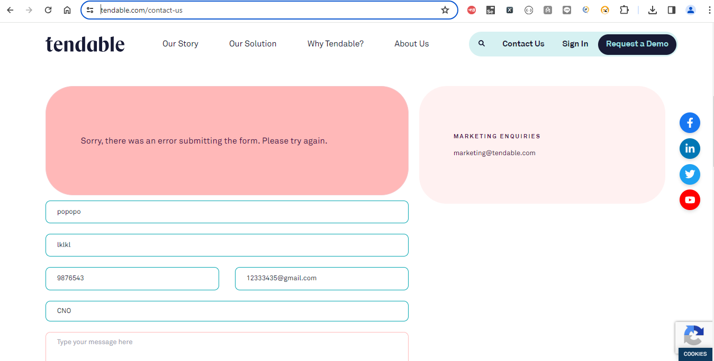

**Sprint**:XXXX

**Release:** XXXX

**Severity:** Medium

**Priority:** as per business (High)

**Created By:** Mr. XYZ

**Created on:** 01/01/2024

**Status:** Open