



**Data Base Project**

**Topic name**

**Vaccination Management System**.

**Submitted To:**

Name: Rifat Tasnim Anannya

ID: 1801-1845-2

Lecturer, CS

**Submitted By:**

Name: Pranta Das

ID: 20-43888-2

**Section: F**

**(2) Description:**

❖Patients are identified by their unique NID number, and their names, ages and mobile numbers must be recorded.

❖Hospital is identified by Hospital ID, Hospital name, Hospital address. Many patients goes hospital regularly.

❖Doctors are identified by unique doctor’s registration number, doctor’s name, and skills.

❖Each hospital has many doctors.

❖ The vaccination process has unique Vaccine Registration Number, first dose date, and second dose date must be recorded.

❖ The hospital stores many vaccines in their pharmacy section.

❖ Each doctor can give many vaccines and each patient can take only one vaccine at one time.

❖ The vaccine process has a Vaccine record that only keeps patients' NID numbers and counts the remaining vaccine.

❖ Medical record has uniquely registration ID of patient and first dose date and second dose date. Each patient has a separate medical record.

❖ The hospital conserves all vaccinations record.

❖The hospital keeps their patient's medical records.

**(3) ER –Diagram**

**(4) Normalization**

**Green for Primary Key**

**Red** for Foreign key

Patient <Goes> Hospital

Goes(**P_NID**, P_Name,P_Age, P_MobNo,**H_ID**, H_Name, H_Add)

**1NF:**

P_MobNo is multivalued attribute.

**2 NF:**

1. **P_NID**, P_Name, P_Age, P_Mob.No
2. **H_ID**, H_Name, H_Add

**3NF:**

No Transitive dependency

1. **P_NID**, P_Name, P_Age, P_Mob.No
2. **H_ID**, H_Name, H_Add

**Table From**: Goes

1. **P_NID**, P_Name, P_Age, H_ID
2. **H_ID**, H_Name, H_Add
3. **P_NID**, **P_Mob.No**- **Composite PK**

Patient<has>Medical record.

Has(**P_NID,** P_name,P_Age,P_MobNo, **R_ID**, First_Dose_Date, Sec_Dose_ Date)

**1NF:**

P_MobNo is Multivalued attribute

**2NF:**

1. **P_NID,** P_name, P_Age,P_MobNo
2. **R_ID**,First_Dose_Date, Sec_Dose_ Date

**3NF:**

No Transitive dependency

1. **P_NID,** P_name, P_Age, P_MobNo
2. **R_ID**,First_Dose_Date, Sec_Dose_Date

**Table From**:(Has)

1. **P_NID,** P_name, P_Age, R_ID
2. **R_ID**,First_Dose_Date, Sec_Dose_Date
3. **P_NID**, **P_Mob.No**- **Composite PK**

Patient<Takes>Vaccine

**Takes**(**P_NID,** P_name, P_Age, P_MobNo, **Vacc_RegNo**, Vacc_name, First_Dose_Date, Sec_Dose_Date)

**1NF:**

P.Mob.No is Multivalued attribute

**2NF:**

1. **P_NID,** P_name, P_Age, P_MobNo
2. **Vacc_RegNo**, Vacc_name ,First_Dose_Date, Sec_Dose_Date

**3NF:**

No Transitive dependency

1. **P_NID,** P_name, P_Age, P_MobNo
2. **Vacc_RegNo**, Vacc_name, First_Dose_Date, Sec_Dose_Date

**Table From**:(Takes)

1. **P_NID,** P_name, P_Age, Vacc_RegNo
2. **Vacc_RegNo**, Vacc_name , First_Dose_Date, Sec_Dose_Date
3. **P_NID**, **P_Mob.No**- **Composite PK**

vaccine<has> record.

**Has** (**Vacc_RegNo**, Vacc_name, First_Dose_Date, Sec_Dose_Date, **P_NID**, Rem_Vac)

**1NF**:

No multuivalued attribute.

**2NF**:

1. **Vacc_RegNo**, Vacc_name, First_Dose_Date, Sec_Dose_Date.
2. **P_NID**,Rem_Vac.

**3NF**:

No Transitive dependency

1. **Vacc_RegNo**, Vacc_name, First_Dose_Date, Sec_Dose_Date
2. **P_NID**,Rem_Vac.

**Tables from: (**Has**)**

1. **Vacc_RegNo**, Vacc_name, First_Dose_Date, Sec_Dose_Date, P_NID
2. **P_NID**, Rem_Vac.

Doctor<Gives>vaccine.

**Gives**(**D_RegNo**, D_Name,Skill,**Vacc_RegNo**, Vacc_name, First_Dose_Date, Sec_Dose_Date)

**1NF:**

Skill is multivalued Attribute.

**2NF:**

1. **D_RegNo**, D_Name,Skill.
2. **Vacc_RegNo**, Vacc_name, First_Dose_Date, Sec_Dose_Date

**3NF:**

No Transitive dependency

1. **D_RegNo**,D_Name,Skill.
2. **Vacc_RegNo**, Vacc_name, First_Dose_Date, Sec_Dose_Date

**Table from: (**Gives**)**

1. **Vacc_RegNo**, Vacc_name, First_Dose_Date, Sec_Dose_Date, D_RegNo.
2. **D_RegNo**, D_Name
3. **D. RegNo**, **Skill.** - Composite PK

Hospital <Has>Doctor.

**Has**(**H_ID**, H_Name, H_Add, **D_RegNo**, D_Name, Skill)

**1NF**:

Skill is multivalued Attribute.

**2NF**:

1. **H_ID**, H_Name, H_Add
2. **D_RegNo**, D_Name, Skill

**3NF**:

No Transitive dependency

1. **H_ID**, H_Name, H_Add
2. **D_RegNo**, D_Name, Skill

**Table From**: (Has)

1. **D_RegNo**, D_Name,H_ID
2. **H_ID**, H_Name, H_Add
3. **D. Reg No**, **Skill.** - Composite PK

Hospital< Keep > Medical Record.

**Keep**(**H_ID**, H_Name, H_Add, **R_ID**, Vacc_name, First_Dose_Date, Sec_Dose_Date)

**1NF:**

No Multivalued Attribute

**2NF:**

1. **H_ID**, H_Name, H_Add
2. **R_ID**, Vacc_name, First_Dose_Date, Sec_Dose_Date

**3NF:**

No Transitive dependency

1. **H_ID**, H_Name, H_Add
2. **R_ID**, Vacc_name, First_Dose_Date, Sec_Dose_Date

**Tables from:**(Keep)

1. **R_ID**, Vacc_name, First_Dose_Date, Sec_Dose_Date, H_ID
2. **H_ID**, H_Name, H_Add

Hospital<Stores> Vaccine.

**Stores**(**H_ID**, H_Name, H_Add,**Vacc_RegNo**, Vacc_name, First_Dose_Date, Sec_Dose_Date)

**1NF:**

No multivalued Attribute.

**2NF:**

1. **H_ID**, H_Name, H_Add
2. **Vacc_RegNo**, Vacc_name, First_Dose_Date, Sec_Dose_Date

**3NF**:

No Transitive dependency

1. **H_ID**, H_Name, H_Add
2. **Vacc_RegNo**, Vacc_name, First_Dose_Date, Sec_Dose_Date

**Table From**: (Stores)

1. **Vacc_RegNo**, Vacc_name, First_Dose_Date, Sec_Dose_Date, H_ID
2. **H_ID**, H_Name, H_Add

Hospital< Conserve > Vaccine Record

**Conserve** (**H_ID**, H_Name, H_Add, **P_NID**, Rem_Vac)

**1NF**:

No Multivalued Attribute

**2NF**:

1. **H_ID**, H_Name, H_Add
2. **P_NID**, Rem_Vac

**3NF**:

No Transitive dependency

1. **H_ID**, H_Name, H_Add
2. **P_NID**, Rem_Vac.

**Tables from:(Conserve)**

1. **P_NID**, Rem_Vac, H_ID
2. **H_ID**, H_Name, H_Add

**Final list after Normalization**–

1. **P_NID**, P_Name, P_Age, Rem_Vac, H_ID, R_ID, Vacc_RegNo-> **Patientb**
2. **H_ID**, H_Name, H_Add-> **Hospitald**
3. **P_NID**, **P_Mob.No**- **Composite PK-> Contact**
4. **Vacc_RegNo**, Vacc_name, First_Dose_Date, Sec_Dose_Date, D_RegNo, P_NID, H_ID **>Vaccine_Record**
5. **D. RegNo**, **Skill.** - Composite PK**- > Qualification**
6. **D_RegNo**, D_Name, H_ID **-> Doctora**
7. **R_ID**, Vacc_name, First_Dose_Date, Sec_Dose_Date, H_ID **-> Medical_Records**

**(5) Table Creation**

1. **P_NID**, P_Name, P_Age, Rem_Vac, H_ID, R_ID, Vacc_RegNo->**Patientb**

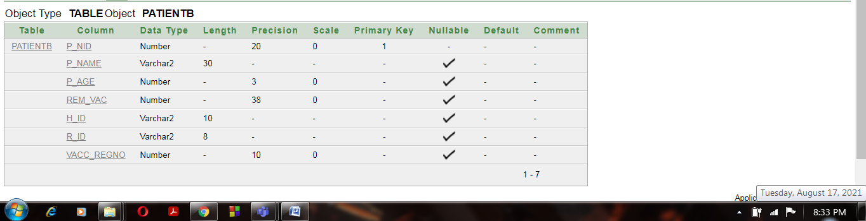

**Primary key:**

alter table Patientb

add constraint Pa_Pk primary key(P_NID)

**Foreign key:**

alter table Patientb

add constraint Pa1_fk foreign key(H_ID)

references Hospitald(H_ID)

alter table Patientb

add constraint Pa2_fk foreign key(R_ID)

references Medical_Records(R_ID)

alter table Patientb

add constraint PVR_fk foreign key(Vacc_RegNo)

references Vaccine_Records(Vacc_RegNo)

1. **H_ID**, H_Name, H_Add-> **Hospitald**

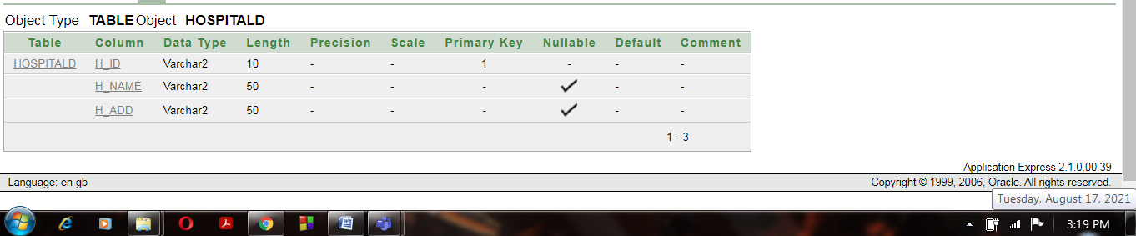

**Primary key:**

alter table Hospitald

add constraint Ho_Pk primary key(H_ID)

1. **P_NID**, **P_Mob.No**- **Composite PK - > Contact**

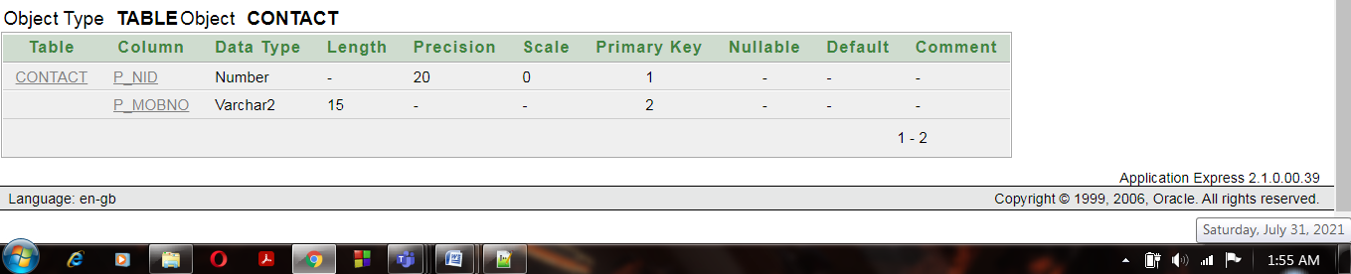

**Composite Primary key:**

alter table Contact

add constraint C_Pk primary key(P_NID, P_MobNo)

1. **Vacc_RegNo**, Vacc_name, First_Dose_Date, Sec_Dose_Date, D_RegNo, P_NID, H_ID **>Vaccine_Records**

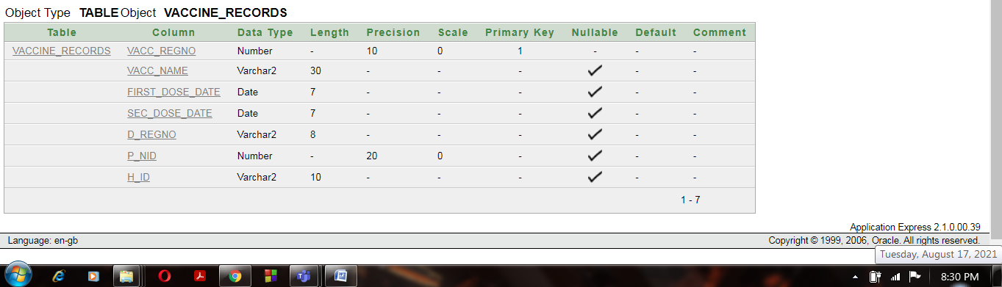

**Primary key:**

alter table Vaccine_Records

add constraint VacR_Pk primary key(Vacc_RegNo)

**Foreign key:**

alter table Vaccine_Records

add constraint VacR1_fk foreign key(H_ID)

references Hospitald(H_ID)

alter table Vaccine_Records

add constraint VacR2_fk foreign key(P_NID)

references Patientb(P_NID)

alter table Vaccine_Records

add constraint VacR3_fk foreign key(D_RegNo)

references Doctora( D_RegNo)

1. **D. RegNo**, **Skill.** - Composite PK**- >Qualification**

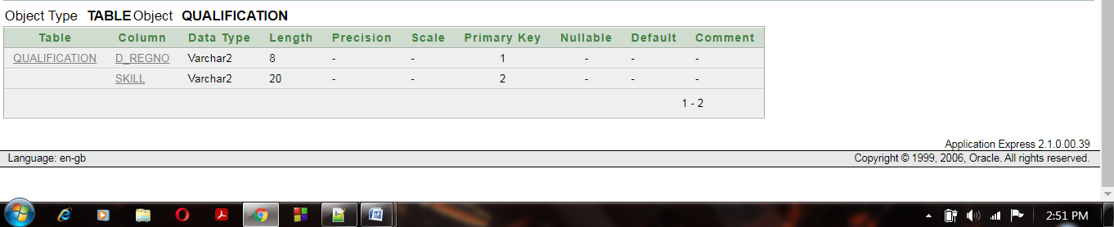

**Composite Primary key:**

alter table Qualification

add constraint Q_Pk primary key(D_RegNo,Skill)

1. **D_RegNo**, D_Name, H_ID**- >Doctora**

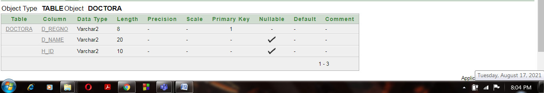

**Primary key:**

alter table Doctora

add constraint D_Pk primary key(D_RegNo)

**Foreign key:**

alter table Doctora

add constraint Do_fk foreign key(H_ID)

references Hospitald(H_ID)

1. **R_ID**, Vacc_name First_Dose_Date, Sec_Dose_Date, H_ID **- > Medical_Records**

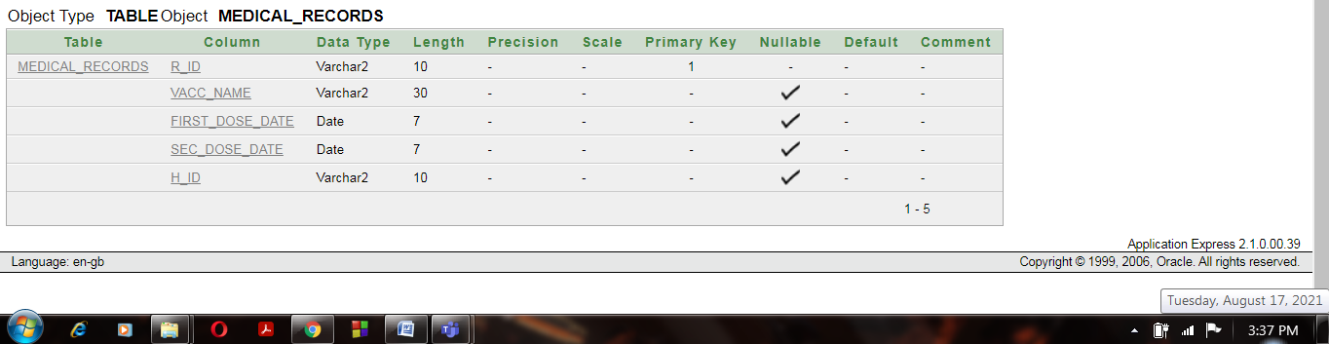

**Primary key:**

alter table Medical_Records

add constraint MeR_Pk primary key(R_ID)

**Foreign key:**

alter table Medical_Records

add constraint MeR_fk foreign key(H_ID)

references Hospitald(H_ID)

**6) Sequence:**

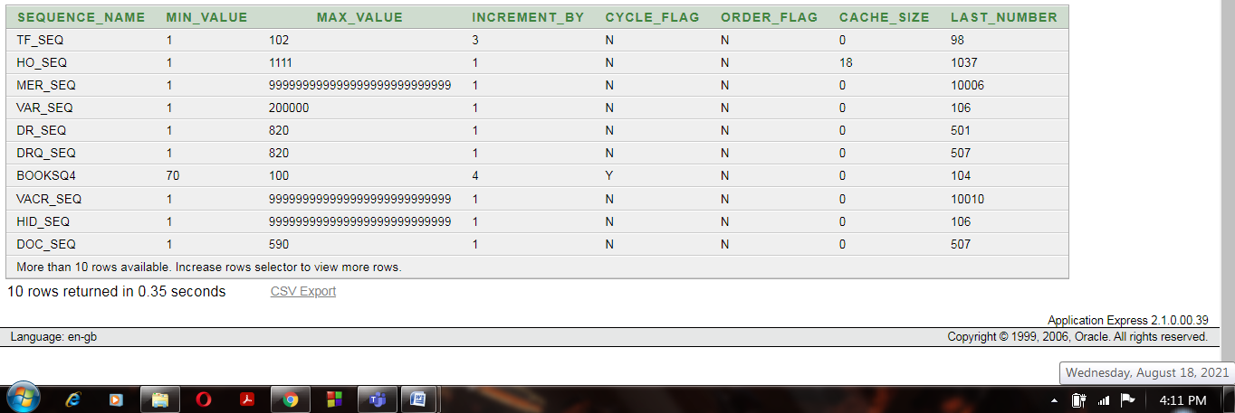

**7) Insertion Data:**

**01)** **Patientb -Table:**

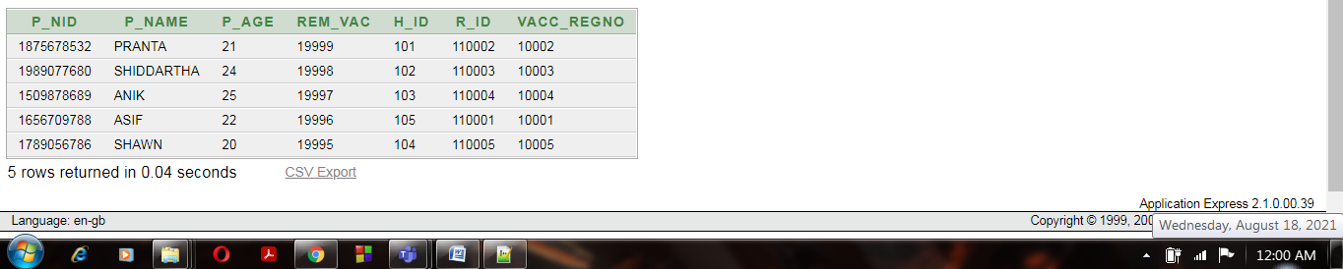

**02)** **Hospitald -Table:**

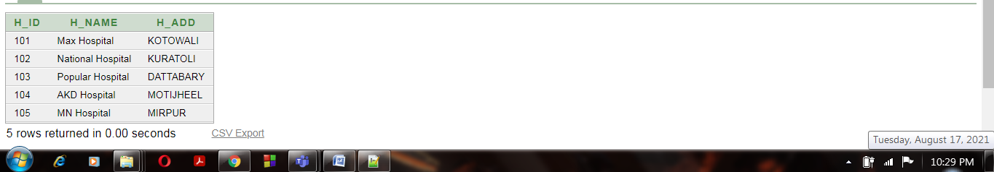

**03)** **Contact-Table: Composite**

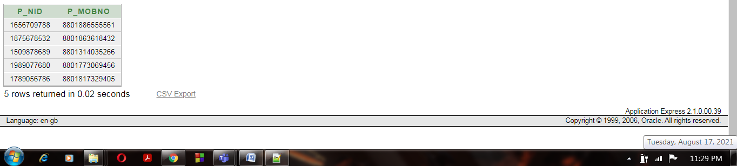

**04)** **Vaccine_Records -Table**

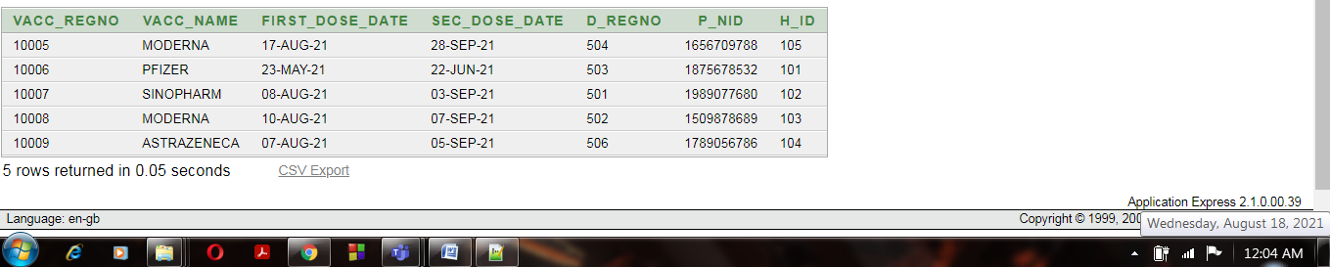

**05)** **Qualification- Table:**

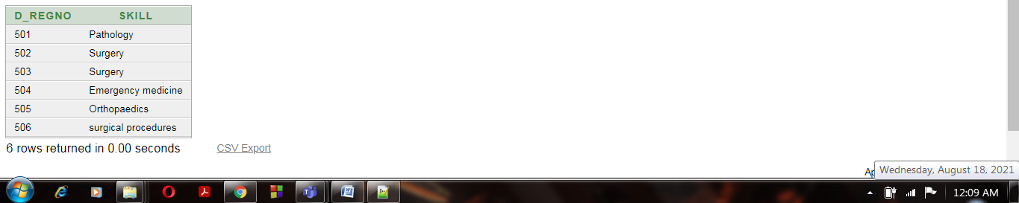

**06) Doctora -Table**

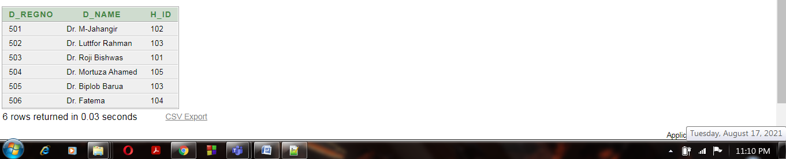

**07) Medical_Records** –**Table**

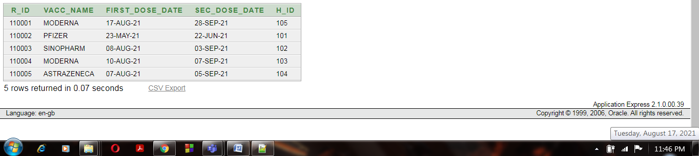

**8) Add Constraint:**

1. alter table Patientb

modify P_Age number not NULL

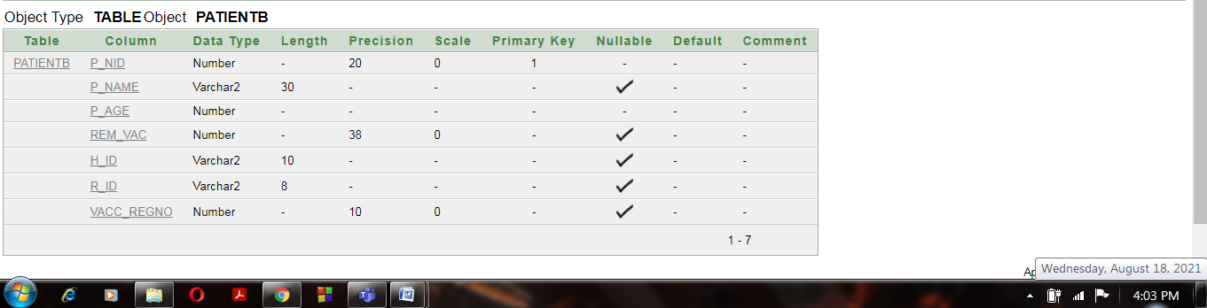

1. alter table Contact

modify P_MobNo default NULL

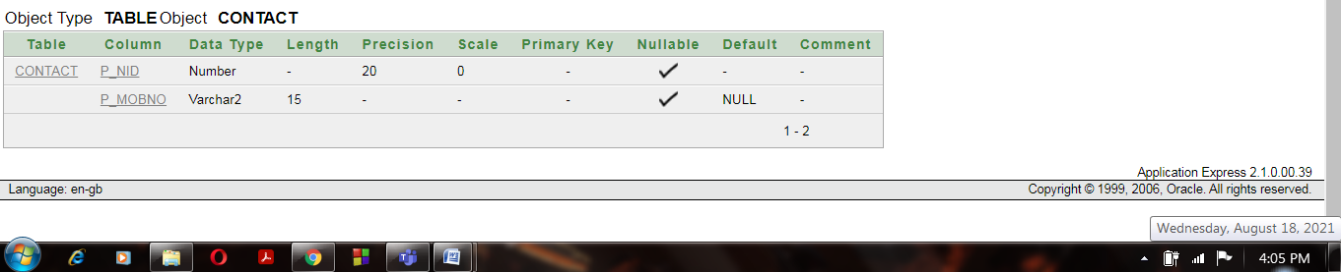

1. alter table Patientb

Add check (P_Age>=18)

**9) Question:**

1. Write a query which display the output like this sample answer “Pranta got his vaccine from Dr. Luttfor Rahman on Popular Hospital  ”
2. Write a query to display the Patients name, Hospital number, and Hospital’s name for all patients.
3. Create a query to display the name and 1st vaccine date of any patient got 1st dose after Anik.
4. Display all Doctors including Dr. Luttfor Rahman, who works in MN Hospital.
5. Find the number of patients who have age>20 select p_age,
6. write a query to display the number of people with vaccine.
7. Display the average, maximum, and minimum of age from patient’s table.
8. Create a view called pop_h based on hospitals name, address where hospital's id is 1003. Change the name of the headings for H_NAME to Hospital Name and H_ADD to Hospital Address.
9. Write a query to display details of patients like “Pranta" who is a patient. from patient table
10. Write a query to display H_Name which have a 'T' at the middle
11. Write a query to change the primary key
12. Write a query to display the information of all patients whose name starts with ‘P'.