Survival Analysis of Primary Biliary Cirrhosis Patients Using Kaplan–Meier and Cox Proportional Hazards Models
PRANTIK DUTTA
M.Sc. STATISTICS AND COMPUTING (BHU)
Abstract
Survival analysis provides statistical methods for analysing time-to-event data in the presence of censoring. This project applies survival-analysis techniques to the Primary Biliary Cirrhosis (PBC) dataset available in R. The analysis was performed on 312 complete observations after removal of missing values. Death was considered the event of interest, resulting in 125 deaths and 187 censored observations.
The Kaplan–Meier estimator was used to estimate the overall survival function and compare survival distributions across treatment, sex, and disease-stage groups. Log-rank tests were subsequently used to formally assess differences between groups. No statistically significant difference was observed between the treatment groups (p = 0.750), whereas survival differed significantly by sex (p = 0.039) and very strongly by disease stage (p < 0.001).
A multivariable Cox proportional hazards model was then fitted using age, sex, treatment, bilirubin, albumin, edema and disease stage as explanatory variables. Age, sex, bilirubin, albumin, edema and stage 4 showed statistically significant associations with the hazard of death, whereas treatment did not. The model had a concordance of 0.839, indicating strong discrimination.
However, the global Schoenfeld residual test indicated violation of the proportional hazards assumption (p = 0.0109), with bilirubin being particularly problematic (p = 0.0055). Therefore, the Cox model results should be interpreted as associations under a model whose proportional-hazards assumption is not fully satisfied.

1. Introduction
Survival analysis is a statistical methodology designed to study the time until the occurrence of an event of interest. Although the term survival is commonly associated with death, the methodology is applicable to many time-to-event problems, including disease recurrence, machine failure, customer churn and product failure.
A distinguishing characteristic of survival data is censoring. Censoring occurs when the event has not been observed for a subject during the available observation period. For example, if a patient remains alive at the end of follow-up, the exact time at which death would occur is unknown. The observation nevertheless contains valuable information because we know that the patient survived at least until the end of follow-up.
The PBC dataset contains follow-up information on patients with primary biliary cirrhosis. The original dataset contains 418 observations and 20 variables. The observed follow-up time ranges from 41 to 4795 days, while disease stage ranges from 1 to 4.
For this project, the analysis concentrates on survival time and selected clinical and demographic variables: treatment, age, sex, bilirubin, albumin, edema and disease stage.
Three major statistical approaches are employed:
- Kaplan–Meier estimation — to estimate survival probabilities.
- Log-rank testing — to compare survival distributions between groups.
- Cox proportional hazards regression — to investigate the relationship between patient characteristics and the hazard of death.
Together, these methods provide a progression from descriptive survival analysis to group comparison and multivariable modelling.

2. Objectives
The objectives of the study are:
- To analyse the survival experience of patients with primary biliary cirrhosis.
- To estimate the overall survival function using the Kaplan–Meier method.
- To compare survival between treatment groups.
- To examine differences in survival between male and female patients.
- To investigate survival differences across disease stages.
- To perform log-rank tests for the corresponding group comparisons.
- To identify factors associated with the hazard of death using Cox regression.
- To estimate hazard ratios and corresponding 95% confidence intervals.
- To assess the proportional hazards assumption using Schoenfeld residuals.
- To evaluate the overall performance and limitations of the fitted Cox model.

3. Data Description
The original PBC dataset contains 418 patients and 20 variables. The variables selected for the present analysis were:
Table 1. Variables used in the analysis.
Variable | Description
time | Follow-up time in days
status | Original patient outcome
trt | Treatment group
age | Patient age
sex | Sex
bili | Serum bilirubin
albumin | Serum albumin
edema | Edema status
stage | Disease stage
The original status variable was coded as:
- 0 = censored
- 1 = transplant
- 2 = death
For this project, a new binary variable status_death was created:
- 0 = censored
- 1 = death
Thus, transplant observations were treated as censored.
Important methodological limitation
This treatment of transplantation as censoring is a simplification. In a more advanced survival analysis, transplantation can be considered a competing risk, because transplantation changes the subsequent risk of death and prevents observation of death under the original disease pathway.
Therefore, the present analysis should be understood as a conventional time-to-death analysis rather than a competing-risks analysis.

4. Data Pre-processing
Missing observations were removed using complete-case analysis.
After preprocessing, n = 312 patients remained in the analysis. Among these:
- 125 patients experienced death
- 187 patients were censored
The corresponding percentages were:
$$\begin{matrix}\frac{125}{312}×100 & =40.06\% \\ \frac{187}{312}×100 & =59.9\%\end{matrix}$$
Thus, approximately 40.1% of the analytical sample experienced the event, while approximately 59.9% were censored.
The final sample consisted of 158 patients in Treatment 1 and 154 patients in Treatment 2. There were 36 males and 276 females. Disease-stage frequencies were 16, 67, 120 and 109 for stages 1 through 4 respectively.

5. Exploratory Data Analysis
Histograms were generated for:
- Age
- Bilirubin
- Albumin
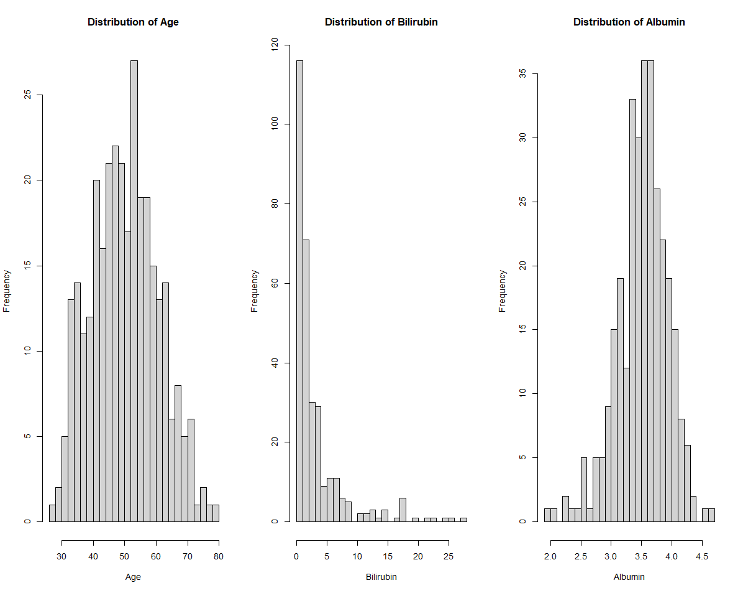
These plots were used to understand the distributions of important continuous covariates before survival modelling.
The descriptive statistics show that the mean age in the analytical sample was approximately 50.02 years, while the median age was approximately 49.79 years. Bilirubin had a mean of approximately 3.26, and albumin had a mean of approximately 3.52.

6. Survival Analysis

6.1 Survival Function
The survival function is defined as
 | $$S\left(t\right)=P\left(T>t\right)$$ | (1)
where $T$ represents the time until death.
Thus, $S\left(t\right)$ represents the probability that an individual survives beyond time $t$.
For example, if $S\left(2000\right)=0.70$, it means that approximately 70% of patients are estimated to survive beyond 2000 days.

7. Kaplan–Meier Estimator
The Kaplan–Meier estimator is a non-parametric estimator of the survival function that accounts for right-censored observations.
It is given by
 | St=ti≤t​1-dini, | (2)
where:
- $d_{i}$ = number of deaths at time $t_{i}$
- $n_{i}$ = number of patients at risk immediately before $t_{i}$
The estimator produces a step-shaped survival curve.

Interpretation of the curve
- A downward step represents one or more deaths.
- A censoring mark represents an observation that ended without the event being observed.
- A flat region indicates that no death occurred during that interval.

8. Kaplan–Meier Survival Analysis
The overall Kaplan–Meier estimator was fitted to all 312 patients.
The estimated survival probability gradually declined over follow-up. At approximately 1,000 days, the estimated survival probability was about 0.825. At 2,000 days, it had decreased to approximately 0.692, and at 3,000 days it was approximately 0.570.
The estimated survival probability reached approximately 0.500 at 3358 days. This is therefore an appropriate estimate of the median survival time.
 | $$\text{Median survival}≈3358 \text{days}$$ | (3)
This corresponds to approximately
 | $$\frac{3358}{365.25}≈9.19 \text{years}.$$ | (4)

Interpretation
The Kaplan–Meier analysis indicates a gradual decline in survival over the follow-up period. Approximately half of the analytical population remained event-free until around 3358 days, or roughly 9.2 years.
The confidence interval around the survival estimate widens at later follow-up times because progressively fewer patients remain under observation. This is an important feature of the survival curve and means that estimates toward the extreme right-hand side should be interpreted with greater uncertainty.
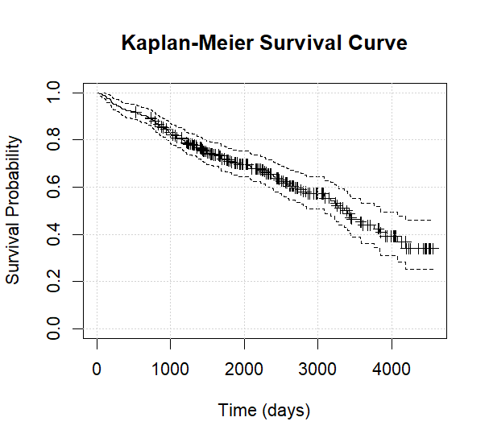
Figure 1. Overall Kaplan–Meier survival curve.
Figure interpretation: The curve demonstrates decreasing survival probability with increasing follow-up time. Censoring marks indicate patients for whom death was not observed during their available follow-up.

9. Kaplan–Meier Survival by Treatment
Separate Kaplan–Meier curves were estimated for Treatment 1 and Treatment 2.
There were:
- Treatment 1: 158 patients
- Treatment 2: 154 patients
The survival curves showed broadly similar patterns.
For example, near the later portion of follow-up, Treatment 1 had an estimated survival of approximately 0.319 at 4191 days, while Treatment 2 had an estimated survival of approximately 0.361 at 3853 days. However, differences at the tail of the curves are based on relatively few patients and should therefore not be overinterpreted.
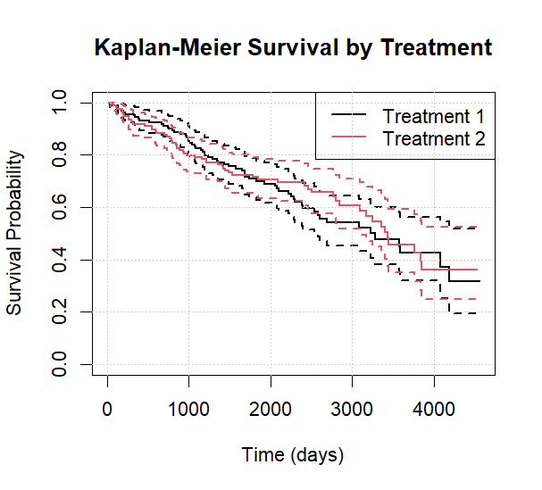
Figure 2. Kaplan–Meier survival curves by treatment.

10. Log-Rank Test: Treatment
The log-rank test was used to formally compare the survival distributions of the two treatment groups.

Hypotheses
 | $$\begin{matrix}H_{0} & : S_{1}\left(t\right)=S_{2}\left(t\right), \\ H_{1} & : S_{1}\left(t\right)≠S_{2}\left(t\right).\end{matrix}$$ | (5)
The test produced χ² = 0.1 with 1 degree of freedom and p = 0.7498.

Interpretation
Since p = 0.7498 > 0.05, there is insufficient statistical evidence to conclude that the survival distributions differ between Treatment 1 and Treatment 2.
This result is also consistent with the visual similarity of the Kaplan–Meier curves.
It is important not to interpret this as proof that the treatments are identical. Rather, the observed data do not provide sufficient evidence of a survival difference under the log-rank test.

11. Kaplan–Meier Survival by Sex
Kaplan–Meier curves were subsequently estimated separately for male and female patients.
The analytical sample contained:
- 36 males
- 276 females.
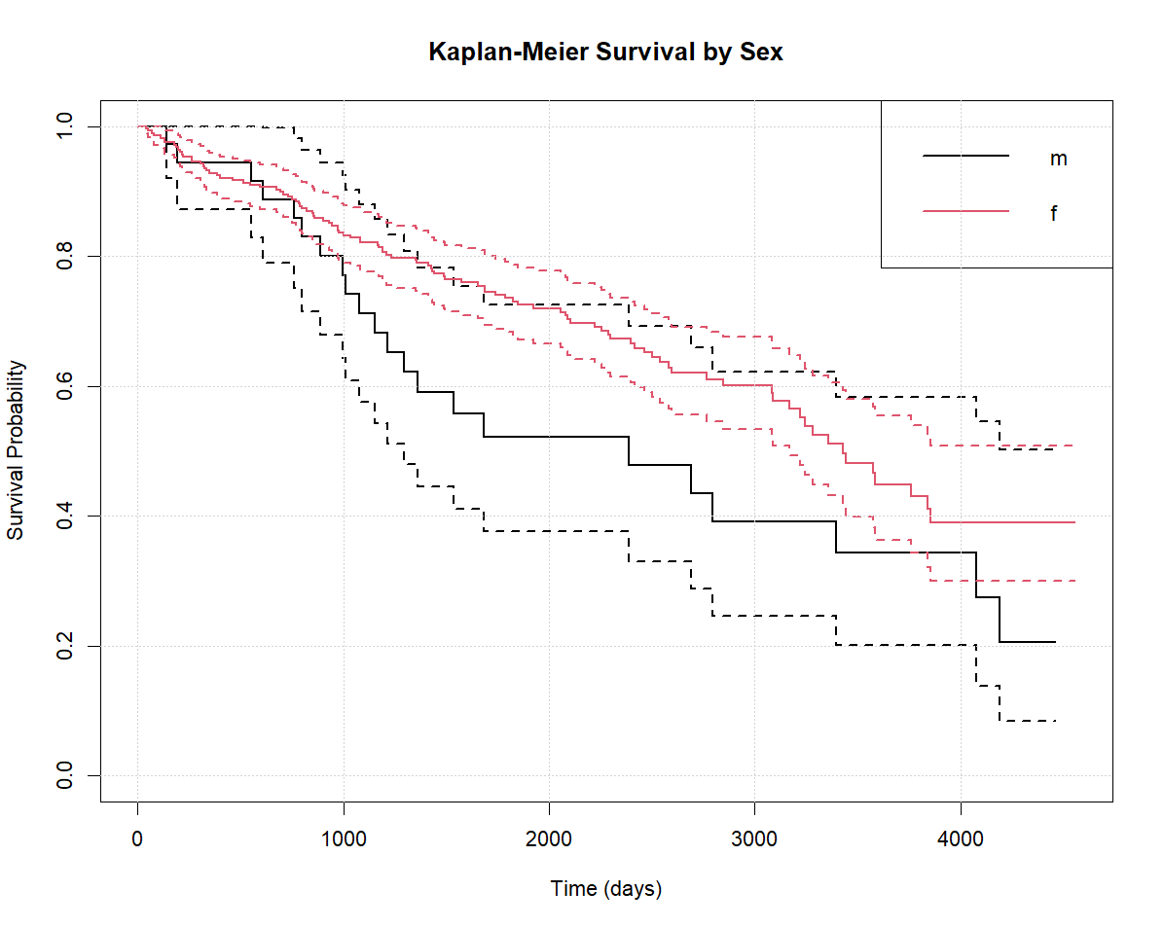
Figure 3. Kaplan–Meier survival curves by sex.
The curves show a difference in the observed survival experience between the two groups.
Because the male group is considerably smaller than the female group, the estimated survival curve for males is based on fewer observations and should be interpreted with this imbalance in mind.

12. Log-Rank Test: Sex
The log-rank test produced χ² = 4.3 with 1 degree of freedom and p = 0.0388.

Interpretation
Since p = 0.0388 < 0.05, there is statistical evidence of a difference in survival distributions between male and female patients in this analytical sample.
This is an unadjusted comparison. Therefore, it does not establish that sex itself causes the observed difference. Differences in other patient characteristics may contribute to the observed survival patterns.
The subsequent Cox model provides an adjusted analysis.

13. Kaplan–Meier Survival by Disease Stage
Disease stage was divided into four groups:
Table 2. Number of patients by disease stage.
Stage | Number of patients
Stage 1 | 16
Stage 2 | 67
Stage 3 | 120
Stage 4 | 109
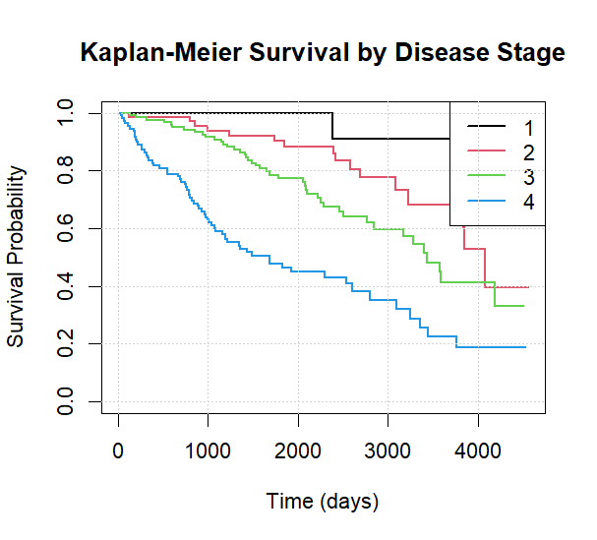
Figure 4. Kaplan–Meier survival curves by disease stage.
The survival curves show substantial separation between disease-stage groups, particularly between the lower and higher stages.
The stage 4 group shows a considerably greater number of observed deaths relative to its expected number under the null hypothesis.

14. Log-Rank Test: Disease Stage
The log-rank test produced χ² = 53.8 with 3 degrees of freedom and p = 1.215 × 10⁻¹¹.

Interpretation
The p-value is far below 0.05.
Therefore, there is very strong statistical evidence that survival distributions differ across disease stages.
The observed and expected deaths also illustrate the contribution of the different groups. For example:
- Stage 1: 1 observed vs 9.9 expected
- Stage 2: 16 observed vs 32.3 expected
- Stage 3: 43 observed vs 51.2 expected
- Stage 4: 65 observed vs 31.6 expected.
Stage 4 contributes strongly to the overall log-rank statistic because considerably more deaths were observed in this group than would be expected if survival were the same across stages.

15. Cox Proportional Hazards Model
The Cox proportional hazards model was fitted using
$$Age+Sex+Treatment+Bilirubin+Albumin+Edema+Stage$$
The model contained 312 observations and 125 events.
The fitted model was
 | $$\begin{matrix}h\left(t∣X\right)=​ & h_{0}\left(t\right)exp(β_{1} Age+β_{2} Sex+β_{3} Treatment \\ & +β_{4} Bilirubin+β_{5} Albumin+β_{6} Edema+β_{7} Stage)\end{matrix}$$ | (6)

16. Cox Regression Results
Table 3. Multivariable Cox regression results (hazard ratios with 95% confidence intervals).
Variable | Hazard ratio | 95% CI | p-value
Age | 1.0249 | 1.0056–1.0445 | 0.0111
Female vs male | 0.5521 | 0.3350–0.9101 | 0.0198
Treatment 2 vs Treatment 1 | 0.9746 | 0.6775–1.4021 | 0.8899
Bilirubin | 1.1347 | 1.1012–1.1692 | < 0.001
Albumin | 0.3950 | 0.2394–0.6519 | < 0.001
Edema | 2.6486 | 1.4292–4.9083 | 0.0020
Stage 2 vs Stage 1 | 4.0164 | 0.5255–30.6970 | 0.1803
Stage 3 vs Stage 1 | 5.8084 | 0.7876–42.8362 | 0.0844
Stage 4 vs Stage 1 | 9.4656 | 1.2749–70.2782 | 0.0280

17. Interpretation of Cox Regression

17.1 Age
The hazard ratio for age was HR = 1.0249 with p = 0.0111.
This means that, holding the other variables constant, a one-year increase in age was associated with approximately a 2.49% increase in the hazard of death.
The 95% confidence interval was 1.0056–1.0445 and did not include 1.
Therefore, age showed a statistically significant positive association with the hazard of death.

17.2 Sex
The hazard ratio for females relative to males was HR = 0.5521. The p-value was 0.0198.
Thus, after adjusting for the other variables, females had an estimated hazard approximately 44.8% lower than males:
$$\left(1-0.5521\right)×100≈44.8\%.$$
The confidence interval was 0.3350–0.9101 and did not include 1.
Therefore, sex remained statistically associated with survival after adjustment.
This should be interpreted as an association, not a causal effect.

18. Treatment
The hazard ratio for Treatment 2 relative to Treatment 1 was HR = 0.9746. The p-value was 0.8899.
The confidence interval was 0.6775–1.4021.
Because the confidence interval includes 1 and the p-value is substantially greater than 0.05, there is insufficient statistical evidence of an association between treatment group and hazard of death in this multivariable model.
This agrees with the earlier log-rank analysis, which also found no significant difference between treatment groups.

19. Bilirubin
Bilirubin had a hazard ratio of HR = 1.1347 with p < 0.001.
Thus, a one-unit increase in bilirubin was associated with approximately a 13.47% increase in the hazard of death, conditional on the other variables in the model.
The 95% confidence interval was 1.1012–1.1692, which lies entirely above 1.
Therefore, bilirubin showed a strong positive association with the hazard of death.
However, an important issue emerges later: the proportional-hazards test indicates that bilirubin does not satisfy the proportional-hazards assumption. Therefore, this single hazard ratio should be interpreted cautiously as an overall model-based association rather than necessarily a constant hazard ratio throughout follow-up.

20. Albumin
Albumin had HR = 0.3950 with p < 0.001.
This indicates that a one-unit increase in albumin was associated with an estimated 60.5% reduction in hazard:
$$\left(1-0.3950\right)×100≈60.5\%.$$
The confidence interval was 0.2394–0.6519 and did not include 1.
Thus, albumin demonstrated a strong negative association with the hazard of death after adjustment for the other covariates.

21. Edema
The estimated hazard ratio for edema was HR = 2.6486 with p = 0.0020.
Therefore, the presence of edema was associated with approximately
$$\left(2.6486-1\right)×100≈164.9\%$$
higher hazard of death relative to the reference condition, holding the other variables constant.
The 95% confidence interval was 1.4292–4.9083, which excludes 1.
Hence, edema showed a statistically significant positive association with the hazard of death.

22. Disease Stage
Stage 1 was used as the reference category.

Stage 2
HR = 4.0164 with p = 0.1803.
Although the point estimate suggests a higher hazard relative to Stage 1, the confidence interval is very wide (0.5255–30.6970).
Since the interval contains 1, the association is not statistically significant at the 5% level.

Stage 3
HR = 5.8084 with p = 0.0844.
The point estimate suggests substantially higher hazard relative to Stage 1, but the 95% confidence interval includes 1 (0.7876–42.8362).
Therefore, the evidence is insufficient to establish a statistically significant difference at the 5% level.

Stage 4
Stage 4 had HR = 9.4656 with p = 0.0280.
The 95% confidence interval was 1.2749–70.2782.
Therefore, Stage 4 had an estimated hazard approximately 9.47 times that of Stage 1, after adjustment for the other variables.
The confidence interval excludes 1, indicating a statistically significant association at the 5% level.
The very wide confidence interval reflects considerable uncertainty in the estimate, particularly because the Stage 1 group contained only 16 patients.

23. Cox Model Performance
The Cox model produced a concordance statistic of C = 0.839.
The concordance statistic measures the model’s ability to correctly discriminate between patients with different survival experiences.
A value of 0.5 corresponds approximately to random discrimination, while larger values indicate better concordance.
The value of 0.839 indicates strong discriminative ability within this dataset.
The likelihood-ratio, Wald and score tests were all highly significant, p < 2 × 10⁻¹⁶.
This indicates that the set of covariates, considered jointly, provides substantial information about the observed survival outcomes.

24. Hazard Ratio Plot
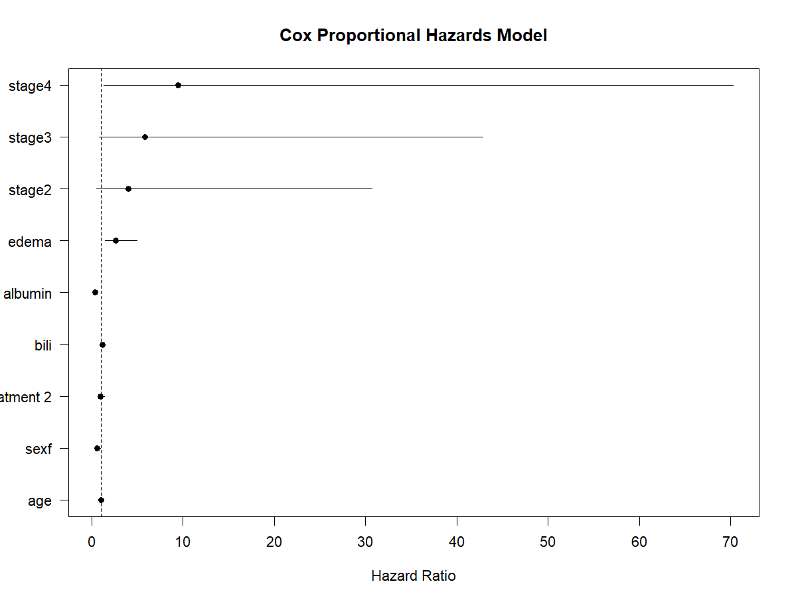
Figure 5. Cox proportional hazards model: estimated hazard ratios with 95% confidence intervals.
The vertical reference line at HR = 1 represents no association.
Variables whose confidence intervals lie entirely above 1 are associated with higher hazard, while those entirely below 1 are associated with lower hazard.
From the estimated confidence intervals:
- Age → above 1
- Bilirubin → above 1
- Edema → above 1
- Stage 4 → above 1
- Female sex → below 1
- Albumin → below 1
- Treatment → crosses 1
- Stage 2 → crosses 1
- Stage 3 → crosses 1.

25. Proportional Hazards Assumption
The Cox model assumes proportional hazards.
This means that the hazard ratio between two individuals or groups is assumed to remain approximately constant over time.
The assumption was examined using Schoenfeld residuals through the cox.zph() procedure.
The results were:
Table 4. Tests of the proportional-hazards assumption based on Schoenfeld residuals.
Variable | p-value
Age | 0.4184
Sex | 0.6048
Treatment | 0.4976
Bilirubin | 0.0055
Albumin | 0.4979
Edema | 0.0699
Stage | 0.0573
Global | 0.0109

26. Interpretation of Proportional Hazards Test
For an individual covariate:
 | $$H_{0}: \text{Proportional hazards assumption holds}$$ | (7)
A small p-value provides evidence against the assumption.
Most variables did not show significant evidence of violation.
However, bilirubin had a p-value of 0.0055, indicating a statistically significant violation of the proportional-hazards assumption.
The global test also gave p = 0.0109.
Therefore, the proportional-hazards assumption is not fully satisfied for the fitted model.
This is an important finding.
The Cox model should therefore not be presented as a perfectly valid constant-hazard-ratio model across the entire follow-up period.
The violation associated with bilirubin suggests that its effect on the hazard may change over time.
Potential extensions for a more advanced analysis would include:
- time-dependent covariates,
- stratified Cox models where appropriate,
- interactions between covariates and time,
- or alternative survival models.
For this project, identifying the violation is itself an important part of a proper survival-analysis workflow.

27. Schoenfeld Residual Plot
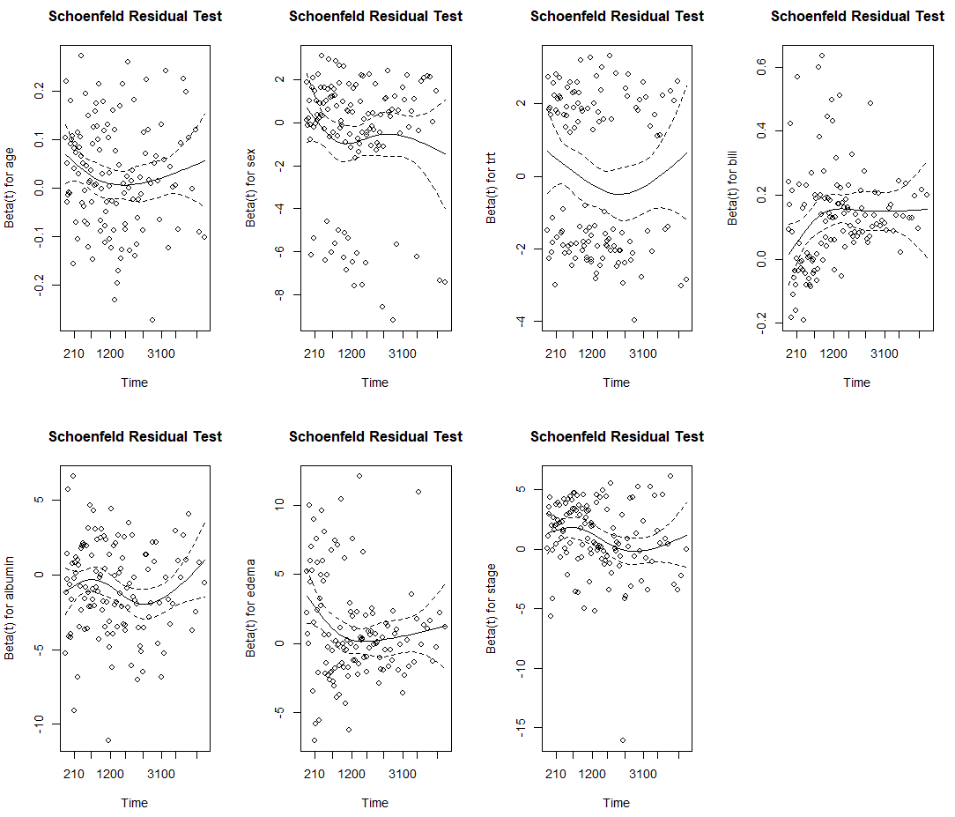
Figure 6. Schoenfeld residual diagnostics.
The Schoenfeld residual plots provide a graphical assessment of whether the effect of a covariate changes systematically with time.
The formal test identifies bilirubin as the primary covariate for which the proportional-hazards assumption is questionable.

28. Overall Results Summary
The main findings can be summarized as follows:
Table 5. Summary of the main results.
Analysis | Result | Interpretation
Overall KM | Median ≈ 3358 days | 50% estimated survival around 9.2 years
Treatment log-rank | p = 0.7498 | No significant survival difference
Sex log-rank | p = 0.0388 | Significant survival-distribution difference
Stage log-rank | p = 1.22 × 10⁻¹¹ | Strong evidence of stage-related survival differences
Age Cox HR | 1.0249 | Higher age associated with higher hazard
Female Cox HR | 0.5521 | Lower estimated hazard than males
Treatment 2 HR | 0.9746 | No significant adjusted association
Bilirubin HR | 1.1347 | Higher bilirubin associated with higher hazard
Albumin HR | 0.3950 | Higher albumin associated with lower hazard
Edema HR | 2.6486 | Edema associated with higher hazard
Stage 4 HR | 9.4656 | Higher estimated hazard than Stage 1
Cox concordance | 0.839 | Strong discrimination
Global PH test | p = 0.0109 | PH assumption violated
These values are directly from the submitted R output.

29. Interpretation
The analysis demonstrates that survival outcomes in the PBC cohort vary considerably according to patient characteristics.
The Kaplan–Meier analysis showed a gradual decline in survival probability throughout follow-up, with the estimated median survival occurring at approximately 3358 days.
Treatment did not show a statistically significant survival difference. This result was consistent across both the Kaplan–Meier/log-rank comparison and the adjusted Cox model. The treatment log-rank test produced p = 0.7498, while the adjusted treatment hazard ratio was 0.975 with p = 0.890.
In contrast, sex showed a statistically significant difference in the unadjusted survival analysis. The log-rank p-value was 0.0388, and sex remained statistically significant in the Cox model after adjustment.
Disease stage produced the strongest group-level evidence. The log-rank test gave p = 1.215 × 10⁻¹¹, indicating substantial differences in survival distributions across stages. Stage 4 also showed a significantly elevated hazard relative to Stage 1 in the Cox model.
Among continuous clinical variables, bilirubin and albumin showed strong associations with mortality. Higher bilirubin was associated with increased hazard, whereas higher albumin was associated with reduced hazard. Edema was also positively associated with the hazard of death.
The model demonstrated strong discrimination with a concordance of 0.839. Nevertheless, the proportional-hazards assumption was violated globally, primarily because of bilirubin. Consequently, the Cox regression should be interpreted with this model limitation in mind.

30. Limitations
Several limitations should be acknowledged.

1. Complete-case analysis
The original dataset contained 418 observations, but only 312 remained after removing observations with missing values.
Complete-case analysis can potentially introduce selection bias if the missingness mechanism is related to patient characteristics or survival.

2. Transplantation treated as censoring
Transplantation was classified as censored rather than as a competing event.
A competing-risks framework could provide a more technically appropriate analysis.

3. Proportional-hazards violation
The global Schoenfeld test was significant, and bilirubin violated the proportional-hazards assumption.
Consequently, the standard Cox model does not completely satisfy one of its principal assumptions.

4. Small Stage 1 group
Only 16 patients belonged to Stage 1, leading to very wide confidence intervals for the stage coefficients.
For example, the Stage 4 hazard ratio had a 95% confidence interval extending from 1.275 to 70.278.

5. Observational interpretation
The results demonstrate statistical associations. They should not automatically be interpreted as causal effects of the covariates on survival.

31. Conclusion
This project demonstrated the application of several fundamental survival-analysis techniques to the PBC dataset.
The Kaplan–Meier estimator provided a non-parametric description of survival, with the estimated median survival occurring at approximately 3358 days, or approximately 9.2 years.
The log-rank analysis showed that survival distributions did not differ significantly between the two treatment groups (p = 0.7498). In contrast, a statistically significant difference was observed between male and female patients (p = 0.0388), while disease stage showed a very strong association with survival distributions (p < 0.001).
The multivariable Cox model identified age, sex, bilirubin, albumin, edema and Stage 4 as statistically significant predictors/associates of the hazard of death at the 5% significance level. Treatment was not statistically significant after adjustment.
In particular, increasing age and bilirubin were associated with increased hazard, while female sex and higher albumin were associated with lower estimated hazard. Edema was associated with substantially higher hazard, and Stage 4 showed an estimated hazard approximately 9.47 times that of Stage 1.
The model demonstrated strong discriminatory ability, with a concordance statistic of 0.839. However, the global Schoenfeld residual test was significant (p = 0.0109), indicating that the proportional-hazards assumption was not fully satisfied. Bilirubin was particularly responsible for this violation (p = 0.0055).
Overall, the project illustrates the importance of using a sequence of survival-analysis methods: Kaplan–Meier estimation for describing survival, log-rank testing for group comparisons, and Cox regression for multivariable analysis. It also demonstrates that model diagnostics are essential; a statistically strong Cox model should not be interpreted without checking whether its underlying assumptions are satisfied.
For a more advanced extension, the analysis could incorporate time-varying effects for bilirubin, competing-risks methodology for transplantation, and potentially alternative survival models to address the limitations identified in the present analysis.
References
Austin, P.C., Lee, D.S. and Fine, J.P. (2016) 'Introduction to the analysis of survival data in the presence of competing risks', Circulation, 133(6), pp. 601–609.
R Core Team (2024) R: A Language and Environment for Statistical Computing. Vienna: R Foundation for Statistical Computing. Available at: https://www.R-project.org/ (Accessed: 4 October 2026).
Schoenfeld, D. (1982) 'Partial residuals for the proportional hazards regression model', Biometrika, 69(1), pp. 239–241.
Therneau, T.M. (2024) survival: A Package for Survival Analysis in R. R package. Available at: https://CRAN.R-project.org/package=survival (Accessed: 4 October 2026).
Therneau, T.M. and Grambsch, P.M. (2000) Modeling Survival Data: Extending the Cox Model. New York: Springer.

APPENDIX
# ============================================================
# SURVIVAL ANALYSIS - PBC DATASET
# ============================================================

# InstalL
# install.packages("survival")

library(survival)

# Load PBC dataset
data("pbc", package = "survival")

# Check data
head(pbc)
dim(pbc)
summary(pbc)

# ------------------------------------------------------------
# 1. SELECT VARIABLES
# ------------------------------------------------------------

data <- pbc[, c(
"time",
"status",
"trt",
"age",
"sex",
"bili",
"albumin",
"edema",
"stage"
)]

# ------------------------------------------------------------
# 2. CREATE EVENT VARIABLE
# ------------------------------------------------------------
# Original:
# 0 = censored
# 1 = transplant
# 2 = death
#
# Here:
# 0 = censored
# 1 = death

data$status_death <- ifelse(data$status == 2, 1, 0)

# ------------------------------------------------------------
# 3. REMOVE MISSING VALUES
# ------------------------------------------------------------

data <- na.omit(data)

dim(data)

table(data$status_death)

prop.table(table(data$status_death)) * 100

# ------------------------------------------------------------
# 4. CONVERT CATEGORICAL VARIABLES
# ------------------------------------------------------------

data$trt <- factor(
data$trt,
levels = c(1, 2),
labels = c("Treatment 1", "Treatment 2")
)

data$sex <- factor(data$sex)

data$stage <- factor(data$stage)

# ============================================================
# 5. BASIC EXPLORATORY ANALYSIS
# ============================================================

summary(data)
par(mfrow=c(1,3))
hist(
data$age,
main = "Distribution of Age",
xlab = "Age",
breaks = 20
)

hist(
data$bili,
main = "Distribution of Bilirubin",
xlab = "Bilirubin",
breaks = 20
)

hist(
data$albumin,
main = "Distribution of Albumin",
xlab = "Albumin",
breaks = 20
)

# ============================================================
# 6. SURVIVAL OBJECT
# ============================================================

surv_object <- Surv(
data$time,
data$status_death
)

head(surv_object)

# ============================================================
# 7. OVERALL KAPLAN-MEIER ANALYSIS
# ============================================================

km_fit <- survfit(
surv_object ~ 1,
data = data
)

summary(km_fit)

# Median survival
km_fit$table

# Kaplan-Meier plot
plot(
km_fit,
main = "Kaplan-Meier Survival Curve",
xlab = "Time (days)",
ylab = "Survival Probability",
conf.int = TRUE,
mark.time = TRUE
)

grid()

# ============================================================
# 8. SURVIVAL BY TREATMENT
# ============================================================

km_trt <- survfit(
Surv(time, status_death) ~ trt,
data = data
)

summary(km_trt)

plot(
km_trt,
col = 1:2,
lwd = 2,
main = "Kaplan-Meier Survival by Treatment",
xlab = "Time (days)",
ylab = "Survival Probability",
conf.int = TRUE
)

legend(
"topright",
legend = levels(data$trt),
col = 1:2,
lwd = 2
)

grid()

# ------------------------------------------------------------
# 9. LOG-RANK TEST: TREATMENT
# ------------------------------------------------------------

logrank_trt <- survdiff(
Surv(time, status_death) ~ trt,
data = data
)

print(logrank_trt)

p_trt <- 1 - pchisq(
logrank_trt$chisq,
df = length(logrank_trt$n) - 1
)

cat("Treatment log-rank p-value =", p_trt, "\n")

# ============================================================
# 10. SURVIVAL BY SEX
# ============================================================

km_sex <- survfit(
Surv(time, status_death) ~ sex,
data = data
)

plot(
km_sex,
col = 1:length(levels(data$sex)),
lwd = 2,
main = "Kaplan-Meier Survival by Sex",
xlab = "Time (days)",
ylab = "Survival Probability",
conf.int = TRUE
)

legend(
"topright",
legend = levels(data$sex),
col = 1:length(levels(data$sex)),
lwd = 2
)

grid()

# ------------------------------------------------------------
# 11. LOG-RANK TEST: SEX
# ------------------------------------------------------------

logrank_sex <- survdiff(
Surv(time, status_death) ~ sex,
data = data
)

print(logrank_sex)

p_sex <- 1 - pchisq(
logrank_sex$chisq,
df = length(logrank_sex$n) - 1
)

cat("Sex log-rank p-value =", p_sex, "\n")

# ============================================================
# 12. SURVIVAL BY DISEASE STAGE
# ============================================================

km_stage <- survfit(
Surv(time, status_death) ~ stage,
data = data
)

plot(
km_stage,
col = 1:length(levels(data$stage)),
lwd = 2,
main = "Kaplan-Meier Survival by Disease Stage",
xlab = "Time (days)",
ylab = "Survival Probability",
conf.int = FALSE
)

legend(
"topright",
legend = levels(data$stage),
col = 1:length(levels(data$stage)),
lwd = 2
)

grid()

# ------------------------------------------------------------
# 13. LOG-RANK TEST: STAGE
# ------------------------------------------------------------

logrank_stage <- survdiff(
Surv(time, status_death) ~ stage,
data = data
)

print(logrank_stage)

p_stage <- 1 - pchisq(
logrank_stage$chisq,
df = length(logrank_stage$n) - 1
)

cat("Stage log-rank p-value =", p_stage, "\n")

# ============================================================
# 14. COX PROPORTIONAL HAZARDS MODEL
# ============================================================

cox_model <- coxph(
Surv(time, status_death) ~
age + sex + trt + bili + albumin + edema + stage,
data = data
)

summary(cox_model)

# ============================================================
# 15. HAZARD RATIOS
# ============================================================

HR <- exp(coef(cox_model))

CI <- exp(confint(cox_model))

p_values <- summary(cox_model)$coefficients[, 5]

cox_results <- data.frame(
Variable = names(HR),
Hazard_Ratio = HR,
Lower_95_CI = CI[, 1],
Upper_95_CI = CI[, 2],
P_Value = p_values
)

print(cox_results)

# ============================================================
# 16. COX MODEL RESULTS
# ============================================================

print(cox_results)

# Plot estimated hazard ratios with 95% confidence intervals

HR <- cox_results$Hazard_Ratio
lower <- cox_results$Lower_95_CI
upper <- cox_results$Upper_95_CI

plot(
HR,
seq_along(HR),
xlim = range(c(lower, upper)),
yaxt = "n",
xlab = "Hazard Ratio",
ylab = "",
main = "Cox Proportional Hazards Model",
pch = 19
)

segments(
lower,
seq_along(HR),
upper,
seq_along(HR)
)

abline(
v = 1,
lty = 2
)

axis(
2,
at = seq_along(HR),
labels = cox_results$Variable,
las = 1
)

# ============================================================
# 17. PROPORTIONAL HAZARDS ASSUMPTION
# ============================================================

ph_test <- cox.zph(cox_model)

par(mfrow=c(2,4))

plot(
ph_test,
main="Schoenfeld Residual Test"
)

par(mfrow=c(1,1))

# ============================================================
# 18. FINAL SUMMARY
# ============================================================

cat("\n====================================\n")
cat("FINAL SURVIVAL ANALYSIS SUMMARY\n")
cat("====================================\n")

cat("Number of patients:", nrow(data), "\n")

cat(
"Number of deaths:",
sum(data$status_death == 1),
"\n"
)

cat(
"Number censored:",
sum(data$status_death == 0),
"\n"
)

cat(
"Treatment log-rank p-value:",
p_trt,
"\n"
)

cat(
"Sex log-rank p-value:",
p_sex,
"\n"
)

cat(
"Stage log-rank p-value:",
p_stage,
"\n"
)

cat("\nCox Regression Results:\n")

print(cox_results)

cat("\nProportional Hazards Test:\n")

print(ph_test)

