
- Home
- About Us
- Products & Services
- How We Work
- Contact Us
- Download

Request for Quotation
Get Demo

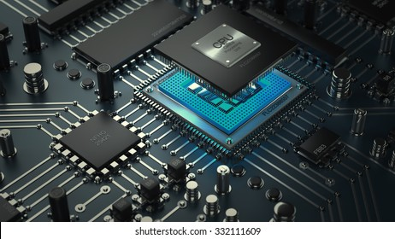


Hardware & Solution
We take pride in providing top-quality computer hardware solutions that are tailored to meet the needs of our clients. Our commitment to quality and customer satisfaction is unwavering, and we strive to exceed your expectations with every interaction. If you are looking for reliable and high-performance computer hardware solutions, look no further than our website.
we offer comprehensive computer hardware solutions to meet all your technology needs. We understand that having reliable and high-performance computer hardware is essential in today's fast-paced world. That's why we offer a range of hardware solutions that are specifically designed to enhance your computing experience.

What We Offer

DELL TECHNOLOGIES

Dell provides end to end solution for customers Desktop Notebook Server Storage Hyper-converged Infrastructure Virtual Desktop Infrastructure Networking
- Desktop
- Notebook
- Server.
- Storage.
- Hyper-converged Infrastructuret.
- Virtual Desktop Infrastructure.
- Networking.

HP

Hp provides end to end solution for customers
- Desktop
- Notebook
- Printer
- Scanner .

HPE
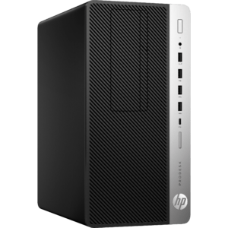
Hpe provides end to end solution for customers
- Server
- Hyper-converged Infrastructure
- Virtual Desktop Infrastructure
- Networking

CISCO
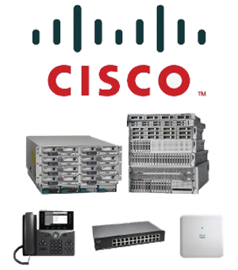
Our comprehensive suite of hardware solutions and countrywide logistics services span the entire hardware manufacturing lifecycle
- Networking.
- Network Security.
- Servers . .
- Hyper-converged Infrastructure .

JUNIPER
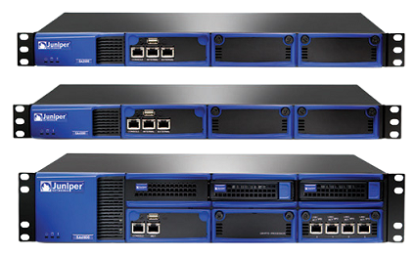
Juniper Networks provides high-performance networking & cybersecurity solutions to service providers, enterprise companies & public sector organizations
- Networking
- Network Security
- Wireless Solution

F5

F5 application services ensure that applications are always secure and perform the way they should—in any environment and on any device
- Local Traffic Manager
- Web Application Firewall
- Advanced Firewall Manager
- Access Policy Manager
- Fraud Protection Service
- DNS Cloud Service
- Policy Enforcement Manager
- Secure Web Gateway

FORTINET
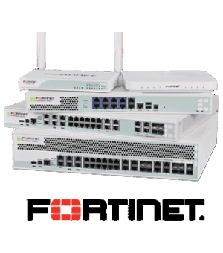
F5 application services ensure that applications are always secure and perform the way they should—in any environment and on any device
- Local Traffic Manager
- Web Application Firewall
- Advanced Firewall Manager
- Access Policy Manager
- Fraud Protection Service
- DNS Cloud Service
- Policy Enforcement Manager
- Secure Web Gateway

SOPHOS
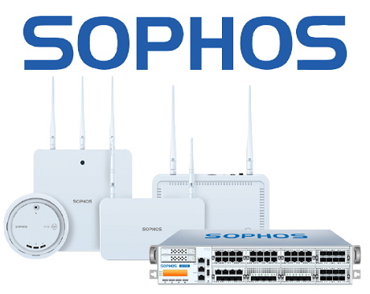
It's available for multiple platforms including hardware appliances, virtual environments and as a software ISO to install on Intel x86 hardware of your choice.
- Sophos Firewall.
- Sophos Wireless.
- Sophos Switch.
- Sophos Zero Trust Network.



With a mission to deliver Excellence, through Innovation in designing solutions, implementing those in an innovative way using the right technologies. Pakiza Technovation Limited is the newest concern of renowned Pakiza Group, the standard of excellence in all its business sectors. Pakiza Technovation Limited always love to optimize, not to be lowest price, its solution to meet its client’s requirement & thus ensure value for money.

Address
Head office : House# 97, Road# 11/A,
Dhanmondi, Dhaka-1209, Bangladesh
+880 9612 811 111
info@pakizatvl.com
Registered office: Khordo Nowpara,Rasulpur Narsingdi (Sadar), Narsingdi-1600, Bangladesh

Get Connected

App privacy and policy


© 2023 Pakiza Technovation Limited

