
- Home
- About Us
- Products & Services
- How We Work
- Contact Us
- Download

Request for Quotation
Get Demo




Security and Surveillance
Software is an essential component of modern technology, and software solutions can provide effective solutions to a wide range of problems. By automating tasks, improving collaboration, and providing valuable insights, software can help businesses and individuals become more productive and efficient. As technology continues to evolve, we can expect to see even more innovative software solutions that will help us work smarter and achieve our goals more effectively. Software solutions is their ability to automate repetitive tasks, allowing users to focus on more valuable work. For example, a marketing team can use marketing automation software to streamline their campaigns and reduce the time and effort needed to carry out various tasks. Similarly, a customer service team can use a ticketing system to manage customer requests more efficiently, reducing the workload on individual agents.

Security and Surveillance we offer

Hikvision

We are providing the end to end IP CCTV Solution for Medium and Large Enterprise Clients.
- NVR or Server bases IP CCTV Solution.
- Thermal Camera Solution.
- Face Detection Access Contro

ZTKECO

ZKTeco Co., Ltd is a globally renowned enterprise with biometric verifications as its core technique.
- Biometrics Attendance system
- Face Detection Access Control and Attendance system
- Archway Gate and metal Detector
- Gate Barrier System

GARRETT

The Garrett is an USA based Company. The company has set goals to empower their customers with better products, better technology and better information.
- Archway Gate and metal Detector
- Gate Barrier System

SUPREMA
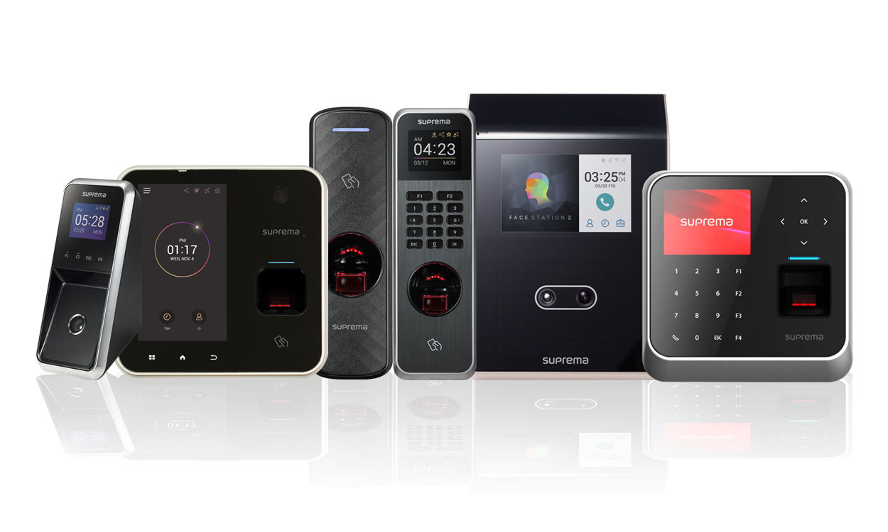
Suprema is a leading global provider of access control, time & attendance, and biometrics solutions.
- Biometrics Attendance system
- Face Detection Access Control and Attendance system

PA System
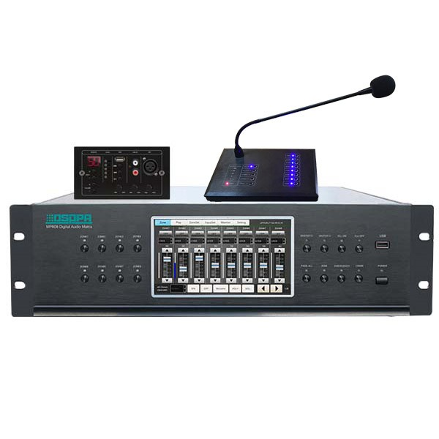
PA system are announcements of movements at large area with many speakers are widely used to make announcements in public, institutional and commercial buildings and locations.



With a mission to deliver Excellence, through Innovation in designing solutions, implementing those in an innovative way using the right technologies. Pakiza Technovation Limited is the newest concern of renowned Pakiza Group, the standard of excellence in all its business sectors. Pakiza Technovation Limited always love to optimize, not to be lowest price, its solution to meet its client’s requirement & thus ensure value for money.

Address
Head office : House# 97, Road# 11/A,
Dhanmondi, Dhaka-1209, Bangladesh
+880 9612 811 111
info@pakizatvl.com
Registered office: Khordo Nowpara,Rasulpur Narsingdi (Sadar), Narsingdi-1600, Bangladesh

Get Connected

App privacy and policy


© 2023 Pakiza Technovation Limited

